**BDTM: Big data tool for managers**

**1st Internal answer sheet**

**USN: 1SI22BA003**

**Name: Aditi Ramesh**

**Class Section: 2nd semester, ‘A’ section[MBA]**

**Q1. Demonstrate MySQL Database operation**

1. Create a database CARS in MySQL

CREATE DATABASE CARS;



B. List all the databases available in MySQL

SHOW DATABASES;

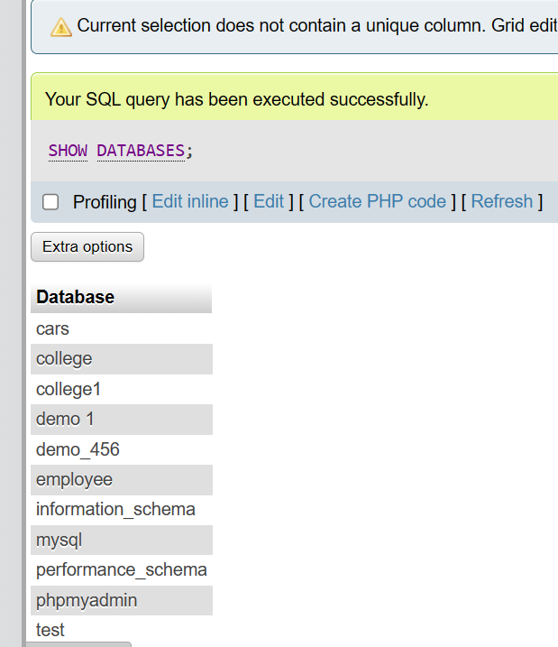

C.Select the CARS database, and list all the tables available in CARS database.

SHOW TABLES;

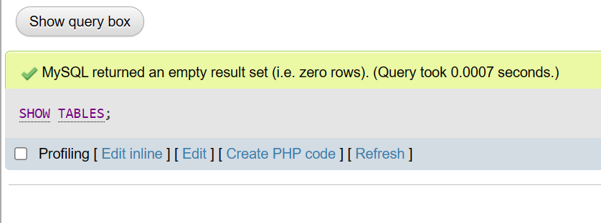

D. Remove CARS database from MySQL

DROP DATABASE CARS;

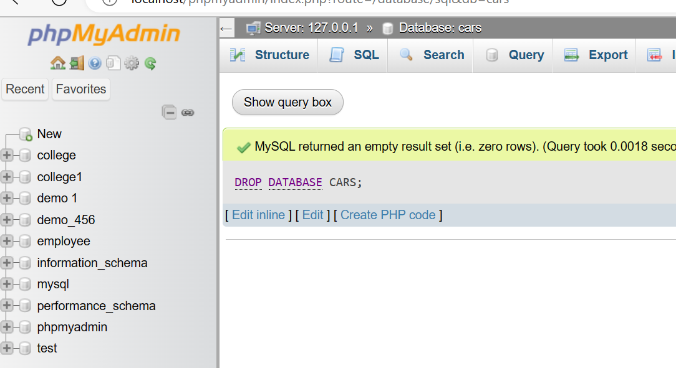

E. List all the databases available in MySQL

SHOW DATABASES;

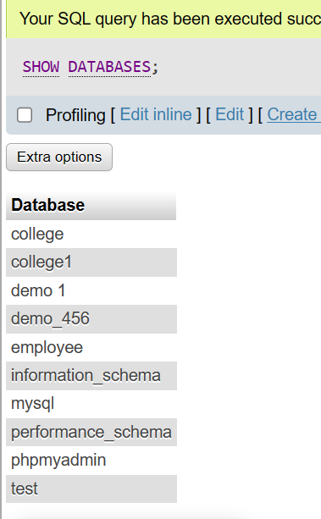

-------------------------------[10]

**Q2. Demonstrate Basic RDBMS table operations with MySQL**

1. Create database MOBILE, and create above given PRODUCT table in MOBILE database

CREATE DATABASE MOBILE;

CREATE TABLE PRODUCT

(

PRODUCT_ID SMALLINT,

PRODUCT_NAME VARCHAR(20),

MRP TINYINT,

CURRENCY CHAR(10)

);



1. Insert above given sample records in PRODUCT table

INSERT INTO product VALUES('PRD_1001','Mobile Back Cover','150','INR');

INSERT INTO product VALUES('PRD_1002', 'Mobile Glass',' 3 ','USD');

INSERT INTO product VALUES('PRD_1003',' Flip Cover' ,'250' ,'INR');

INSERT INTO product VALUES('PRD_1004', 'Screencast' ,'500' ,'INR');

INSERT INTO product VALUES('PRD_1005' ,'Earphones' ,'300' ,'INR');

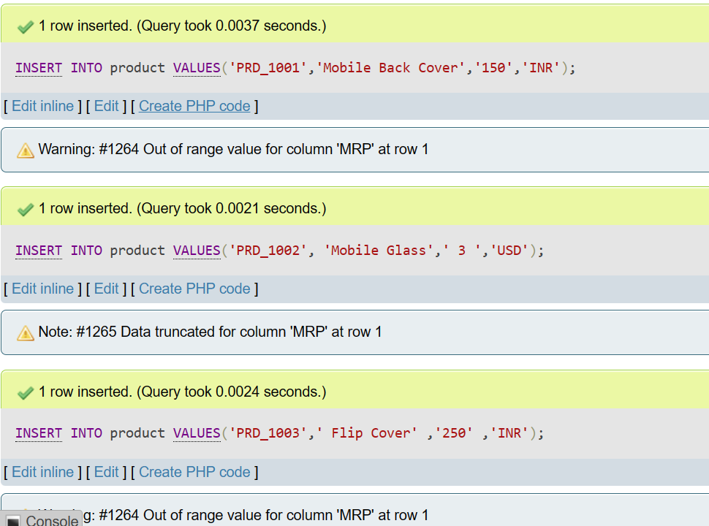

1. Display PRODUCT table structure

DESCRIBE PRODUCT;



D. Truncate PRODUCT table

TRUNCATE TABLE product;

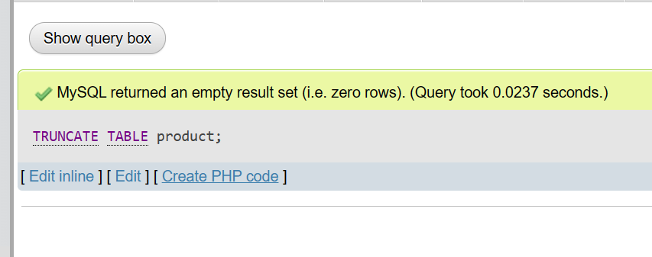

E.Delete PRODUCT table from MOBILE database

DROP TABLE PRODUCT;

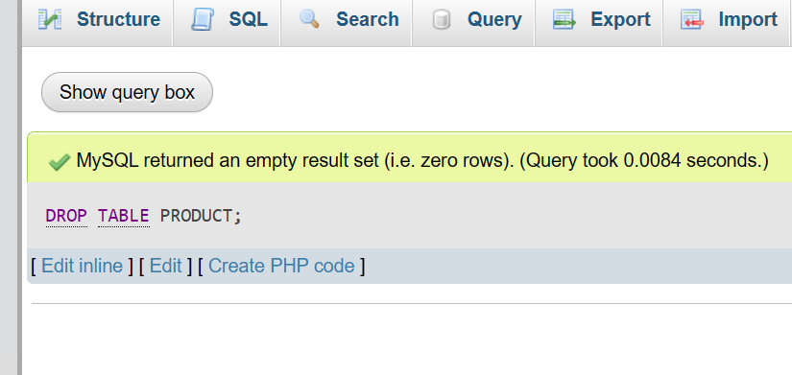

--------------------------[10]

Q3. Demonstrate NOT NULL, UNIQUE and DEFAULT Constraints in MySQL RDBMS Table

1. USN with UNIQUE constraint

CREATE TABLE students_exam

(

USN CHARACTER(10) UNIQUE,

NAME VARCHAR(20) NOT NULL,

DOB DATE,

ADDRESS VARCHAR(45),

CITY VARCHAR(10) DEFAULT 'TUMKUR',

STATE VARCHAR(10) DEFAULT 'KARNATAKA',

PINCODE INT DEFAULT 572103,

CGPA INT DEFAULT 0

);

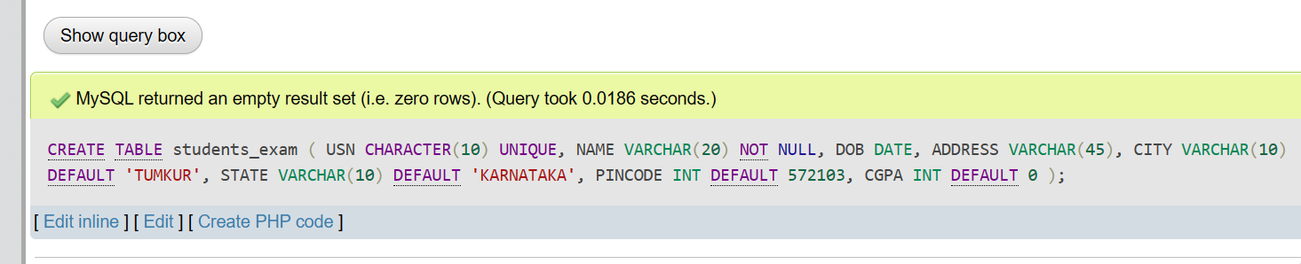

B. Insert above records into the students_exam table

(Note : The error message is expected while inserting records into the table and place same error message as

part of answers for 3rd, 4th & 5th records)

INSERT INTO students_exam VALUES ('1SI23MBA01', 'AAA', '1995-01-01', 'B H ROAD', 'TUMKUR', 'KARNATAKA', 572103, 8.5);

INSERT INTO students_exam VALUES ('1SI23MBA02', 'BBB', '1996-01-01', 'BANGALORE', 'BANGALORE', 'KARNATAKA', 560001, 9.5);

INSERT INTO students_examV VALUES ('1SI23MBA02', 'BBB', '1996-01-01', 'TUMKUR', 'BANGLORE', 'KARNATAKA', 572103, 9.5);

INSERT INTO students_exam VALUES ('1SI23MBA04', '1999-01-01', 'B H ROAD', 'TUMKUR', 'KARNATAKA', 572106, 8.5);

INSERT INTO students_exam VALUES ('1SI23MBA05', 'FFF', '1999-01-01', 'B H ROAD','TUMKUR');

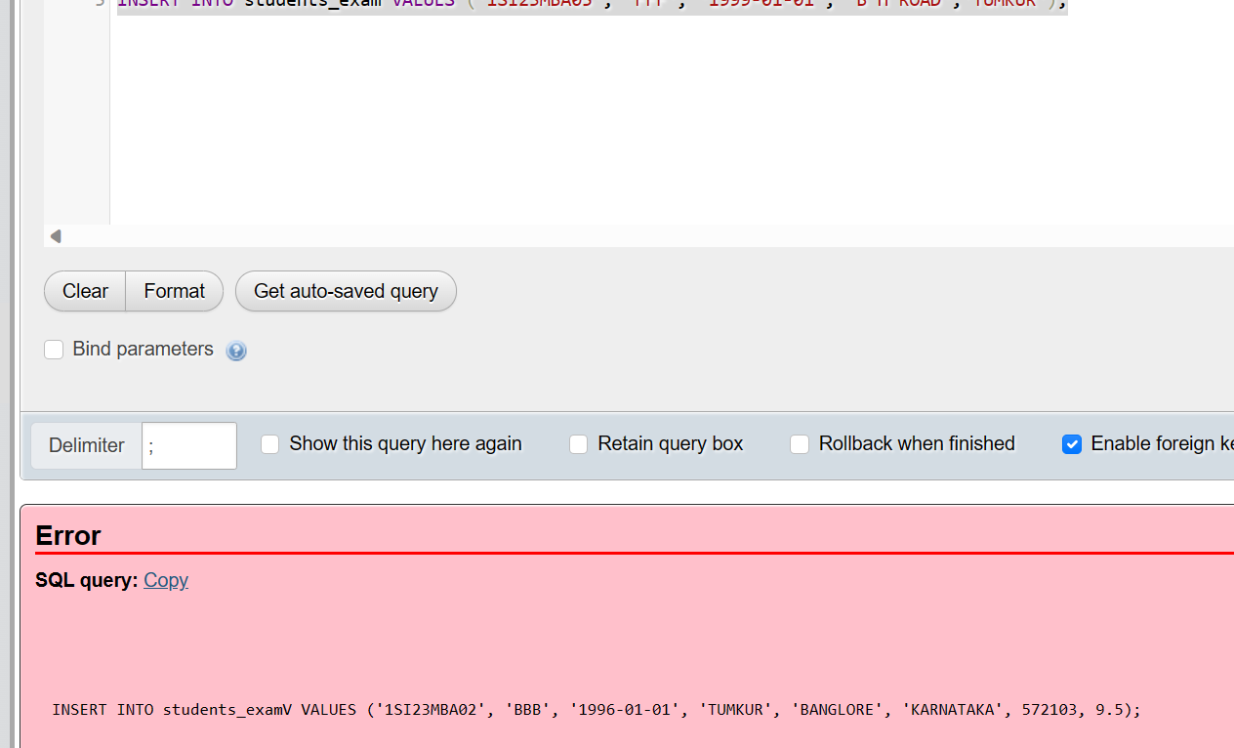

-----------------[3] NOT NULL & DEFAULT constraint queries are not proper.

Q4. Working with SELECT clause in MySQL Table

1. Display single column name from student_details table

SELECT 'COLUMN' FROM student_details;

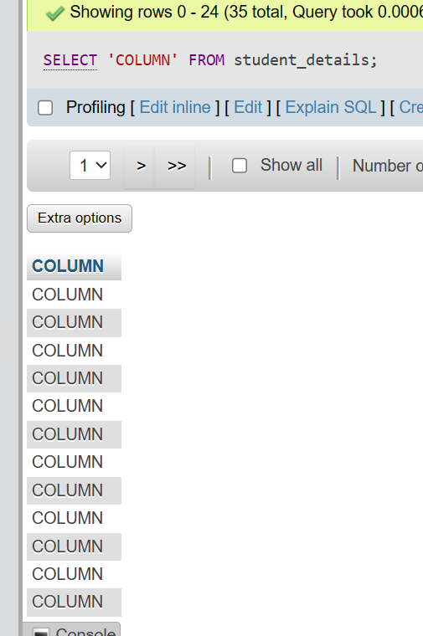

---------------asked to display name column

1. Display unique values for class from student_details

SELECT DISTINCT CLASS FROM student_details;

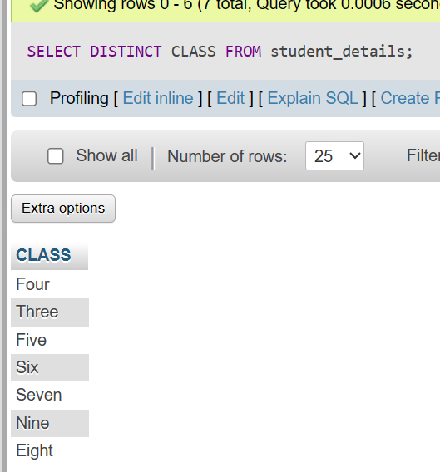

1. Display unique values for name, class details from student_details table

SELECT DISTINCT name,class details FROM student_details;

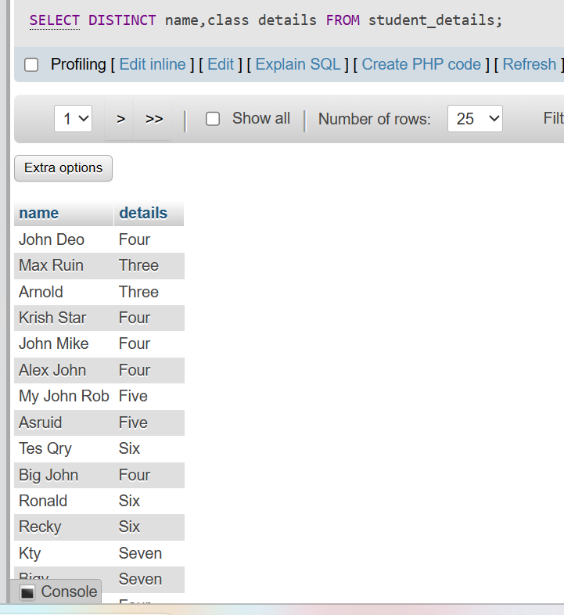

1. Display distinct records from student_details

SELECT DISTINCT records FROM student_details;

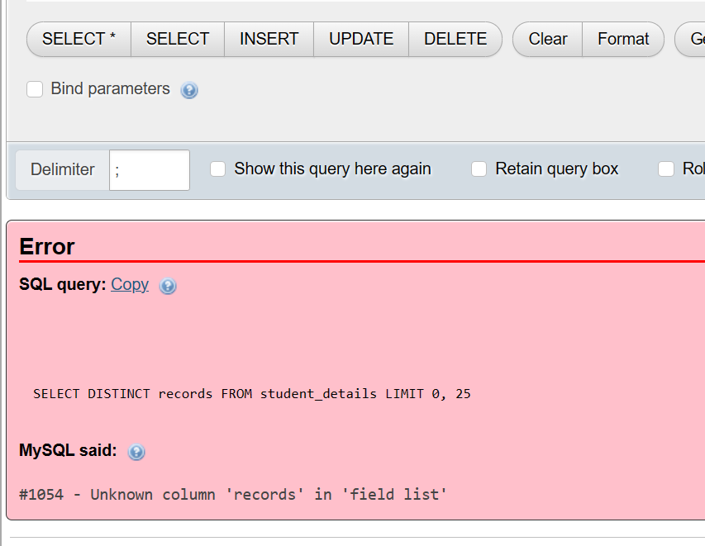

----not valid