**BDTM: Big data tool for managers**

**Second Internal answer sheet**

**USN: 1SI22BA003**

**Name: Aditi Ramesh**

**Class Section: 2nd semester, ‘A’ section [MBA]**

**1.A**

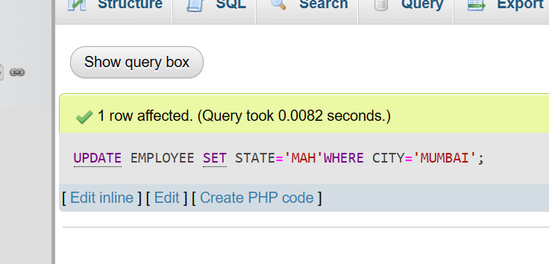

B. 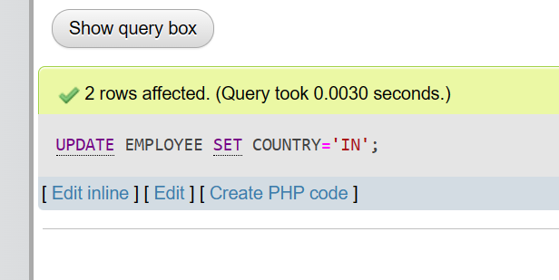

C. DELETE FROM EMPLOYEE WHERE NAME='EEE';

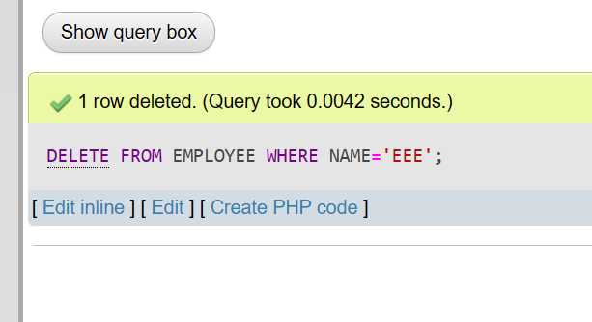

d. DELETE FROM EMPLOYEE WHERE STATE='MAH';

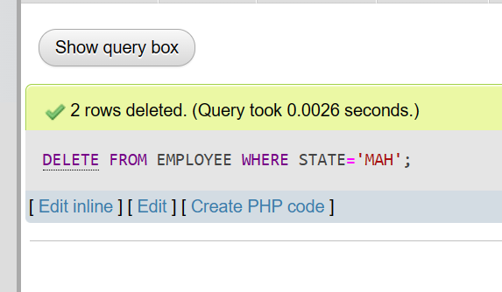

E. SELECT * FROM EMPLOYEE;

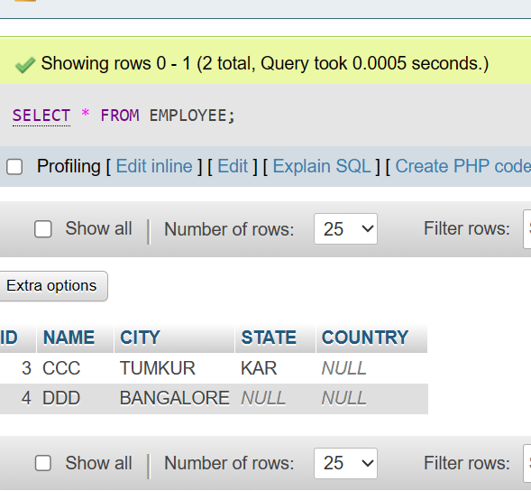

-----------------------Q1[10]

2a 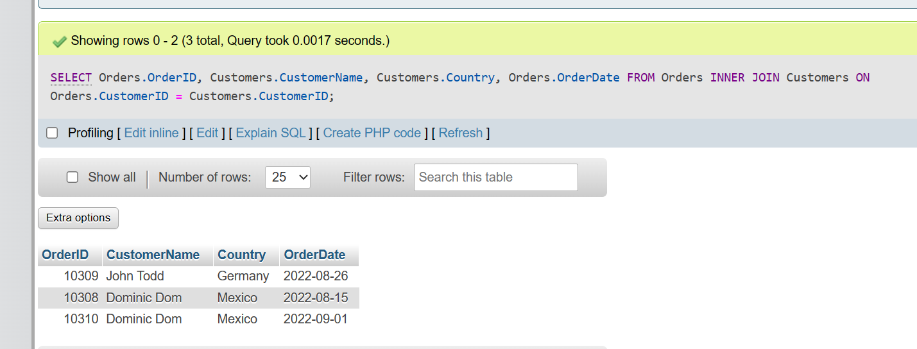

2b 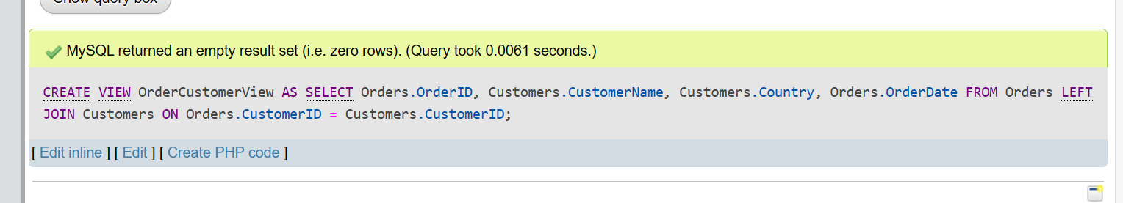

2c 

2d 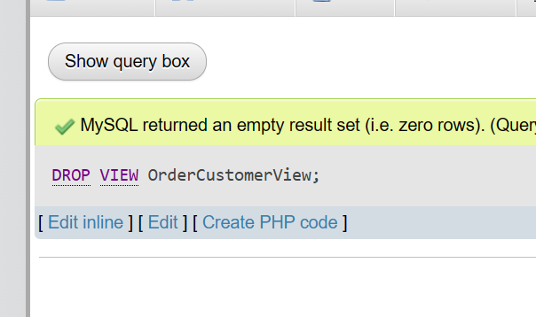

-------------------------Q2[10]

3a 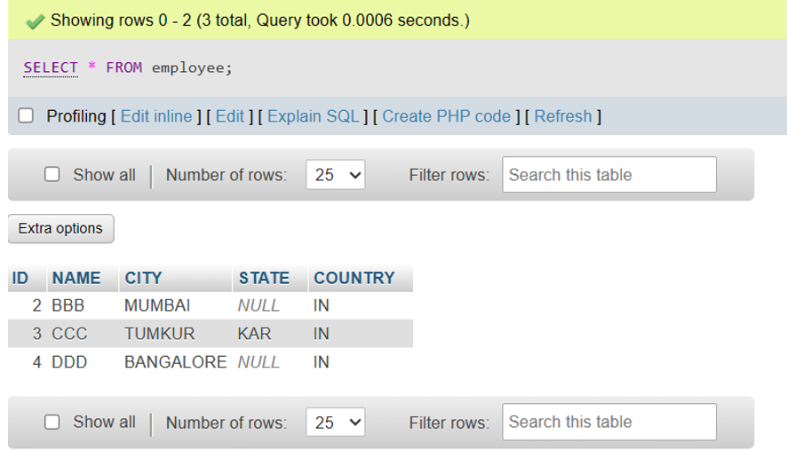

----------------------------UNION ALL is missing

3b

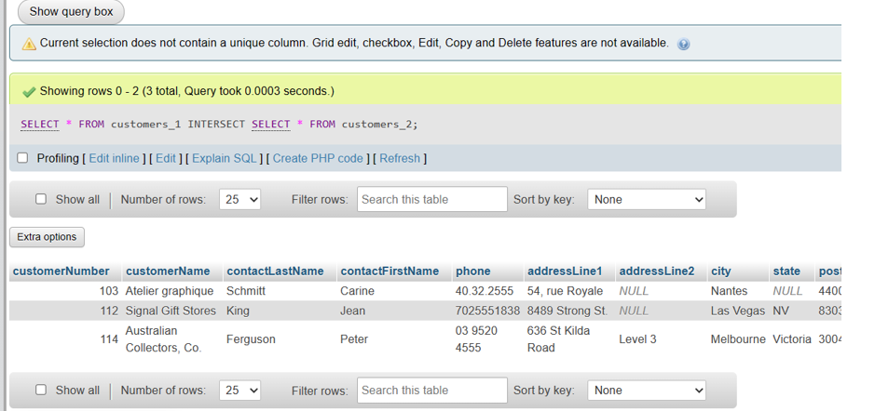

----------------------------------Q3[5]

4a

1.my_vector<-c(99,86,63,81,48)

print(my_vector)

2. print (my_vector)

3.length(my_vector)

4.sorted_vector<-sort(my_vector)

print(Sorted_vector)

-----------------------------------Q4A[5]

4b

1.data=c(8,4,3,-5,6,-2,7,9,-8)

num mat=matrix(data,nrow=3,ncol=3)

print(num mat)

2.print(num mat)

----------------------------------Q4b[1] # Statement has errors and output is not matching with QP

5

b.head(vehicle_park,n=20)

tail(vehicle_park,n=55)

c.summary(vehicle_park)

d.vehicles_2010<-subset(vehicle_park,RegistrationYear==2010

e.age_group_column<-vehicle_park$AGE_GROUP

-----------------Q5[5]