**Big Data Tools for Managers**

**Dept. of MBA, Siddaganga Institute of Technology-Tumkur**

Below is the employee dataset; this exercise makes you familiar with update and delete records in MySQL table.

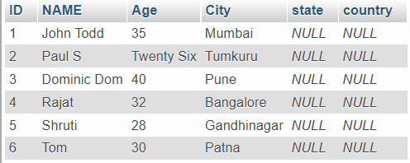

Download customer dataset from below link:

<https://bit.ly/3KLlmNM>

Write SQL Code for following Statements.

1. Import employee data into MySQL…ignore this step if you imported already.
2. Display all the records from employee table
3. Update Age with appropriate numbers for Employee ID : 2 / Employee Name : Paul S
4. Display all the records after updating Age
5. Update State name as per city
6. Display all the records after updating State
7. Update country name as India for all the employee
8. Display all the records after updating Country
9. Delete employee who all are from Karnataka
10. Display all the records after deleting Karnataka employee
11. Delete all the employee records
12. Display all the records after deleting all the records
13. Import dataset

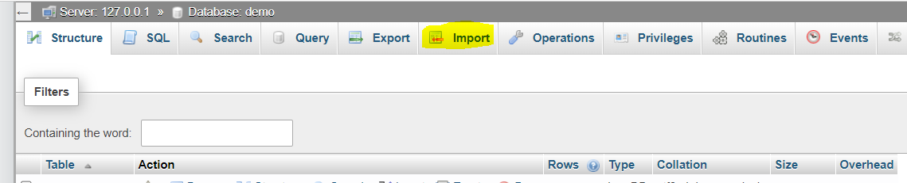

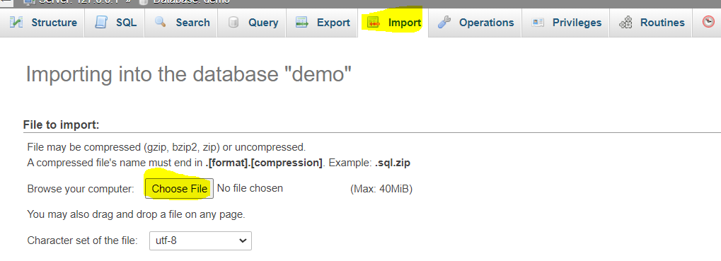

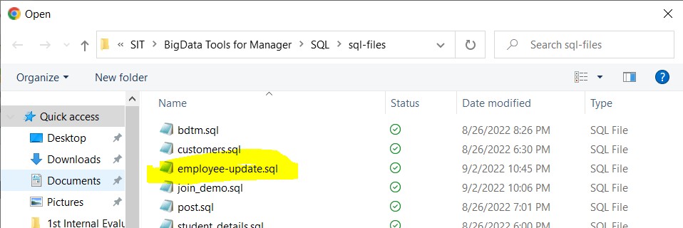

Click on Open after selecting employee-update.sql file

1. Display all the records from employee table

SELECT * FROM employee;

1. Update Age with appropriate numbers for Employee ID : 2 / Employee Name : Paul S

UPDATE employee SET Age=26 WHERE ID=2;

OR

UPDATE employee SET Age=26 WHERE NAME='Paul S';

1. Display all the records after updating Age

SELECT * FROM employee;

1. Update State name as per city

UPDATE employee SET STATE = 'Karnataka' WHERE CITY IN ('Tumkuru','Bangalore');

UPDATE employee SET STATE = 'Maharashtra' WHERE CITY IN ('Pune','Mumbai');

UPDATE employee SET STATE = 'Bihar' WHERE CITY = 'Patna';

UPDATE employee SET STATE = 'Gujarat' WHERE CITY = 'Gandhinagar';

1. Display all the records after updating State

SELECT * FROM employee;

1. Update country name as India for all the employee

UPDATE employee SET country='India';

1. Display all the records after updating Country

SELECT * FROM employee;

1. Delete employee who all are from Karnataka

DELETE FROM employee WHERE state='Karnataka';

1. Display all the records after deleting Karnataka employee

SELECT * FROM employee;

1. Delete all the employee records

TRUNCATE TABLE employee;

1. Display all the records after deleting all the records

SELECT * FROM employee;