SITMUN administrator
USER MANUAL

1. Introduction 5
1.1. Document content 5
2. Application description 5
2.1. Generic components 5
2.1.1. Application Menu 5
2.1.2. Data Tables 7
2.1.2.1. Edited fields 7
2.1.2.2. Filters 8
2.1.2.2.1. Column Filter 8
2.1.2.2.2. Column Sorting 8
2.1.2.2.3. General Filter 8
2.1.2.3. Buttons 9
2.1.2.3.1. Edit buttons 9
2.1.2.3.2. Action buttons 9
2.1.3. Forms 10
2.1.3.1. Buttons 10
2.1.3.2. Fields 10
2.1.3.2.1. Translation fields 11
2.1.3.3. Internal tables 12
2.1.3.4 Status column 12
2.1.3.4. Dialogs 13
2.2. Sections 14
2.2.1. Connections 14
2.2.1.1. Generic table 14
2.2.1.2. Form 14
2.2.1.3. Tasks internal table 15
2.2.2. Services 15
2.2.2.1. Generic table 15
2.2.2.2. Form 16
2.2.2.3. Parameters configuration internal table 17
2.2.2.4. Layers to register internal table 18
2.2.3. Layers 18
2.2.3.1. Generic table 18
2.2.3.2. Form 19
2.2.3.3. Spatial selection internal table 20
2.2.3.4. Parameter configuration internal table 21
2.2.3.5. Territorial filter internal table 22
2.2.3.6. Territory internal table 23
2.2.3.7. Layer permissions configuration internal table 23
2.2.3.8. Nodes internal table 23
2.2.4. Trees 24
2.2.4.1. Generic table 24
2.2.4.2. Form 24
2.2.4.3. Folders and nodes 25
2.2.4.3.1. Buttons 25
2.2.4.3.2. Folder form 26
2.2.4.3.3. Node form 26
2.2.4.3.4. Drag and drop 26
2.2.5. Background Layers 27
2.2.5.1. Generic table 27
2.2.5.2. Form 27
2.2.5.3. Cartography configuration internal table 28
2.2.5.4. Roles internal table 28
2.2.6. Permissions on layers 29
2.2.6.1. Generic table 29
2.2.6.2. Form 29
2.2.6.3. Cartography configuration internal table 29
2.2.6.4. Roles internal table 30
2.2.7. Territories 30
2.2.7.1. Generic table 30
2.2.7.2. Form 31
2.2.7.3. Permissions internal table 31
2.2.7.4. Children permissions internal table 32
2.2.7.5. Child territories internal table 32
2.2.7.6. Child territories internal table 33
2.2.7.7. Cartography internal table 33
2.2.7.8. Tasks internal table 33
2.2.8. Roles 34
2.2.8.1. Generic table 34
2.2.8.2. Form 34
2.2.8.3. Permission group layers configuration internal table 34
2.2.8.4. Tasks internal table 35
2.2.8.5. Applications internal table 35
2.2.9. Users 36
2.2.9.1. Generic table 36
2.2.9.2. Form 36
2.2.9.3. Permissions internal table 37
2.2.9.4. Data associated to territory table 38
2.2.10. Task groups 39
2.2.10.1. Generic table 39
2.2.10.2. Form 39
2.2.11. Basic Tasks 40
2.2.11.1. Generic table 40
2.2.11.2. Form 40
2.2.11.3. Parameters internal table 41
2.2.11.4. Territory internal table 42
2.2.11.5. Roles internal table 42
2.2.12. Download tasks 43
2.2.12.1. Generic table 43
2.2.12.2. Form 43
2.2.12.3. Parameters internal table 44
2.2.12.4. Territory internal table 44
2.2.12.5. Roles internal table 45
2.2.13. Document tasks 45
2.2.13.1. Generic table 45
2.2.13.2. Form 46
2.2.13.3. Territory internal table 46
2.2.13.4. Roles internal table 46
2.2.14. Query tasks 47
2.2.14.1. Generic table 47
2.2.14.2. Form 47
2.2.14.3. Territory internal table 48
2.2.14.4. Roles internal table 48
2.2.14.5. Parameter internal table 48
2.2.15. More information tasks 49
2.2.15.1. Generic table 49
2.2.16.2 Form 49
2.2.15.2. Territory internal table 50
2.2.15.3. Roles internal table 50
2.2.15.4. Parameter internal table 51
2.2.16. Locator tasks 52
2.2.16.1. Generic table 52
2.2.16.2. Form 52
2.2.16.3. Territory internal table 53
2.2.16.4. Roles internal table 53
2.2.16.5. Parameter internal table 53
2.2.17. Report tasks 54
2.2.17.1. Generic table 54
2.2.17.2. Form 55
2.2.17.3. Territory internal table 55
2.2.17.4. Roles internal table 55
2.2.18. Thematic tasks 56
2.2.18.1. Generic table 56
2.2.18.2. Form 56
2.2.18.3. Territory internal table 56
2.2.18.4. Roles internal table 57
2.2.19. FME Extraction tasks 57
2.2.19.1. Generic table 57
2.2.19.2. Form 58
2.2.19.3. Territory internal table 58
2.2.19.4. Roles internal table 58
2.2.20. Applications 59
2.2.20.1. Generic table 59
2.2.20.2. Form 59
2.2.20.3. Parameter configuration internal table 60
2.2.20.4. Template configuration internal table 60
2.2.20.5. Roles internal table 61
2.2.20.6. Background internal table 61
2.2.20.7. Tree internal table 61

- Introduction
This document has been prepared as help for Sitmun3 users.

  - Document content
This document gives a short description of how the application works and introduce the application to the users that have access to Sitmun3.

- Application description

  - Generic components
This section describes the generic components that can be found throughout the application.
    - Application Menu
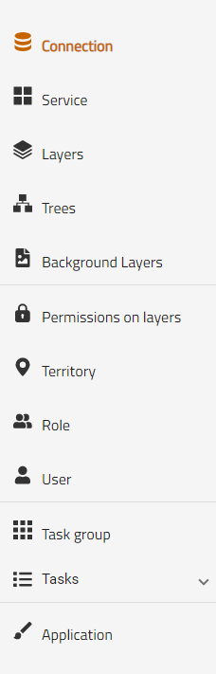

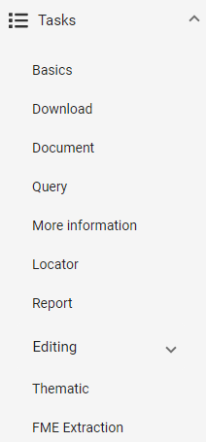

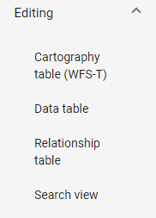

The menu is common to the entire application and is located on the left side of the screen. It is formed by the section name and its icon. When we select one of the sections it will take you to the corresponding screen.
Clicking on the "Tasks" drop-down will open the drop-down with all available task screens (right image).
The selection we are currently in will be its name marked orange.

    - Data Tables
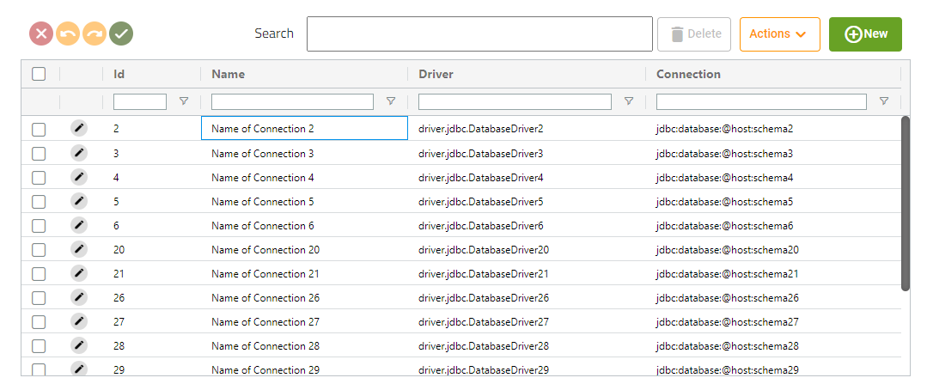
To show data from different sections we will have a table like this.
      - Edited fields
Clicking on a field will allow you to edit the cell value (if the field clicked can be modified), once the new value is written, pressing the intro key will change the value in the table and highlight the modified green cell.
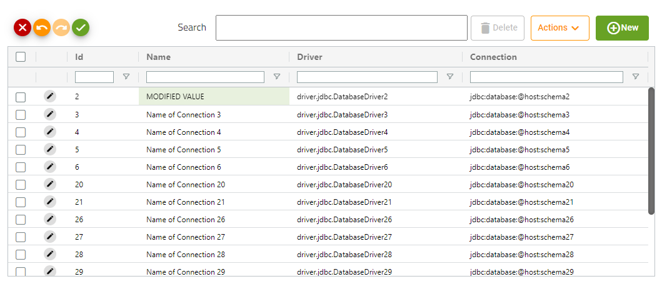
(IMPORTANT: Modifying a value does not mean that it has already been saved, we will see how to do it in other sections)

      - Filters
        - Column Filter
Below each column we see a text field that will allow us to filter by the values of that column.
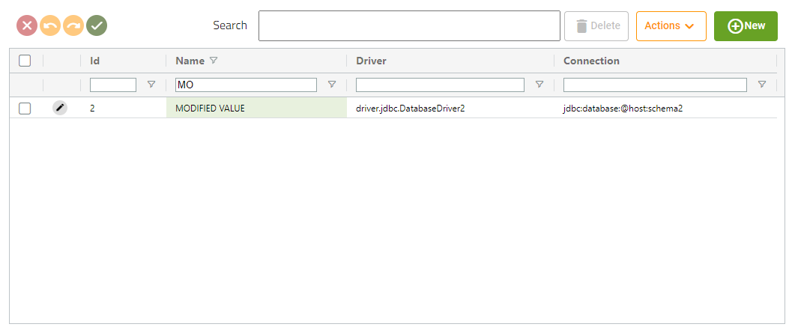
To the right of the text field we will see a button that allow us to select how the filter is been applied
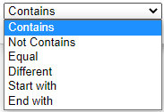
        - Column Sorting
Clicking on the column name will allow us to order the table ascending or descending by that column.



If one table is sorted by more than one column, a number will appear next to the label showing the sort order

        - General Filter
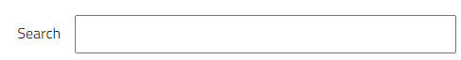
This text field will allow you to filter by a value over all columns.
      - Buttons
        - Edit buttons

The edit buttons will be displayed at the top-left of the table, if we have not edited any field, it will be disabled (left image), otherwise they will be enabled (the undo and redo buttons may not be the two activated according to the edits)
 | Discard changes button: Pressing that button will discard all edit changes.
 | Undo button: Pressing that button will undo the last change.
 | Redo button: Pressing that button will redo the last undo action (only available if you have pressed the undo button before.
 | Save changes button: This button will save all the changes we have made on the table. (IMPORTANT: That button will only be available in external tables, in form’s tables it won’t be available)

        - Action buttons

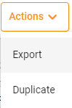
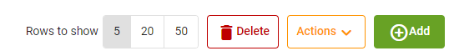

The action buttons will be displayed at the top-right of the table.
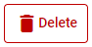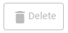 | The delete button will delete the selected rows. If we are in a generic table, the element will be deleted immediately. If we are in a form table, it will be marked as pending delete and will be deleted later. (We will deepen in other sections). The delete button will only be available if we have any column selected by the checkbox of the first column.
 | The new button only will be available on a generic tables (where it will redirect us to a form to create a new element) and in a few form tables (where it will open a dialog to create the new element.
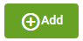 | The add button only will be available on the tables that there isn’t the new button. This button will open a dialog to select a new elements of the same type as the table entity to introduce it on the table
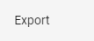 | Export button will start a download of a csv file where there will be the columns of the table and the selected rows.
Example:
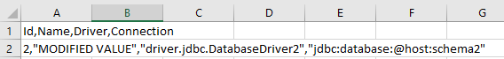
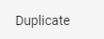
Duplicate button will duplicate the selected rows, introducing the new elements to the table (on generic tables will be created immediately). This button only will be available on a generic tables and in a few form tables.
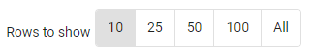
Rows to show button will only be available on form tables, allow the user to modify the number of values displayed in the table.

    - Forms
      - Buttons

The form buttons will be displayed on the top-right of the screen.

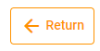 | The return button will redirect us to the generic table of the element type that we are editing.
 | The save button will save create or save all the changes of the element, form changes will be saved first, and if it goes correctly, it will save all the changed made on the element tables.

      - Fields
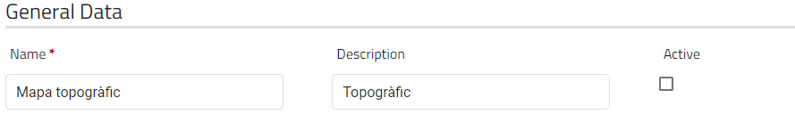
Every form will have their own fields to edit/create the element.
If a field has a red star at the end of its name, it will indicate that you must fill that field before send the form.

        - Translation fields
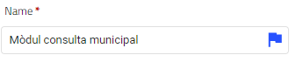
The blue flag at the end of the entrance means that that field is translatable, if you click on it a dialog will be shown
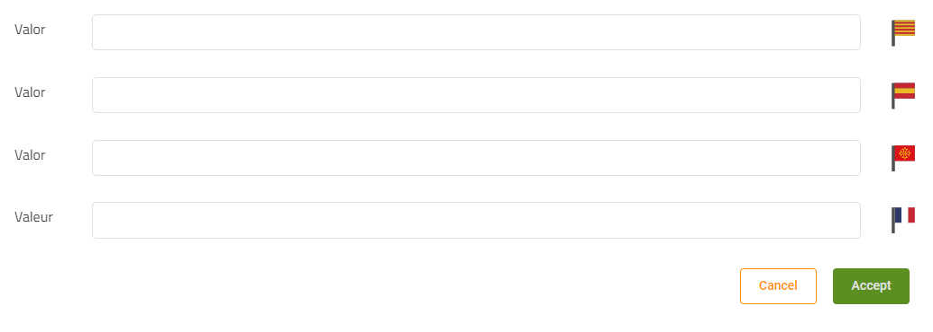
This dialog allows the user to define a translation for the selected field in 5 different languages (Catalan-Spanish-English-French-Aranese), the language the user is using will not appear, as it will take as value the one entered in the form field.
If a field already has a translation for any language, it will be shown when the dialog opens.

Important: Accept button does not save the translations, they will be saved when the user clicks on the save button
        - Password fields
Form fields referring to passwords will not display previously saved passwords, if the checkbox 'password set' is checked it will mean that this entity already has a saved password, and if we fill in the form these fields we will overlay the stored password.

      - Internal tables

Forms can have their own internal tables that will allow the user to manage relations of the edited/new element.
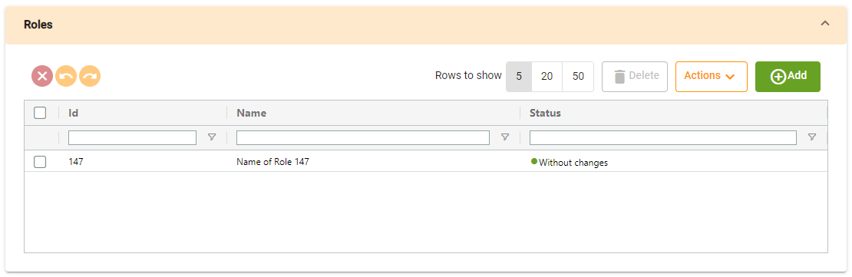
Pressing on the drop-down button, will allow the user to hide the table, but all the tables will be opened by default.
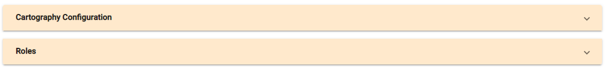

2.1.3.4 Status column
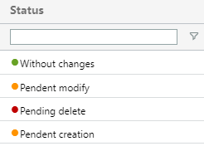

Almost all internal tables will have a status column, that will show the user the status of the row.

This status indicates that the rows has not been changed and it is not a new element. The row is in its original status.

This row has been edited by the user, but the changes are not saved yet.

This row has been marked by the user to be deleted, but the element is not deleted yet.

This row has been added to the table, but the elements not exist yet.

      - Dialogs
Clicking on the add/new button will open a dialog that allows the user to select the elements that will be added to the table
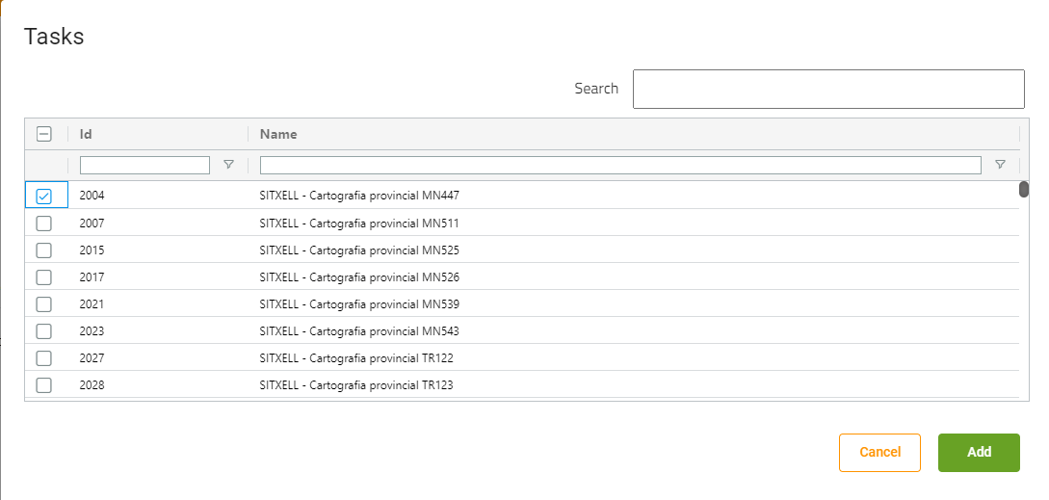
(Some tables only allow the user to select one element)
If the internal button has the “new button”, it will open a dialog with a internal form to create the element:
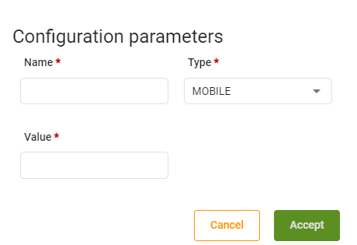

  - Sections
    - Connections
      - Generic table

This screen will show us all the connections that the application has.
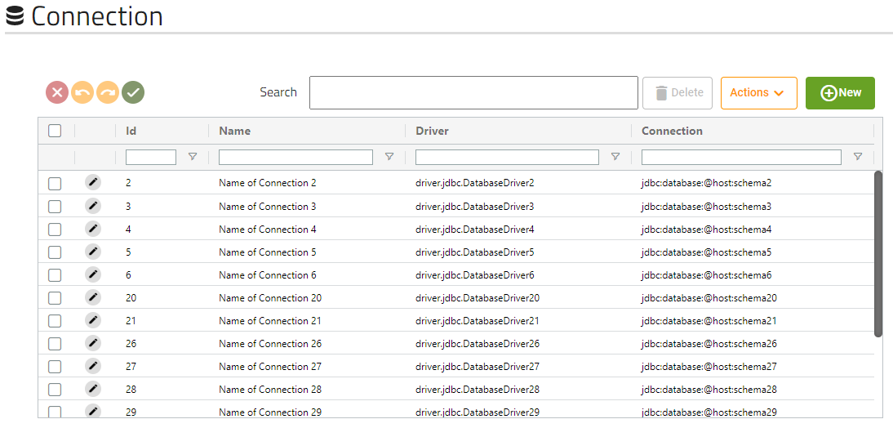
      - Form
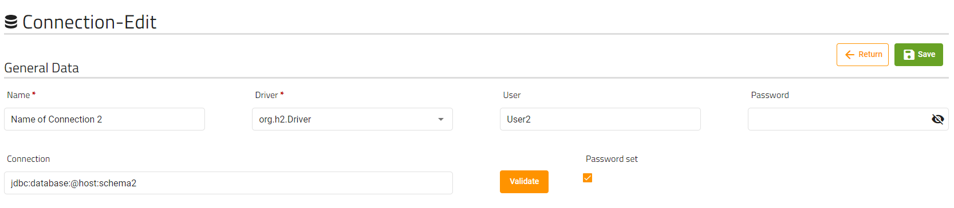
These are the fields that the user can modify of a connection. The validate button will validate that de connection introduced is correct.

      - Tasks internal table
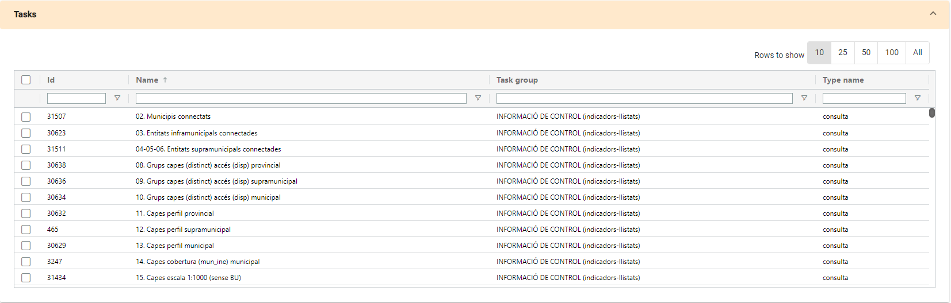
Tasks table will show us the tasks that are related to the connection, this table is not editable; it is read-only.
    - Services
      - Generic table
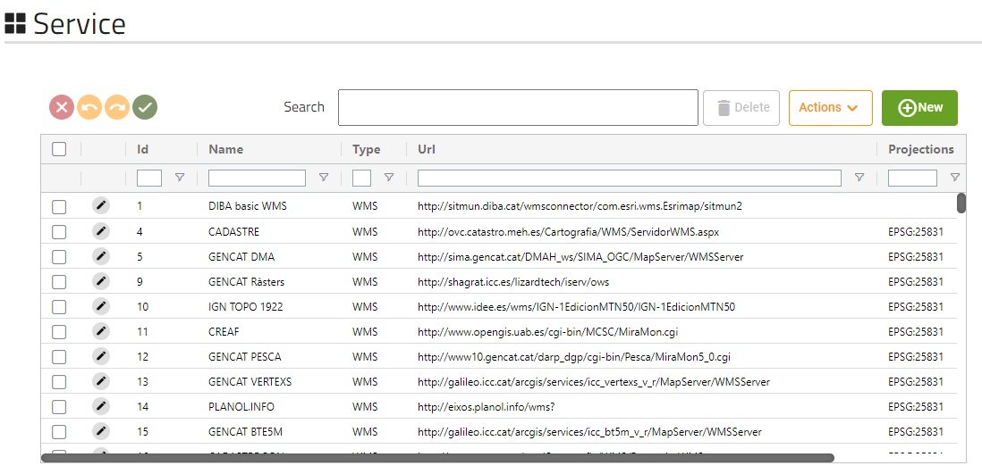
This screen will show us all the services that the application has.

      - Form
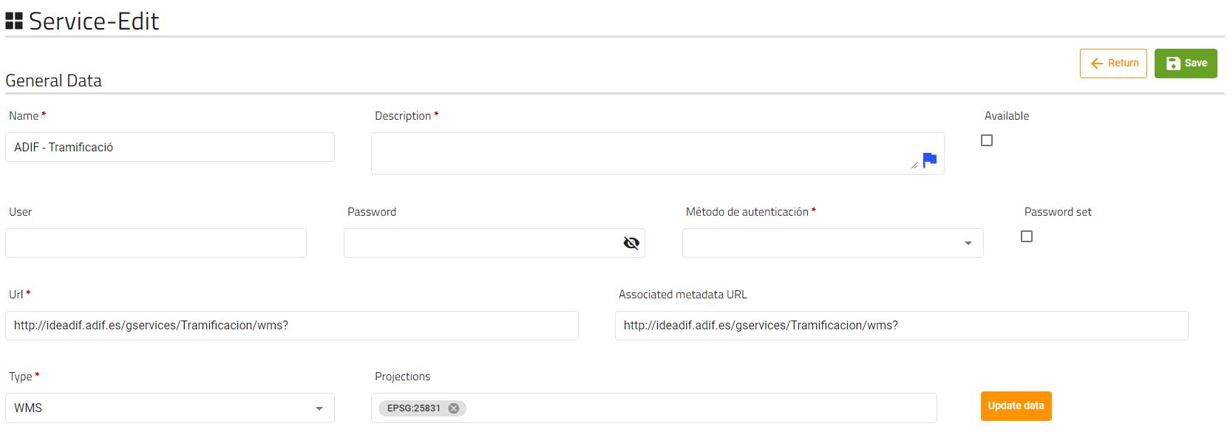

These are the fields that the user can modify of a service. The update data will update the the service data with the data retrieved from the Url field
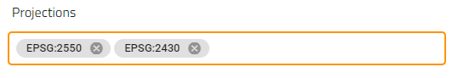
The projections field must be filled by elements made by EPSG:code of the projection.

      - Parameters configuration internal table
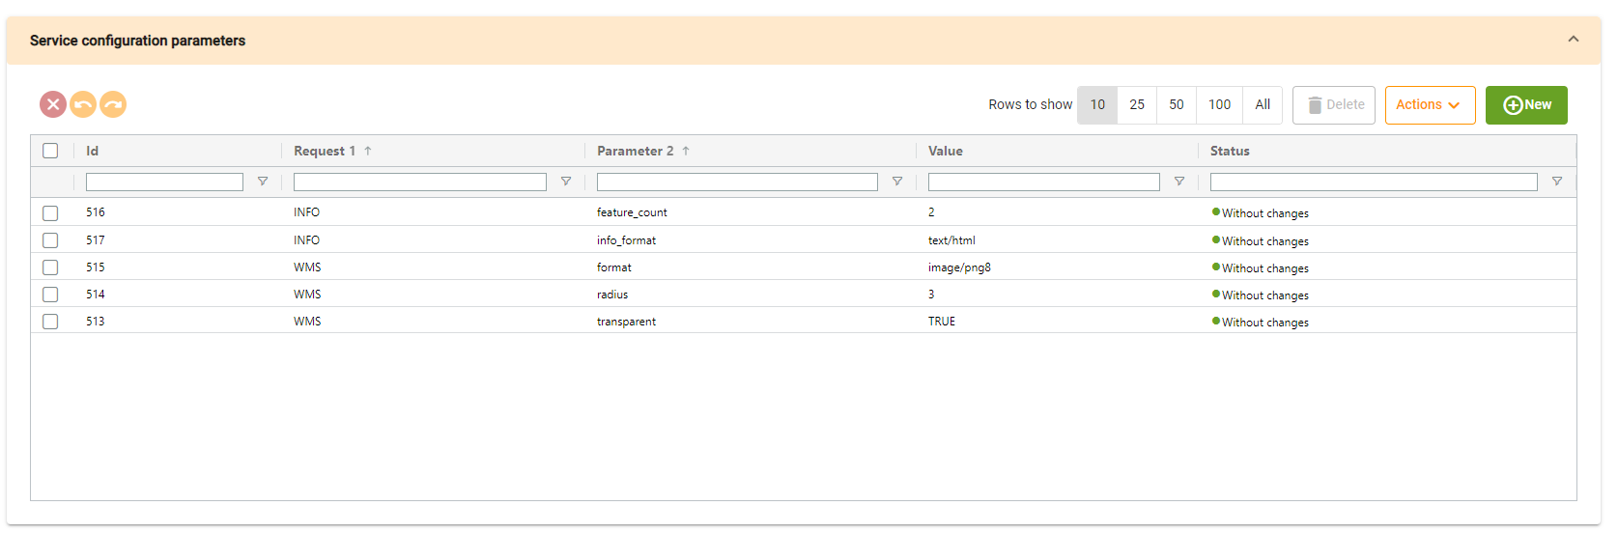
Tasks table will show us the parameters configuration that are related to the service.
Clicking on new will show us the dialog with the form to create a new parameter:
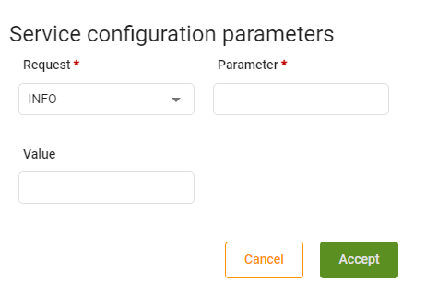

      - Layers to register internal table
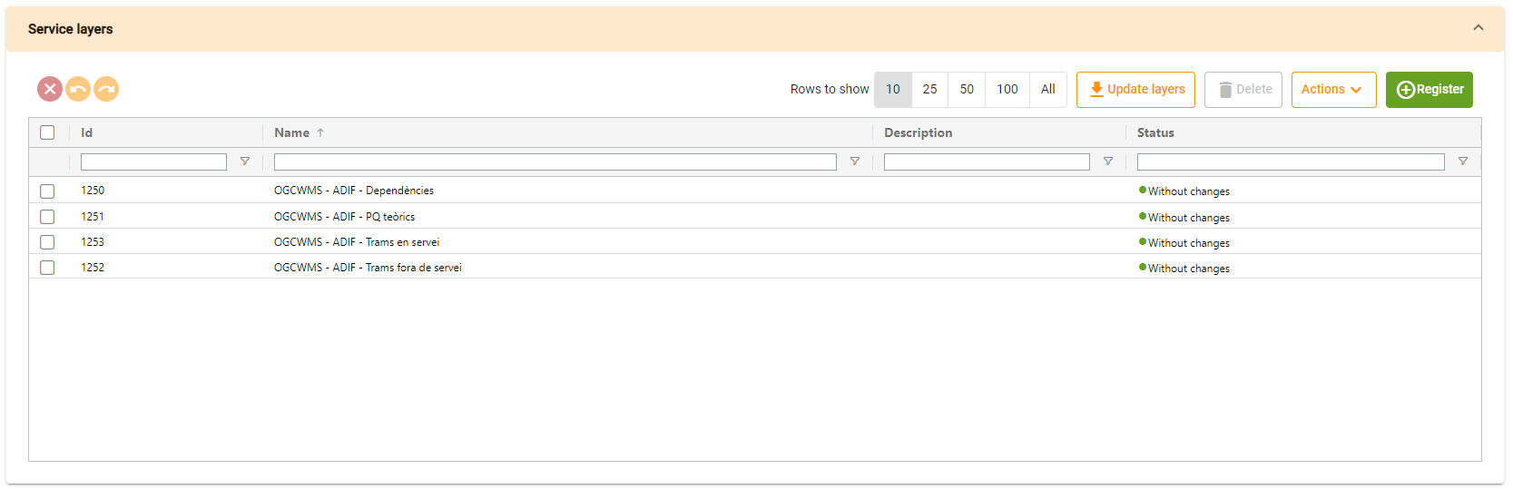
This table relates to the “Update data” button (form), licking this button will update the form data with the data received from the url field and include the service layers in this table, if you want to add layers without updating the form data, you will have to click on the 'Update add' button on the top-right of the table.
When layers are loaded, if you want to create this layers on the application , you will have to select this layers and click the ‘Register’ button (changes will be applied when user clicks on form save button).

This table has three status different from other tables:
- Unregistered layer: The layer exists on the service and user has not check it to be registered.
- Pending registration: The user has marked the layer to be registered when we save the service entity.
- Not available: The layers is saved on the application service but not appears on the data retrieved from the url field.

    - Layers
      - Generic table
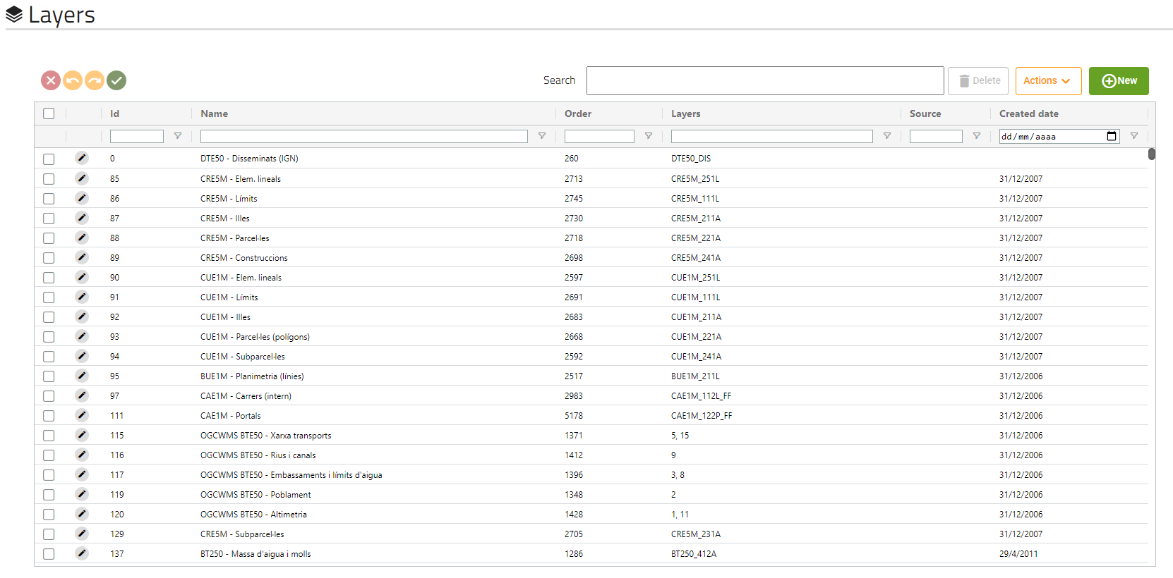
This screen will show us all the layers that the application has.

      - Form
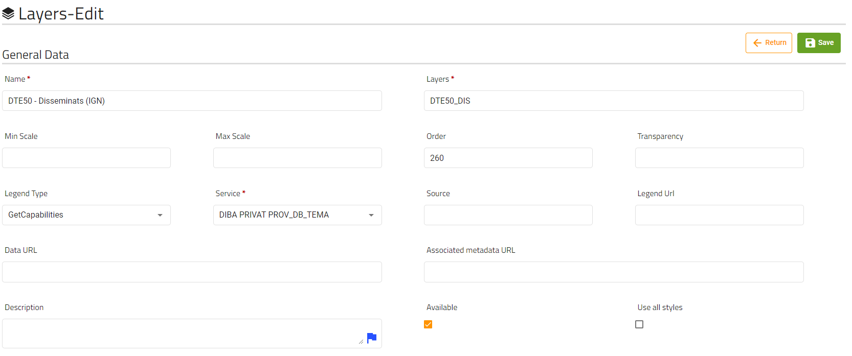
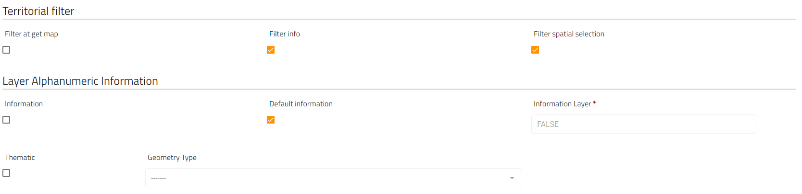
These are the fields that the user can modify of a layer.
The field “Information Layer” will only be available and required if the field “information” is marked.
The field “Geometry Type” will only be available if the field “thematic” is marked.

      - Spatial selection internal table
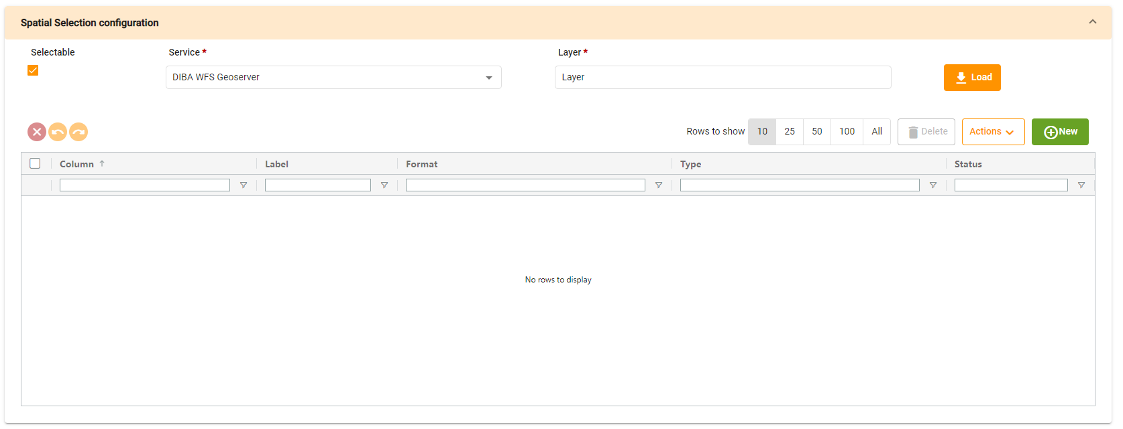
Spatial selection table will show us the spatial selection parameters that are related to the layer.

This table allows the user to upload all parameters of the entered layer of the selected service; this option is only available if the 'selectable' field is checked.

The user will be able to remove all current parameters on the table or only add the new ones:

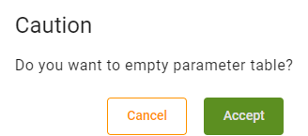

Also you can create new spatial selection parameter manually clicking on new button:
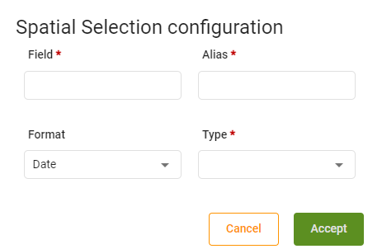

      - Layer Alphanumeric Attributes Configuration table
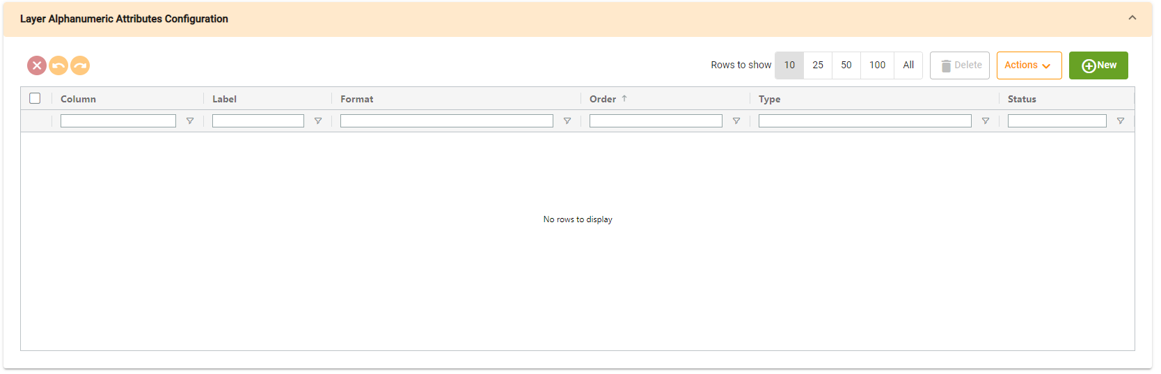
This table will show us the Layer alphanumeric attributes configuration that are related to the layer.
Clicking on new will show us the dialog with the form to create an alphanumeric attribute:
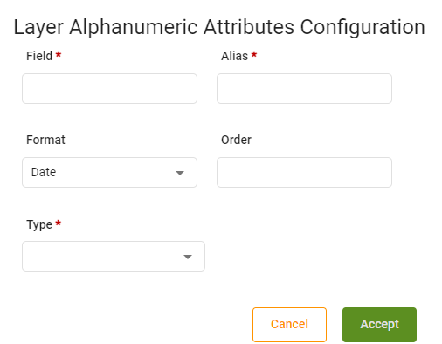

      - Territorial filter internal table
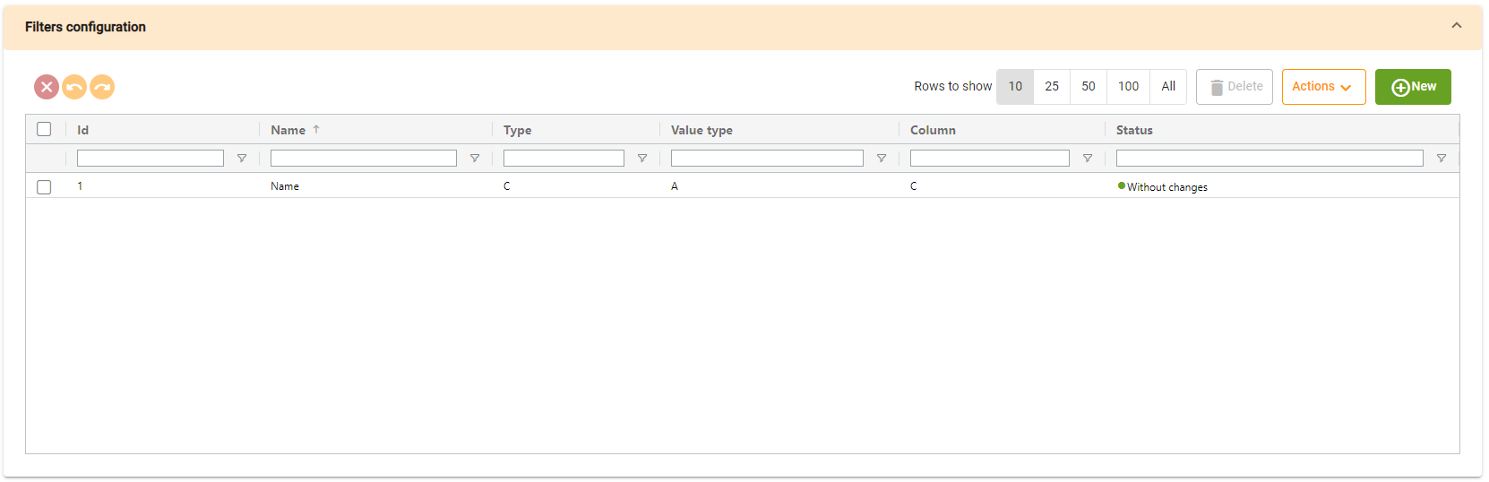
Territorial filter table will show us the territorial filters that are related to the layer.
Clicking on new will show us the dialog with the form to create a new parameter:
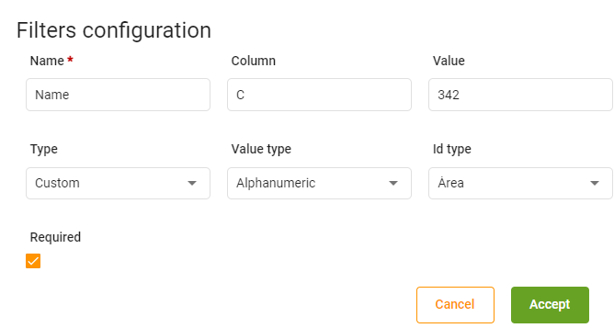

      - Styles configuration
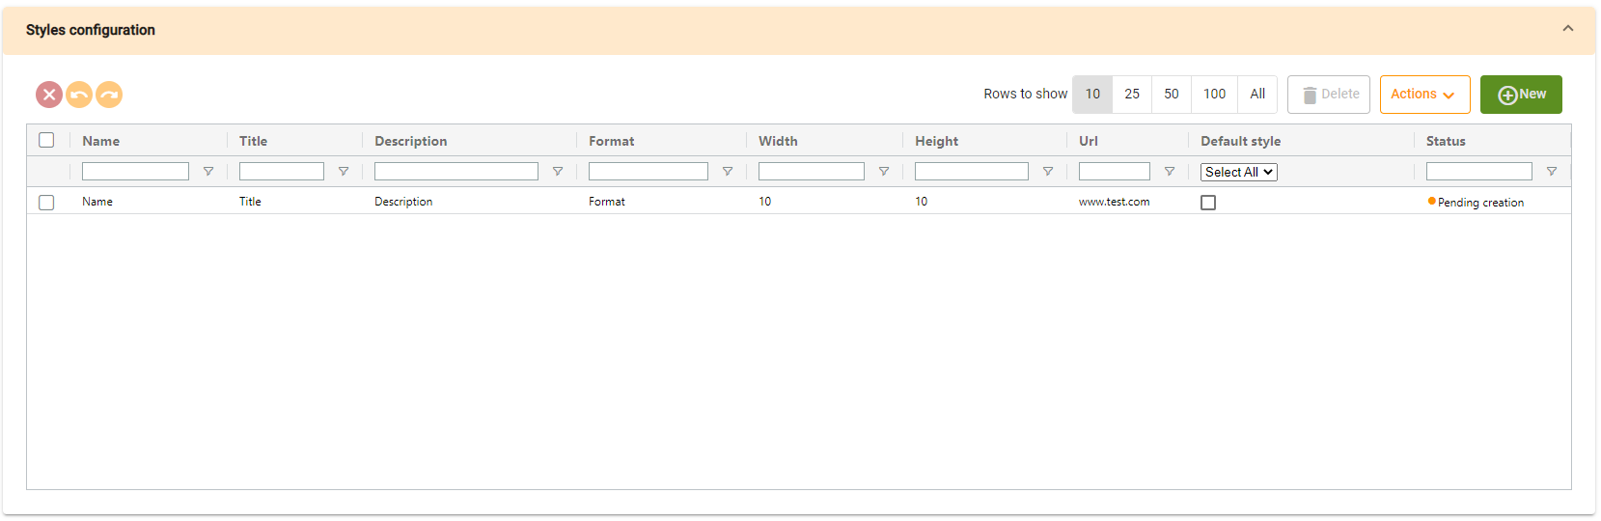
Styles configuration table will show us the styles that are related to the layer.
Clicking on new will show us the dialog with the form to create a new style:
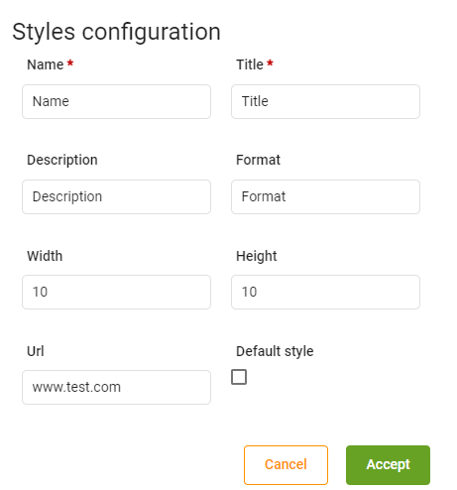

      - Territory with layer access table
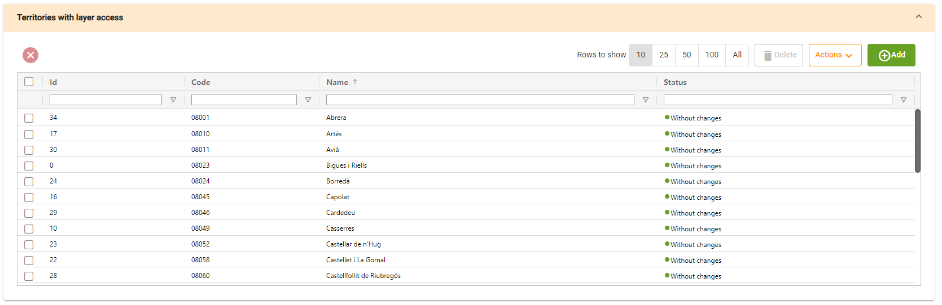
This table will show us the territories with access to the layer.
      - Permission groups and Roles that have access to the layer
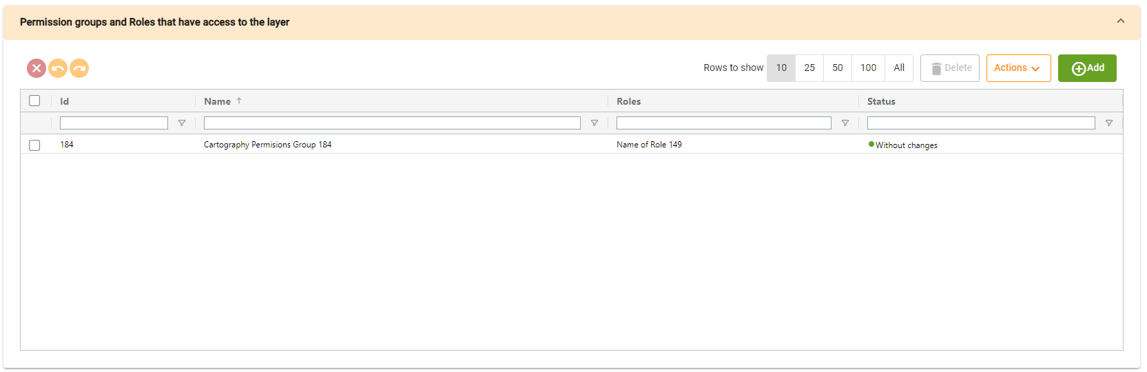
This table will show us the layer permissions configurations and roles that have access to the layer
      - Trees and Nodes containing the layer
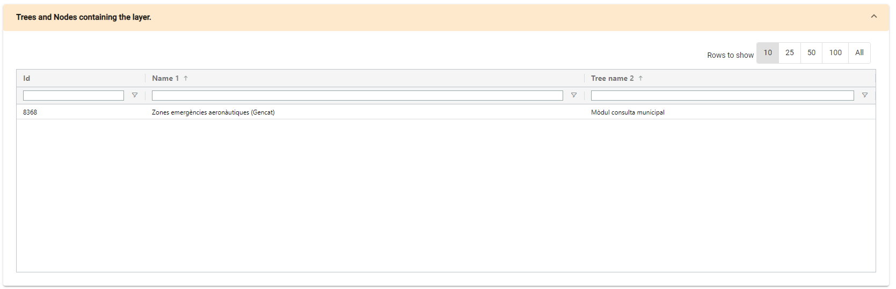
This table will show us the nodes and trees that are related to the layer, this table is not editable; it is read-only.

    - Trees
      - Generic table
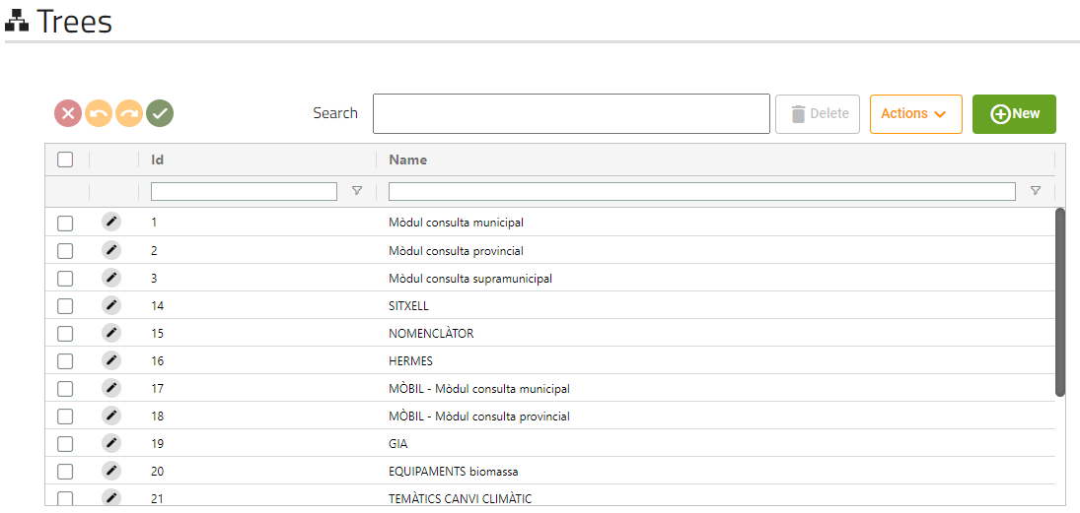
This screen will show us all the trees that the application has.
      - Form
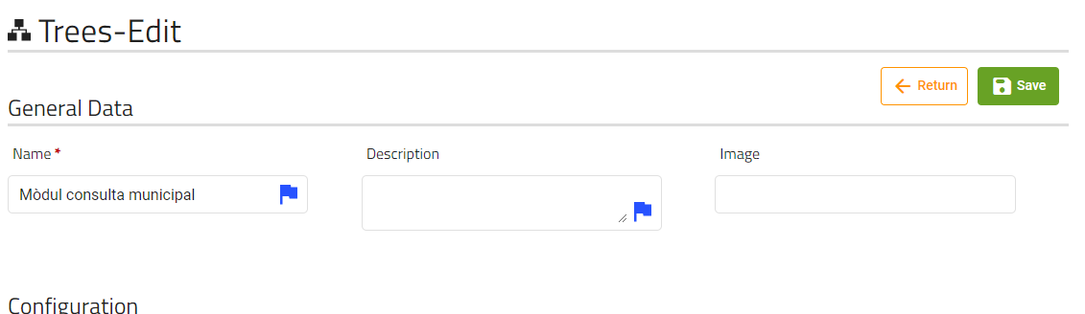
These are the fields that the user can modify of a layer.

      - Folders and nodes
A tree is composed of folders and nodes.
This icon will appear if a node is a folder, if is not a folder no icon will be displayed.

The different folders and nodes will be displayed as follows:
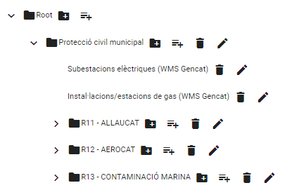
        - Buttons
This icon will appear if the node is a folder and has children nodes, clicking on it will show them

This icon will open the form to add a folder to the node selected, only will be displayed if the node is a folder.

This icon will open the form to add a node that is not a folder to the node selected, only will be displayed if the node is a folder.

This button will mark the node and its children as deleted; the nodes deleted will be displayed as follows:
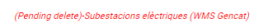

This button will open the corresponding form (depending on the node if is folder or not) to edit the item.

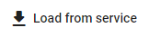
Load from service button allows user to load al layers from a WMS service into the tree.

        - Folder form
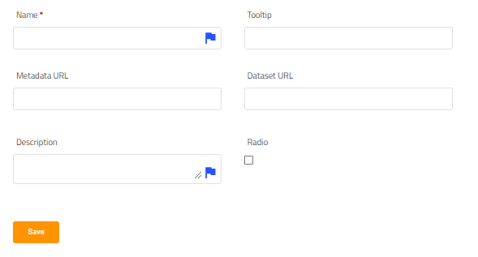
These are the field that a folder has and the user can modify, clicking on save we will mark the folder as pending to save/pending to create
        - Node form
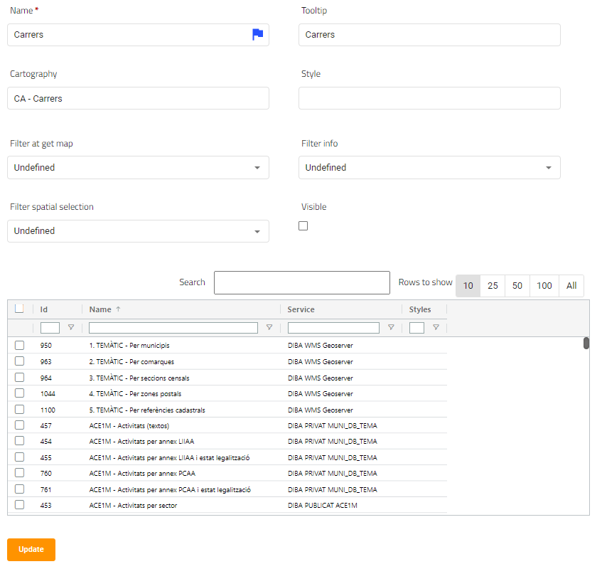
These are the field that a node has and the user can modify. Cartography is a read-only field, it shows the cartography name of the node’s cartography, we must select 1 cartography on the above table (only 1 selection is allowed).
Style field must contain a style (or more than one separated by comma) related to the layer selected.
Clicking on save we will mark the node as pending to save/pending to create.
        - Drag and drop
The folders tree has available the drag and drop function, you can press on any node/folder and drag to another, as all internal changes, it will only be saved when the user press the save button.

      - Applications table

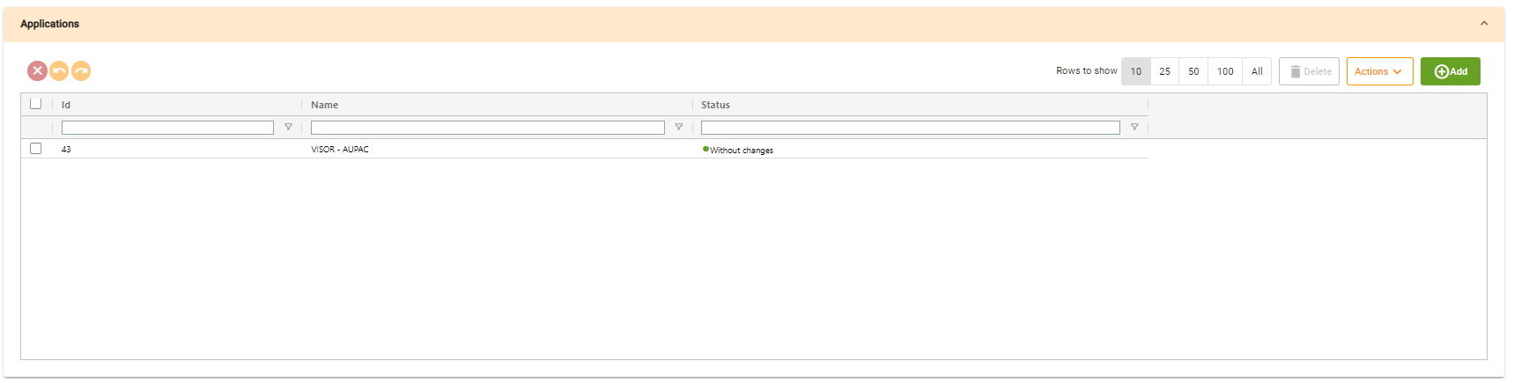

Applications table will show all the applications related to the tree.

    - Background Layers
      - Generic table
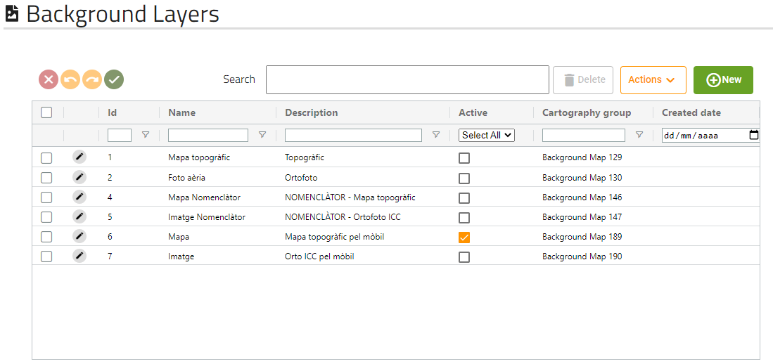
This screen will show us all the background layers that the application has.
      - Form
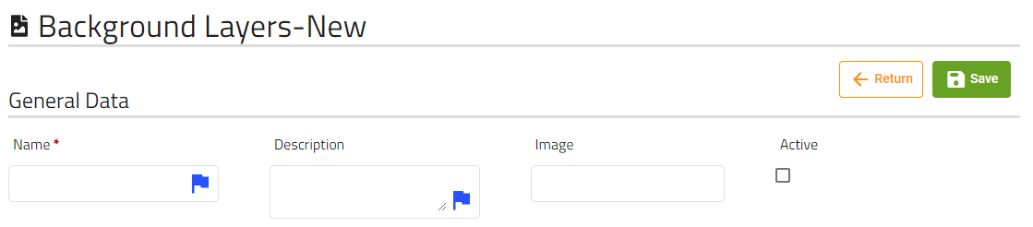
These are the fields that the user can modify of a background map.
When we click on save button, a permission on layer will be created with the same name as name field if it does not already exist, then will create the background layers and will associate the permission on layer created with the new background layers.

Important: The internal tables showed above the form, refers to the internal tables of the permission on layer created, not to the background layer.

      - Layer that are part of this background map
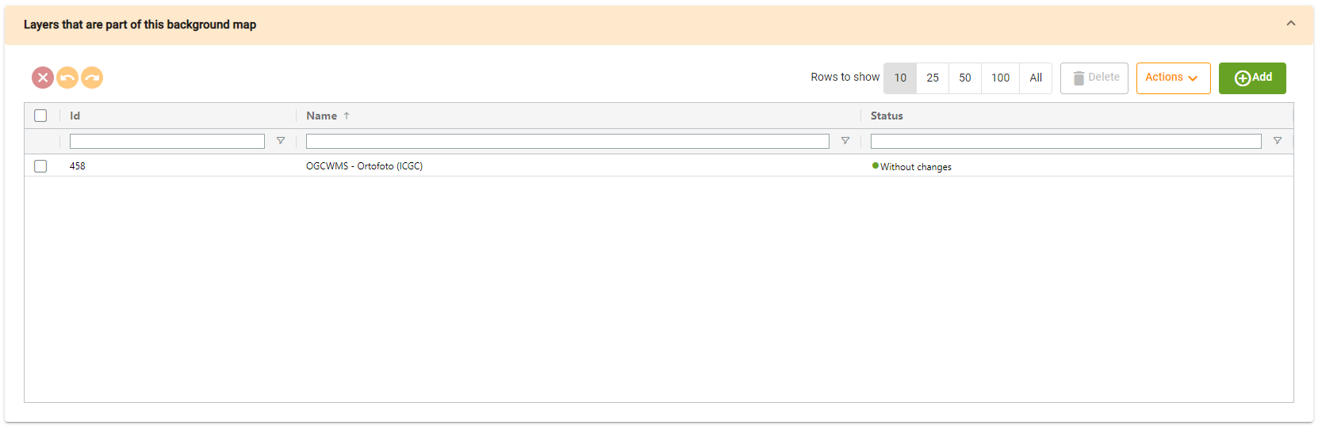
This table shows the layers that are part of this background map.

      - Roles that have permission to access this background map
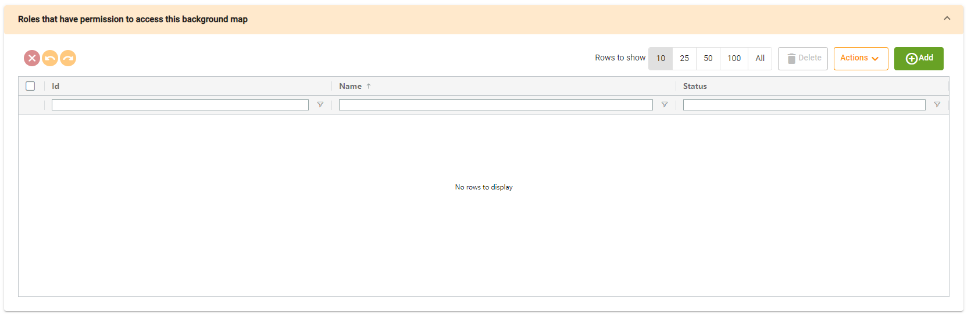
This table shows the roles that have permission to access this background map.
      - Applications
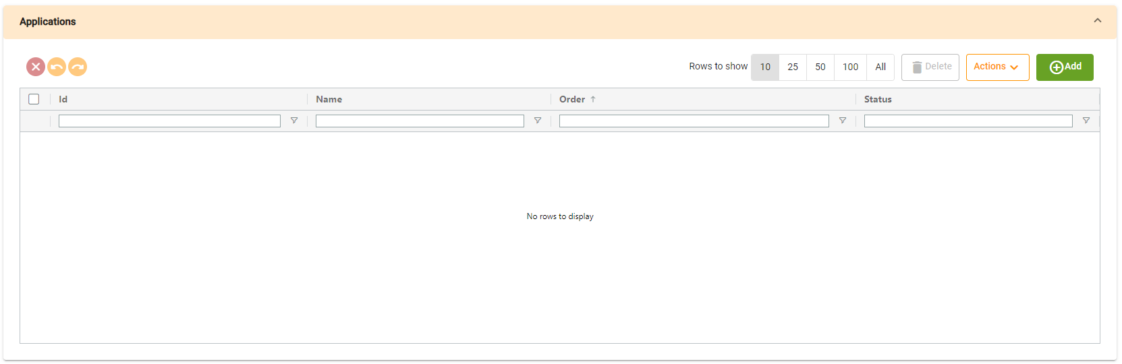
This table shows the applications related to this background map.

    - Permissions on layers
      - Generic table
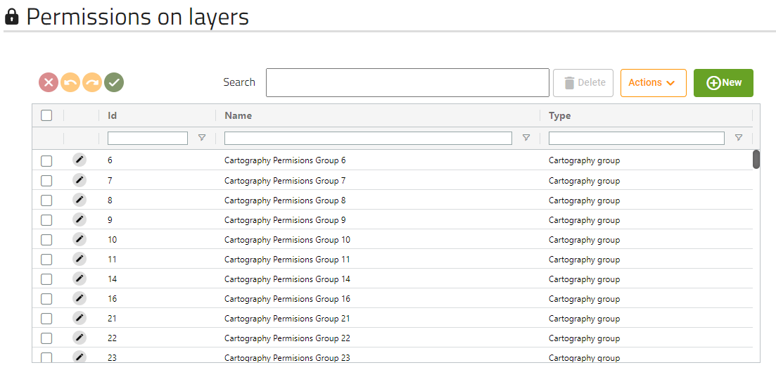
This screen will show us all the Permissions on layers that the application has.
      - Form
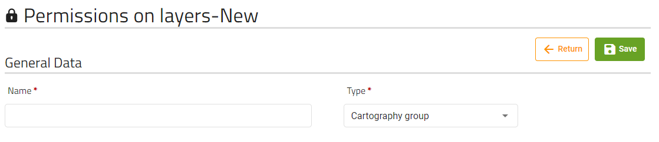
These are the fields that the user can modify of a permission on a layer.

      - Layers that are part of this permission group table
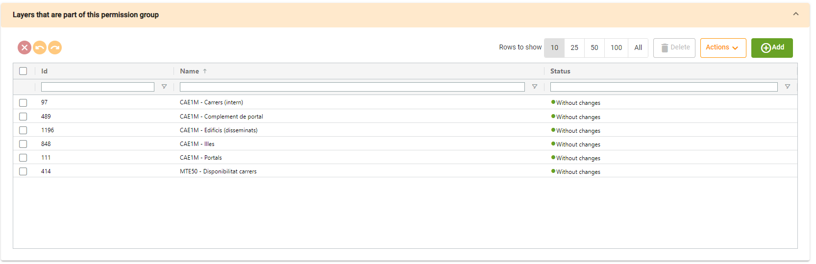
This table shows the layers that are part of this permission group.

      - Roles that have permission to access this permission group
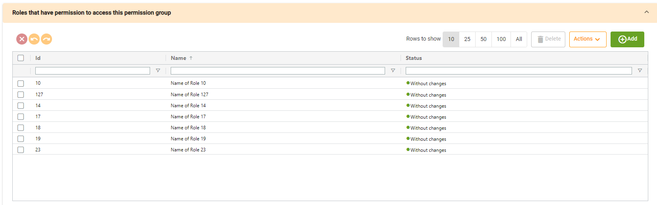
This table will show us the roles that have permission to access this permission group.

    - Territories
      - Generic table
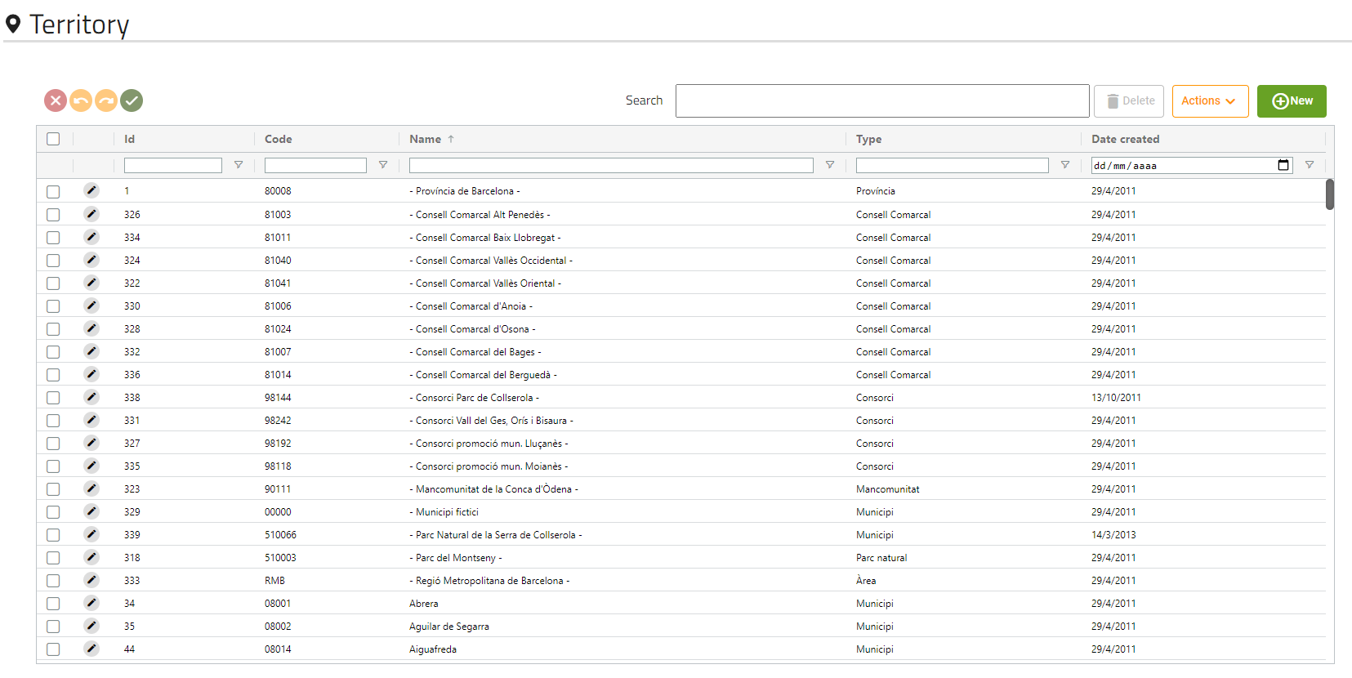
This screen will show us all the territories that the application has.
      - Form
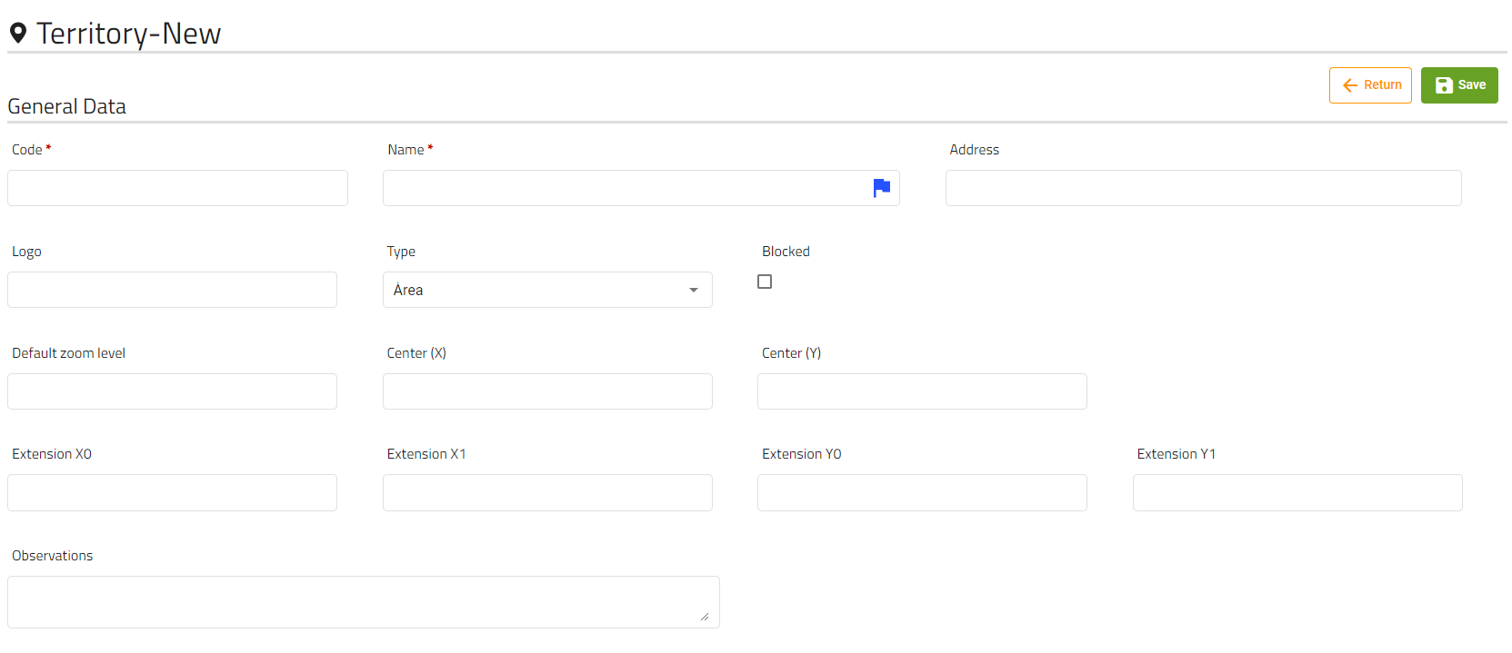
These are the fields that the user can modify of a territory.
Logo must be a url.

      - Roles and users with access to this territory
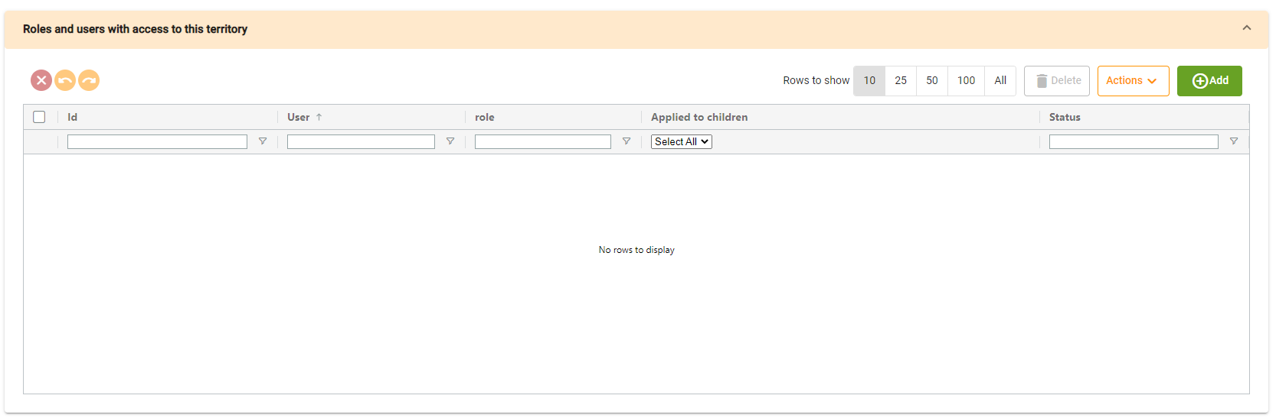
This table will show us the roles and users with access to the territory.
Clicking on add, will open a dialog with two tables (users and roles), where you must select at least one of them to create a new permission:
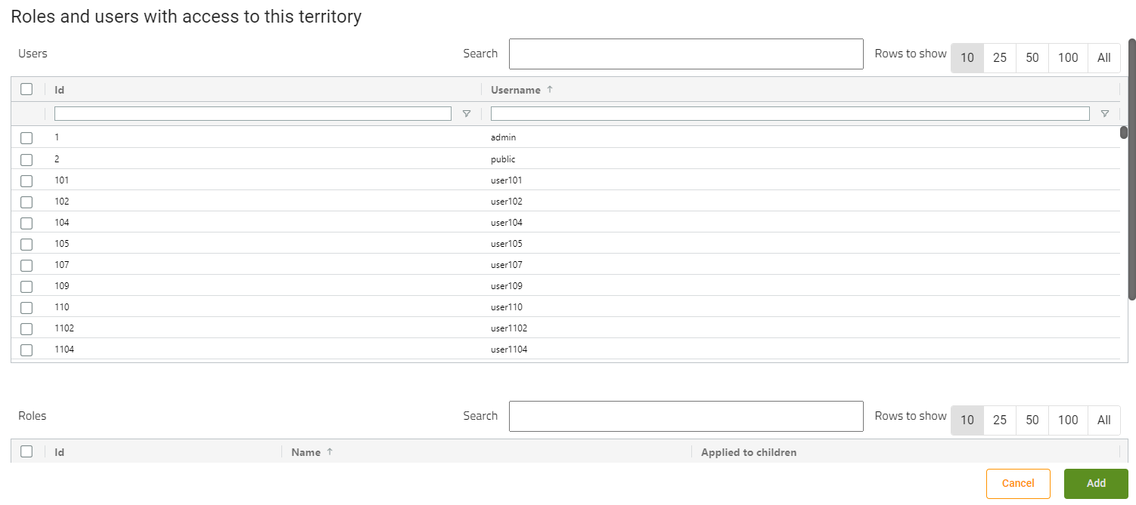
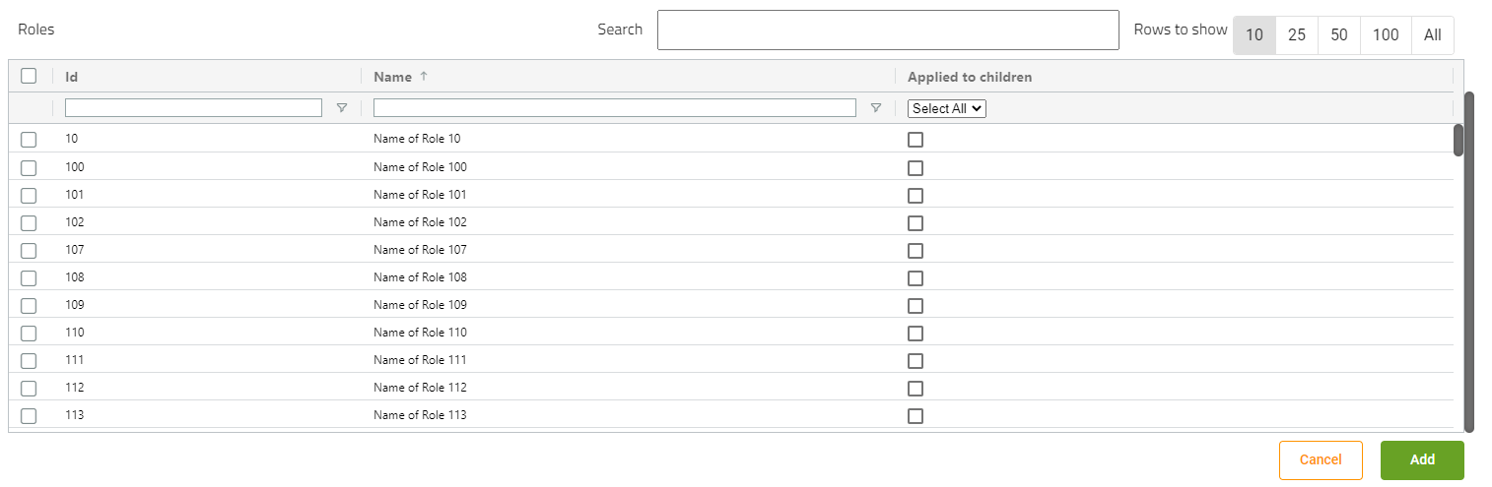

Applied to children checkbox will only be available based on the territory type.

      - Child territories internal table
Important: This table only appear based on the territory type.
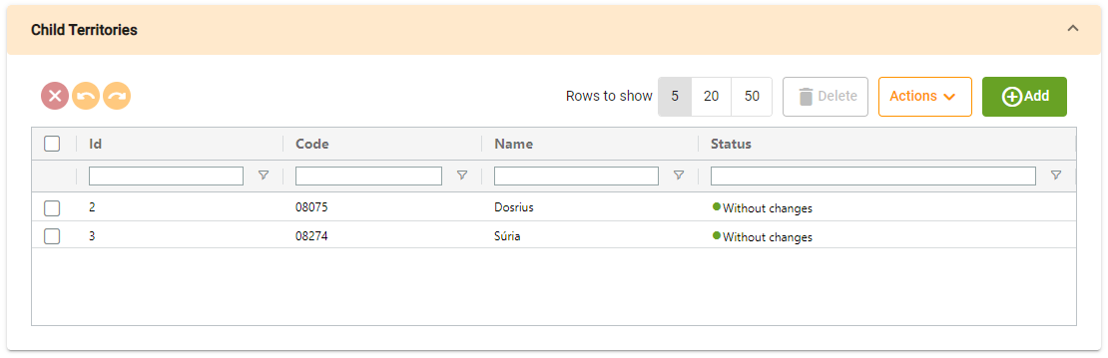
This table shows the territory’s children.
      - Parent territories internal table
Important: This table only appear based on the territory type.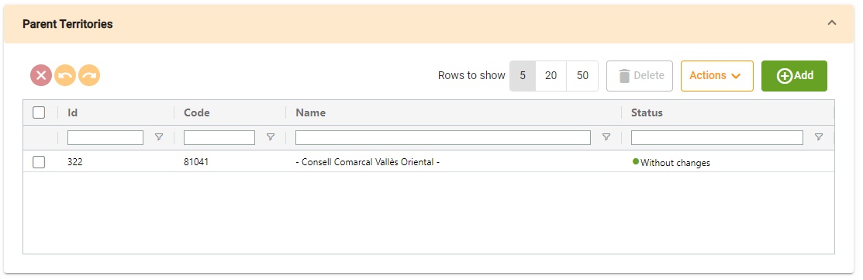
This table shows the territory’s parent.

      - Layers internal table
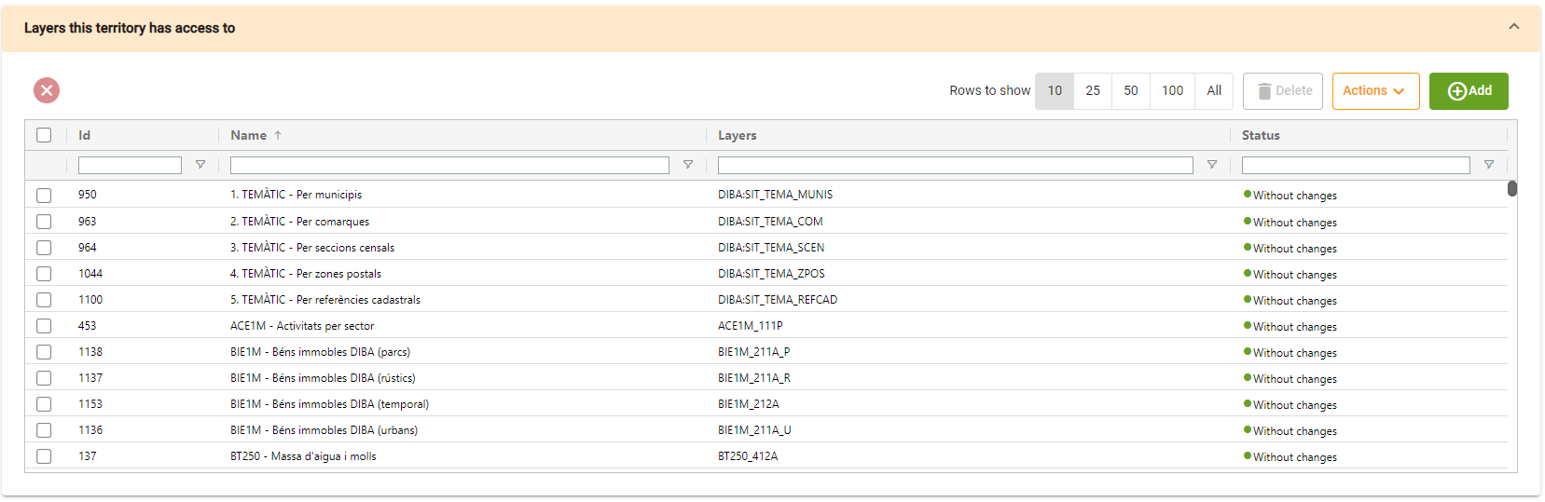
Layers table will show us the layers that this territory has access to.

      - Tasks internal table
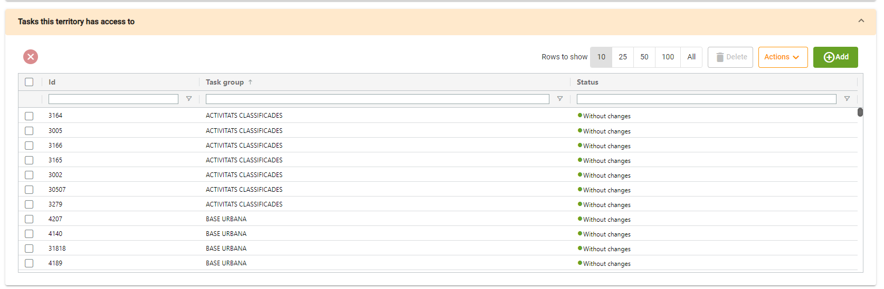
Task table will show us the tasks that this territory has access to.

    - Roles
      - Generic table
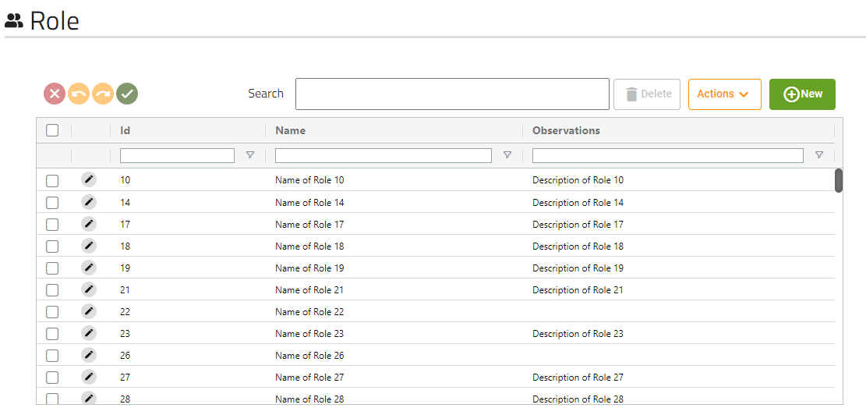
This screen will show us all the roles that the application has.
      - Form
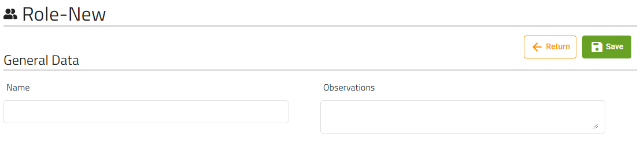
These are the fields that the user can modify of a role.
      - Merge territory and user
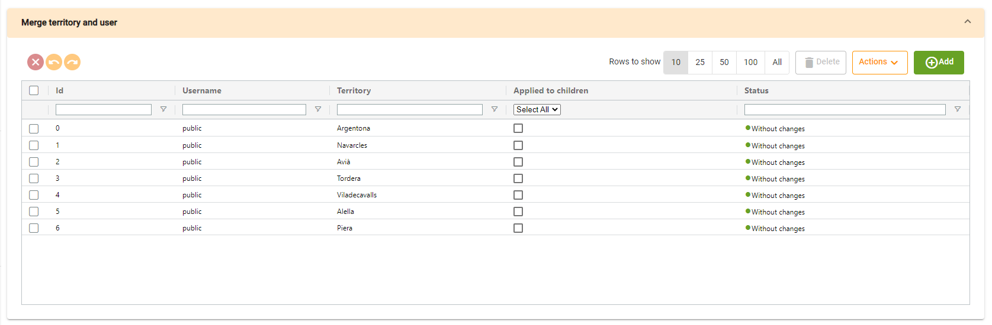
This table will show us the merge of territories and users that are related to the role.
Clicking on add, will open a dialog with two tables (territories and users), where you must select one territory and at least one of each:
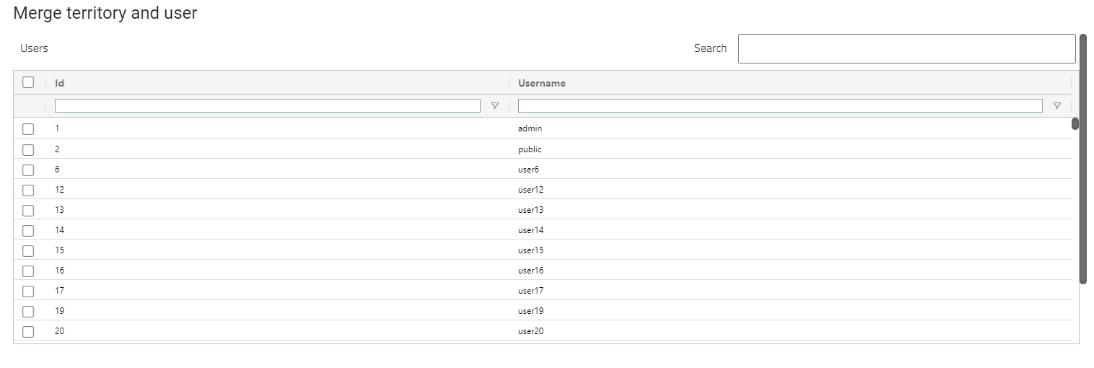
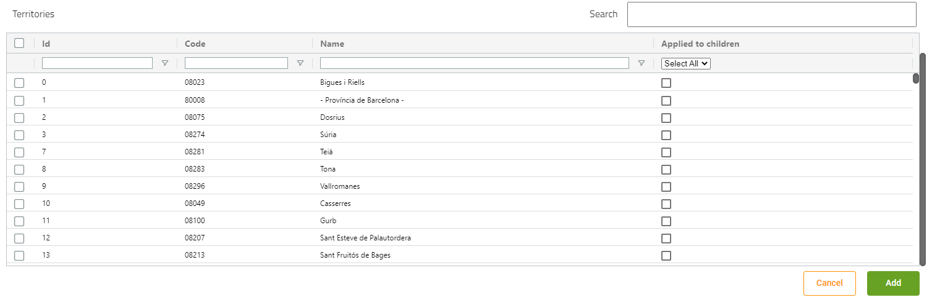

      - Permission group layers configuration internal table
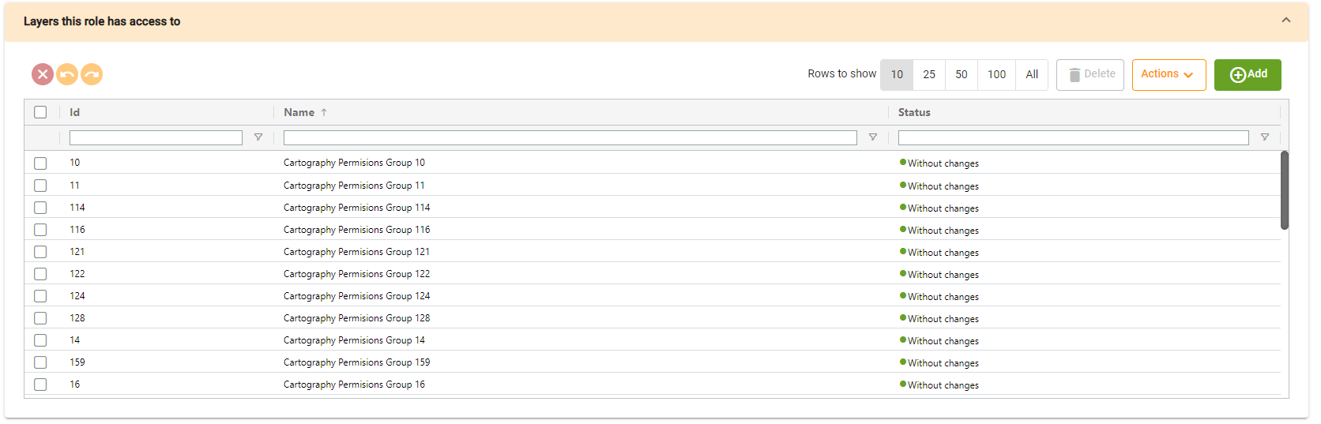
This table will show us the permission groups that are related to the role.

      - Tasks internal table
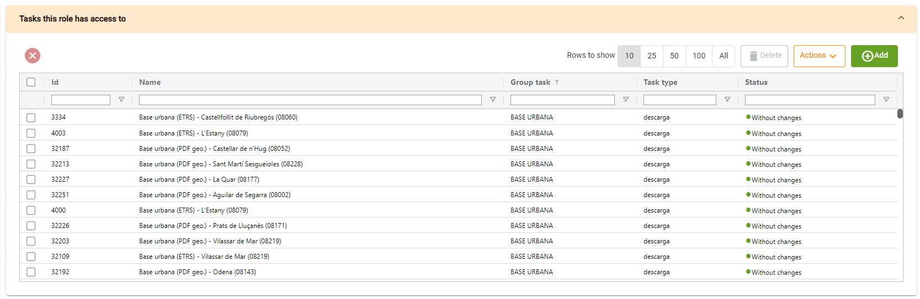
Tasks table will show us the tasks that are related to the role.

    - Users
      - Generic table
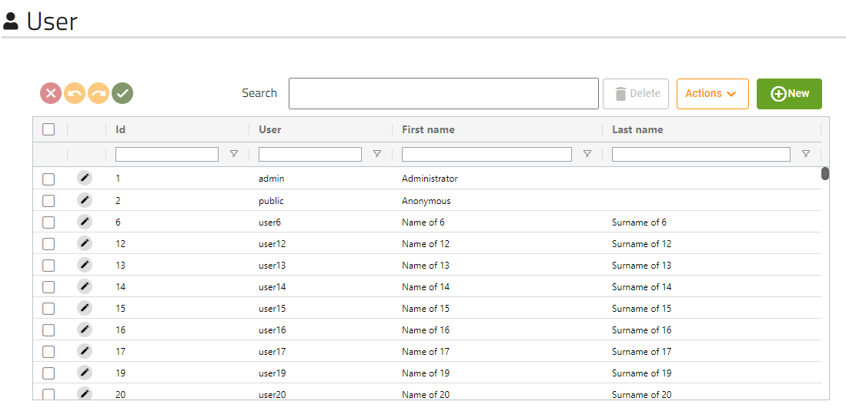
This screen will show us all users that the application has.
      - Form
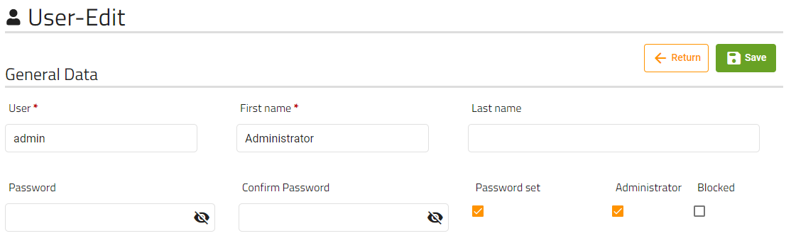
These are the fields that the user can modify of a user.
The password and confirm password fields will never show the password of the user, but if “Password set” checkbox is selected will mean the password is already stored, so if you put any password on the field, it will modify the user password. If checkbox is unmarked will mean that the user has not a password saved.
      - Permissions internal table
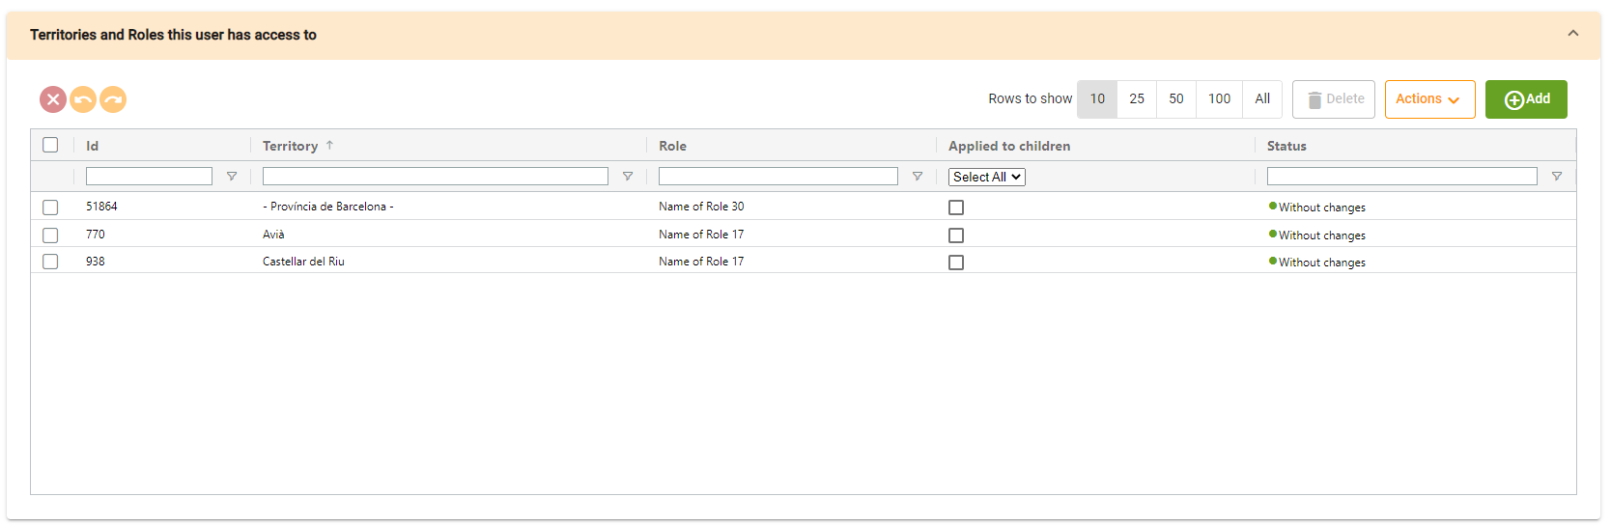
Permissions table will show us the territories and roles that this user has access to.
Clicking on add, will open a dialog with two tables (territories and roles), where you must select one territory and at least one role:
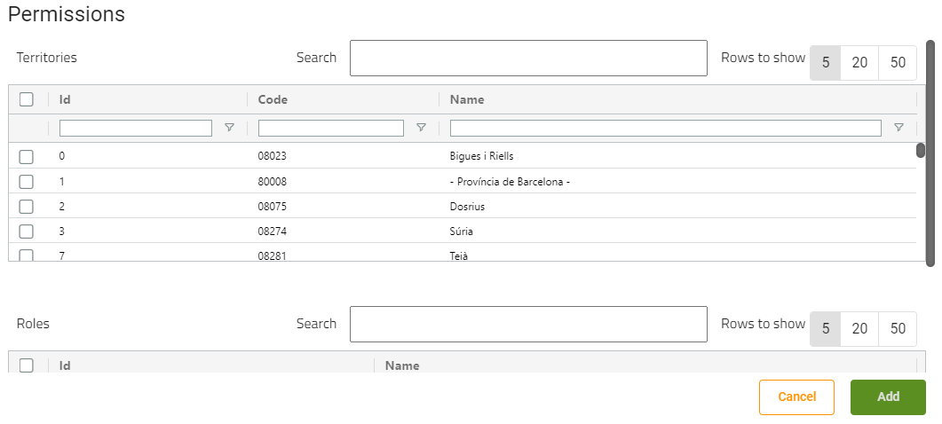
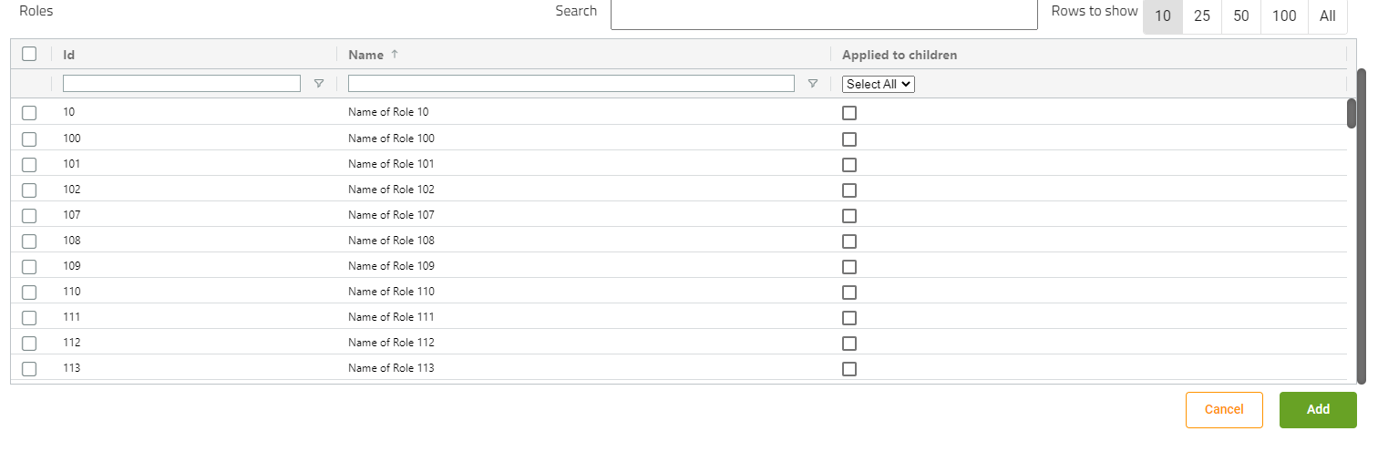

If we check the applied children checkbox on roles selection, this permit will also be applied to territory’s children.

      - Data associated to territory table
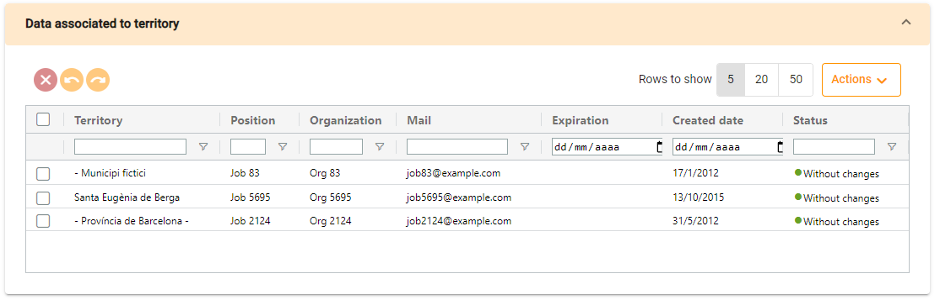
This table will show the data of territories on which the user has permission, you cannot add or delete elements on the table (you can edit the fields), it will be done automatically depending on the permissions table.

    - Task groups
      - Generic table
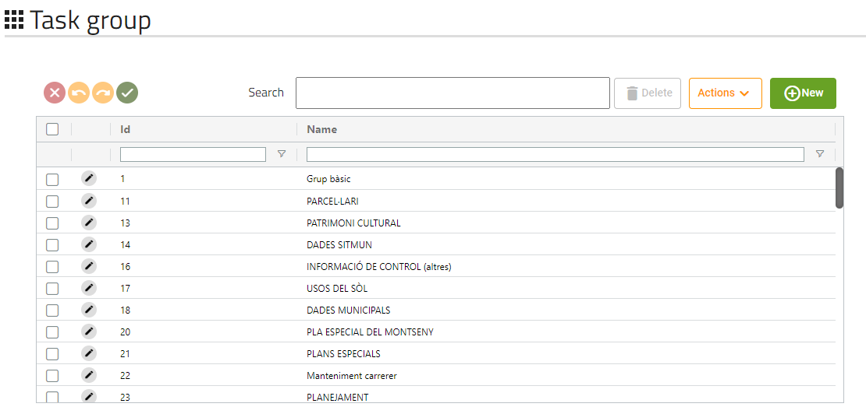
This screen will show us all tasks groups that the application has.
      - Form
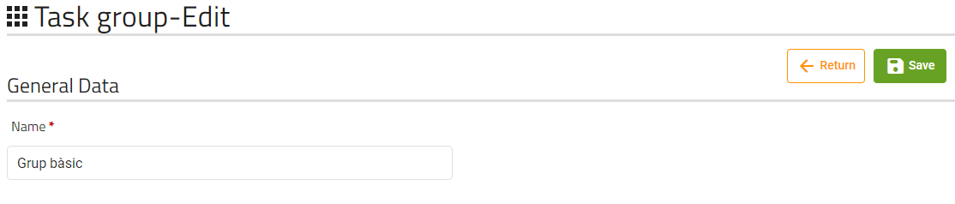
Task group only has the field “Name” to be modified.

    - Basic Tasks
      - Generic table
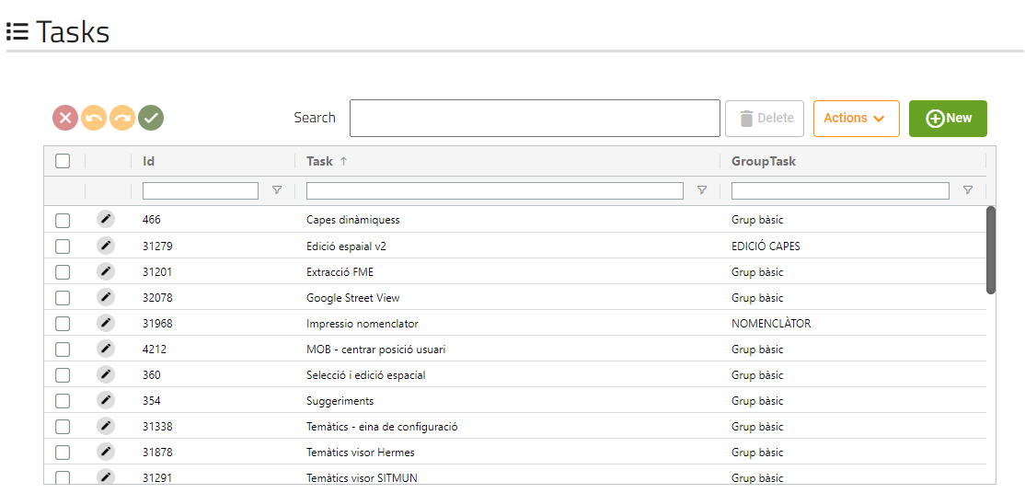
This screen will show us all basic tasks that the application has.
      - Form
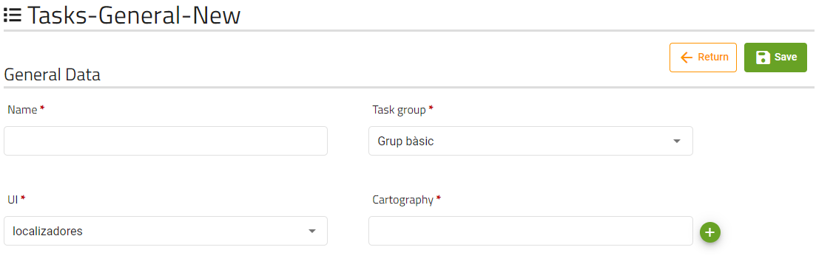
These are the fields that the user can modify of a task.
The cartography field is a read-only field, where the cartography’s name of the task’s cartography will be displayed, clicking on the green button will open a dialog to select a cartography:
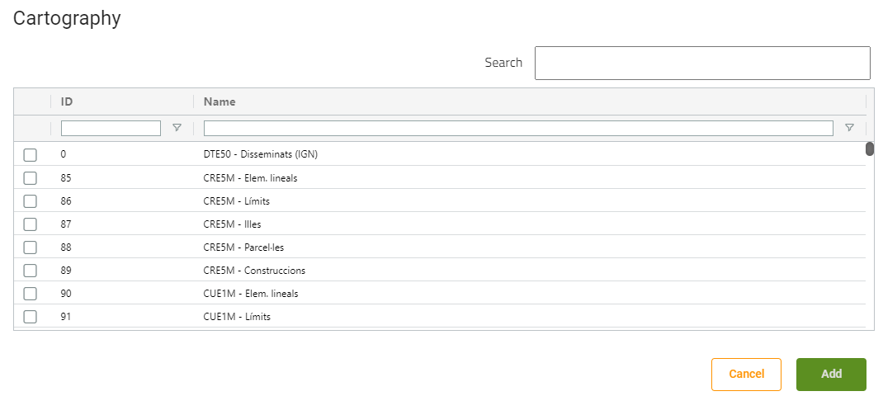
If a cartography is already selected, the buttons displayed will be different:
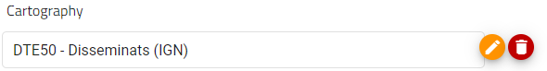
Orange button will allow the user to change the task’s cartography opening the dialog, and red button will disassociate the cartography from the task.
      - Parameters internal table
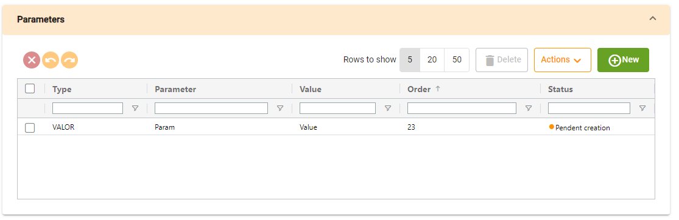
Permissions table will show us the permissions that the task has, if we click on new, a dialog will be opened with the form to create it:
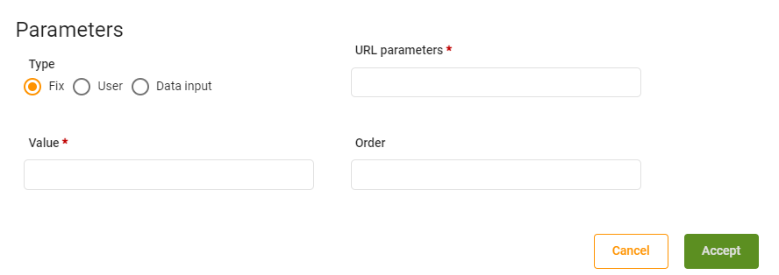
      - Territory internal table
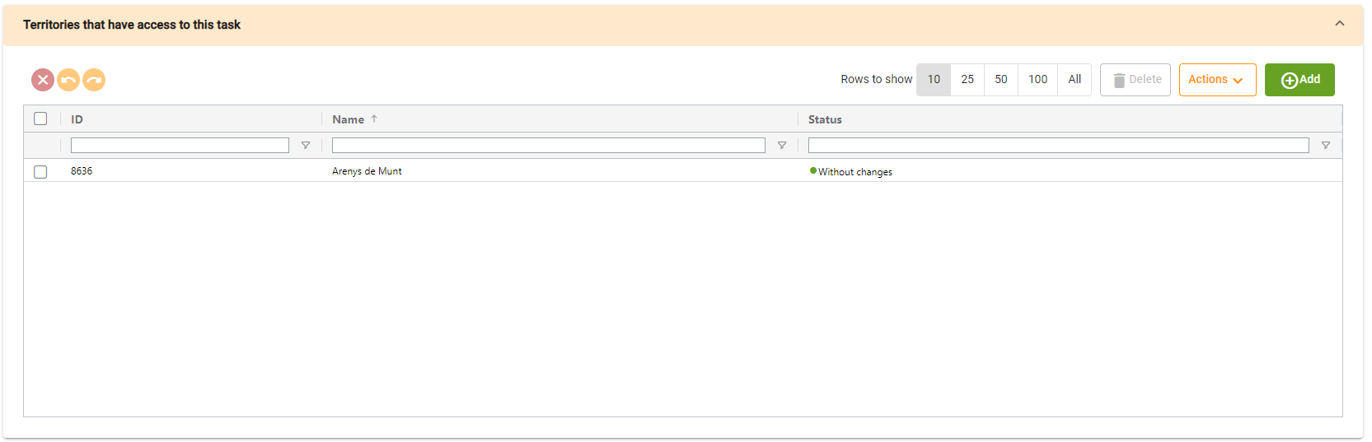
Territory table will show us the territories that have access to this task
      - Roles internal table
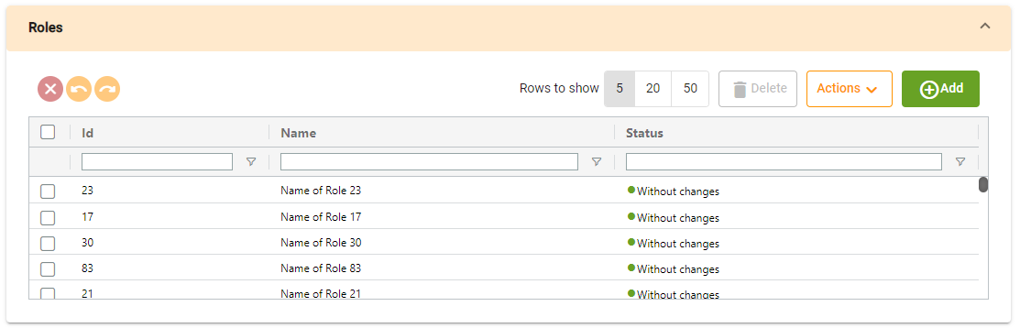
Roles table will show us the roles that have access to this task.
    - Download tasks
      - Generic table
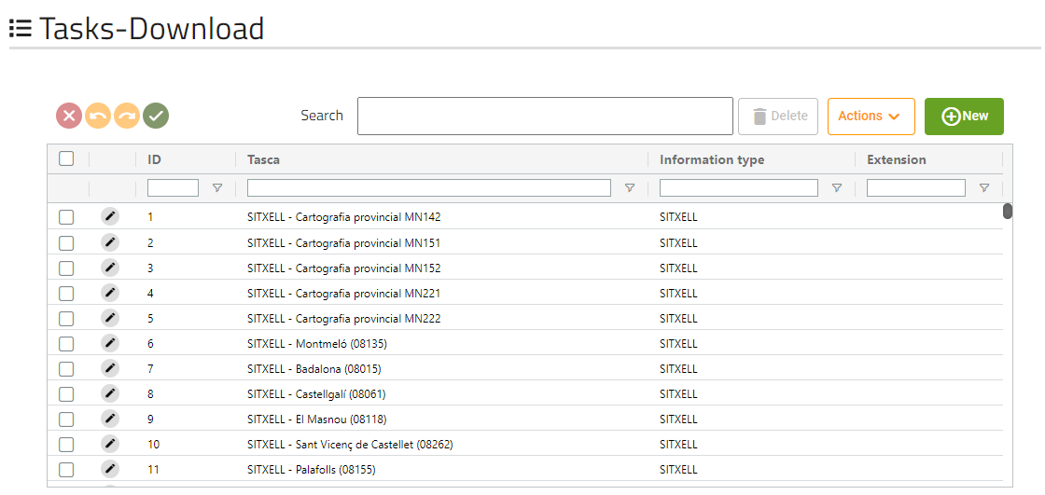
This screen will show us all download tasks that the application has.
      - Form
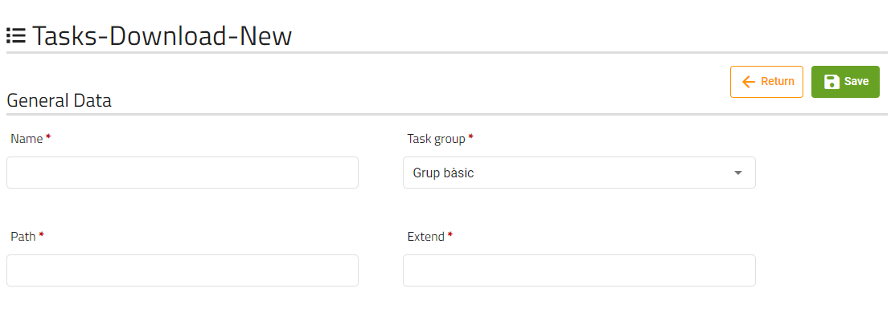

      - Territory internal table
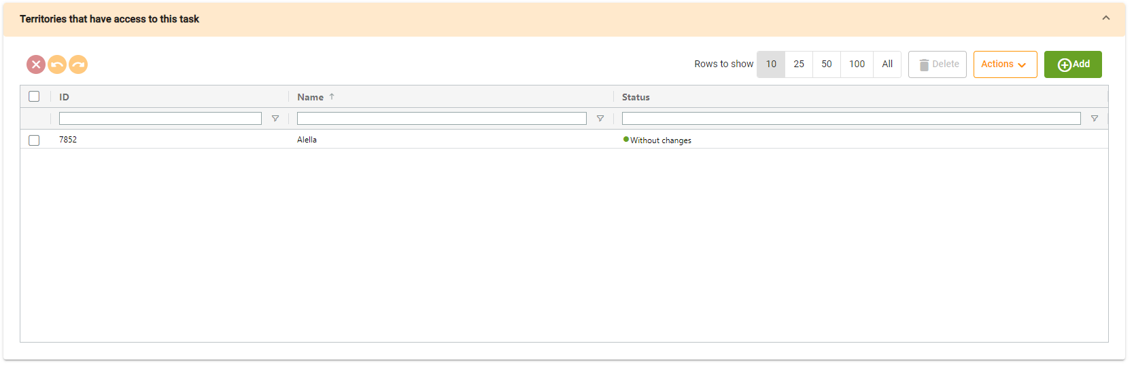
Territory table will show us the territories that have access to this task.
      - Roles internal table
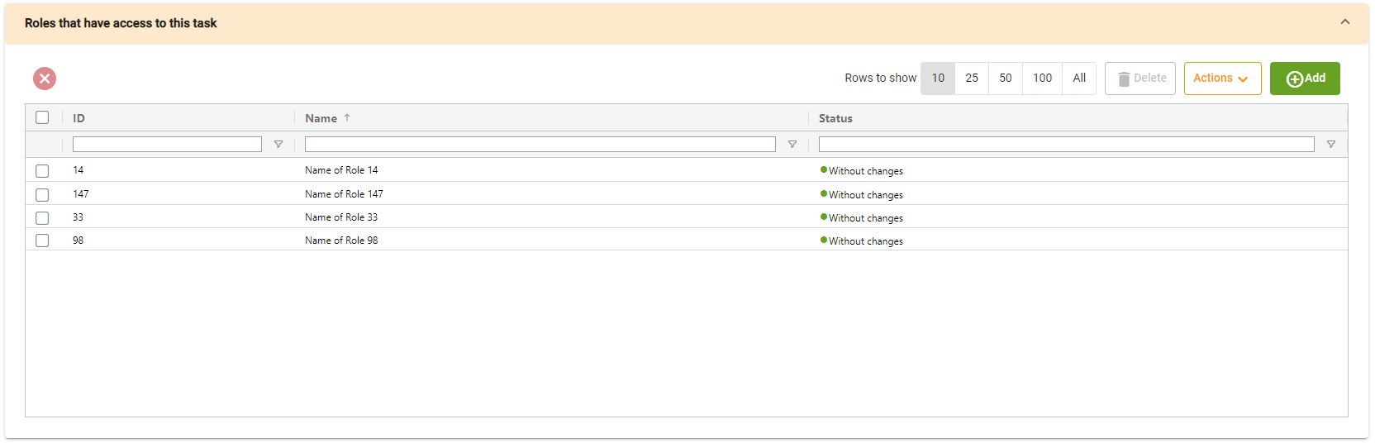
Roles table will show us the roles that have access to this task.

    - Document tasks
      - Generic table
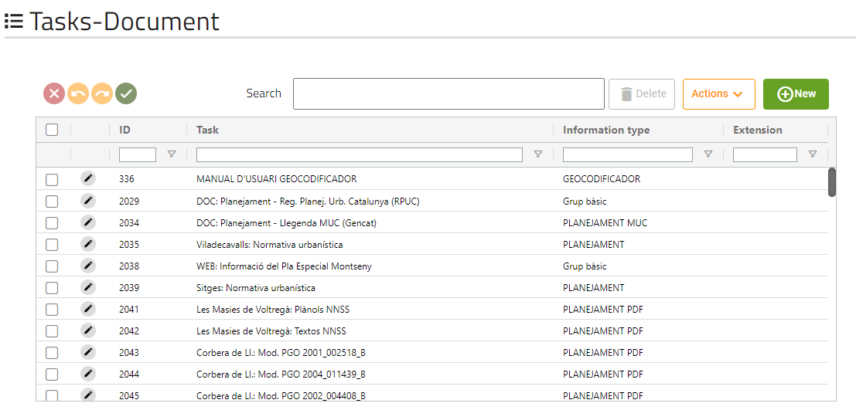
This screen will show us all document tasks that the application has.
      - Form
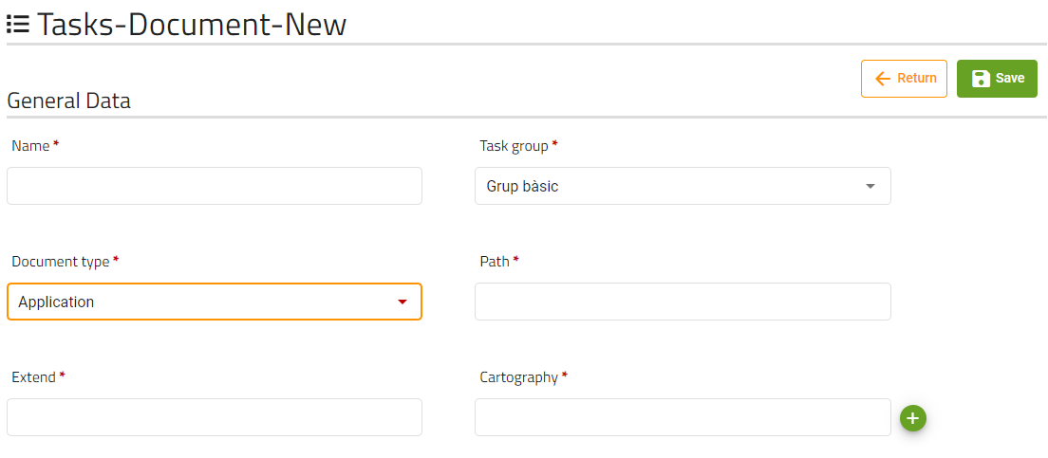
Cartography field will only be available if document type value is ‘Layer’.

      - Territory internal table
Territory table will show us the territories that have access to this task.
      - Roles internal table
Roles table will show us the roles that have access to this task.
    - Query tasks
      - Generic table
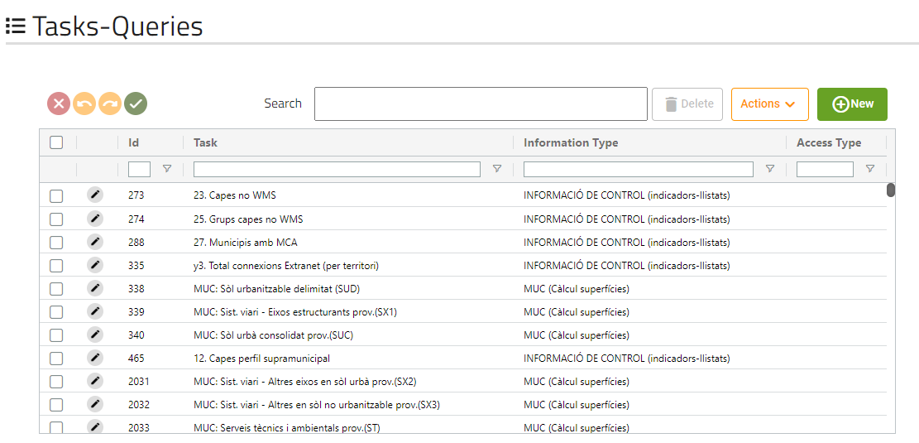
This screen will show us all query tasks that the application has.
      - Form
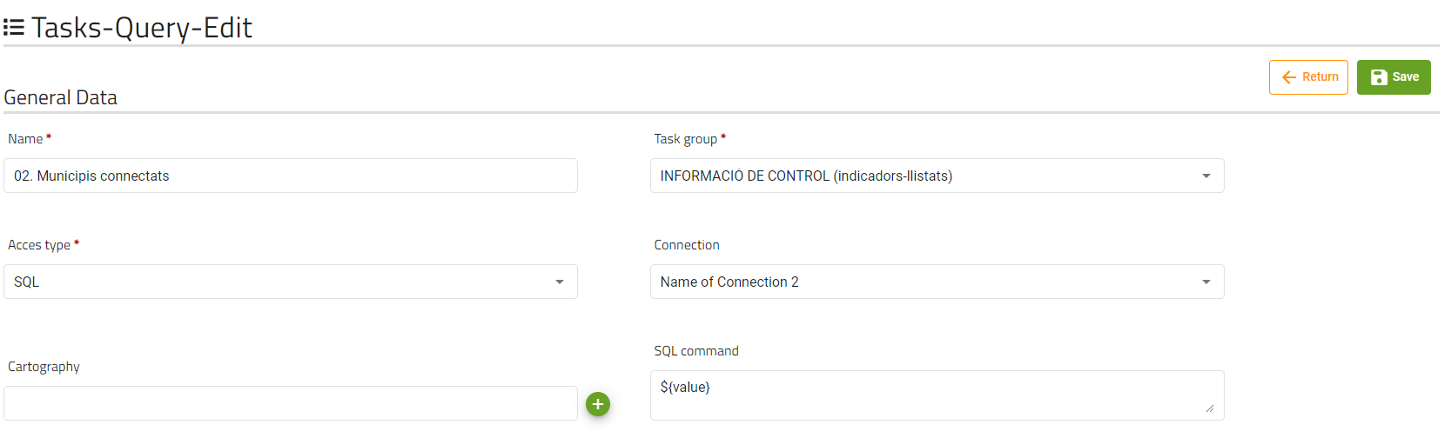
The fields shown can be changed based on the 'access type' field.

      - Territory internal table
Territory table will show us the territories that have access to this task.
      - Roles internal table
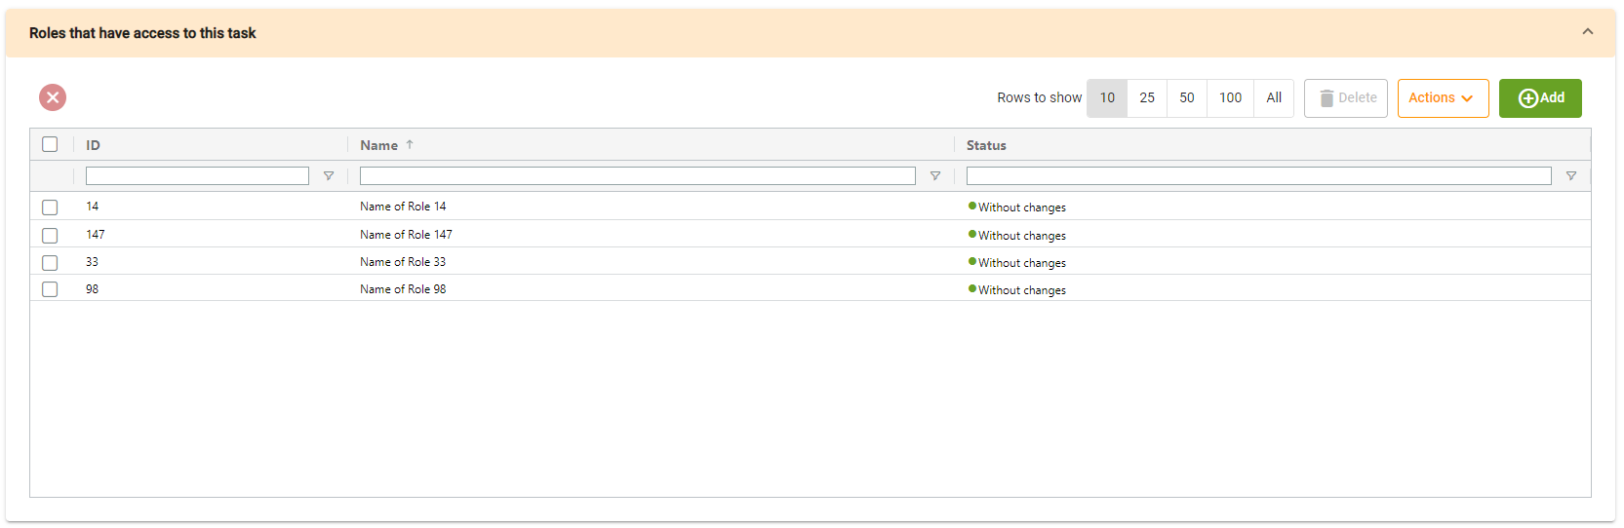
Roles table will show us the roles that have access to this task.
      - Parameter internal table
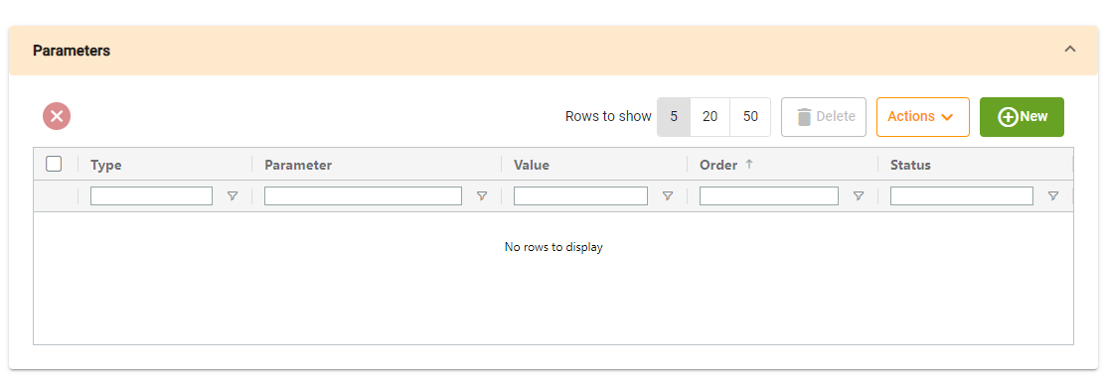
Permissions table will show us the permissions that the task has, if we click on new, a dialog will be opened with the form to create it:
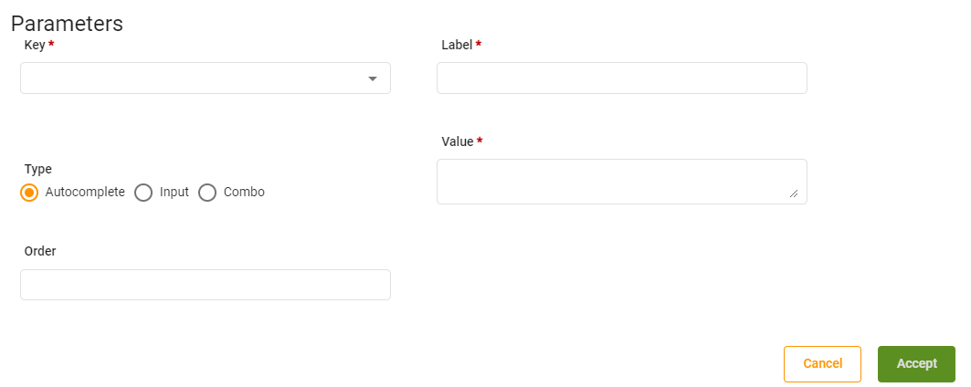
The key selector depends on main form SQL command field, all values written on value field matching the next pattern ${VALUE} will be shown on key selector.

    - More information tasks
      - Generic table
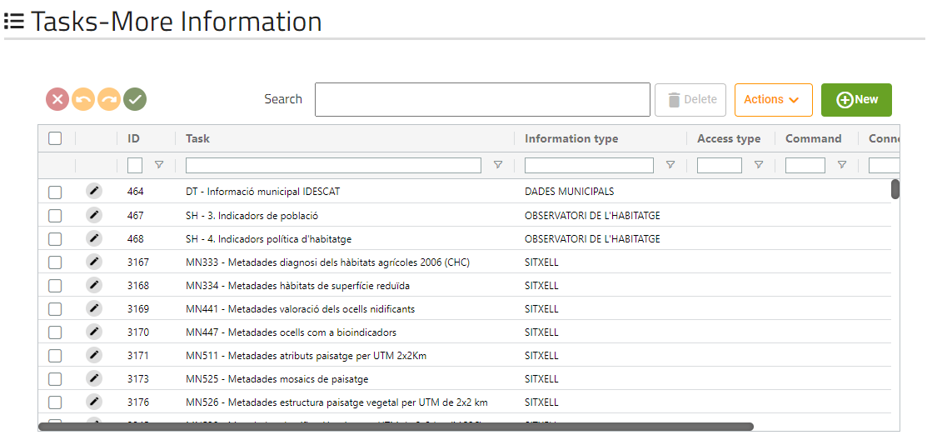
This screen will show us all more-information tasks that the application has.

      - Form
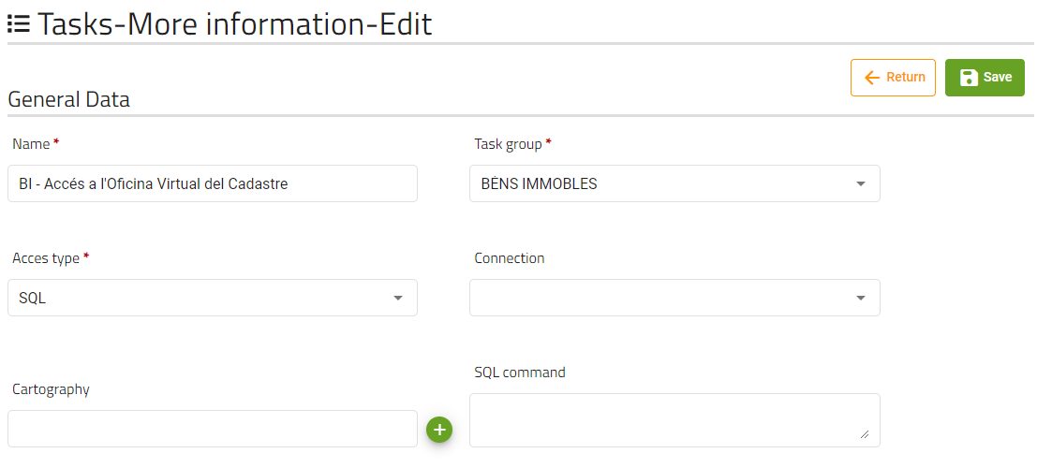
The fields shown can be changed based on the 'access type' field
      - Territory internal table
Territory table will show us the territories that have access to this task.
      - Roles internal table
Roles table will show us the roles that have access to this task.
      - Parameter internal table
Permissions table will show us the permissions that the task has, if we click on new, a dialog will be opened with the form to create it:
The key selector depends on main form SQL command field, all values written on value field matching the next pattern ${VALUE} will be shown on key selector.

    - Locator tasks
      - Generic table
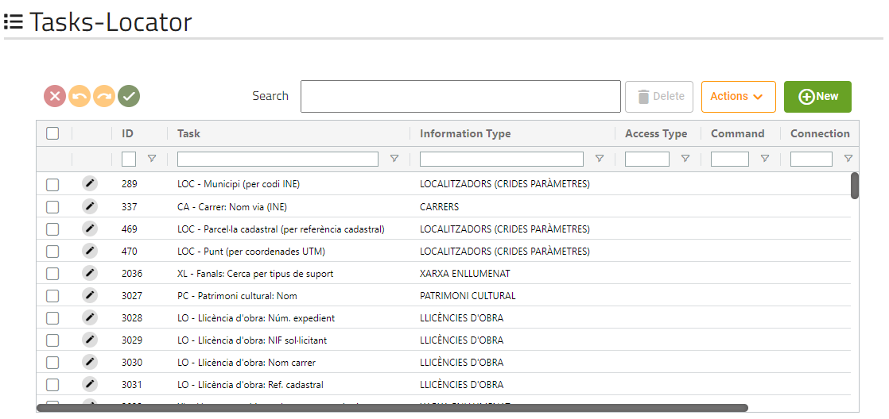
This screen will show us all locator tasks that the application has.
      - Form
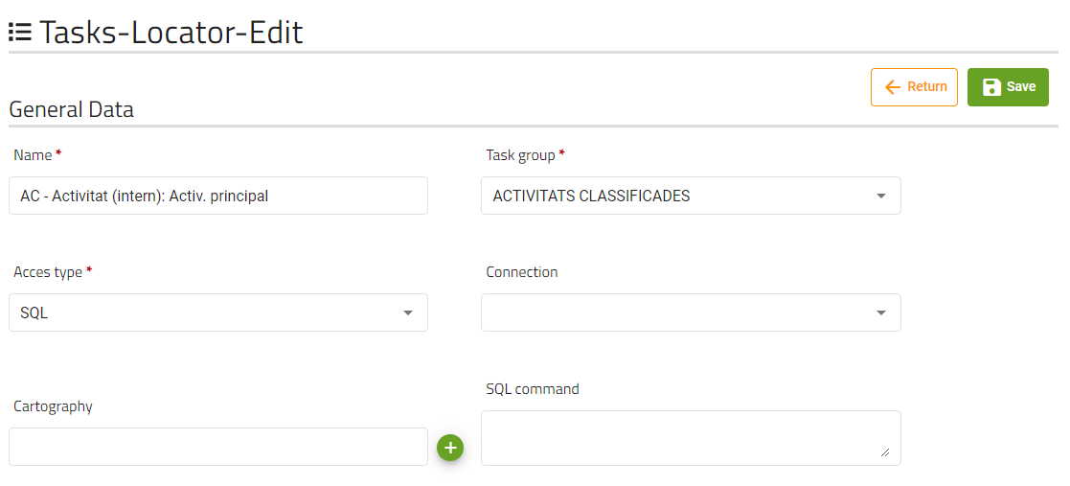
The fields shown can be changed based on the 'access type' field.

      - Territory internal table
Territory table will show us the territories that have access to this task.
      - Roles internal table
Roles table will show us the roles that have access to this task.
      - Parameter internal table
Permissions table will show us the permissions that the task has, if we click on new, a dialog will be opened with the form to create it:
The key selector depends on main form SQL command field, all values written on value field matching the next pattern ${VALUE} will be shown on key selector.

    - Report tasks
      - Generic table
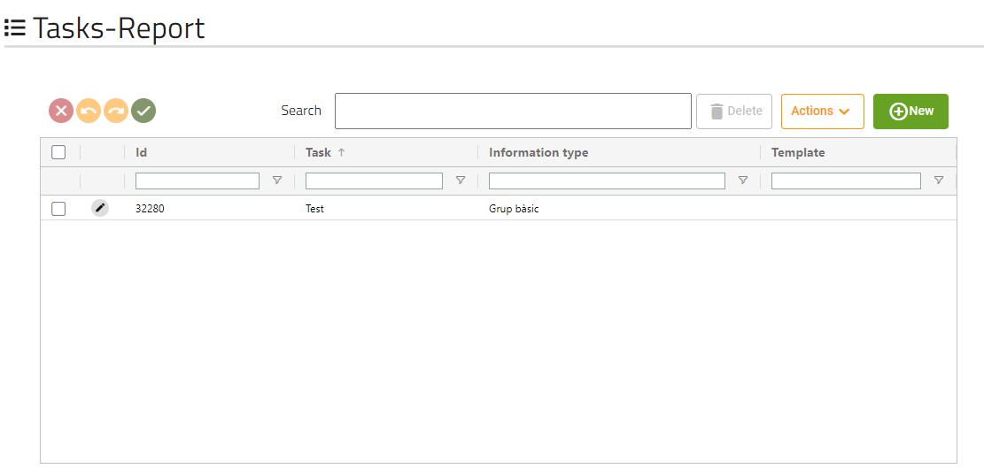
This screen will show us all report tasks that the application has.

      - Form
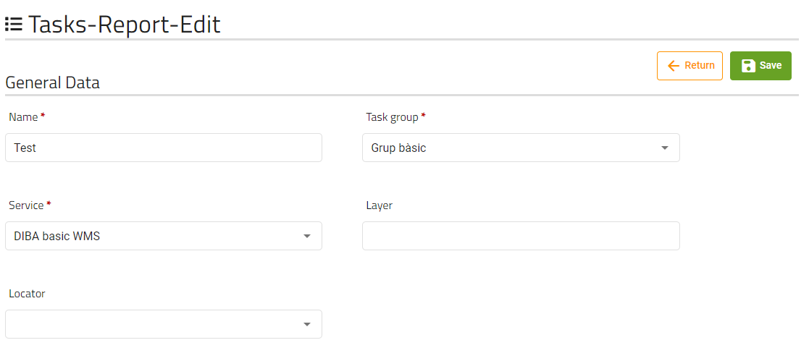

      - Territory internal table
Territory table will show us the territories that have access to this task.
      - Roles internal table
Roles table will show us the roles that have access to this task.

    - Thematic tasks
      - Generic table
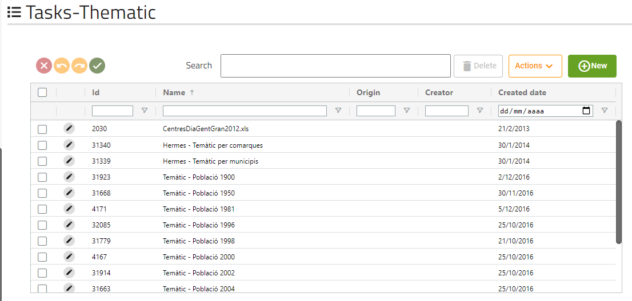
This screen will show us all report tasks that the application has.
      - Form
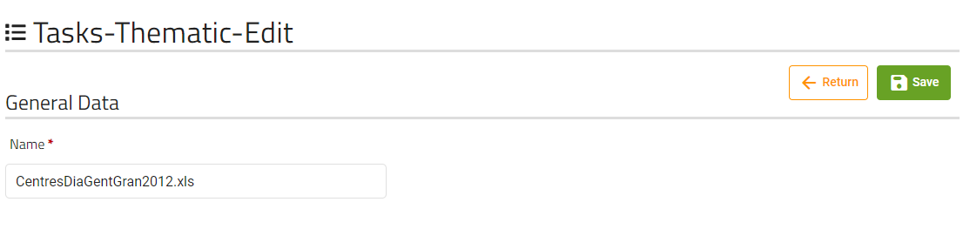
      - Territory internal table
Territory table will show us the territories that have access to this task.
      - Roles internal table
Roles table will show us the roles that have access to this task.
    - FME Extraction tasks
      - Generic table
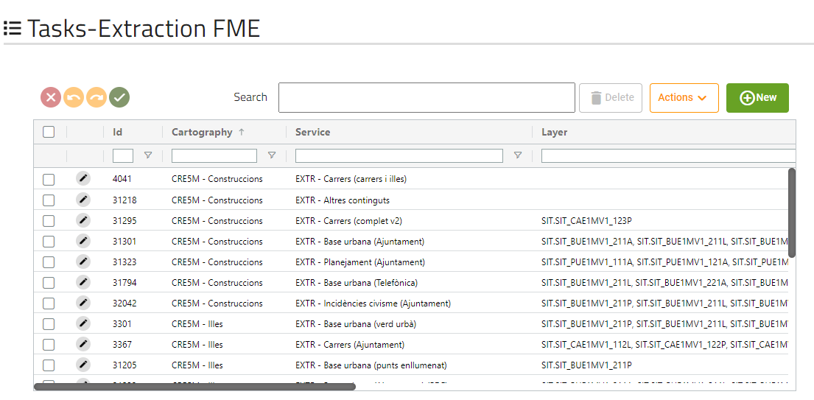
This screen will show us all FME extraction tasks that the application has.

      - Form
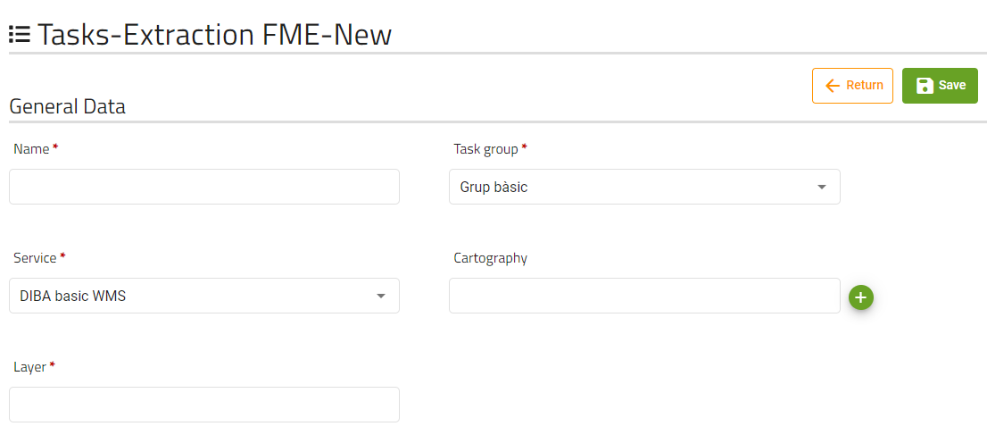
      - Territory internal table
Territory table will show us the territories that have access to this task.
      - Roles internal table
Roles table will show us the roles that have access to this task.
    - Applications
      - Generic table
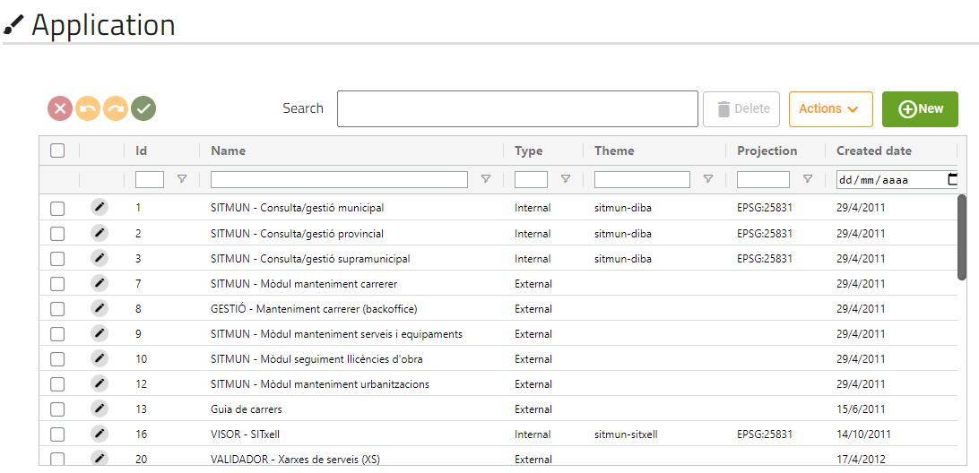
This screen will show us all applications that the application has.
      - Form
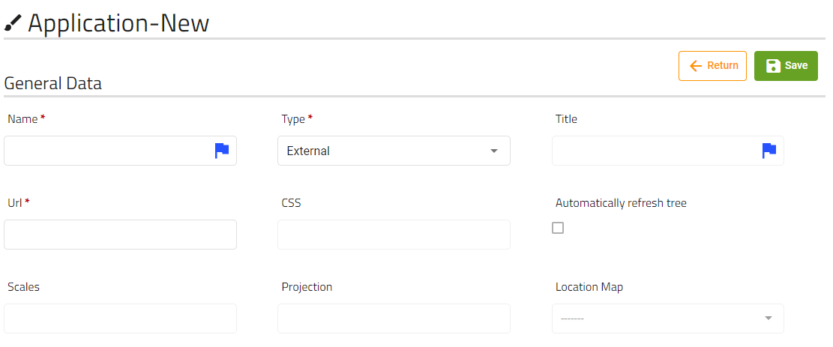
These are the fields that the user can modify of an application.
Scales must be numbers separated by commas.
If type field has “External” selected, only name, type, and URL fields will be editable.

      - Parameter configuration internal table
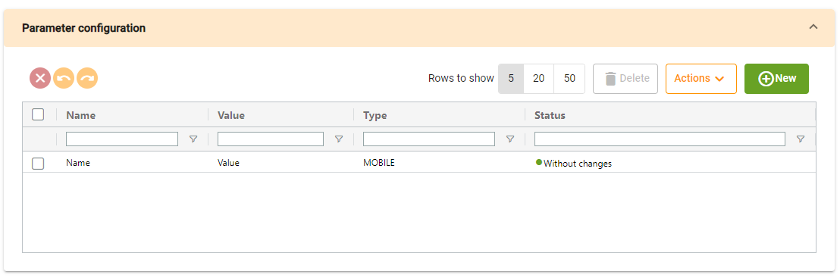
Parameter configuration table will show us the parameters configuration that the application has, clicking on new a dialog will be opened with a form to create the new parameter:
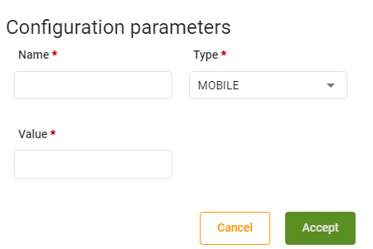
      - Template configuration internal table
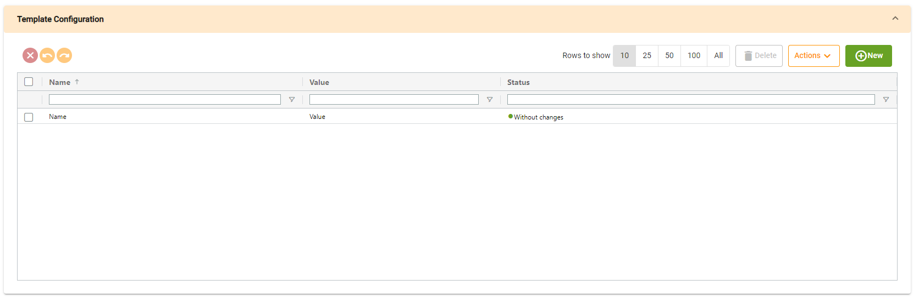
Template configuration table will show us the templates configuration that the application has, clicking on new a dialog will be opened with a form to create the new template configuration:
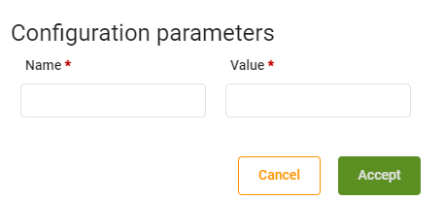
      - Roles internal table
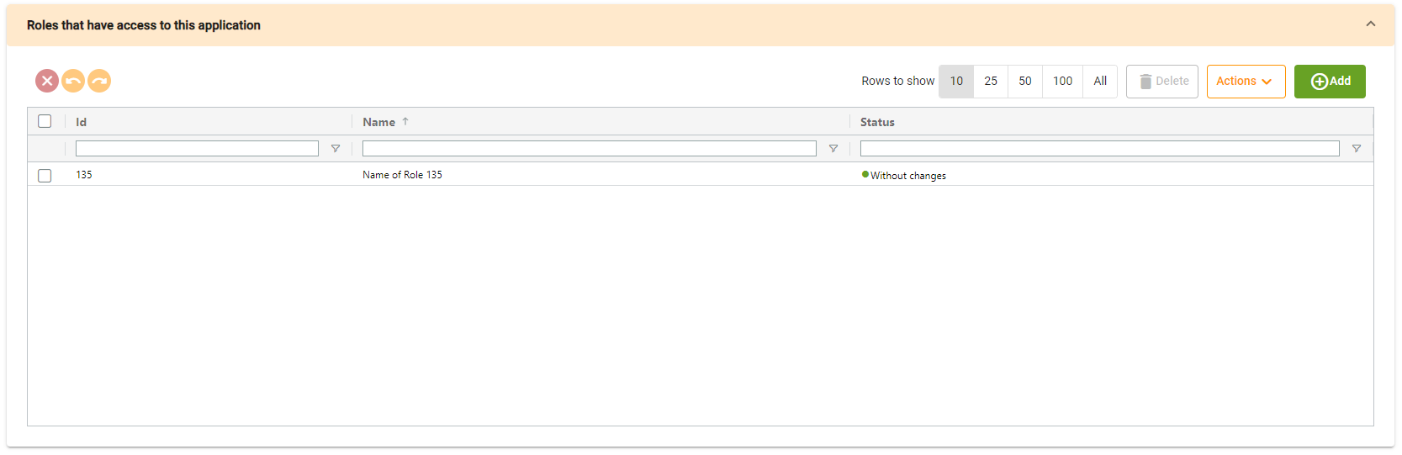
Roles table will show us the roles that has access to this application
      - Background internal table
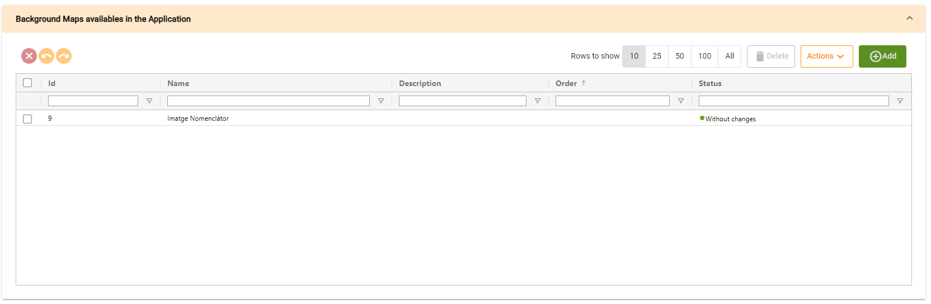
Background table will show us the backgrounds that are available in the application.
      - Tree internal table
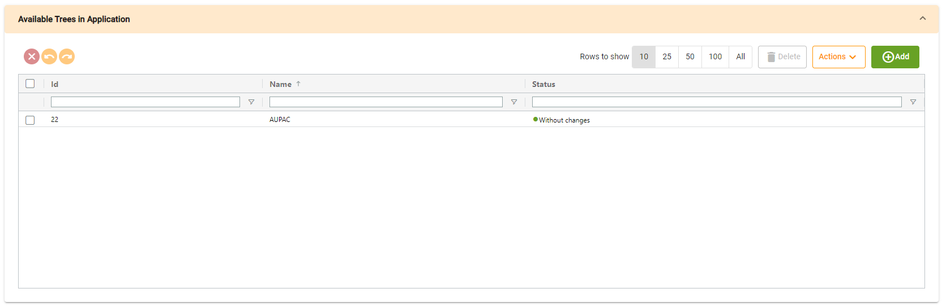
Tree table will show us the trees that are related to the application.

