**Introduction and it’s background**

Fire safety is a major concern in the Philippines, yet its importance is often overlooked by the public. This persistent threat is clear from the very start of the year, with the Bureau of Fire Protection (BFP) reporting nine fire incidents in the National Capital Region on the first day of 2025 alone (Conejos, 2025). A big part of the problem comes from preventable hazards; BFP data shows that from January 1 to February 27, 2025, electrical issues were the leading cause of 625 fires nationwide (Rita, 2025). The BFP also points to other factors, linking the rise in fire incidents to extreme heat and fluctuations in electricity demand (Patron, 2025). This situation shows the limits of a reactive approach and points to the need for better, community-focused education that shifts the focus from reacting to emergencies to proactively reducing risk.

The scale of this challenge on a national level is significant. In 2024 alone, the Bureau of Fire Protection recorded a total of 18,217 fire incidents across the country, an 11.2 percent increase from the previous year (Villamente, 2024). These fires resulted in an estimated P13.8 billion in damage to property (Villamente, 2024). Beyond the financial cost, the human toll was also severe, with over 340 civilian fatalities and more than 1,330 injuries reported during the same period (Chavez, 2025; Villamente, 2024). These staggering national figures highlight the widespread nature of the issue and demonstrate the critical need for effective fire safety and preparedness programs at the community level.

The danger posed by these incidents is magnified in densely packed residential areas, where fires can spread with devastating speed. A catastrophic fire in the Isla Puting Bato community in Tondo, Manila, on November 23, 2024, serves as a stark example. The blaze, which began in a single home, spread so rapidly through the community's light, combustible materials that it destroyed approximately 1,000 houses and displaced 2,000 families within hours (Hoey, 2024; Calucin, 2024; Delizo, 2024). Such events demonstrate how structural vulnerabilities in densely built environments can turn a localized fire into a large-scale disaster, highlighting a critical risk factor that is present in many communities across the nation.

In Sta. Cruz, Laguna, fire safety is a major concern for the same reasons. Based on preliminary consultations with the local Bureau of Fire Protection (BFP), many high-risk areas in the municipality are characterized by high-density housing. While many structures are made of concrete, the primary hazard stems from how closely residential and commercial buildings are packed together, often with minimal to no spacing between them. This proximity means that a single fire can easily spread and endanger an entire neighborhood, a problem compounded by the municipality’s mix of urban and rural zones that challenges the reach of conventional fire safety programs.

While the Bureau of Fire Protection (BFP) in Sta. Cruz is doing its best to educate the public, their current programs do not go far enough to address these specific risks. Based on consultations with Chief FINSP Cesar Morfe Jr. and FO3 Lorena Nanale, the main approach relies on social media for announcements and occasional community talks rather than structured education. These efforts are limited by several key problems: the lack of a single, centralized platform dedicated to fire safety; educational materials that are too general and not tailored to the interests of different age groups like children; and a lack of interactive tools that encourage engagement. This creates a significant gap where educational outreach is passive, leading to a situation where critical safety information is easily forgotten and fails to build the practical skills needed for proactive fire safety.

To address these issues, this study proposes the development of SafeScape, a web-based, AI-driven platform for fire safety education and risk assessment designed specifically for Sta. Cruz, Laguna. New technologies offer a chance to make fire safety programs better and more suited to local needs (Nagaraju et al., 2024). SafeScape will bring together several tools to bridge the identified gaps, including interactive educational lessons for different age groups, a 2D digital twin feature for residential risk assessment (Abbas et al., 2024), and an AI-powered chatbot for safety questions based on BFP protocols (Parekh, 2024). The platform will also introduce a basic training prototype using AR/VR technology to demonstrate skills like using a fire extinguisher (Kang et al., 2023). By integrating these modern tools, the goal is to equip residents with not just knowledge, but with practical digital tools to strengthen preparedness, encourage participation, and support a more coordinated emergency response within the community.

**Research Problem**

Current fire safety efforts in Sta. Cruz, Laguna, are often reactive, with significant limitations in community engagement and a lack of modern training tools for both residents and fire personnel. While the Bureau of Fire Protection (BFP) works diligently, their traditional methods such as social media posts and occasional talks are not sufficient to address the specific risks of a community with densely packed housing and a diverse population. This results in a critical gap where residents are aware of fire dangers but lack the specific, accessible education needed for proactive prevention and effective emergency response.

The absence of a centralized digital platform means that educational materials are difficult to access and are often too general to be effective for different age groups, particularly children. This lack of interactive and targeted tools hinders the development of practical skills and perpetuates a reactive mindset toward fire safety. Therefore, there is a clear need for a predictive, interactive, and inclusive digital system that can facilitate early fire hazard detection, deliver tailored education, and improve emergency response coordination within Sta. Cruz, Laguna.

This study aims to address the following research questions:

1. How can an inclusive website be designed to effectively deliver age-appropriate educational content and interactive tools on fire safety to the community?
2. How can AI-driven digital twin simulations be implemented for fire risk assessment and predictive analytics to shift fire safety measures from reactive to proactive?
3. How can immersive VR/AR training modules be created to provide safe, hands-on experience in fire scenarios for both BFP personnel and community members?
4. How can IoT sensor networks be integrated for real-time monitoring of fire hazards and to facilitate early warning alerts?
5. How can the system’s usability, functionality, and effectiveness be evaluated in enhancing fire safety awareness and preparedness within the community?

**Research Objectives**

The main goal of this study is to design, develop, and evaluate SafeScape, an inclusive AI-driven platform that enhances fire safety, risk assessment, education, and community preparedness in Sta. Cruz, Laguna.

Specifically, it aims to:

1. To design and develop an inclusive website offering age-appropriate educational content, interactive tools, and multimedia resources on fire prevention and emergency response.
2. To implement AI-driven digital twin simulations for fire risk assessment and predictive analytics to shift from reactive to proactive fire safety measures.
3. To create immersive VR/AR training modules for BFP personnel and community members to provide hands-on experience in fire scenarios.
4. To evaluate the system’s usability, functionality, and effectiveness in enhancing fire safety awareness and preparedness within the community.

**Research Framework**

…

**Theoretical Framework**

The development of the SafeScape platform is grounded in established principles from computer science, disaster management, and educational technology. This study is anchored on the recent developments in artificial intelligence, simulation, and immersive learning to support a web-based system that enhances proactive fire safety. The core philosophy of this approach is to leverage AI to shift the focus of fire safety from a reactive model centered on emergency response and recovery to a proactive model that prioritizes preparation and prevention, as conceptualized in Figure 1.

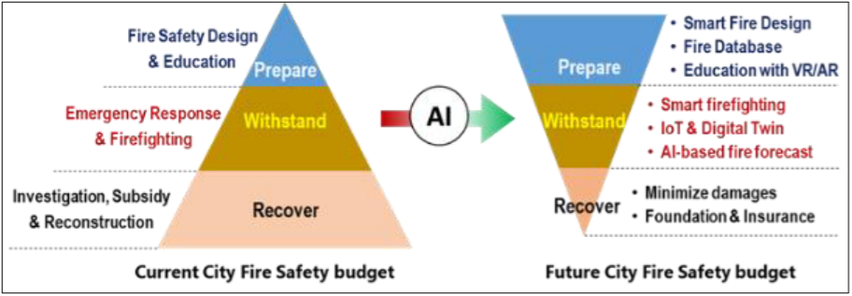Figure 1. The vision of AI's role in shifting fire safety focus (Parekh, 2024).

The central innovation of SafeScape—its ability to assess and predict fire risk—is anchored in the theory of Artificial Intelligence (AI) for predictive analytics. The use of Machine Learning (ML) models allows for this critical shift toward a proactive stance. A comprehensive review by Singh et al. (2024) on wildfire spread models reveals that ML models demonstrate superior efficiency and accuracy over traditional methods by leveraging diverse datasets for dynamic forecasting. This approach is validated on a global scale by McNorton et al. (2024), who developed a data-driven "Probability of Fire" (PoF) forecast using machine learning that outperforms existing fire danger indices. The implementation of such a model follows a structured methodology, as demonstrated by Hu et al. (2022), whose two-step machine learning process for casualty prediction provides a proven framework for developing reliable predictive systems for emergency scenarios, as illustrated in Figure 2.

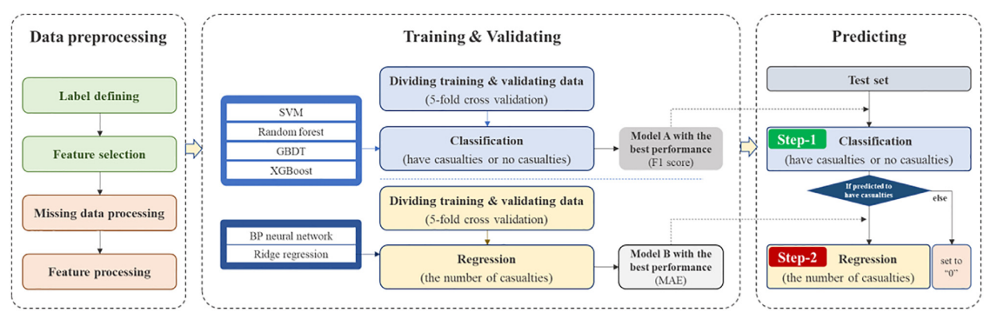

Figure 2. The two-step machine learning methodology flowchart (Hu et al., 2022).

This predictive capability is made tangible through Digital Twin technology, a virtual model of a real-world system that serves as a dynamic counterpart for simulation. As shown in Figure 3, the core concept involves a continuous interaction between a physical entity and its virtual model, facilitated by a twin database (Liu et al., 2023). This creates a closed loop of "perception-analysis-control" for safety management. To simulate dynamic events within this digital twin, SafeScape employs Agent-Based Modeling (ABM), a sophisticated technique for modeling the behavior of autonomous agents. Foundational work by Mirahadi et al. (2019) demonstrates a framework, shown in Figure 4, for integrating building models with fire dynamics and agent-based crowd simulations. SafeScape applies this theory by using the Mesa library in Python to create agents that represent residents, allowing the system to simulate evacuation patterns based on the AI's fire risk predictions.

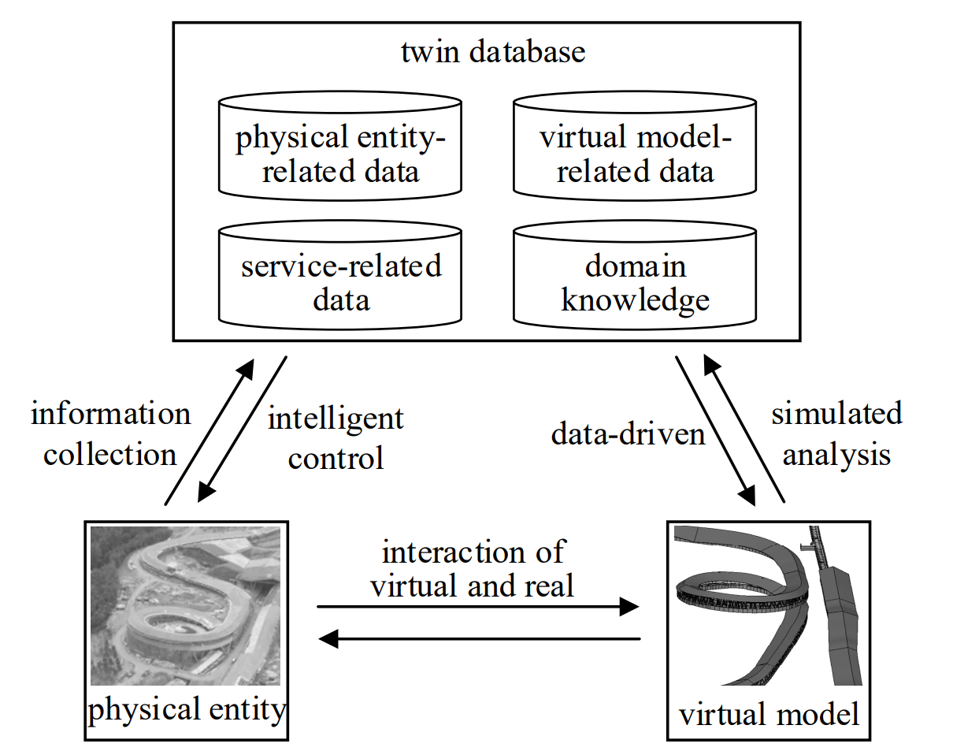

Figure 3. The conceptual model of a digital twin (Liu et al., 2023).

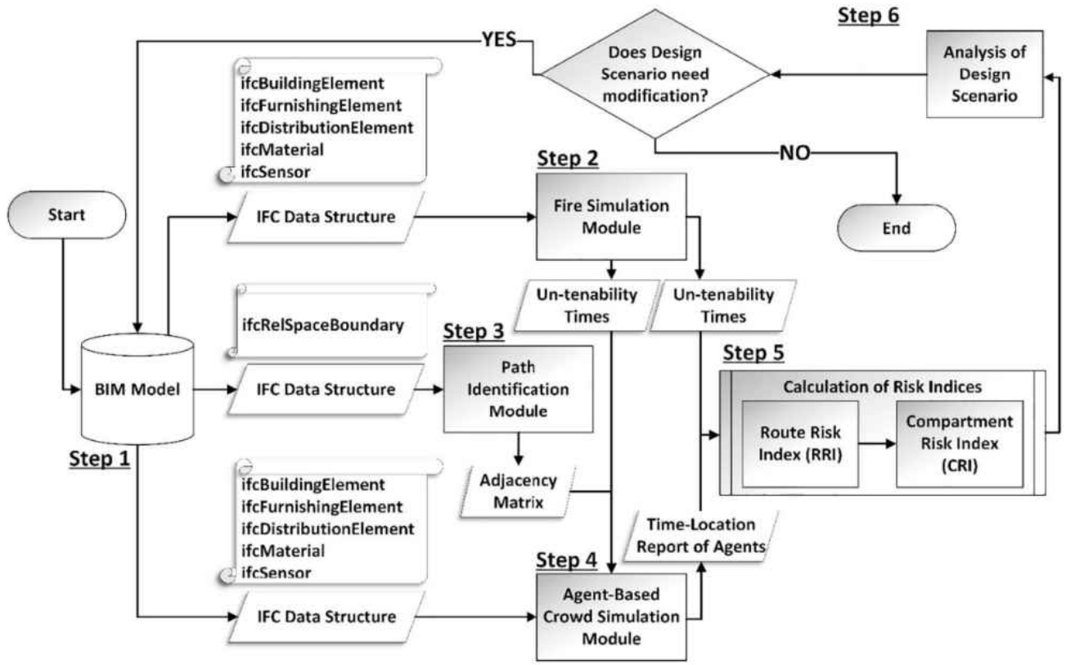

Figure 4. Framework for performance-based evaluation of building evacuations (Mirahadi et al., 2019).

However, simply visualizing risk is not enough to ensure preparedness; residents must also be trained on how to respond. Therefore, SafeScape's educational mission is supported by theories of immersive and interactive learning. To address the ineffectiveness of passive information delivery, the platform incorporates principles of Behavioral Skills Training (BST), a structured, four-step process involving instruction, modeling, rehearsal, and feedback, as illustrated in Figure 5. Research by Fu & Li (2023) on a Virtual Reality-based Serious Game (VR-SG) for fire safety demonstrated that this type of immersive and engaging training significantly improves the learning and retention of evacuation skills.

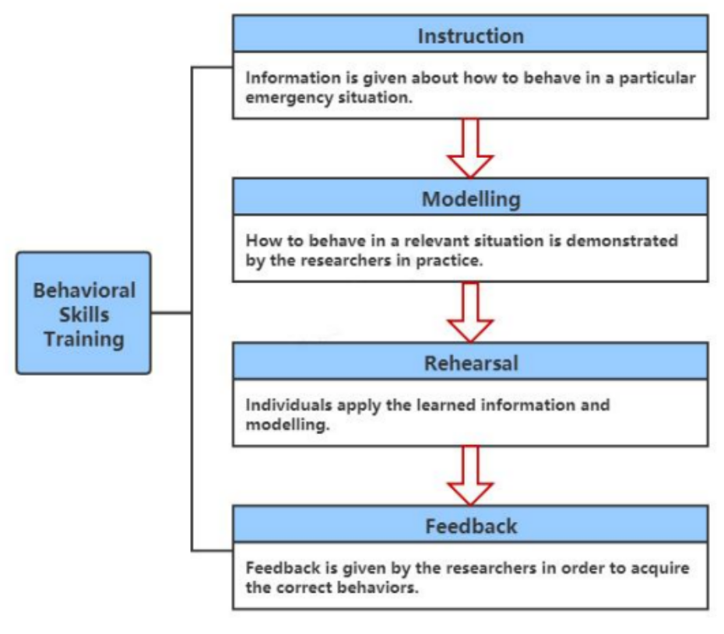

Figure 5. The four components of Behavioral Skills Training (Fu & Li, 2023).

To further enhance engagement and provide on-demand information, the platform includes an AI Chatbot grounded in the principles of Conversational AI. The successful adoption of such a tool is supported by the Technology Acceptance Model (TAM), a foundational theory that posits that a user's intention to use a new technology is determined by its Perceived Usefulness and its Perceived Ease of Use, as shown in Figure 6. Research by de la Roca et al. (2024) applies this model to educational chatbots, emphasizing their role in enhancing user engagement through personalized, 24/7 assistance. SafeScape's chatbot is designed on this principle, providing a user-friendly interface for residents to ask fire safety questions and receive immediate, reliable answers based on BFP protocols.

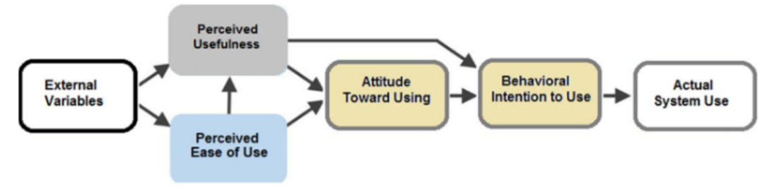

Figure 6. The Technology Acceptance Model (de la Roca et al., 2024; adapted from Davis, 1989).

Ultimately, the effectiveness of these advanced technological tools is dependent on their ability to foster genuine community preparedness. The theoretical basis for SafeScape's community-centric approach is the need to bridge the gap between perceived and actual readiness for disasters. Research by Cisternas et al. (2024) on household preparedness found that even in high-risk areas, residents rarely participate in preparedness activities, highlighting the importance of accessible tools that encourage community involvement. SafeScape is directly founded on this principle, aiming to overcome low participation by providing an engaging, user-friendly platform that promotes a proactive approach to fire safety, a critical need in vulnerable communities like Sta. Cruz, Laguna.

**Conceptual Framework**

…  
  
**Scope and Limitations of the Study**

This study focuses on the design, development, and implementation of SafeScape, an inclusive AI-driven platform for digital fire safety, risk assessment, education, and community preparedness in Sta. Cruz, Laguna. It aims to provide proactive, accessible, and data-informed tools for promoting residential fire safety awareness and risk mitigation.

Scope:

Geographical Focus: The project is specifically tailored for the municipality of Sta. Cruz, Laguna, and its community.

Primary Application: The system is centered on residential fire safety, providing educational resources and risk assessment tools for households.

Technological Components: The core of the project involves the development of a web-based educational platform, an AI-driven predictive model for fire risk assessment, a 2D digital twin for hazard simulation, and the integration of IoT sensors for real-time monitoring.

Training Module: The study includes the creation of a proof-of-concept VR/AR module to demonstrate potential applications for basic fire response training.

Limitations:

Generalizability: As the platform is designed specifically for the context of Sta. Cruz, Laguna, its findings and direct applicability may not be generalizable to other municipalities without further adaptation.

Data Dependency: The accuracy and effectiveness of the AI-driven predictive models are highly dependent on the quality and quantity of the historical fire data and user-provided information that can be collected.

Prototype Nature of VR/AR: The VR/AR training module will be developed as a basic prototype to demonstrate functionality. It is not intended to be a full-scale, deployable training simulation for comprehensive professional use.

**Significance of the Study**

This research will contribute significantly to improving fire safety management by combining the technological expertise of the College of Computer Studies with the operational knowledge of the Bureau of Fire Protection (BFP). The development of the SafeScape platform is expected to provide substantial benefits to various stakeholders within the community of Sta. Cruz, Laguna.

The study will be beneficial to the following:

Community Residents. The platform will empower residents, including children, teens, and adults, with the knowledge and digital tools needed to proactively prevent and effectively respond to fires. Age-appropriate educational modules and interactive risk assessment tools will help foster a culture of preparedness at the household level.

BFP Sta. Cruz Personnel. SafeScape will serve as a modern digital platform to support and augment the BFP's public education campaigns. The immersive VR/AR training modules will offer a safe and repeatable method for enhancing firefighter skills and readiness, while the integrated IoT network will improve incident response coordination.

Schools and Educational Institutions. The platform will provide interactive, BFP-standard resources that can be used for more effective fire safety lessons and drills, helping to integrate modern safety education into the curriculum.

Barangay Leaders and Local Government Units (LGUs). Local leaders can utilize the platform to enhance community-wide preparedness campaigns, identify high-risk areas through the system's analytics, and promote a more coordinated emergency response strategy.

Future Researchers. This study will serve as a practical model for how AI, digital twin, and other advanced technologies can be applied to improve disaster resilience in other municipalities, contributing to the broader fields of community resilience and smart emergency management systems.