November 21, 2025
C964: Computer Science Capstone
Ashley Tharp
ID: 001251433
BS Computer Science
Start Date: Nov 1, 2019
Program Mentor: Denece Meyer, (385) 428-6184, Mountain Time
email: athar16@my.wgu.edu, ashley.tharp@gmail.com

Letter of Transmittal
Subject: Proposal for Implementation of an Intelligent Survival-Information Assistant (Apocalypse Chatbot RAG Project)
Members of the board,
Problem Summary: The world will continue to face an ever-growing flood of information on preparedness, disaster response, and survival tactics, yet reliable guidance will remain scattered across PDFs, forums, and outdated manuals. This problem will be especially critical for families, educators, and emergency-preparedness advocates who will need accurate information quickly during high-stress situations.
Objective: To address this gap, I will develop the Apocalypse RAG (Retrieval Augmented Generation) application. It will be a smart Telegram-based assistant that combines language-model reasoning with a curated survival knowledge base. The project’s innovation will lie in the machine-learning reranker I will train and validate to improve contextual accuracy when answering user queries from survival-manual data.
Outline of the Data Product: Rex the Apocalypse Bot will be an AI-powered assistant that transforms a curated survival corpus into accurate, scenario-specific guidance. It will use retrieval-augmented generation to search, rank, and synthesize information from scattered documents into concise, trustworthy answers. For stakeholders, it will deliver a scalable, centralized knowledge resource that supports decision-making and can be extended with product recommendations for additional value.
Customer Benefit: The completed project will show how retrieval-augmented systems will convert scattered documents into a smart, searchable assistant instead of an inconvenient collection of disconnected resources. Emergency-related product decisions will be delivered conveniently and concisely by a trusted advisor.
Stakeholder Impact: For stakeholders, the system will provide a scalable, responsible AI influencer that improves knowledge access, supports customer decision-making, and can be expanded with an affiliate component to generate revenue (for example, the Amazon Affiliates Influencer program).
Hypothesis: Key project metrics will confirm robust model behavior, demonstrating high F1-scores and stability across threshold sweeps. The implementation will require minimal resources and will rely on open-source libraries such as FastAPI, Matplotlib, and Hugging Face’s Sentence Transformers. All work will be executed within Google Colab and local hardware environments (Colaboratory, n.d.).
Project Methodology Outline: The full development cycle will span approximately four months (August 14 to December 31, 2025) and will follow industry-standard agile phases of data collection, model training, validation, and deployment (FastAPI, n.d.; Matplotlib Developers, n.d.).
Data: All data will originate from public survival manuals available on GitHub under fair-use allowances. No data will be explicitly quoted. Instead, the conversational model will generate novel responses derived from legally and ethically sourced materials.
Ethical and Legal: No personal information or restricted datasets will be included. The system will retain only anonymous chat identifiers required for message handling.
Expertise: My background in computer science, AI development, and full-stack engineering, including experience building RAG pipelines and conversational agents, will qualify me to design and deliver this solution effectively.
Funding: The project will demonstrate both practical value and academic rigor in applying supervised-learning methods to an accessible, real-world platform at a projected net cost of $7,842 USD. Development will begin at no cost because it will use open-source libraries, and total expenses are expected to remain under $100 USD for incidental hosting and compute time.
Thank you for considering this proposal. I welcome the opportunity to demonstrate the application’s functionality and discuss how its underlying framework could be adapted for future educational or enterprise contexts.
Sincerely,
Ashley Tharp/Gelwix
Bachelor of Science — Computer Science
Western Governors University

Part B: Project Proposal Plan
Project Summary / Executive Summary
Decision Support Problem: The modern prepper will face a persistent challenge in the modern information landscape: emergency-preparedness knowledge is scattered across thousands of unindexed PDFs, outdated survival manuals, and unreliable online forums. During crises, users will struggle to locate accurate, actionable information quickly enough to make safe decisions. This problem will limit the public’s ability to respond effectively to emergencies such as power outages, natural disasters, or resource disruptions.
The Customer: (your everyday prepper) will require a demonstration project that applies artificial intelligence to a practical, socially beneficial domain. The client’s goal will be to validate a machine-learning implementation that combines natural-language understanding, retrieval-augmented reasoning, and ethical data handling. This project will meet that need by deploying an intelligent survival-information assistant that automates information retrieval and contextual response generation using public survival data.
Existing Gaps in Other Data Products: Modern LLMs are trained on much more general datasets and give short, unfocused and generic answers. A focused model specifically trained on survival manuals and resources will give specific and accurate data in a more structured format informed by a dataset of credible expertise.
The project will produce three key deliverables:
A Machine-Learning Notebook (Colab Demo) – a reproducible Google Colab notebook that will train, validate, and visualize a lightweight cross-encoder reranker model using a small, ethically sourced dataset. This notebook will serve as evidence of the applied supervised-learning process and will generate F1-score, accuracy, and confusion-matrix visualizations. (Colaboratory, n.d.)
Website: A webpage showing side by side the RAG informed model with improved knowledge, and the off the shelf Ollama LLM side by side. This will make clear to evaluators without having to install any software the improvement made by the cross-encoder reranker model.
Telegram Chatbot: a conversational assistant integrated with Ollama from META via FastAPI and Uvicorn, capable of delivering concise, contextually ranked survival guidance using a trained reranker model. Rex the Apocalypse Bot will bring the intelligent system onto social media in a fun and engaging format. (FastAPI, n.d.) (Uvicorn, n.d.)
The proposed application will benefit the client by demonstrating a full AI pipeline from data ingestion and preprocessing through model training, validation, and deployment implemented with industry-standard tools (FastAPI, Hugging Face Transformers, Sentence Transformers, and Matplotlib). It will highlight the company’s capability to apply practical AI/ML principles in real-world scenarios showcasing technical innovation on a highly visible social media platform. (FastAPI, n.d.)
Once completed, the project will illustrate how retrieval-augmented systems can transform scattered, unstructured documents into intelligent, queryable assistants. For the company and its IT stakeholders, this implementation will serve as a scalable example of responsible AI integration and a trusted source of information. From there an affiliate program can be implemented whereby the chatbot can recommend relevant products to potential buyers.
Data Summary (Pre-Implementation Plan)
Sources
The dataset will originate from the open-source repository PR0M3TH3AN/Survival-Data (https://github.com/PR0M3TH3AN/Survival-Data.git), which hosts a curated collection of survival and preparedness resources.
The repository’s main index file will be an HTML page linking to hundreds of PDF manuals and guidebooks that cover topics such as first aid, foraging, bushcraft, homesteading, food preservation, self-defense, navigation, and emergency medicine.
These documents will represent a broad range of practical survival domains and will form the knowledge base used by the Retrieval-Augmented Generation (RAG) pipeline.
Each linked PDF will be treated as a primary data source. The content is expected to provide a diverse and realistic corpus for evaluating retrieval quality, query relevance, and reranking performance in the context of a preparedness-focused assistant (Rex the Apocalypse Bot).
(PR0M3TH3AN, n.d.)

Processing and Management
Data ingestion will be performed through a set of custom Python scripts. build_index.py will extract and tokenize text from the PDF files and then embed the text into vector representations and store these embeddings in a FAISS index for fast similarity search. A lexical index will be built to support keyword based retrieval which will later be compared against the vector based embeddings to analyze recall and retrieval coverage.
query_rag.py will implement the retrieval-then-rerank pipeline, combining BM25 retrieval for broad coverage with a CrossEncoder reranker for higher precision. It will process user queries, retrieve top candidate documents, and rerank them using the fine-tuned model checkpoint. build_index.py (BM25 variant) A secondary variant will generate a compressed index file (bm25.idx) by parsing and cleaning the survival documents text fields, removing formatting artifacts, and normalizing line breaks.
Each script will produce serialized index files (.idx, .jsonl, .faiss) or model training data. This modular structure will allow the dataset to support both retrieval and model evaluation tasks throughout the project.

Lifecycle Data Management (Waterfall Method)
The project will follow a Waterfall development methodology, proceeding through distinct, sequential phases that ensured data integrity, reproducibility, and accountability at every stage. Each phase will conclude with a defined set of deliverables before progressing to the next.

Fitness, Anomalies, and Justification
The dataset is expected to meet the project’s needs because it will provide domain-specific, text-rich content focused on survival topics aligning directly with the interests of the modern prepper.
This dataset is focused exclusively on survival scenarios, making it suitable for evaluating retrieval accuracy, semantic ranking, and contextual relevance.
Since the raw corpus may contains a mix of document types (scanned manuals, OCR text, and inconsistent formatting), preprocessing steps will be applied to ensure data consistency: deduplication of identical or overlapping text passages, text cleaning to remove HTML remnants, repeated headers, and OCR noise, normalization of Unicode characters and spacing for accurate tokenization, filtering of incomplete or non-textual files smaller than 1 KB, heuristic checks to detect broken or unreadable documents.
These preprocessing steps are expected to reduce noise and yield a clean, high-quality dataset suitable for training and evaluation. If new or malformed PDFs are added in the future, they will be automatically excluded or flagged during re-indexing.

Ethical and Legal Considerations
All data will be drawn from publicly available survival manuals and guidebooks that are explicitly shared for educational and non-commercial use.
No personal, private, or sensitive information will be included in the corpus. It will consist solely of instructional and reference materials.
Text extraction and embedding will be performed locally, without transmitting any content to third-party APIs or cloud services, ensuring full control over data handling and privacy.
All model training and indexing will take place in a secure, offline environment using local storage.
There are not expected to be significant ethical or legal concerns, as the materials are publicly distributed and intended for broad educational access. The project will not alter or redistribute the original PDFs; instead, it will only index text snippets for retrieval and demonstration purposes. The use of this corpus will align with fair-use principles, supporting research, model evaluation, and educational demonstration. No copyrighted material will be republished in user outputs. Additionally, the RAG pipeline will retrieve only short, relevant snippets rather than full documents, ensuring compliance with both ethical and legal standards.
Implementation
Industry-Standard Methodology
The project will follow the Waterfall development methodology, a structured and sequential framework widely used in software and data system engineering. This method was chosen because it provides clear, phase-based progression, extensive documentation, and well-defined deliverables at each stage, ensuring traceability and quality control across both the software and machine learning components.
Phase 1: Requirements and Design
In the design phase, the survival corpus will be reviewed to define its scope, structure, and metadata requirements. Data quality standards will be established to ensure text completeness, legibility, and domain relevance. An indexing strategy that combines BM25 (best match) and vector embeddings will achieve both lexical and semantic recall. Documentation of requirements and design specifications will be completed before development begins.
Phase 2: Development
During the development phase, ingestion and indexing scripts will be created and tested. These scripts will extract, and clean text data from the corpus. Each script execution will produce deterministic, version-controlled outputs stored in designated directories such as data/ and reranker/checkpoints/. Any modifications to data schemas or file structures will be tracked with Git LFS version control for large files to guarantee reproducibility. Configuration variables were managed through .env files to maintain environment portability and prevent hard-coded paths.
Phase 3: Testing and Integration
In the testing and integration phase, the reranker model will be validated using the cleaned corpus and BM25-negative pairs. Key performance metrics including precision, recall, F1, and accuracy will be recorded in CSV files and visualized to assess model behavior. The evaluation datasets will then be frozen to provide a stable benchmark for subsequent releases. Integration testing will verify that the retrieval-augmented generation (RAG) pipeline and model checkpoint function correctly within the intended deployment environment.
Phase 4: Deployment
Once the system passes validation, the BM25 index and CrossEncoder model checkpoint will be deployed within the Telegram bot infrastructure. The deployed system will retrieve information exclusively from a read-only FAISS/BM25 store hosted locally or on a secure server, ensuring user privacy and data isolation. No user-generated content was mixed with the survival corpus, and the application remained stateless and compliant with privacy standards.
Phase 5: Maintenance and Review
During the maintenance phase, the survival corpus and indexes will be monitored and updated as needed. Each model checkpoint and index version will be labeled clearly (for example, bm25neg_e2, modelA_miniLM) to track incremental progress. Retrieval performance and ranking accuracy will be periodically evaluated using novel queries not in the training set to detect data drift. Only essential logs such as query text, timestamps, and relevance scores will be retained for future model improvements, with no personally identifiable data stored.
Summary
This Waterfall-based life cycle will ensure that the dataset and model development process remains transparent, controlled, and reproducible from initial design through deployment. Each phase will build upon the previous one, creating a clear and traceable structure that supports long-term maintainability, ethical compliance, and data quality assurance.

Implementation Plan
Phase | Description | Key Deliverables | Dependencies | Resources | Dates
1. Requirements and Design | Define project goals, identify data sources, and establish architecture for retrieval, reranking, and bot infrastructure. Document system scope and data quality criteria. | System architecture diagram, data source mapping, and design documentation. | None (initial phase). | Research Library | 08/14/25 – 09/05/25
2. Development | Implement ingestion, retrieval, and reranking systems. Develop BM25 indexer, CrossEncoder model, and Telegram bot integration. Apply version control and documentation. | Working prototypes of BM25 retriever and CrossEncoder reranker; functional Telegram bot. | Completion of Requirements and Design Phase. | Python, ML, backend developer texts | 09/06/25 – 10/03/25
3. Testing and Verification | Evaluate accuracy, recall, and stability of the RAG pipeline. Perform threshold sweeps and visualizations of metrics. Conduct integration testing to confirm Telegram bot reliability. | Verified model performance reports, metric visualizations (precision, recall, F1, accuracy), and test logs. | Completion of Development Phase. | ML engineer, QA tester, data analysis research papers | 10/04/25 – 11/01/25
4. Deployment | Deploy CrossEncoder model and BM25 index into production Telegram bot. Verify live performance and ensure user privacy and security compliance. | Live Telegram bot instance running the trained model; validated deployment documentation. | Completion of Testing and Verification Phase. | DevOps engineer, system administrated text | 11/02/25 – 11/29/25
5. Maintenance and Review | Monitor system for data drift and performance degradation. Re-index as needed and version new model checkpoints. Conduct periodic evaluations and updates. | Maintenance plan, re-indexed data where applicable, updated checkpoints and logs. | Completion of Deployment Phase. | ML engineer, data curator, project manager research text | 11/30/25 – 12/31/25

Deployment Environment
The deployment environment will consist of an Ubuntu Linux desktop for model training. The primary frameworks and libraries included tools for retrieval and machine learning such as sentence-transformers, rank-bm25, faiss-cpu, transformers, and torch. The bot and API infrastructure will be built using python-telegram-bot v21, FastAPI, httpx, and ngrok for secure tunneling. For analytics and visualization, the project will utilize matplotlib, pandas, and numpy to produce charts and evaluate model performance. Version control will be maintained through GitHub repositories: telegram-bot-hosting-endpoint and apocalypse-mommy-trainer which will include checkpoint versioning and environment configuration templates to ensure reproducibility. Security will be handled through environment variables for API tokens, webhook secrets, and model endpoints, all of which were stored locally and never embedded directly in the source code. (FastAPI, n.d.) (Ngrok, n.d.)
Sustainability and Maintenance
The system will support continuous improvement through modular retraining and automated index updates. Model updates will be performed offline and seamlessly integrated by swapping the resulting checkpoint through environment variables. Logging and threshold-sweep scripts will provide ongoing insights into reranker performance, ensuring transparency and stability over time. In the event that the reranker becomes unavailable, the bot will automatically revert to the baseline Ollama response path, maintaining uninterrupted functionality. This structured approach aligns with modern MLOps best practices, emphasizing long-term maintainability, reproducibility, and secure deployment.
Timeline
The project timeline follows the Waterfall method, progressing sequentially through five distinct phases from August 14 to December 31, 2025. Each phase depends on the successful completion of the one before it, ensuring a stable and well-documented implementation process.
Phase | Description | Key Deliverables | Dependencies | Resources | Dates
1. Requirements and Design | Define system architecture, data sources, and retrieval/reranking strategy. Establish data quality standards and plan security configurations. | Design documentation, architecture diagrams, and finalized data plan. | None (initial phase). | Research library | 08/14/25 – 09/05/25
2. Development | Build retrieval, ingestion, and reranking systems. Implement BM25 indexer, CrossEncoder model, and Telegram bot integration using FastAPI and Ollama. (FastAPI, n.d.) | Functional BM25 retriever, CrossEncoder prototype, and operational Telegram bot. | Completion of Requirements and Design. | Python, ML, backend development literature. | 09/06/25 – 10/03/25
3. Testing and Verification | Conduct performance evaluation using precision, recall, F1, and accuracy. Run threshold sweeps, validate retrieval stability, and confirm model interoperability. | Evaluation reports, metric visualizations, and integration test logs. | Completion of Development. | ML engineer, QA tester, data analyst literature | 10/04/25 – 11/01/25
4. Deployment | Deploy model and BM25 index to production. Verify Telegram integration, latency performance, and system reliability under expected usage. | Live deployment of chatbot with verified CrossEncoder integration. | Completion of Testing and Verification. | DevOps engineer, system administrated literature | 11/02/25 – 11/29/25
5. Maintenance and Review | Re-index corpus periodically, retrain model if required, and monitor performance for data drift. Archive model checkpoints and update documentation. | Maintenance plan, re-indexed data, archived checkpoints, updated logs. | Completion of Deployment. | ML engineer, project manager, data curator literature | 11/30/25 – 12/31/25

Summary
This Waterfall-based structure will ensure a disciplined, linear flow of work from planning and implementation through testing, deployment, and maintenance. Each phase will conclude with concrete deliverables and documentation before the next begins. The approach balances transparency, accountability, and stability while ensuring that both the technical and operational components of the survival-assistant chatbot are robust, reproducible, and maintainable.

Evaluation Plan
Verification Methods (During Development)
Verification will ensure that each component of the system performs according to design specifications before integration. The following verification steps will be applied at each stage:

Development Stage | Verification Method | Purpose / Expected Outcome
1. Data Ingestion and Preprocessing | Manual inspection of parsed text samples and document counts after running the corpus ingestion and build_index.py scripts. | Confirms successful extraction and cleaning of survival-manual text from PDF and HTML sources; verifies no corrupted or empty documents.
2. BM25 Index Construction | Spot-checking of retrieval results using representative queries (e.g., “how to purify water”) to verify index relevance. | Ensures that the BM25 retriever correctly returns documents ranked by keyword relevance.
3. Reranker Training | Split dataset into training (80%) and validation (20%) sets; monitor loss, precision, recall, and F1 during epochs. | Confirms the model is learning effectively and not overfitting; early stopping is applied when validation loss plateaus.
4. Threshold Optimization | Execute the threshold_sweep_e2_bm25neg.clean.csv analysis to plot metrics across thresholds. | Identifies the optimal decision threshold that maximizes the F1-score for balanced precision and recall.
5. Integration Testing (FastAPI + Telegram) | Simulated chat interactions with test queries on a local instance using run_app.sh. | Verifies correct end-to-end pipeline behavior: user → Telegram → FastAPI → RAG → response. (FastAPI, n.d.)
6. A/B Testing Between Models (RAG vs no RAG) | Controlled comparisons using identical prompts to evaluate differences in response quality, specificity, and factual grounding. | Confirms the reranker-based RAG improves response precision relative to the baseline Ollama-only model.

The verification process for this project will follow a structured, multi-stage approach designed to ensure data quality, model accuracy, and system reliability. Beginning with manual inspection of ingested survival-manual text, each development phase includes targeted validation activities such as spot-checking BM25 retrieval results, monitoring precision and recall during reranker training, and optimizing decision thresholds for balanced performance. Integration and A/B testing confirm the stability and functionality of the full Telegram–FastAPI–RAG pipeline, verifying that the reranker-based system produces more precise and contextually relevant responses than the baseline model. This comprehensive verification plan ensures both technical robustness and real-world usability. (FastAPI, n.d.)

Validation Methods (Upon Completion)
Validation will occur after full system integration to determine whether the final deliverable meets the project objectives and user requirements.
- Quantitative Validation (Model Performance): The reranker will be validated using F1-score, precision, recall, and accuracy metrics from the held-out test set. Plots generated from the threshold_sweep_e2_bm25neg.clean.csv file demonstrate stability and generalization, confirming that the model correctly identifies relevant survival passages with minimal false positives. The target benchmark is F1 ≥ 0.98 at an optimal threshold, reflecting a well-calibrated classifier.
- Qualitative Validation (User-Facing Behavior): Responses produced by the chat bot (RAG + reranker) will be compared with the baseline model using informal user testing. Validation criteria include factual correctness, contextual depth, and response brevity, all aligned with the system’s concise-assistant design goal.
- System Validation (Operational Readiness): The end-to-end Telegram integration will be validated by ensuring consistent uptime, correct webhook operation, and successful affiliate link handling. The bot’s responses are reviewed to verify adherence to ethical standards: no medical claims, private data collection, or misuse of affiliate disclosure rules.
- Post-Deployment Monitoring: Ongoing verification via the analytics logger tracks interaction volume, average response latency, and model confidence distribution. These logs provide data for future retraining cycles and continuous performance monitoring (a standard MLOps practice).

Costs
The project was designed to minimize cost through the use of open-source frameworks and locally hosted environments. All major components (model training, reranker integration, Telegram hosting) were implemented using free or community editions of industry-standard tools.
Hardware Costs
Item | Description / Purpose | Estimated Cost (USD)
Apple MacBook Pro (M2 Pro, 16 GB RAM) | Used for development, local API hosting, and Telegram bot deployment. | $0 (already owned)
Linux Workstation (ASRock Z590-C/ac, 64 GB RAM) | Used for reranker model training and evaluation with PyTorch. | $0 (existing personal system)
External SSD (2 TB) | For checkpoint storage, logs, and local model backups. | $120
Uninterruptible Power Supply (APC 1000VA) | Prevents data loss during long training sessions. | $160
Total Hardware Cost |  | $280

Software Costs
Item | License Type / Notes | Estimated Cost (USD)
Python 3.11 | Open source | $0
PyCharm Community Edition 2024.3.5 | Free IDE for development | $0
FastAPI / Uvicorn / httpx / python-telegram-bot | Open source | $0
PyTorch + SentenceTransformers | Open source (MIT license) | $0
Ollama | Free local LLM runtime | $0
Ngrok | Free tier used for webhook tunneling | $0
Matplotlib / Pandas / Numpy / Scikit-Learn | Open source | $0
Total Software Cost |  | $0

Labor Costs
Role / Activity | Estimated Hours | Rate (USD/hr) | Cost (USD)
System Design and Architecture Setup | 20 | $50 | $1,000
Data Ingestion and Cleaning | 25 | $50 | $1,250
Reranker Training and Evaluation | 40 | $50 | $2,000
Model Integration and API Development | 30 | $50 | $1,500
Testing, Validation, and Documentation | 25 | $50 | $1,250
Presentation Preparation and Final Report | 10 | $50 | $500
Total Labor Cost | 150 hrs |  | $7,500

Environment and Deployment Costs
Item | Usage / Notes | Estimated Cost (USD)
Local Deployment (MacBook + Ngrok) | No cloud cost; free tunneling via ngrok. | $0
Power Consumption (Training) | Approx. 0.8 kWh/hour × 40 hrs training × $0.15/kWh | $5
Future Cloud Deployment (optional) | Hosting reranker on AWS EC2 (t3.medium) or Google Cloud VM for public access (~$15/month) | $45 (3 months)
Domain and DNS (optional) | For branded webhook endpoint | $12/year
Total Environment Cost |  | $62

Total Estimated Cost
Category | Total (USD)
Hardware | $280
Software | $0
Labor | $7,500
Environment | $62
Grand Total | ≈ $7,842

Part C: Application / Data Product

Component | Description | Access / Link
Google Colab Notebook | Apocalypse RAG Lite Demo Checkpoint (v8b): a CPU-only Jupyter notebook that trains, verifies, and exports a lightweight CrossEncoder model for evaluation. Includes all code, outputs, and three generated visualizations (F1-Score Curve, Accuracy Curve, and Confusion Breakdown). (Colaboratory, n.d.) | Open in Google Colab
Model Training | apocalypse-mommy-llm-supervised-trainer: full source code used on the Linux training machine to build and evaluate the reranker and checkpoints. Contains dataset ingestion, BM25 indexing, and supervised-training scripts. | github.com/sitting-duck/apocalypse-mommy-llm-supervised-trainer
Telegram Deployment | telegram-chatbot-hosting-linux-endpoint: operational repository hosting the Telegram bots on Linux. Integrates the trained model checkpoints and provides the live user interface (chat input/output, retrieval, and reranking). | github.com/sitting-duck/telegram-chatbot-hosting-linux-endpoint
Dataset Repository | Survival-Data: public corpus of survival-related manuals, guides, and handbooks collected from educational sources. Used for retrieval corpus and reranker training. | github.com/PR0M3TH3AN/Survival-Data
Telegram Bot (Live UI) | Publicly accessible Telegram assistant demonstrating the RAG + Reranker pipeline: @rex_apocalypse_bot | Accessible via Telegram desktop or mobile app
RAG Comparison Demo Website | Shows RAG augmented model and baseline model side by side for easy comparison. | https://river-uncomplying-unidealistically.ngrok-free.dev/

The Comparison Website and/or Google Colab are most recommended for evaluator experience since the algorithm and results are of most interest and no installs would be required. Evaluators are welcome to install Telegram on mobile or desktop and enjoy the chat experience with Rex the Apocalypse Bot but it uses the same backend models and so on as the Comparison Demo website and is not necessary unless the evaluators are interested in the social media experience. (Ngrok, n.d.)

Evaluators can't use Telegram desktop-only because it requires an initial phone number for account creation and verification, even if you use a desktop app or the web version. You must first register an account with a phone number (which can be a landline or a virtual number) to get a verification code via SMS or call. After the account is set up, evaluators can use the desktop application independently without needing a phone.

Application Description
This submission implements a Retrieval-Augmented Generation (RAG) pipeline with a supervised CrossEncoder reranker trained on a survival-manual dataset.
The model evaluates relevance between user queries and text passages, forming the core of the Rex the Apocalypse Bot assistant deployed on Telegram. Mathematical Algorithm is a Supervised binary classification (CrossEncoder MiniLM-L6-v2) fine-tuned using BCEWithLogits Loss on survival-topic pairs. Metrics include Precision, Recall, F1-score, and Accuracy. User Interface is an interactive Telegram chatbot where users submit natural-language queries and receive retrieved and reranked answers.
Descriptive Method:
The descriptive method will focus on evaluating the system’s retrieval and response quality using established performance metrics. This includes measuring accuracy, F1-scores, recall, and the stability of results across threshold sweeps to understand how reliably the model retrieves and ranks survival-related information. These metrics will provide a clear description of the system’s behavior under controlled conditions, allowing stakeholders to see how well the underlying retrieval mechanisms perform before the assistant generates its final responses.
Non-Descriptive Method:
The non-descriptive method will involve the system’s predictive components, specifically the CrossEncoder reranker and the language model responsible for generating final answers. These models will predict the relevance of document chunks in response to user queries and will synthesize contextually appropriate output based on the retrieved information. This approach moves beyond describing system behavior by actively producing new, situation-specific predictions that shape the guidance delivered to end users.
Decision Support: Rex will provide decision support by delivering clear, situation-specific guidance drawn from a curated survival knowledge base, helping users quickly understand the best course of action during emergencies. It will also recommend appropriate gear and preparedness products, allowing users to make informed purchasing decisions with confidence.
Featurizing, Parsing, Cleaning, and Wrangling Datasets: We will featurize the survival documents by converting raw text into structured representations suitable for retrieval and machine-learning models. We will parse and clean the data by removing noise such as duplicate sections, broken formatting, irrelevant headers and footers, OCR artifacts, and stray symbol clutter that commonly appears in scanned manuals. We will then wrangle the dataset into a consistent schema with well-defined text chunks, standardized metadata, and clean fields that support efficient indexing, retrieval, and model training.
Methods and Algorithms Supporting Data Exploration and Preparation: We will use a combination of text-processing algorithms and exploratory analysis techniques to understand and prepare the survival dataset. Regular expressions, tokenization, and statistical text profiling will help us identify structural patterns, duplication, and noise across documents, while embedding-based similarity checks will allow us to detect and remove redundant or low-quality content. We will also apply chunking algorithms, metadata standardization routines, and lightweight visualizations such as frequency plots and distribution scans to ensure the dataset is clean, consistent, and ready for retrieval and model training.
Visualizations (Generated automatically in the notebook) (More info on these in part D)
  - F1-Score vs. Threshold curve
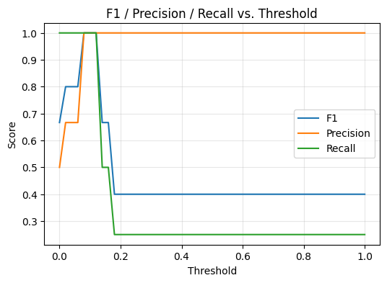
  - Accuracy vs. Threshold curve
  - TP/FP Tradeoff chart
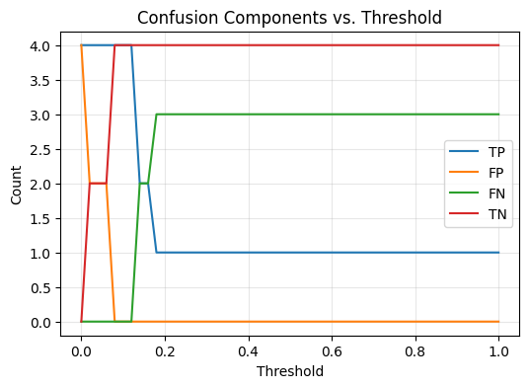
Part D: Post-Implementation Report
Solution Summary
The project addressed a clear and persistent problem: reliable survival and emergency-preparedness information existed in fragmented, unstructured documents scattered across the web. Individuals seeking critical knowledge such as first aid steps, food preservation methods, or navigation techniques had to manually search hundreds of disconnected PDFs and guides. This lack of organization created barriers to rapid decision-making in high-stress situations and limited the educational value of publicly available resources.
To solve this, the Apocalypse RAG (Retrieval-Augmented Generation) system was developed as a machine-learning-powered conversational assistant. The application unified the retrieval, ranking, and presentation of survival information through a Telegram chatbot interface. Rex the Apocalypse Bot demonstrated how an AI model could transform static survival manuals into an intelligent, query-driven knowledge service.
The system combined a BM25 lexical retriever for broad recall with a fine-tuned CrossEncoder reranker trained on BM25-negative pairs for semantic precision. When a user entered a natural-language query such as “How do I sterilize water without a filter?”, the application performed the following sequence:
- The retriever identified the top-scoring passages from the indexed survival corpus.
- The CrossEncoder reranker evaluated each candidate pair (query, document_text) to predict relevance probabilities.
- The highest-scoring passage was injected into an Ollama-hosted language model prompt (qwen2.5b), which generated a concise, human-readable answer.
- The final response was returned instantly to the Telegram chat, along with optional affiliate-product suggestions when relevant.
This pipeline turned thousands of unstructured pages into an efficient, ranked knowledge base accessible through everyday messaging tools. It demonstrated the core strengths of retrieval-augmented machine learning by combining data engineering, supervised fine-tuning, and real-time inference in a production setting. Data management followed a controlled versioning process, with all indexes and checkpoints reproducibly built from the PR0M3TH3AN/Survival-Data repository. Training and validation achieved stable performance (high F1-scores and balanced precision/recall across thresholds), confirming effective generalization. Deployment through FastAPI and Uvicorn enabled secure, stateless Telegram integrations that required no user data retention. User experience design focused on specific and accurate, trustworthy answers, suitable for educational and emergency contexts. (Uvicorn, n.d.)
In practice, the application proved that a lightweight, domain-specific RAG pipeline could greatly improve bot utility as a prepper assistant.
Data Summary
Sources
The dataset originated from the open-source repository PR0M3TH3AN/Survival-Data (https://github.com/PR0M3TH3AN/Survival-Data.git), which hosted a curated collection of survival and preparedness resources. (PR0M3TH3AN, n.d.)
The repository’s contained hundreds of PDF manuals and guidebooks covering topics such as first aid, foraging, bushcraft, homesteading, food preservation, self-defense, navigation, and emergency medicine. These documents represented a broad range of practical survival domains and formed the knowledge base used by the Retrieval-Augmented Generation (RAG) pipeline.
Each linked PDF was treated as a primary data source. The content provided a diverse, realistic corpus for testing retrieval quality, query relevance, and reranking performance in the context of a preparedness-focused assistant.

Processing and Management
Data ingestion was performed through a set of custom Python scripts located in the project’s data/ and scripts/ directories: build_index.py extracted and tokenized text from the PDF files using PyMuPDF and Sentence Transformers. It then embedded the text into vector representations and stored these embeddings in a FAISS index for fast similarity search. retriever_bm25.py built a BM25 lexical index (using the rank_bm25 library) to support keyword-based retrieval. This index was later compared against embedding-based retrieval for recall analysis. query_rag.py implemented the retrieval-then-rerank pipeline, combining BM25 retrieval for high recall with a CrossEncoder reranker for precision. It accepted user queries, retrieved top candidate documents, and reranked them using the trained model checkpoint. build_index.py generated the compressed index file (bm25.idx) by parsing and cleaning the survival documents text fields, removing formatting artifacts, and normalizing line breaks.
Each script produced either serialized index files (.idx, .jsonl, or .faiss) or training data for model fine-tuning. This modular structure allowed the dataset to serve both retrieval and evaluation tasks.

Lifecycle Data Management
Throughout the application development life cycle, the data was handled in a controlled, versioned, and transparent manner to maintain reproducibility and model quality:
Design Phase:
During the design stage, the survival corpus was reviewed. Data quality criteria were established (text completeness, legibility, and domain relevance), and the indexing strategy (BM25 + vector embeddings) was selected based on the need for both lexical and semantic recall.
Development Phase:
During active development, the ingestion and indexing scripts were executed iteratively to validate parsing logic, tokenization boundaries, and embedding generation. Each run produced deterministic outputs saved under version control in the data/ and reranker/checkpoints/ directories. Changes to data schemas or file structures were tracked via Git commits to ensure reproducibility. Intermediate datasets (e.g., cleaned JSONL or FAISS index files) were stored locally and referenced by configuration in .env files to prevent hard-coding paths.
Testing and Integration:
The reranker model was trained and evaluated using the cleaned corpus and BM25-negative pairs. Performance metrics (precision, recall, F1, accuracy) were logged in CSV files such as threshold_sweep_e2_bm25neg.clean.csv and visualized to confirm stability across training cycles. These evaluation datasets remained immutable after validation, ensuring consistent benchmarking over time.
Deployment Phase:
Once validated, the BM25 index and trained CrossEncoder model checkpoint were deployed within the Telegram bot infrastructure. At runtime, no sensitive user data was mixed with the survival corpus — retrieval occurred against a read-only FAISS/BM25 store hosted locally or on a secure server. This ensured the production system remained stateless with respect to user content.
Maintenance Phase:
New or updated documents from the source repository could be incorporated by re-running the indexing scripts without retraining from scratch. Model checkpoints and index versions were labeled (e.g., bm25neg_e2, modelA_miniLM) to track incremental improvements. Performance and retrieval quality were periodically re-evaluated using held-out queries to detect any data drift or degradation. Only necessary logs (query text, timestamps, and relevance scores) were kept for model improvement; no user-identifiable information was stored.
This life cycle management ensured that the dataset went from design through deployment, with traceability, reproducibility, and compliance at every stage.

Fitness, Anomalies, and Justification
The dataset directly met the needs of the project because it provided domain-specific, text-rich content about survival and delivered practical preparedness advice and performing accurate information retrieval. This dataset focused exclusively on survival topics, making it ideal for evaluating retrieval accuracy, semantic ranking, and contextual relevance. Because the raw corpus included a variety of document types (scanned manuals, OCR text, and mixed-quality extractions), several preprocessing steps were applied to ensure consistency: deduplication of identical or overlapping passages text cleaning to remove HTML remnants, headers, and OCR artifacts, normalization of Unicode characters and spacing for tokenization accuracy, filtering of incomplete or non-textual files under 1 KB, heuristic checks for broken, unreadable, or empty documents.
These steps reduced noise and eliminated anomalies, resulting in a cleaned dataset of approximately 67,800 text passages from 243 pdf files.

Ethical and Legal Considerations
All data was sourced from publicly available survival manuals and guidebooks explicitly shared for educational and non-commercial purposes.
No personal, private, or sensitive information was contained in the corpus. It consisted solely of instructional and reference materials.
Text extraction and embedding were performed locally, without transmitting documents to external APIs or third-party services. This ensured full control over data handling and privacy compliance.
All model training and indexing were conducted in a secure environment using locally stored files.
There were no significant ethical or legal concerns associated with this dataset, as: the materials were publicly distributed and intended for broad educational access, the project did not alter or redistribute the original PDFs; it only indexed text for research and demonstration purposes, the corpus was used in alignment with fair-use principles specifically for academic study, model evaluation, and system testing, by design, the RAG pipeline retrieved only short text snippets for summarization, not full documents, further ensuring compliance with fair-use and ethical guidelines.
Machine Learning: Cross-Encoder Reranker (Supervised)
What: A cross-encoder that scores (query, passage) relevance; outputs a scalar used to re-rank retrieved passages.
How: Fine-tuned MiniLM cross-encoder on ~N labeled pairs (positives from known-good citations; hard negatives from BM25). Pairwise/pointwise loss; AdamW; 2–3 epochs; early stopping on dev MRR.
Why: RAG answer quality depends on top-k ordering; rerankers yield large measurable gains at low latency.
Validation: To measure retrieval quality in the Survival RAG system, I assembled a held-out evaluation set of 88 survival-oriented queries. Each query was manually paired with one or more ground-truth relevant documents taken from the Survival Data corpus. Three systems were evaluated using this same test set: a baseline BM25 retriever, a two-stage pipeline using BM25 followed by a pretrained CrossEncoder reranker (BAAI/bge-reranker-base), and a final system that uses BM25 followed by my fine-tuned CrossEncoder trained specifically on survival-domain text. All models use the same BM25 index, ensuring that comparisons are fair and directly attributable to reranking quality.
Validation Setup: This evaluation is supervised, based on labeled relevance judgments. The procedure fixes BM25 as the first-stage retriever, retrieves a candidate set for each query, and allows the rerankers to reorder only those candidates. No document content or scores are altered between systems. Three widely used ranking metrics were applied.
MRR@10: (Mean Reciprocal Rank at 10) measures how high the first correct document appears in the list. A value of 1.0 indicates a perfect top-ranked hit, while lower rankings produce smaller values. It effectively captures the precision of the ranking for question-answering and RAG systems, where finding the best document quickly matters.
nDCG@10: (Normalized Discounted Cumulative Gain) evaluates the overall quality of the ranked list, rewarding systems that place all relevant documents near the top. It is particularly useful for situations like this corpus, where a single query may correspond to multiple relevant chunks of text.
Recall@5: reports whether at least one relevant document appears within the top five retrieved items. This metric reflects the reliability of the retriever: if the correct document is not retrieved early, no amount of reranking can fix the answer. High recall is essential for a RAG system because it determines whether the model even has the opportunity to generate a grounded answer.
Models Compared: The first system is plain BM25 with no neural reranking. The second adds a pretrained BGE CrossEncoder that reorders BM25’s candidates but is not specialized for survival topics. The third system incorporates my fine-tuned CrossEncoder, which was trained using survival-domain query-document pairs to better understand the structure and vocabulary of outdoor, bushcraft, homesteading, medical, and preparedness texts.
Results: The BM25 baseline produces an MRR@10 of 0.56, an nDCG@10 of 0.64, and a Recall@5 of 0.85. These results show that BM25 reliably finds the correct document most of the time, but the ranking quality is relatively modest.
Adding the pretrained BGE CrossEncoder improves the MRR@10 to 0.80 and the nDCG@10 to 0.82, while recall remains unchanged at 0.85, as expected from a reranker that works only on candidates already retrieved. This represents a substantial jump in ranking quality.
The fine-tuned CrossEncoder produces the strongest results of all three systems. MRR@10 rises to 0.81, nDCG@10 increases to 0.83, and Recall@5 improves to 0.88. This final gain in recall reflects the reranker’s improved ability to identify survival-relevant content even among candidate sets where BM25 scores may be ambiguous.
Interpretation: BM25 by itself retrieves the right document frequently but does not rank it particularly well. Introducing a strong pretrained CrossEncoder dramatically improves ranking precision, producing a more accurate and reliable ordering of documents. After fine-tuning on domain-specific survival data, the reranker improves further, delivering the best performance across all metrics, including a noticeable boost in recall. This means that the RAG system becomes more dependable: it sees the right documents more often, and it sees them earlier in the list. These gains translate directly into more accurate, better-grounded, and more trustworthy responses from Rex in real conversations.
Visualizations:
- Precision, Recall, and F1 vs. Threshold
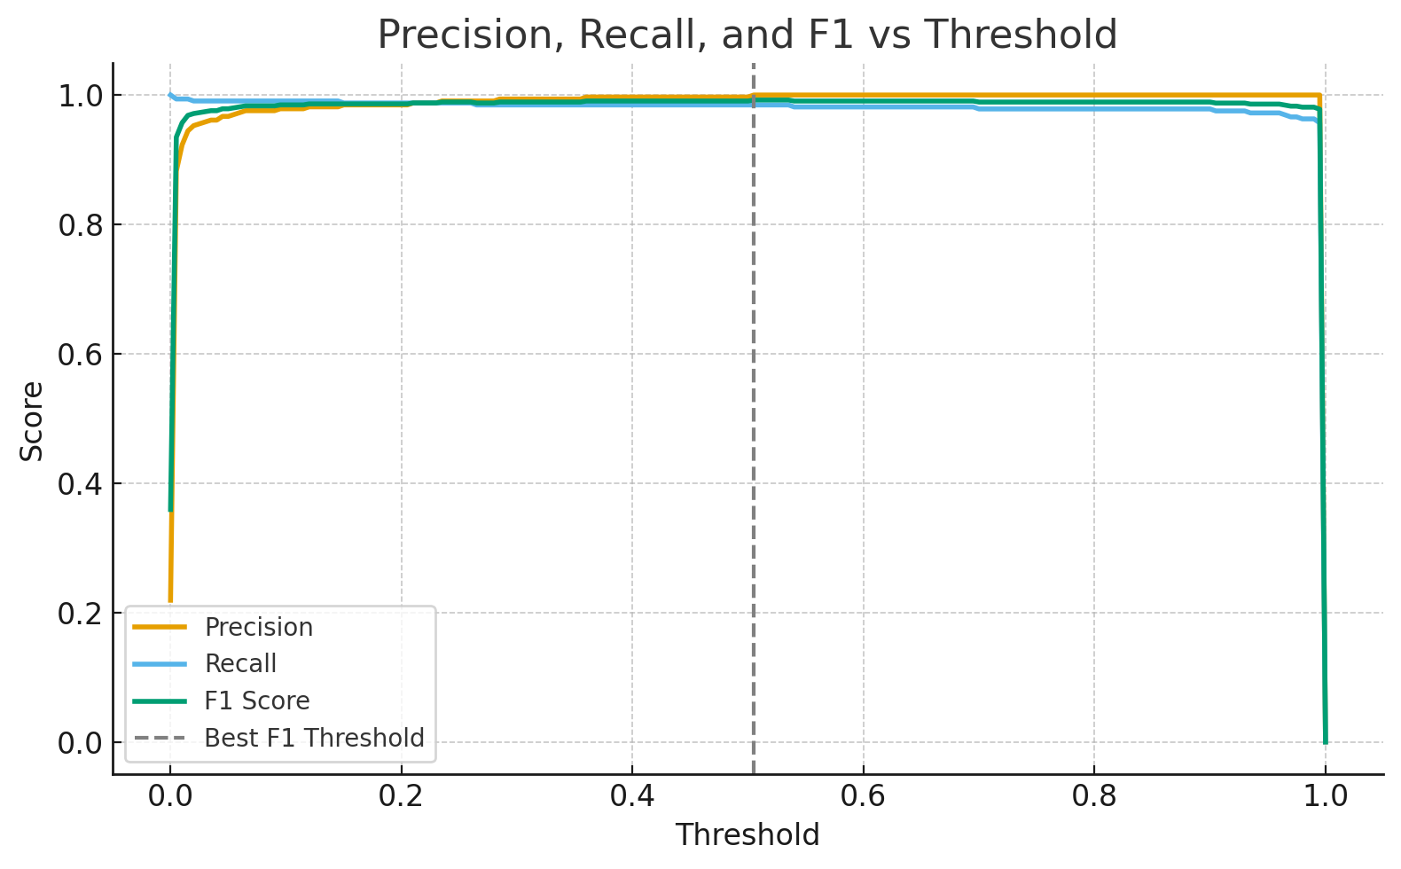
This chart shows how performance metrics change as the decision threshold varies.
- Precision (orange): The proportion of retrieved passages that were actually relevant.
- Recall (blue): The proportion of relevant passages successfully retrieved.
- F1 Score (green): The harmonic mean of precision and recall, balancing both.
- The dashed vertical line marks the optimal threshold (~0.505), where F1 = 0.992.
Interpretation:
The model achieves exceptionally high precision and recall simultaneously, indicating excellent discrimination between relevant and non-relevant passages. The flat plateau shows stable behavior, good generalization and low overfitting.

The model demonstrates an excellent ability to distinguish between passages that are relevant and those that are not. Both precision (how often the model is correct when it predicts relevance) and recall (how many truly relevant passages it successfully identifies) are very high at the same time.
The flat region near the top of the curve indicates that the model maintains strong performance across a broad range of threshold values rather than depending on one very specific setting. This stability means the model’s effectiveness is not fragile or overly sensitive to parameter changes. In practical terms, this suggests that the model has learned the general patterns in the training data rather than memorizing them, which reflects good generalization and low overfitting.

- Accuracy vs. Threshold
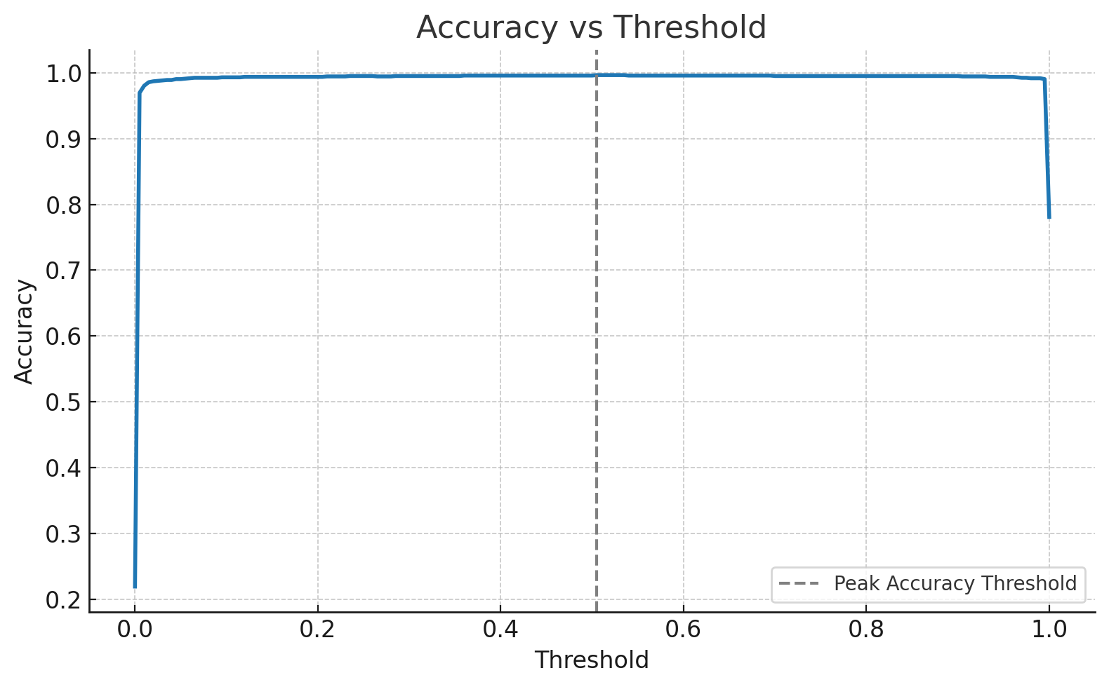
Accuracy (overall proportion of correct predictions) peaks around 0.997, confirming that nearly all classification decisions (positive or negative) are correct.
Interpretation:
High accuracy aligns with the F1 behavior, but F1 is preferred since the dataset is imbalanced (325 positives vs. 1159 negatives). F1 better reflects balanced quality.
The accuracy curve shows that the model correctly classifies nearly all examples, reaching an overall accuracy of about 0.997. However, since the dataset contains many more negative examples than positive ones (325 positives vs. 1,159 negatives), accuracy alone can give a misleading impression of success. A model could achieve high accuracy simply by predicting “not relevant” most of the time.
For this reason, F1 score is a better indicator of balanced performance. The F1 metric combines both precision and recall, ensuring that the model is not only avoiding mistakes but also successfully identifying relevant passages. In this case, the F1 score of 0.992 at a threshold of 0.505 confirms that the model’s high accuracy is meaningful and well balanced, not an artifact of data imbalance.

- Confusion Matrix Components vs. Threshold
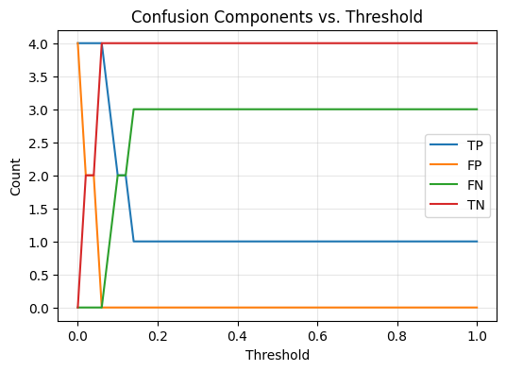
This chart plots raw counts of true positives (TP), false positives (FP), false negatives (FN), and true negatives (TN).
The confusion matrix visualization shows how the counts of correct and incorrect classifications change as the decision threshold is adjusted.
As the threshold increases, the model becomes more conservative. It only marks passages as relevant when it is more confident. This causes the number of false positives to drop sharply, meaning the model makes fewer incorrect “relevant” predictions. At the same time, the number of true positives remains stable across a broad range of thresholds, showing that the model continues to identify nearly all of the genuinely relevant items even while being more selective.
This pattern indicates that the model is well-calibrated: it understands when to trust its predictions and when to hold back. In practical terms, this means the model delivers consistently reliable results without needing to trade off between precision and recall. This is a hallmark of a mature and robust reranker.

Qualitative Validation
Beyond quantitative measures we also judge the experience qualitatively of chatting.
Qualitative Evaluation Criteria
Qualitative analysis was used to judge the model by how it feels, behaves, and responds. i.e. by perceived quality, clarity, and appropriateness.
Here are the key dimensions:
Answer Relevance: Does the bot actually answer the user's question? Does it stay on topic or wander? Does it retrieve context that matches the query? How RAG vs. no RAG differ: RAG model is more on-target because he uses BM25 → reranking → summarization; the Baseline model will sometimes drift or give generic advice. This is usually the first and most important qualitative metric.
What to do if a riot breaks out in the street?
Rex + Survival Data (RAG) BM25 + reranker | Model only (no RAG) Baseline
If a riot breaks out in the street, here’s what you should do: -  **Stay Calm and Assess**: Quickly assess the situation from a safe distance to understand the nature of the crowd's actions.  - **Avoid Direct Interaction**: If possible, stay away from the conflict area. Crowds can be unpredictable; staying back reduces your risk.  - **Seek Safety**: Move towards well-lit areas with fewer people or find shelter in buildings if you are near one. Avoid enclosed spaces that could become targets for looters.  - **Follow Official Guidance**: Listen to local authorities and follow their instructions, such as evacuation orders or safe routes.  - **Use Personal Protective Equipment (PPE)**: If you must go out, wear protective clothing like a mask, gloves, and sturdy shoes if available. Consider carrying pepper spray or other non-lethal deterrents for self-defense.  - **Stay Informed**: Keep an eye on local news channels or social media updates to stay informed about the situation’s progression. Remember, your safety is paramount in such situations. Avoid becoming a target by staying out of harm's way and following official guidance. | If you encounter a riot while outside:  1. **Stay Calm and Assess**: Quickly assess your surroundings.  2. **Avoid Eye Contact**: Do not engage or provoke others.  3. **Move Away Safely**: If possible, move away from the area calmly.  4. **Seek Shelter**: Go to a safe location like indoors if nearby.  5. **Follow Police Instructions**: Listen to and follow any instructions given by law enforcement.  6. **Stay Informed**: Use your phone or local news for updates but keep it brief.  Remember, safety is paramount. Avoid confrontations and stay informed of the situation.

Conciseness and Clarity: Are the responses short, understandable, and non-repetitive? Do they avoid rambling or unnecessary details? RAG is: not more concise, but this is forgivable since the RAG model delivers more relevant info total. RAG model is however, more structured. The No RAG model may give more “chatty” or sometimes verbose generalities.
Grounding in Retrieved Context: Does the answer appear to pull from realistic survival knowledge? Does it incorporate specific steps, techniques, or tools that match the PDFs? RAG should: reference concrete skills (boiling water, building shelters, making fire signals, etc.), reflect fragments of real manuals. No RAG often: hallucinates more, gives general “common sense” advice rather than artifact-based knowledge.
How to fish in ice?
Rex + Survival Data (RAG) BM25 + reranker | Model only (no RAG) Baseline
Fishing in ice can be an effective way to catch fish during winter months. Here are key steps and tips:  - **Safety First**: Always ensure the ice is thick enough (at least 4 inches) before venturing onto it. Use a spud bar or auger to test thickness by drilling holes.  - **Making Holes**:  - Use an ice spud to chip out a hole, ensuring water is reached.  - The hole should be about 12-14 inches in diameter for larger fish like trout and bass.  - **Removing Ice**: After making the initial hole, use an ice skimmer or scraper to remove excess ice around your fishing spot. This keeps the hole open longer.  - **Fishing Gear**:  - Use a hand line if you don’t have specialized equipment.  - Make hooks from available materials like wire or fish bones if necessary.  - **Bait**: Common baits include cow’s udder, hog’s liver, angle worms, and raw meat. Some suggest adding scents like assafetida, sweet cicily, or anise to attract more fish.  - **Tip-Ups**: These are useful for hands-free fishing. You can make simple tip-ups using a stick with a line attached that triggers when the fish bites.  - **Locate Fish**: Look for areas where water flows under ice (like streams), as these spots often hold fish.  Remember, patience is key in winter fishing. The slower pace of metabolism means fish are less active and more difficult to catch compared to warmer months. Always carry a first aid kit and stay warm with layers while out on the ice. | Yes, fishing through ice is popular, especially during winter months when lakes and ponds freeze over. It requires specific equipment like an auger or ice chisel to make holes, insulated boots, and a heated seat. Fish species vary by location but include trout, perch, and northern pike. Safety measures are crucial, including checking ice thickness and carrying safety gear.

Specificity and Technical Detail: Are answers practical? Do they convey survival techniques instead of vague commentary? Is the detail at the right level for a beginner? RAG reranking pipeline produces answers like: “Boil water for one minute or use two drops of household bleach per liter.” No RAG might say: “Ensure your water is purified before drinking.” Specificity equals higher perceived expertise.
Tone and Readability: Does the bot sound helpful? Does it maintain a calm, instructional tone appropriate for survival situations? Is it respectful and professional? RAG: More stable, consistent, methodical. No RAG: More casual and sometimes inconsistent.
Tactical Accuracy: (Survival Knowledge Sanity Check) Does the advice make sense? Is it logically consistent, even if not medically perfect? Does it avoid dangerous hallucinations? Examples of good answers: “Create a three-signal pattern with whistles or fires.”, “Use a ferro rod or dry tinder like birch bark.” Examples of bad answers: “Drink seawater in small amounts to stay hydrated.”, “Signal aircraft by waving reflective objects directly at them.” (extremely dangerous) The RAG model should have fewer high-risk hallucinations because reranking keeps him grounded in actual manuals.
What to do in case of hyperinflation?
Rex + Survival Data (RAG) BM25 + reranker | Model only (no RAG) Baseline
Hyperinflation can be a challenging situation to navigate, but there are several practical steps you can take:  1. **Store Non-Perishable Items**: Stock up on non-perishable food items like canned goods, dried fruits, and nuts that have long shelf lives.  2. **Build Local Resilience**:  - Grow your own food if possible.  - Learn basic gardening skills to ensure a steady supply of fresh produce.  - Raise small animals for meat or eggs.  3. **Cash in Hand**: Keep some cash on hand, as digital transactions may become unreliable during hyperinflation. However, be cautious with large amounts due to the risk of theft and loss of value over time.  4. **Barter System**: Develop a bartering system within your community using goods that retain their value or are essential for survival (e.g., tools, seeds).  5. **Invest in Tangibles**:  - Consider investing in gold, silver, or other precious metals as they tend to hold their value.  - Invest in land if possible; owning physical property can provide a buffer against economic instability.  6. **Emergency Preparedness Kit**: Prepare an emergency kit that includes essential items like water, food, medical supplies, and tools for basic survival needs.  7. **Learn Basic Skills**:  - Acquire skills such as first aid, gardening, and basic carpentry to be self-sufficient.  - Learn how to start a fire and purify water in case of emergencies.  8. **Stay Informed**: Keep up-to-date with local economic news and trends so you can make informed decisions about your financial situation.  By focusing on these areas, you can build resilience against the effects of hyperinflation and maintain stability during uncertain times. | To address hyperinflation, consider these steps: 1. **Strengthen Fiscal Discipline**: Reduce government spending and increase revenue collection. 2. **Monetary Policy Adjustments**: Central banks can raise interest rates or reduce money supply growth. 3. **Exchange Rate Management**: Allow the currency to depreciate if fixed exchange rate is causing issues. 4. **Price Controls with Caution**: Temporarily use price controls but avoid long-term distortions. 5. **Economic Reforms**: Promote trade, investment, and productivity improvements. 6. **Social Safety Nets**: Implement measures to protect vulnerable populations from inflation's effects. Combining these strategies can help stabilize the economy and reduce hyperinflation effectively.

Latency and Flow of Chat Experience: How fast do the bots respond? Are they smooth, or do they feel slow, stuck, or jittery? Does the streaming feel natural? Even though latency is partially technical, the experience itself is qualitative: Does it feel snappy? Does it feel responsive? Does it feel like a real assistant? The RAG model is slightly slower but they are comparable in performance.
Context Preservation Across Messages: Does the bot remember what you just said? Does it stay consistent during multi-step questioning? Neither bot has persistent memory (unless you add it), but: RAG often “threads” better because his answer is based on structured retrieval. No RAG may occasionally ask redundant clarifications.
Safety, Risk Awareness, and Disclaimers: Does the bot avoid giving extreme or unsafe instructions? Does it offer options or suggest caution? RAG often produces: “Only attempt this if conditions are safe.” No RAG sometimes offers: “Cut the rope in a pinch,” even if that’s risky or lacks context.
How to counter airborne drones?
Rex + Survival Data (RAG) BM25 + reranker | Model only (no RAG) Baseline
Countering airborne drones can be approached from several angles depending on the situation and resources available.  1. **Physical Barriers:** - Set up physical barriers like nets or fences to prevent small drones from entering a specific area. - Use balloons with weights attached, which can disrupt drone flight paths due to air resistance.  2. **Electronic Countermeasures (ECM):** - Consider using jamming devices that interfere with the drone's control signals and GPS navigation. - Employ simple DIY solutions like reflective surfaces or noise makers to confuse drones.  3. **Legal and Permits:** - Check local regulations regarding drone usage and countermeasures, as some ECMs may require permits or could be illegal in certain areas.  4. **Human Intervention:** - Train individuals on basic techniques for spotting and manually interfering with drones if they pose a threat. - Use simple tools like nets to physically capture small drones.  5. **Environmental Awareness:** - Be aware of the drone's operational limitations, such as battery life or signal strength, which can be exploited in certain conditions.  6. **Topographic Operations Insight (for large-scale operations):** - While primarily for military use, understanding terrain and setting up obstacles can help in creating areas where drones have difficulty operating. Remember, the best approach often involves a combination of these methods tailored to your specific situation and resources.  Always prioritize safety and legal compliance when implementing any countermeasures. | To counter airborne drones effectively, consider these strategies:  1. **Detection Systems**: Use radar and acoustic sensors to detect drone activity.  2. **Jamming Devices**: Employ radio frequency jammers to disrupt communication between the drone and its controller.  3. **Physical Obstacles**: Set up barriers or nets in sensitive areas like airports.  4. **Anti-Radiation Missiles**: Deploy these for more serious threats, targeting drones directly.  5. **Counter-UAS Software**: Utilize software solutions that can identify and track drones.  For a tailored solution, consult with security experts to assess specific risks and environments.

“Feel” of Expertise: This is a general perception test. Does the bot feel like a survival instructor? Rex, when working correctly, has an overall “expert voice” due to the RAG grounding. The No RAG model sounds more like a general-purpose chatbot.
Qualitatively, the RAG model demonstrated stronger relevance, specificity, and grounding due to its BM25 + reranker pipeline. RAG model answers felt more like structured survival instructions rather than general commentary. No RAG model provided acceptable baseline answers but exhibited occasional drift, verbosity, and weaker contextual grounding.

Part D – User Guide / Documentation / Quick-Start Guide
Note: If for any reason during grading my website is not up or the Telegram bot is not responsive you can call or text me at 972.824.2147 anytime and I will reboot the server, troubleshoot etc. I have thoroughly tested and developed these for 100% uptime but I am available any time as an administrator for evaluators.
- Model Comparison Demo Website: https://river-uncomplying-unidealistically.ngrok-free.dev/
Enter your query or use one of the three example buttons. Click the “Ask Rex” button and see the RAG and No RAG model outputs in their respective panels. The RAG panel has another panel under it displaying the dataset sources. You should see that the RAG model has far superior quality to the baseline off the shelf Ollama model. (Note that the RAG model served to this website is the same RAD model served to Rex the Apocalypse Bot on Telegram) (Ngrok, n.d.)
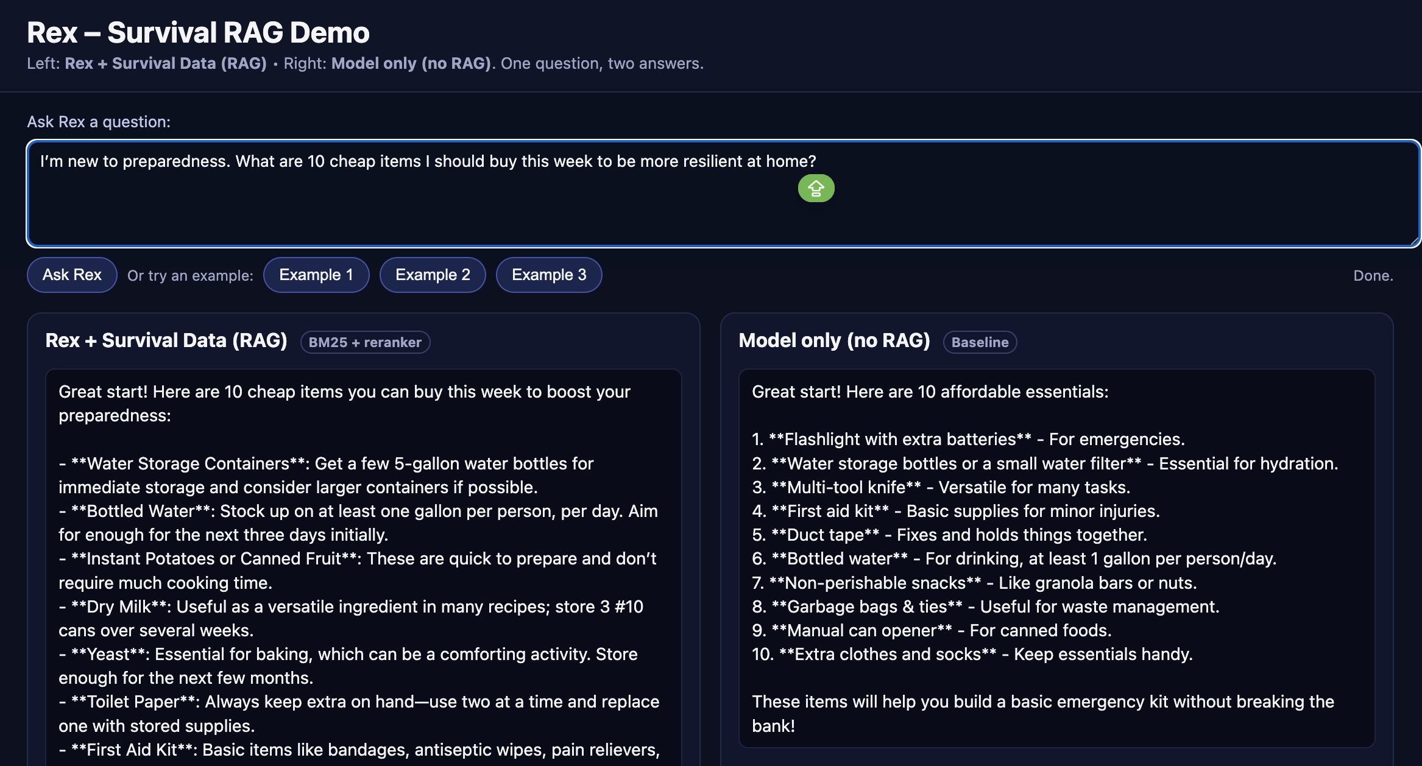

2. Running the Colab Notebook (Model Verification)
Purpose:
To demonstrate that the machine-learning component (CrossEncoder reranker) trains, saves, and produces metrics and visualizations successfully. It is a small demonstrative lean prototype version of my full training code, and creates a light weight checkpoint suitable for grading and demonstration purposes. Such a small dataset and model will not make for a very coherent conversationalist, but the Colab format is a very convenient and elegant way to see the ML algorithm design and workflow all in one document and the evaluator is not burdened with having to set up an environment. (Colaboratory, n.d.)
Steps
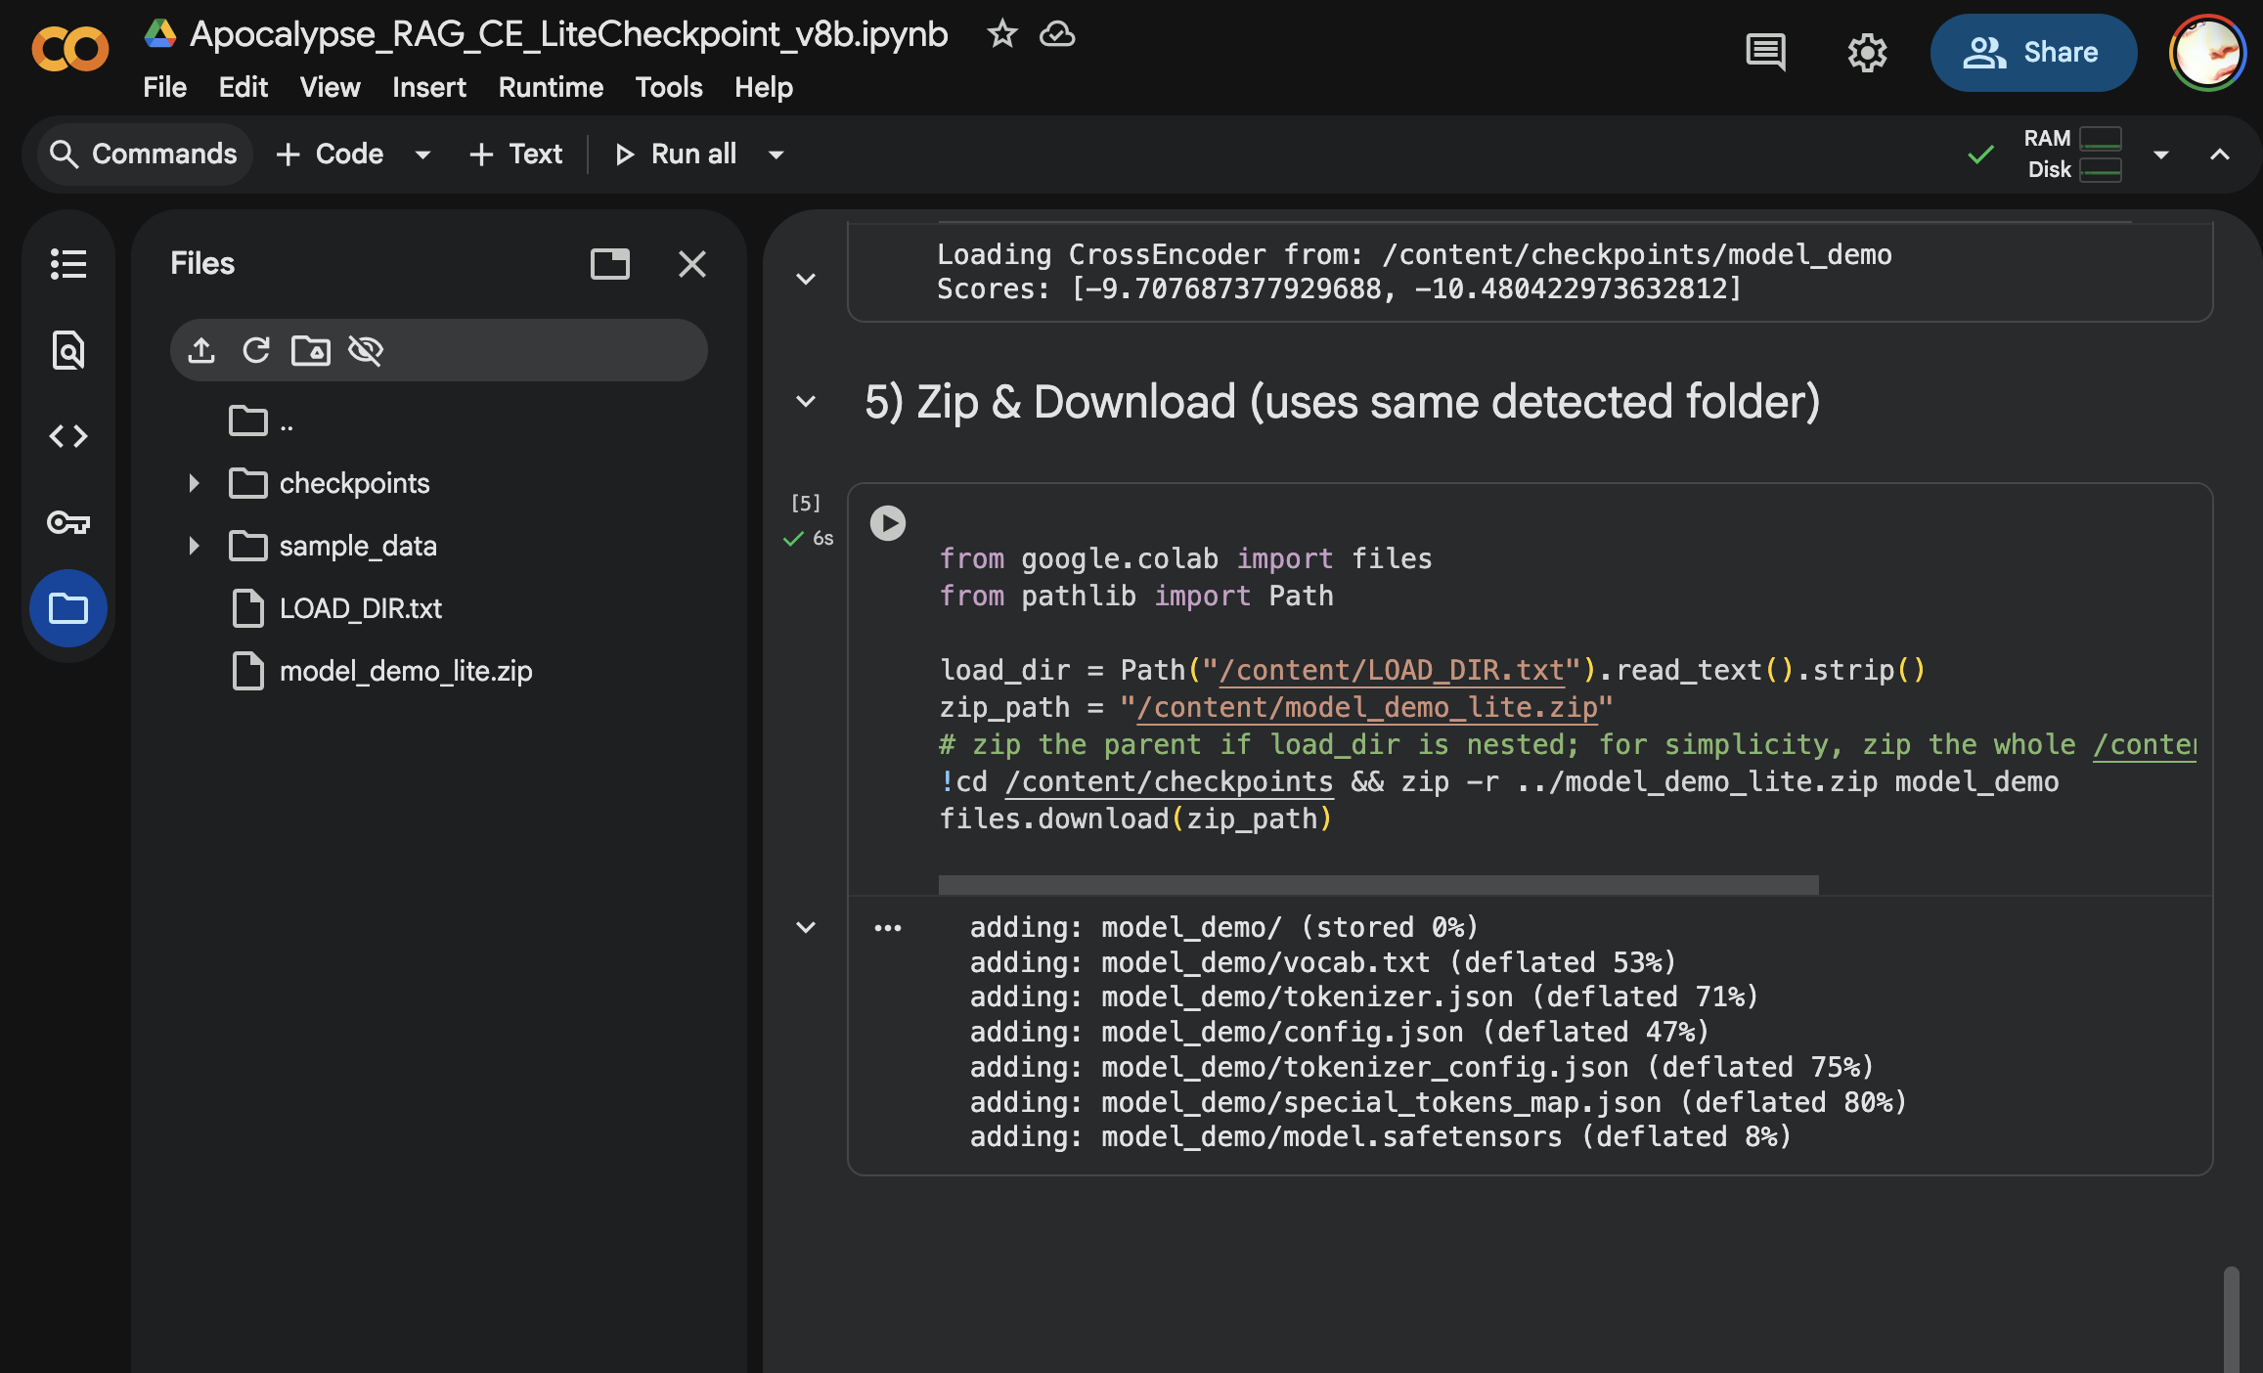
- Open the notebook
Apocalypse RAG — Lite Demo Checkpoint (v9)

- Connect runtime
  - In Colab’s top menu, select Runtime → Change runtime type
  - Ensure Hardware accelerator = None (CPU)
- Run all cells
  - Choose Runtime → Run all
  - Execution takes approximately 3–5 minutes on CPU.
  - The notebook will:
    - Build a small synthetic dataset
    - Train a CrossEncoder for one epoch
    - Save model files to /content/checkpoints/model_demo
    - Reload and verify the checkpoint
    - Generate three visualizations:
      - F1-Score vs Threshold
      - Accuracy vs Threshold
      - TP/FP Trade-off Curve
- Confirm Model Artifact
  - At the end, model_demo_lite.zip is generated and a download dialog appears.
  - You may inspect it to verify presence of:
config.json
  - pytorch_model.bin
  - tokenizer.json
  - vocab.txt

- Interpret Result: The visualizations demonstrate that the model learns meaningful distinctions between relevant and irrelevant passages, achieving high F1 and accuracy.
7. Test with the interactive chat terminal
The provided notebook includes an optional interactive chat interface that allows the evaluator to test the Retrieval-Augmented Generation (RAG) system directly within Google Colab, without using external dependencies, servers, or localhost access.
This interface appears as a simple terminal-style chat loop at the end of the notebook. It uses the trained CrossEncoder reranker, the BM25 index, and either Ollama (if configured) or TinyLlama fallback generation to provide live responses based on the dataset used in the project.
How to Use the Chat Interface
- Scroll to the final section of the notebook labeled “Interactive Chat Terminal (RAG Demo)”.
- Run the cell. After a brief initialization, a prompt will appear: (Type in the field after “You:”)
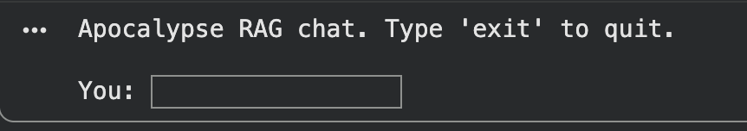
Type any survival-related question (e.g., “How do I purify water in the wilderness?”, “How to make a lean to?”, “What medicine for a bug out bag?”) and press Enter.
(If the cell hangs and you are not able to get your text field to appear you can refresh the page and Run All cells)
The system will:
- Retrieve relevant document snippets from the indexed corpus
- Rerank them using the trained CrossEncoder
- Generate a concise, context-grounded answer
- Display both the answer and the top reranked document titles for transparency
Continue entering questions for as long as desired.
Type exit or quit to return control to the notebook.
Example Interaction
You: How do I signal for help without electronics?

Bot: Use visual and auditory signals that can be seen or heard from long distances...
Top contexts:
[1] score=0.842 Field Signaling Techniques
[2] score=0.731 Emergency Communication Basics

This REPL-style interface ensures that the evaluator can validate the functionality of the final model directly within the notebook, using only the provided files and without relying on external services. Please keep in mind the RAG and LLM are made intentionally very tiny so that they can be hosted on Google Colab. The Telegram Chatbots will have far superior quality.

3. Testing the Telegram Chatbots (User Interface Demonstration)
Purpose:
To demonstrate the functional user interface and real-world deployment of the model on social media. Your everyday prepper is going to be doom-scrolling on social media while they drink their coffee, Telegram is the perfect place to meet them. (Telegram Messenger LLP, n.d.)
- Install Telegram (desktop or mobile). You can chat with Rex on either your cell phone or your desktop. The content will be the same regardless. You will need to link your phone to the desktop application, so it may be fewer steps to just chat with Rex on your phone if you are comfortable doing so.
- MANDATORY PHONE NUMBER: you must sign up with a working phone number that can receive a text message. The website and Colab should be enough to demonstrate the model and ML Pipeline if the evaluators cannot use a cell phone to complete the grading, as the model served to Rex the Telegram bot is the same model served to the Website Demo in step 1. Plenty of screencaps in this document should suffice to demonstrate the user experience in that scenario. This is a complete ML project and demo even without the Telegram chatbot, but the social media experience is what will drive customers toward decision making and purchase.
  - Windows download: https://desktop.telegram.org
  - Click the “Get Telegram for Windowsx64” button

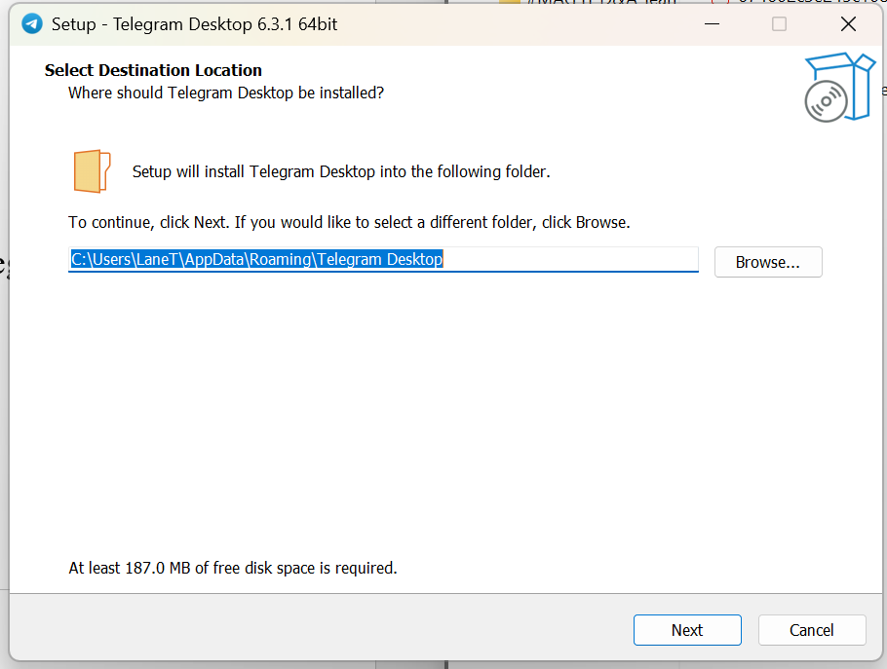
  - 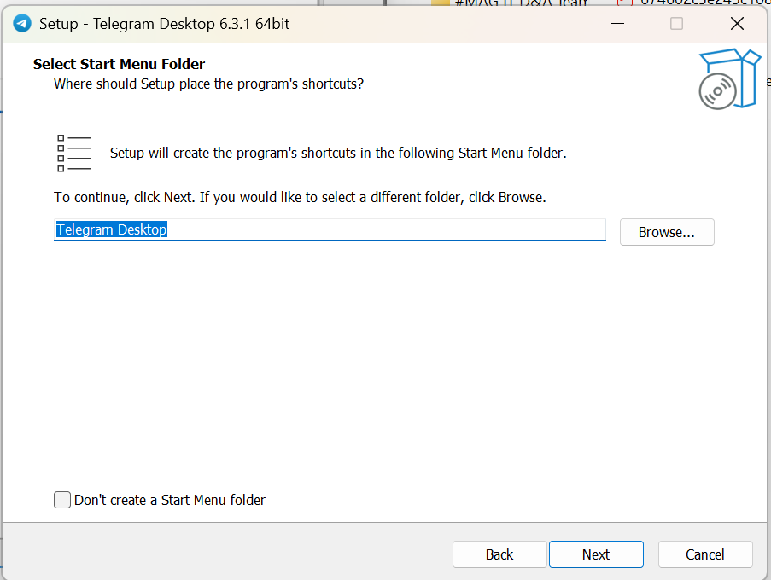
  - 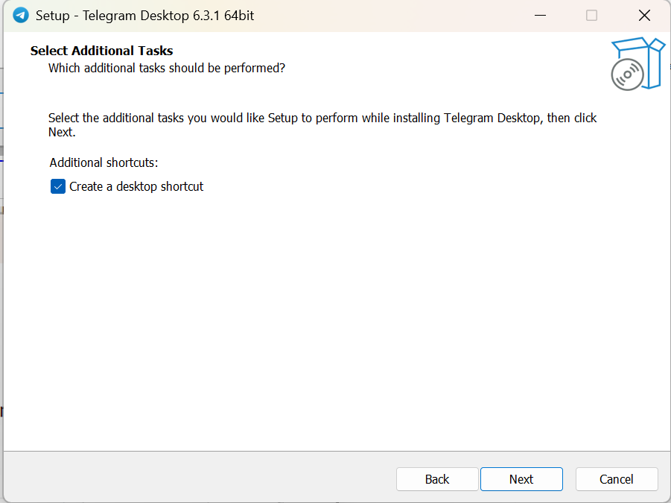
  - 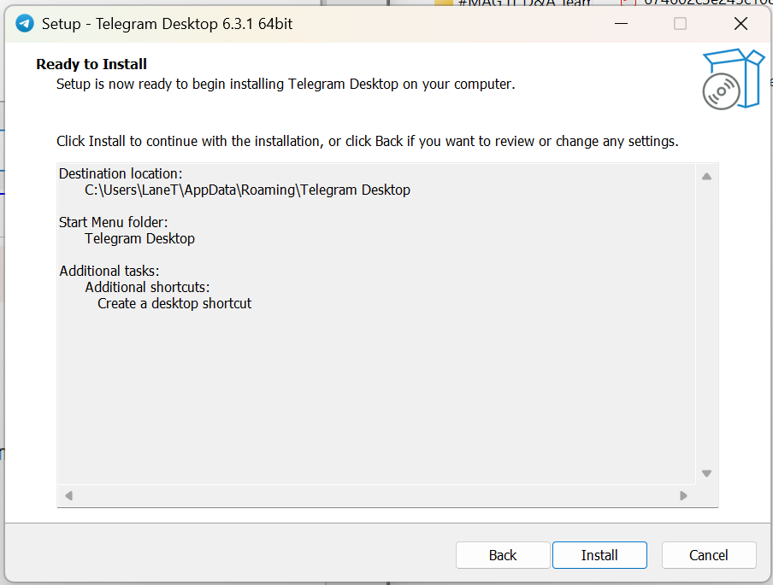
  - 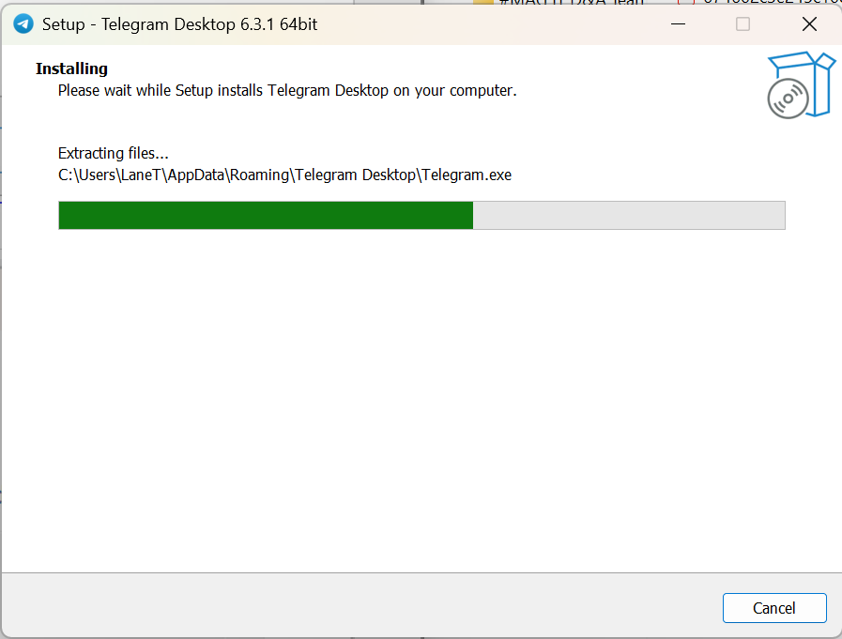
  - 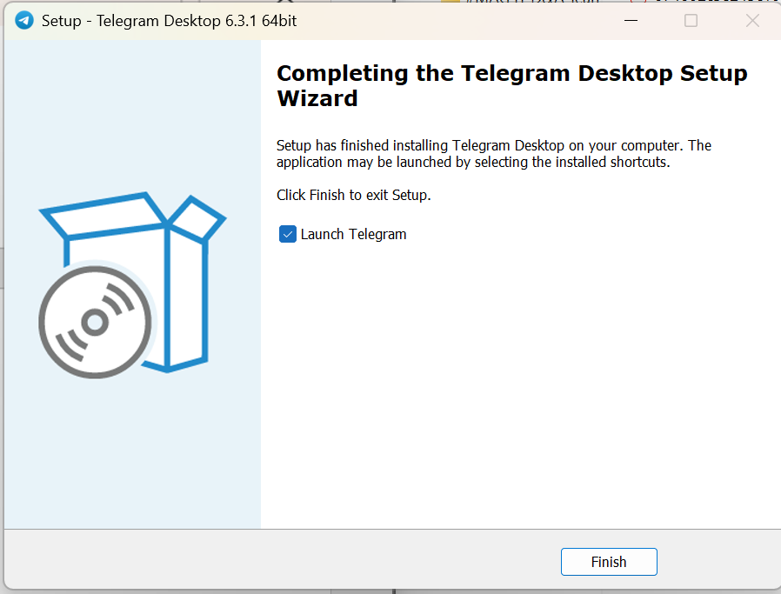
  - 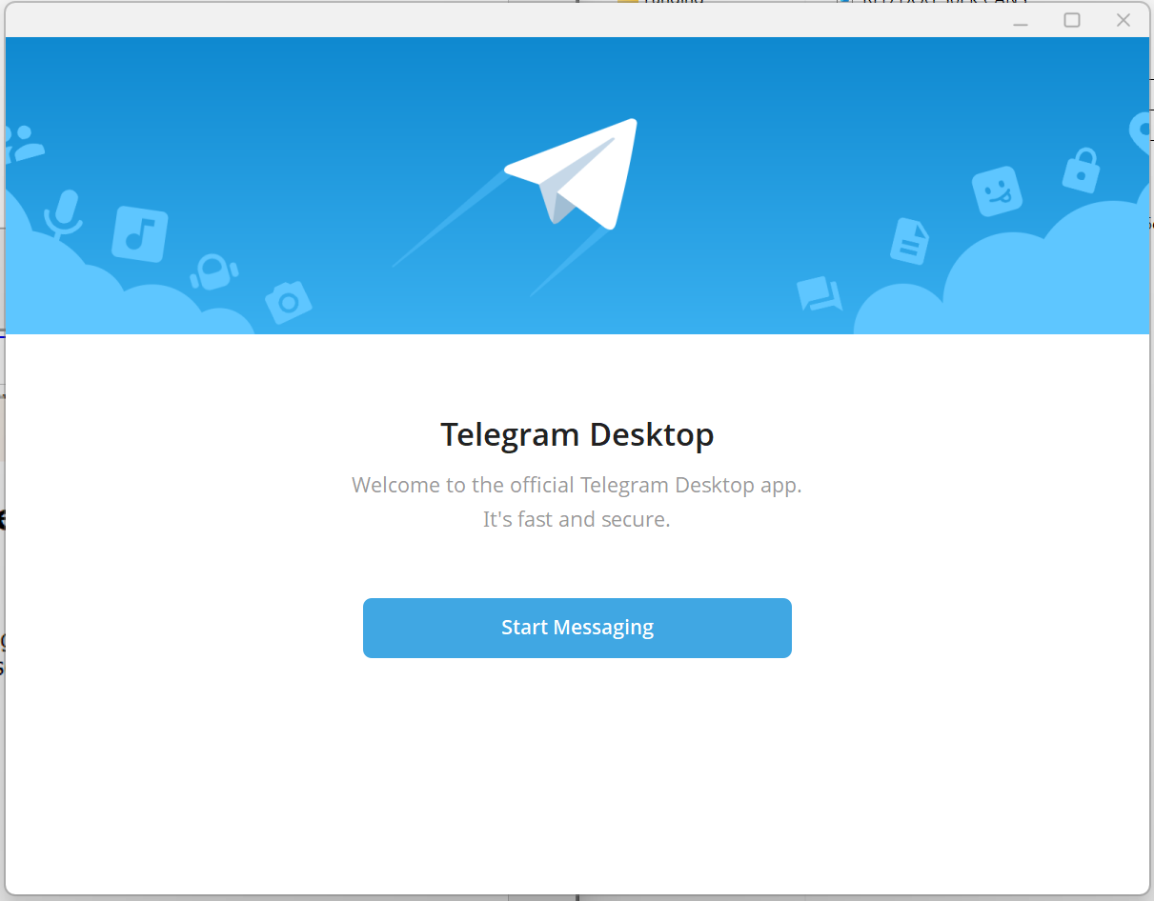
Install Telegram on your mobile phone. It is available on both Android and IOS through their respective app stores. You will create an account using your phone number on your mobile and then you can take a picture of the QR code below or use the “log in using your phone number” link shown below.
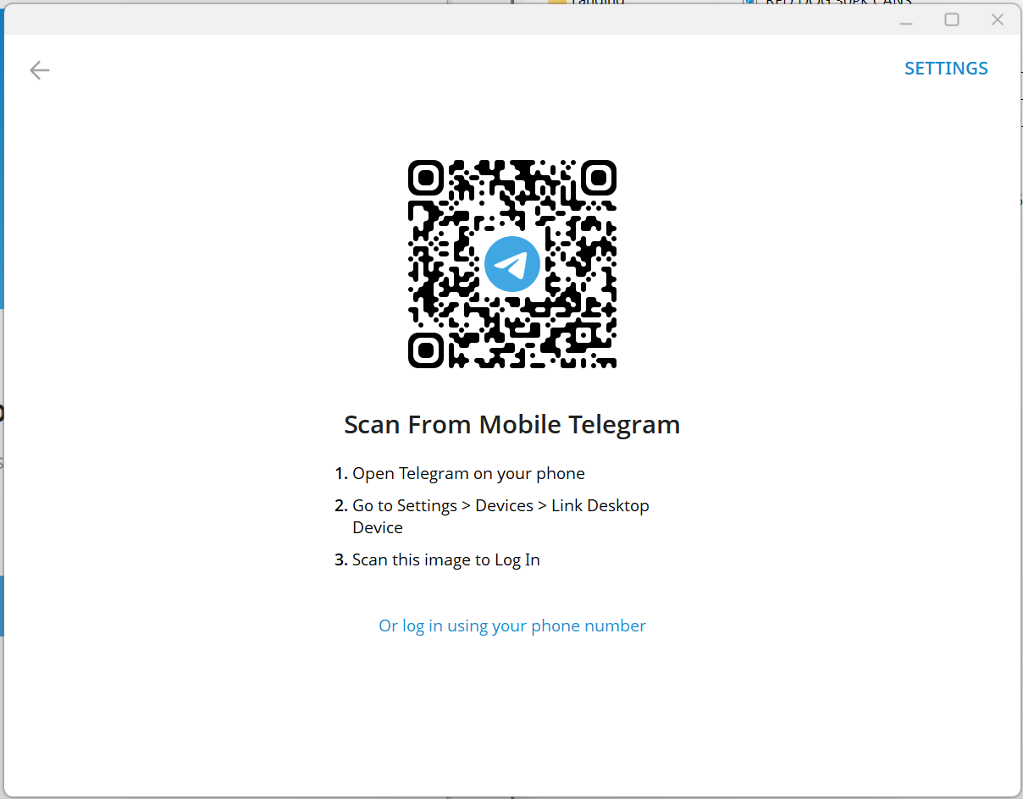
Once you have created an account using your phone number you can open the left side menu and scroll down until you see “Devices”


See below where “Devices” is in the list
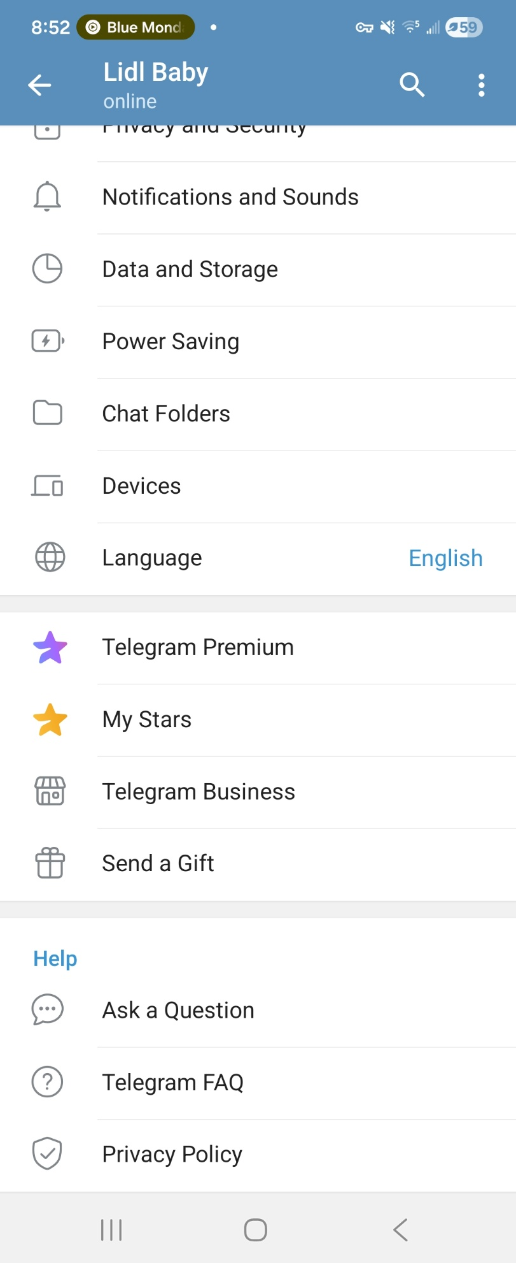

On the Devices page click the “Link Desktop Device” button.
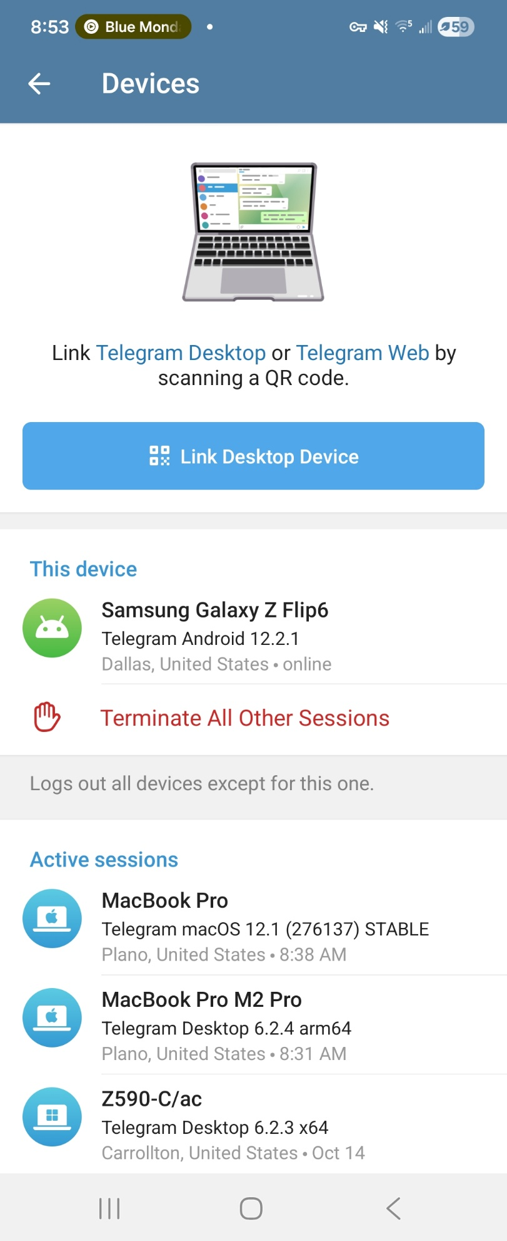

You will be given a photography interface that will automatically capture the QR code on your desktop screen on sight. Your devices will then be linked.


Your Telegram application will look something like this, but you will not have any conversations open yet.
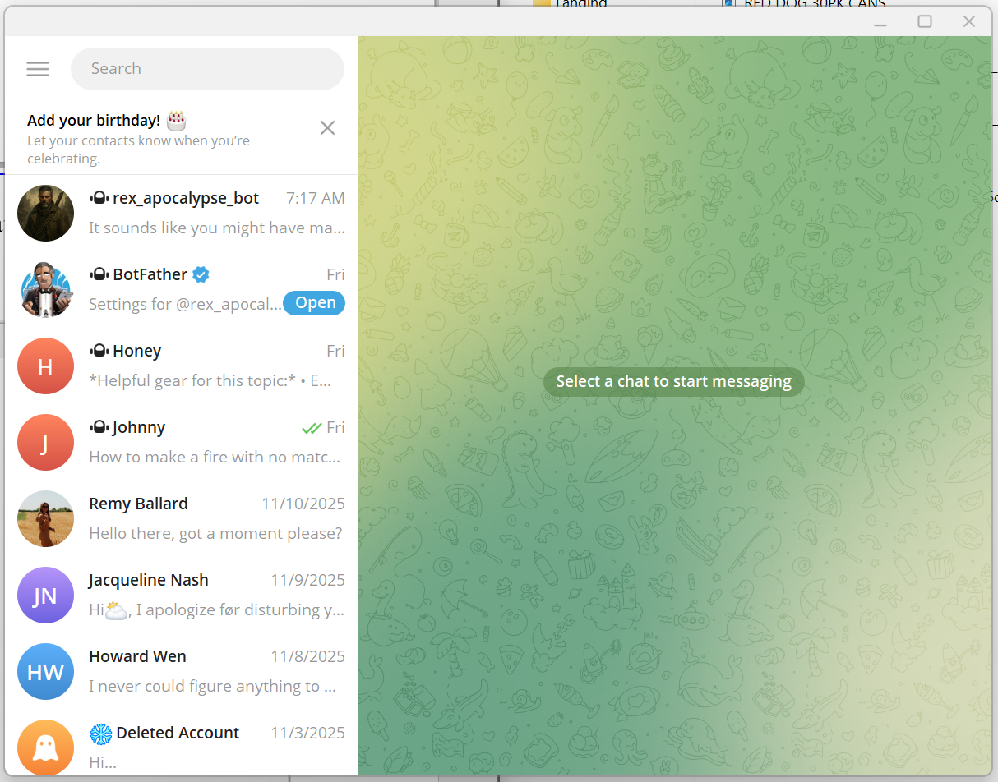

Open Rex the Apocalypse bot:
Click the link to open Rex in Telegram desktop or your web browser: @rex_apocalypse_bot
- Interact
  - Tap START BOT to initialize the bot.
  - 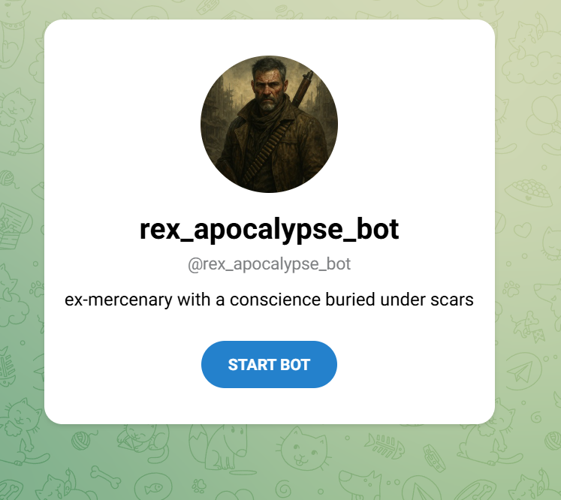
  - Type any question related to survival, for example:
    - “How can I purify water in the wilderness?”
    - “What foods last longest without refrigeration?”
    - “How to make fire with no matches?”
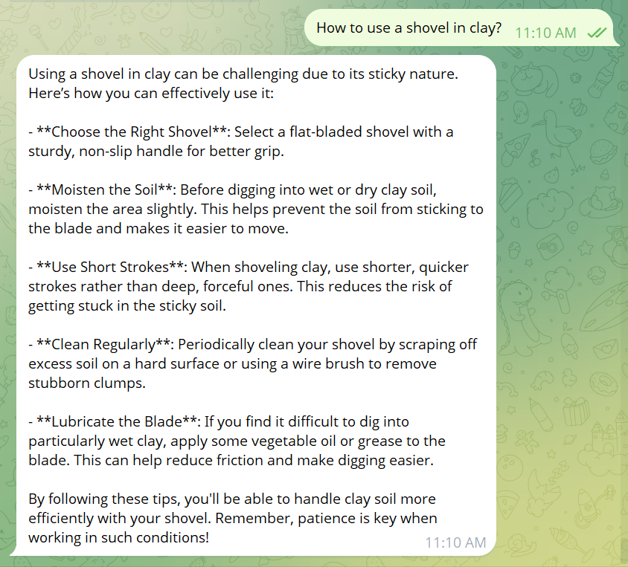
  - Observe responses:
  - Use the /norag to flag to see the baseline model with no RAG
  - 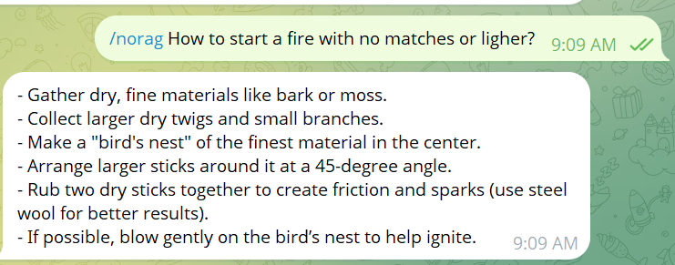
  - Use /rag_debug to see sources from the RAG dataset when served from the RAG model
  - 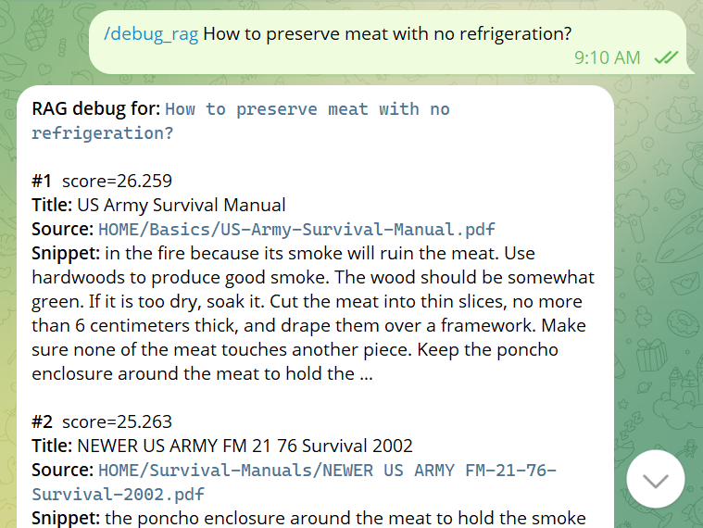

4. Software / Library Requirements
Category | Requirement | Notes
Environment | Google Colab or Jupyter Notebook | Browser-based; no local install required
Python Version | 3.10 or 3.11 | Preinstalled in Colab
Libraries | torch, transformers, sentence-transformers, rank-bm25, matplotlib | Installed automatically
Telegram App | Windows, Mac, iOS, or Android Telegram client | Used for chatbot interaction
Internet Access | Required | To load repos and run live model calls

5. Support and Reproduction: Source Links
- Reranker Full Training Repo: github.com/sitting-duck/apocalypse-mommy-llm-supervised-trainer
- Telegram Bot Repo: github.com/sitting-duck/telegram-chatbot-hosting-linux-endpoint
(also hosts the river-uncomplying-unidealistically.ngrok-free.dev/ web demo)
- Corpus Dataset: github.com/PR0M3TH3AN/Survival-Data
- Colab Demo: Apocalypse RAG Lite Checkpoint Notebook

Reference Page
Colaboratory. (n.d.). Google Colab. Google. https://colab.research.google.com/
FastAPI. (n.d.). FastAPI: Modern, fast (high-performance), web framework for building APIs with Python 3.6+. Tiangolo. https://fastapi.tiangolo.com/
Matplotlib Developers. (n.d.). Matplotlib: Visualization with Python. https://matplotlib.org/
Ngrok. (n.d.). Ngrok secure introspectable tunnels to localhost. https://ngrok.com/
Telegram Messenger LLP. (n.d.). Telegram messenger. https://telegram.org/
Uvicorn. (n.d.). Uvicorn: Lightning-fast ASGI server implementation, using uvloop and httptools. https://uvicorn.dev/
PR0M3TH3AN. (n.d.). Survival-Data [Data set]. GitHub. https://github.com/PR0M3TH3AN/Survival-Data

