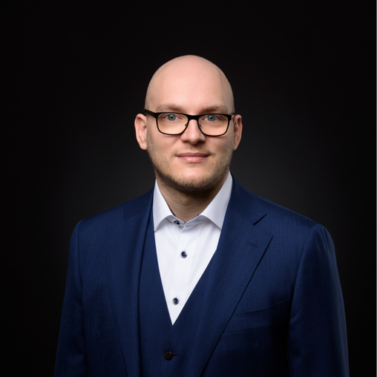
${appliedPosition}
${name} ${i_as_of} ${applicationDate}

${i_introduction}

${i_firstname}: ${firstname}
${i_lastname}: ${lastname}
${i_dob}: ${dob}
${i_age}: ${age} Jahre
${i_nationality}: ${nationality}
${i_residence}: Erfurt

${i_profile}

${selfDescription}

${i_skills}

${i_langs_title}:
${i_langs_text}
${list_skills_tbl}
${skill_category}
${skill_name} |  | ${skill_years}

${/list_skills_tbl}

${i_experience}

${i_projects}

${list_positions}
${position_company}
${i_projects_position}: ${position_position}
${i_projects_technologies}: ${position_technologies}
${i_projects_period}: ${position_startDate} – ${position_endDate}
${i_projects_description}: ${position_description}

${/list_positions}

${i_life_journey}

${i_career}

${career_title} | ${career_description} | ${career_date}

${i_education}

${edu_title} | ${edu_description} | ${edu_date}

${i_contact}

${i_phone}: 0162 93 52 510
${i_email}: richard@integralworq.com

