目录

系统环境 2

安装部署 3

安装lustre服务端 3

客户端lustre安装 6

附件 6

# 系统环境

|  |  |  |  |
| --- | --- | --- | --- |
| 系统 | 角色 | IP地址&hostname | 硬件配置 |
| CentOS Linux release 7.3.1611 | 存储服务端，客户端 | 192.168.179.140 node03 | 内存8GB，4核，50+20GB存储 |
| Ubuntu 16.04.3 | 客户端 | 192.168.179.141 node01 | 内存4GB，4核，20GB存储 |
| CentOS Linux release 7.3.1611 | 客户端 | 192.168.179.134 node02 | 内存8GB，4核，50+20GB存储 |
| Lustre 2.10.4 | X | X | X |

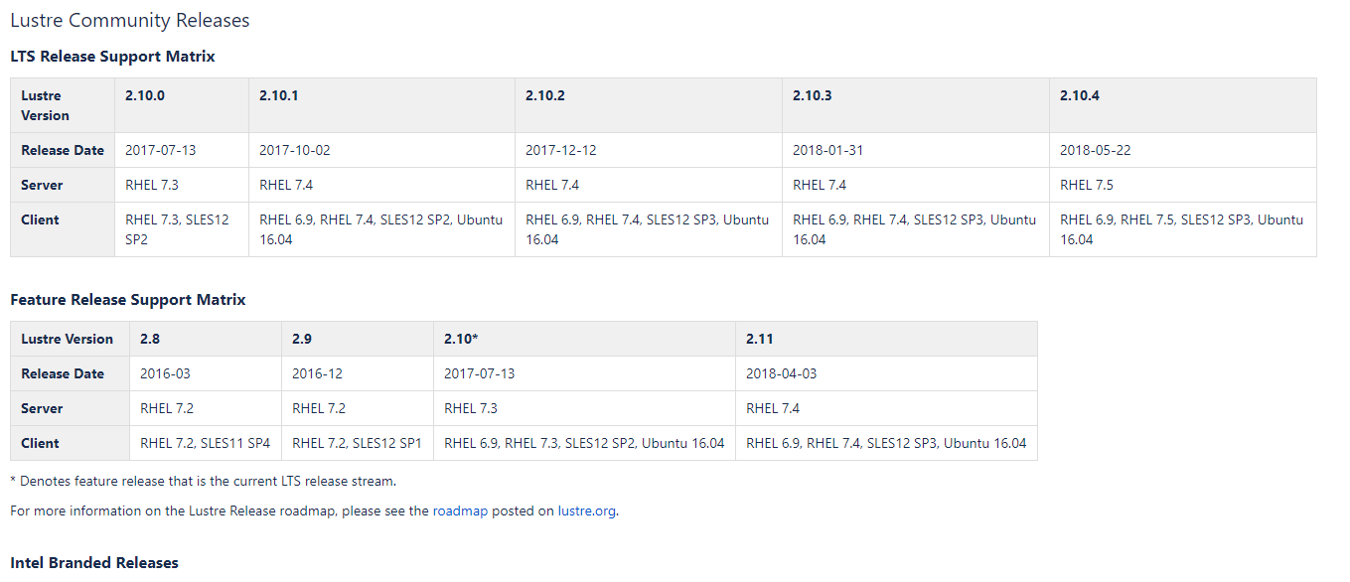

下载地址：https://downloads.whamcloud.com/public/

1. 时间同步
   1. ntpd,过程简单，略
2. 无密访问配置
   1. ssh-keygen,过程简单，略
3. 关闭防火墙、selinux

# 安装部署

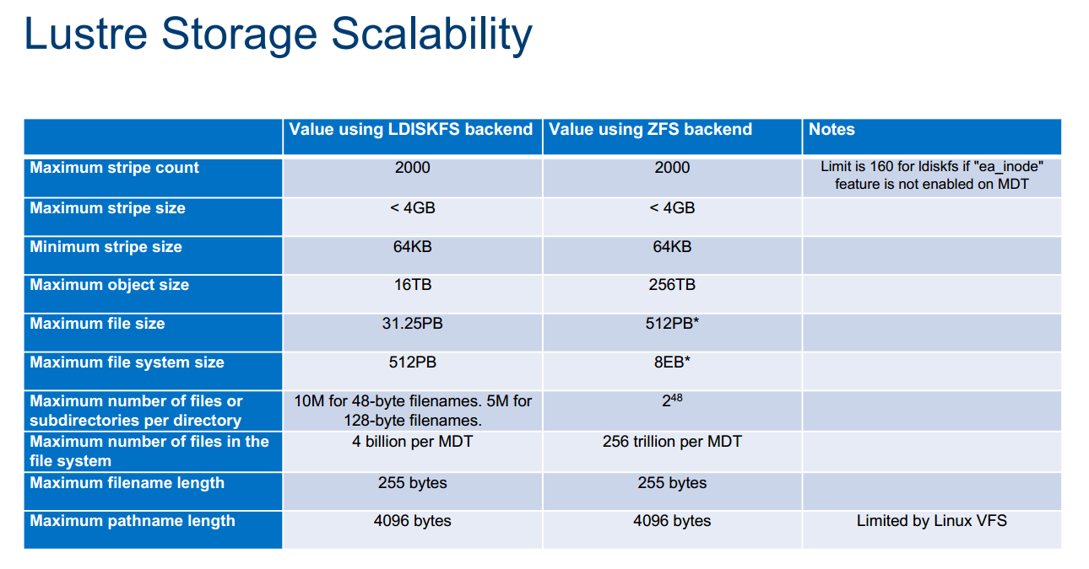

OpenZFS、DKMS

## 安装lustre服务端

|  |
| --- |
| yum install \  asciidoc audit-libs-devel automake bc \  binutils-devel bison device-mapper-devel elfutils-devel \  elfutils-libelf-devel expect flex gcc gcc-c++ git \  glib2 glib2-devel hmaccalc keyutils-libs-devel krb5-devel ksh \  libattr-devel libblkid-devel libselinux-devel libtool \  libuuid-devel libyaml-devel lsscsi make ncurses-devel \  net-snmp-devel net-tools newt-devel numactl-devel \  parted patchutils pciutils-devel perl-ExtUtils-Embed \  pesign python-devel redhat-rpm-config rpm-build systemd-devel \  tcl tcl-devel tk tk-devel wget xmlto yum-utils zlib-devel  #1.安装lustre依赖的系统内核  yum install \  kernel-3.10.0-862.2.3.el7_lustre.x86_64.rpm \  kernel-devel-3.10.0-862.2.3.el7_lustre.x86_64.rpm \  kernel-headers-3.10.0-862.2.3.el7_lustre.x86_64.rpm \  dracut-033-535.el7.x86_64.rpm dracut-config-rescue-033-535.el7.x86_64.rpm \  dracut-network-033-535.el7.x86_64.rpm linux-firmware-20180220-62.2.git6d51311.el7_5.noarch.rpm \  kexec-tools-2.0.15-13.el7.x86_64.rpm  #  yum install kernel-tools-3.10.0-862.2.3.el7_lustre.x86_64.rpm \  kernel-tools-libs-3.10.0-862.2.3.el7_lustre.x86_64.rpm \  kernel-tools-libs-devel-3.10.0-862.2.3.el7_lustre.x86_64.rpm \  kernel-tools-debuginfo-3.10.0-862.2.3.el7_lustre.x86_64.rpm \  kernel-debuginfo-common-x86_64-3.10.0-862.2.3.el7_lustre.x86_64.rpm  #重启机器  shutdown -r now  #2.安装e2fsprogs  yum install e2fsprogs-1.42.13.wc6-7.el7.x86_64.rpm \  e2fsprogs-debuginfo-1.42.13.wc6-7.el7.x86_64.rpm \  e2fsprogs-devel-1.42.13.wc6-7.el7.x86_64.rpm \  e2fsprogs-libs-1.42.13.wc6-7.el7.x86_64.rpm \  e2fsprogs-static-1.42.13.wc6-7.el7.x86_64.rpm \  libcom_err-1.42.13.wc6-7.el7.x86_64.rpm \  libcom_err-devel-1.42.13.wc6-7.el7.x86_64.rpm \  libss-1.42.13.wc6-7.el7.x86_64.rpm libss-devel-1.42.13.wc6-7.el7.x86_64.rpm  #3.安装zfs  yum -y install http://download.zfsonlinux.org/epel/zfs-release.el7_4.noarch.rpm  yum install zfs kmod-lustre-osd-zfs-2.10.4-1.el7.x86_64.rpm -y  yum install spl-0.7.9-1.el7.x86_64.rpm spl-debuginfo-0.7.9-1.el7.x86_64.rpm -y  yum install zfs-debuginfo zfs-dracut zfs-test -y  #4.安装lustre  yum install kmod-lustre-2.10.4-1.el7.x86_64.rpm \  kmod-lustre-osd-ldiskfs-2.10.4-1.el7.x86_64.rpm \  lustre-osd-ldiskfs-mount-2.10.4-1.el7.x86_64.rpm -y  #  yum install \  lustre-2.10.4-1.el7.x86_64.rpm \  lustre-osd-ldiskfs-mount-2.10.4-1.el7.x86_64.rpm \  lustre-resource-agents-2.10.4-1.el7.x86_64.rpm \  lustre-iokit-2.10.4-1.el7.x86_64.rpm \  lustre-tests-2.10.4-1.el7.x86_64.rpm \  kmod-lustre-tests-2.10.4-1.el7.x86_64.rpm -y  #  yum install \  lustre-all-dkms-2.10.4-1.el7.noarch.rpm \  lustre-osd-zfs-mount-2.10.4-1.el7.x86_64.rpm \  zfs-dkms-0.7.9-1.el7.noarch.rpm \  spl-dkms-0.7.9-1.el7.noarch.rpm \  dkms-2.6.1-1.el7.noarch.rpm \  libzfs2-0.7.9-1.el7.x86_64.rpm \  libzpool2-0.7.9-1.el7.x86_64.rpm \  libuutil1-0.7.9-1.el7.x86_64.rpm \  libnvpair1-0.7.9-1.el7.x86_64.rpm \  libzfs2-devel-0.7.9-1.el7.x86_64.rpm -y  #将lustre模块导入内核  modprobe zfs  modprobe lustre  modprobe lnet  modprobe ldiskfs  #查看导入是否成功  lsmod  #硬盘分区以及格式化  ##分区  parted -s /dev/sdb "mkpart primary 0% 20%"  parted -s /dev/sdb "mkpart primary 20% 40%"  parted -s /dev/sdb "mkpart primary 40% 60%"  parted -s /dev/sdb "mkpart primary 60% 80%"  parted -s /dev/sdb "mkpart primary 80% 100%"  ##格式化  mkfs.xfs /dev/sdb1 -f  mkfs.xfs /dev/sdb2 -f  mkfs.xfs /dev/sdb3 -f  #lustre配置  ##MDS  mkfs.lustre --reformat --mgs --backfstype=zfs --fsname=lustre --device-size=1048576 lustre-mgs/mgs /dev/sdb1  ##MDT  mkfs.lustre --reformat --mdt --backfstype=zfs --fsname=lustre --index=0 --mgsnode=node03@tcp --device-size=1048576 lustre-mdt0/mdt0 /dev/sdb2  ##OST  mkfs.lustre --reformat --ost --backfstype=zfs --fsname=lustre --index=0 --mgsnode=node03@tcp --device-size=1048576 lustre-ost0/ost0 /dev/sdb3  ##配置lnet  #/etc/modprobe.d/lustre.conf  options lnet networks="tcp0(ens33)"  ##配置ldev  #/etc/ldev.conf  node03 - mgs zfs:lustre-mgs/mgs  node03 - mdt0 zfs:lustre-mdt0/mdt0  node03 - ost0 zfs:lustre-ost0/ost0  #启动lustre服务  service lustre start  #挂载  mount -t lustre node03:/lustre /mnt/ |

## 客户端lustre安装

|  |
| --- |
| #CentOS7同服务端一样的安装  #挂载  mount -t lustre node03:/lustre /mnt/  #Ubuntu  dpkg -i \  lustre-client-modules-4.4.0-116-generic_2.10.4-1_amd64.deb \  lustre-dev_2.10.4-1_amd64.deb  #挂载  mount -t lustre node03:/lustre /mnt/ |

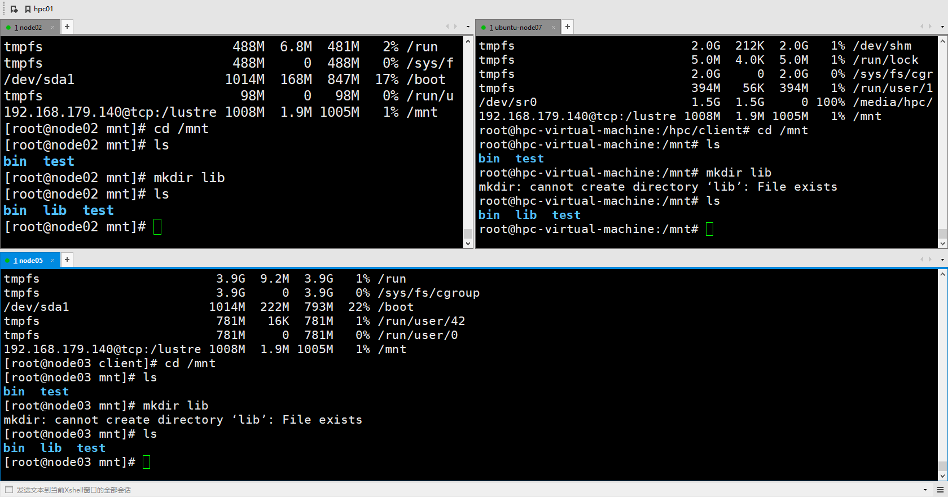

监控

管理

# 

# 附件

<http://wiki.lustre.org/Installing_the_Lustre_Software>

<http://wiki.lustre.org/Lustre_with_ZFS_Install>

<http://cdn.opensfs.org/wp-content/uploads/2017/06/Wed04-BlagodarenkoArtem-Scaling20ldiskfs20for20the20future.20Again.20LUG202017-2.pdf>

<http://wiki.lustre.org/Integrated_Manager_for_Lustre>

<https://github.com/whamcloud/integrated-manager-for-lustre/>

<http://wiki.lustre.org/Lustre_Monitoring_Tool>

<https://github.com/LLNL/lmt>