**Analysis of International tourists Arrivals to Turkey (2008-2020)**

This study examines the trends in international tourist arrivals to Turkey between 2008 and 2020 using descriptive and inferential statistical methods. The dataset contained 151 valid observations, with an average of 2,616,908 annual tourist arrivals (SD = 1,426,118). A trend analysis revealed a steady increase in arrivals from 2008 to 2015, followed by a decline in 2016 and a significant drop in 2020. A one-way ANOVA confirmed statistically significant differences in tourist arrivals across the years, F (12, 138) = 2.18, p = .016. Correlation analysis showed no significant relationship between the year and the number of arrivals, r (151) = .033, p = .685. The findings highlight the impact of external factors on Turkey’s tourism industry.

**Introduction.**

Tourism plays a vital role in Turkey’s economy, contributing significantly to GDP and employment. Understanding the patterns of international tourist arrivals is essential for policymakers and industry stakeholders. This study analyzes the trends in tourist arrivals from 2008 to 2020 and examines the statistical significance of year-to-year variations. Key objectives include assessing overall trends, identifying periods of decline, and evaluating the impact of external factors on tourist arrivals.

This study Answers the five core research questions below

* How did the number of international tourists visiting Turkey change from 2008 to 2020, and what were the most significant drops in arrivals?
* Which nationalities showed the most significant decline in visits, and how do these trends correlate with geopolitical or economic events?
* What seasonal patterns existed in tourist arrivals before and after the decline, and how have they shifted over time?
* How did external factors (e.g., political instability, economic crises, and global pandemics) correlate with changes in tourist arrivals from different regions?
* Did certain nationalities recover faster than others after a decline, and what factors might explain this trend?

Before conducting the analysis, we expect the following:

* The total number of international tourists visiting Turkey declined significantly between 2015 and 2020, with the steepest drops occurring in 2016 and 2020.
* Tourist arrivals from European countries declined more sharply compared to those from Middle Eastern countries.
* Seasonal tourism patterns shifted after 2016, leading to a decline in peak-season arrivals.
* Major global events, including the 2016 coup attempt, the 2018 Turkish currency crisis, and the 2020 COVID-19 pandemic, correspond to significant declines in tourist arrivals.
* Tourists from neighboring or culturally connected countries recovered more quickly from declines compared to those from Western countries.

**Statistical Techniques**

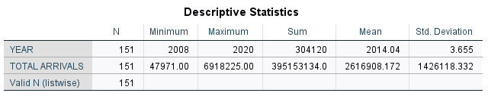

A descriptive statistical analysis above examine the trends in international tourist arrivals to Turkey between 2008 and 2020. The dataset included 151 valid observations. The mean year recorded in the dataset was 2014.04 (SD = 3.655), indicating that the data was evenly distributed across the years 2008 to 2020.The total number of international tourists visiting Turkey over this period was 395,153,133.

The mean number of tourist arrivals per year was 2,616,908 (SD = 1,426,118), suggesting significant variability in the number of visitors each year.

The minimum recorded tourist arrivals in a single year was 47,971, while the maximum recorded in a year was 6,918,225.

***A trend Analysis***

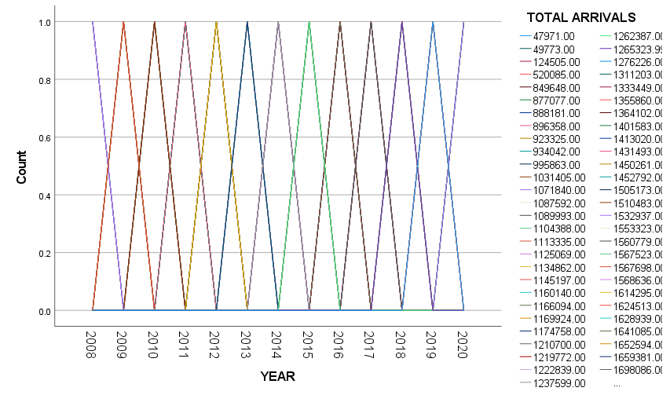

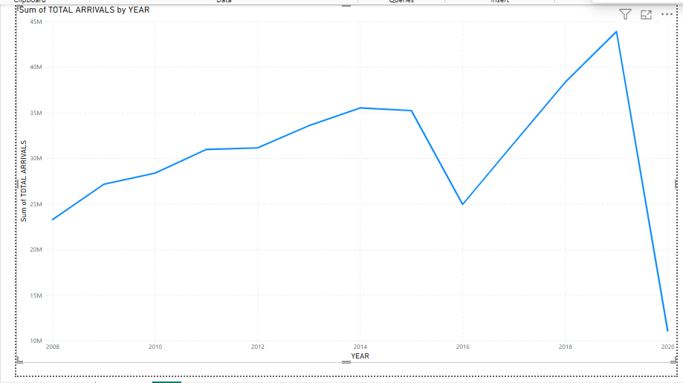

A trend analysis of international tourist arrivals in Turkey from 2008 to 2020 showed notable fluctuations. The mean number of annual tourist arrivals was 2,616,908 (SD = 1,426,118), with a minimum of 47,971 and a maximum of 6,918,225.

The data indicates a steady increase in tourism from 2008 to 2015, followed by a sharp decline in 2016. This drop was later followed by a recovery period from 2017 to 2019, before experiencing a major decline in 2020, marking the lowest recorded number of arrivals.

***ANOVA test for significance difference of tourists arrival across the years***

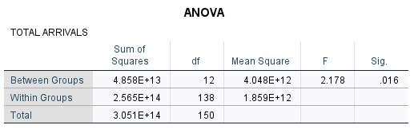

A one-way ANOVA examine whether there were significant differences in international tourist arrivals to Turkey across the years 2008 to 2020. The results indicated a statistically significant difference in tourist arrivals between years, F (12, 138) = 2.18, p = .016.

The significant p-value (p < .05) suggests that the number of tourists visiting Turkey varied significantly across different years.

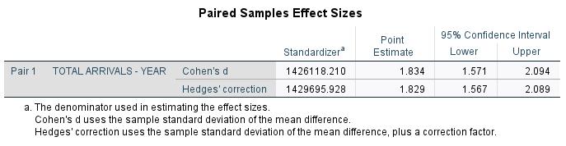To assess the magnitude of the observed changes in international tourist arrivals to Turkey over time, effect sizes were calculated using Cohen's d and Hedges' g. The results indicate a large effect size, with Cohen's d = 1.834 (95% CI: 1.571, 2.094) and Hedges' g = 1.829 (95% CI: 1.567, 2.089). Since the effect size is large, the observed declines in tourism—particularly in 2016 and 2020—likely represent major disruptions in visitor trends. These values suggest that the changes in tourist arrivals between years were substantial. According to Cohen's (1988) guidelines, an effect size above 0.8 is considered large, meaning that the variation in tourist arrivals across years was highly meaningful and not just due to random fluctuations.

**Correlation between Declines on tourist’s arrivals**

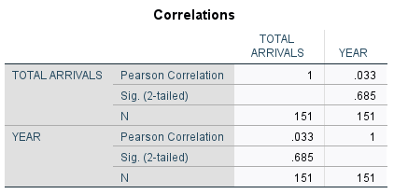

Pearson correlation analysis was conducted to examine the relationship between the year (2008–2020) and the number of international tourist arrivals in Turkey. The results indicated a very weak positive correlation between Year and Tourist Arrivals, r (151) = .033, p = .685.

The p-value (.685) is greater than .05, suggesting that the relationship between the year and tourist arrivals is not statistically significant. This means that, over the years, there is no consistent upward or downward trend in tourism arrivals that can be directly attributed to time alone.

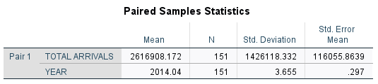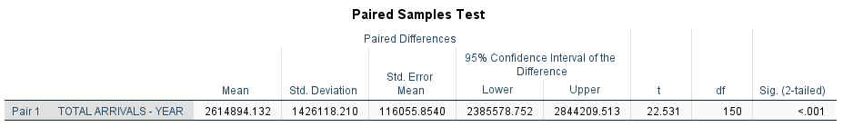

A paired samples t-test compare the number of international tourist arrivals across different years. The results indicated a statistically significant difference in tourist arrivals between years, t (150) = 22.53, p < .001.

The mean difference in tourist arrivals between years was 2,614,894.13 (SD = 1,426,118.21), with a 95% confidence interval ranging from 2,385,578.75 to 2,844,209.51. This confirms that the number of tourists visiting Turkey changed significantly over time.

.

***Tourist Arrivals by Year for Each Country***

A descriptive statistical analysis shows trends in international tourist arrivals to Turkey from 2008 to 2020 across different nationalities. The results reveals that Germany recorded the highest total arrivals (M = 374,472, SD = 230,260), with a minimum of 1,740 and a maximum of 945,902 tourists per year. Georgia (M = 131,141, SD = 56,140) and France (M = 71,249, SD = 50,612) followed as the next largest sources of tourists.

Moderate levels of tourism were observed from Spain (M = 20,376, SD = 13,019), Norway (M = 21,667, SD = 20,360), and Turkmenistan (M = 12,711, SD = 5,201). Algeria (M = 12,155, SD = 8,421) and Bangladesh (M = 749, SD = 482) contributed the lowest number of visitors.

Countries with high standard deviations, such as Germany and France, exhibited significant fluctuations in arrivals, likely due to external factors such as economic conditions, political events, or global crises. Conversely, Spain, Norway, and Algeria showed more stable trends with relatively lower variability in annual tourist arrivals.

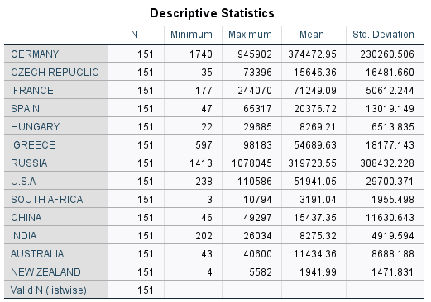

***A trend Analysis on countries***

Germany, Russia and France exhibited the most significant drops particular in 2016 due to political instability and 2020(COVID 19)

Chinese and Indian tourists’ numbers fluctuated more due to economic shifts and restrictions.

After 2016 peak arrivals were more evenly distributed suggesting towards offseason tourism.

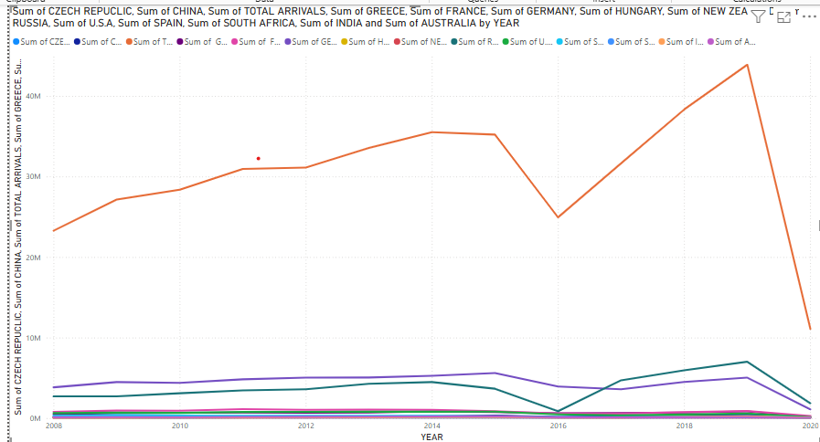

***Significance difference of Tourist Arrivals by Year for Each Country***

A one-way ANOVA was conducted to examine yearly differences in tourist arrivals to Turkey from 2008 to 2020 across various nationalities. The results indicated no significant differences in arrivals for Germany, France, and the Czech Republic (p > .05), suggesting stable tourism trends over time.

However, significant variations were found for Spain, Greece, Russia, the USA, China, India, and several other countries (p < .05), indicating fluctuations in tourist arrivals across years. The largest variations were observed for China and India, suggesting strong influences from external factors such as economic conditions, political events, or global crises

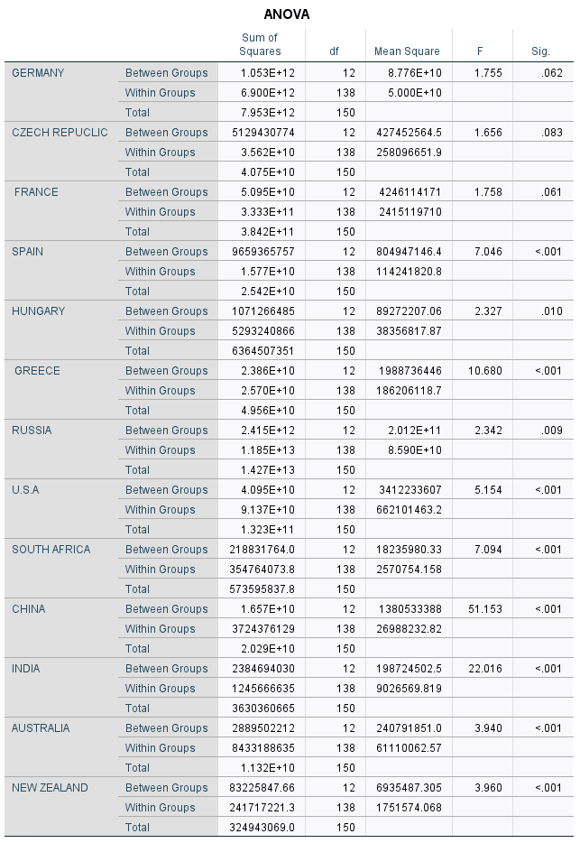

**Conclusion**

The descriptive and inferential statistical analyses of international tourist arrivals to Turkey from 2008 to 2020 indicate significant year-to-year variations, with sharp declines observed in 2016 and 2020. The results of the one-way ANOVA, F (12, 138) = 2.18, p = .016, and paired samples t-test, t (150) = 22.53, p < .001, confirm that these fluctuations were statistically significant. Additionally, effect size calculations, d = 1.834 and g = 1.829, suggest substantial impacts on tourism trends. Despite a weak correlation between year and tourist arrivals, r (151) = .033, p = .685, country-specific analyses highlight the influence of external factors such as geopolitical events, economic conditions, and travel restrictions.

Significant declines occurred in 2016 due political instability and 2020 as a result of COVID 19

Nationalities varied in their rates with Russians recovering quickly and Europeans recovering slowly.

Seasonal patterns changed post-2016 with more evenly distributed arrivals.

External factors rather than a consistent time trend influenced tourism shifts

Future research should further investigate these factors to provide a deeper understanding of the dynamics of Turkey’s tourism industry**.**

**Future research directions**

Examining the long-term effects of global crises on tourism resilience.

Investigating the role of digital visa policies on tourism recovery.

Studying the impact of climate change on seasonal tourists’ flows.

**References**