1. (SELECT)

[SELECT](http://localhost/phpmyadmin/url.php?url=https://dev.mysql.com/doc/refman/8.0/en/select.html) no_antrian, id_customer FROM pendaftaran;

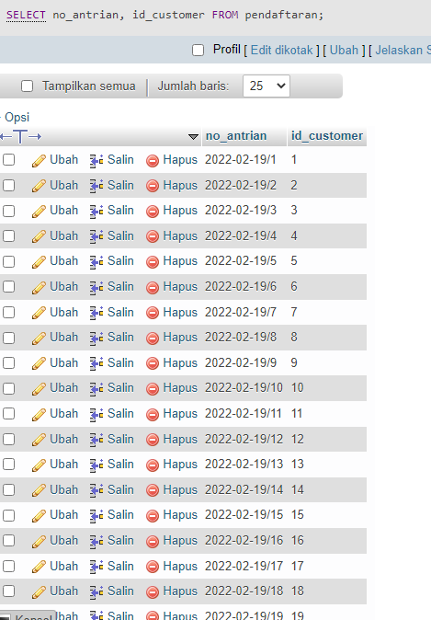

1. ( DISTINCT )

[SELECT](http://localhost/phpmyadmin/url.php?url=https://dev.mysql.com/doc/refman/8.0/en/select.html) DISTINCT alamat FROM customer;

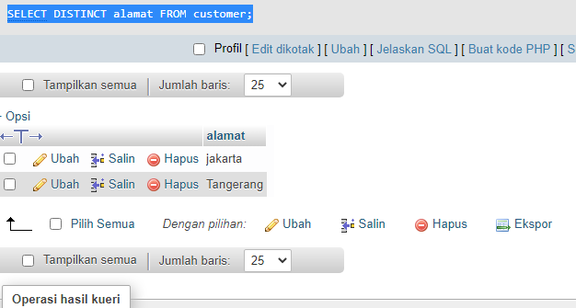

1. ( WHERE )

[SELECT](http://localhost/phpmyadmin/url.php?url=https://dev.mysql.com/doc/refman/8.0/en/select.html) nama, no_hp FROM customer WHERE alamat='jakarta';

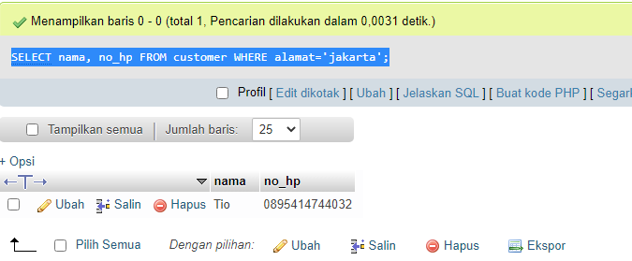

1. ( Sintax AND )

[SELECT](http://localhost/phpmyadmin/url.php?url=https://dev.mysql.com/doc/refman/8.0/en/select.html) nama, no_hp FROM customer WHERE alamat='tangerang' [AND](http://localhost/phpmyadmin/url.php?url=https://dev.mysql.com/doc/refman/8.0/en/logical-operators.html#operator_and) type_mobil='Innova';

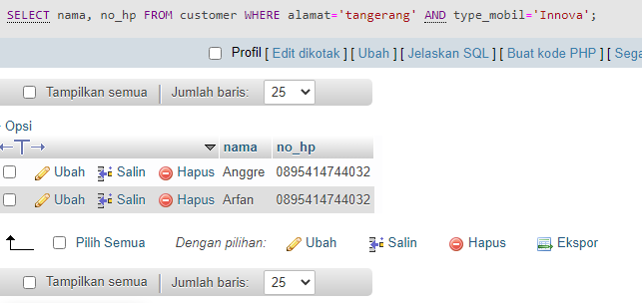

1. ( Sintax OR )

[SELECT](http://localhost/phpmyadmin/url.php?url=https://dev.mysql.com/doc/refman/8.0/en/select.html) nama, no_hp FROM customer WHERE alamat='tangerang' [OR](http://localhost/phpmyadmin/url.php?url=https://dev.mysql.com/doc/refman/8.0/en/logical-operators.html#operator_or) alamat='Jakarta';

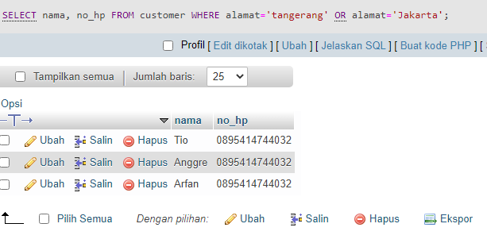

1. ( Sintax NOT )

[SELECT](http://localhost/phpmyadmin/url.php?url=https://dev.mysql.com/doc/refman/8.0/en/select.html) nama, no_hp FROM customer WHERE [NOT](http://localhost/phpmyadmin/url.php?url=https://dev.mysql.com/doc/refman/8.0/en/logical-operators.html#operator_not) alamat='Jakarta';

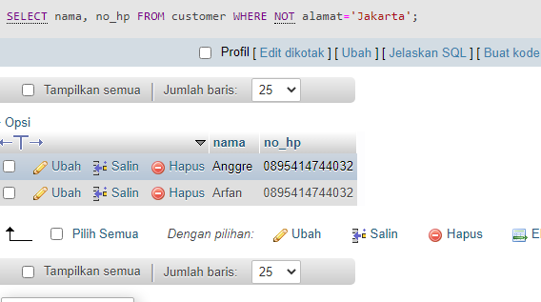

1. ( ORDER BY )

[SELECT](http://localhost/phpmyadmin/url.php?url=https://dev.mysql.com/doc/refman/8.0/en/select.html) no_antrian, id_customer, id_jenis_cucian, tgl_pendaftaran FROM pendaftaran ORDER BY total_biaya DESC;

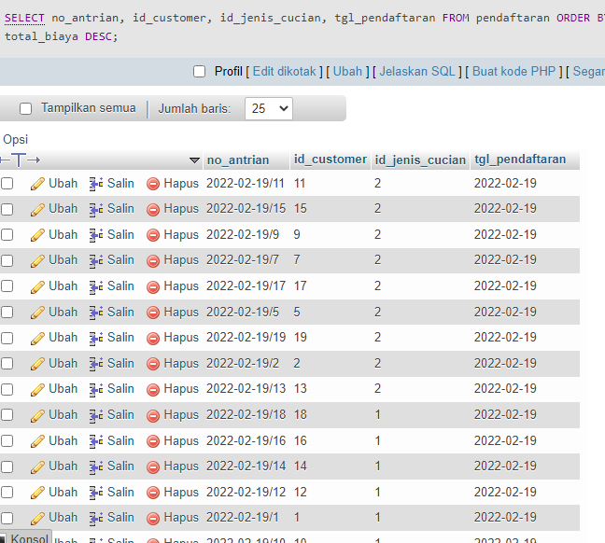

1. ( INSERT INTO )

[INSERT](http://localhost/phpmyadmin/url.php?url=https://dev.mysql.com/doc/refman/8.0/en/insert.html) INTO `customer`(`id_customer`, `nama`, `no_hp`, `alamat`, `nomor_plat`, `type_mobil`) [VALUES](http://localhost/phpmyadmin/url.php?url=https://dev.mysql.com/doc/refman/8.0/en/miscellaneous-functions.html#function_values) ('4','Eni Jumeias','0895414744032','Jakarta','b4544asd','Avanza');

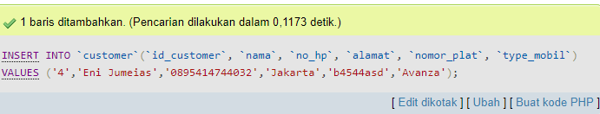

1. ( UPDATE )

[UPDATE](http://localhost/phpmyadmin/url.php?url=https://dev.mysql.com/doc/refman/8.0/en/update.html) `pendaftaran` [SET](http://localhost/phpmyadmin/url.php?url=https://dev.mysql.com/doc/refman/8.0/en/set.html) `id_jenis_cucian`='1', `total_biaya`='35000' WHERE id_pendaftaran ='11';

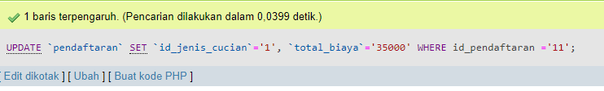

1. ( DELETE )

[DELETE](http://localhost/phpmyadmin/url.php?url=https://dev.mysql.com/doc/refman/8.0/en/delete.html) FROM pendaftaran WHERE id_pendaftaran= '15';

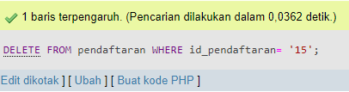

1. ( SELECT MIN() )

[SELECT](http://localhost/phpmyadmin/url.php?url=https://dev.mysql.com/doc/refman/8.0/en/select.html) [MIN](http://localhost/phpmyadmin/url.php?url=https://dev.mysql.com/doc/refman/8.0/en/group-by-functions.html#function_min)(total_biaya) FROM pendaftaran WHERE id_jenis_cucian='2';

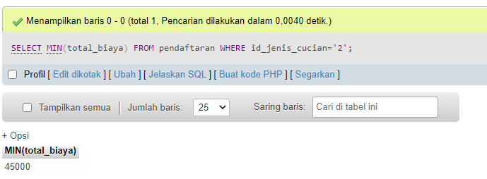

1. ( SELECT MAX() )

[SELECT](http://localhost/phpmyadmin/url.php?url=https://dev.mysql.com/doc/refman/8.0/en/select.html) [MAX](http://localhost/phpmyadmin/url.php?url=https://dev.mysql.com/doc/refman/8.0/en/group-by-functions.html#function_max)(type_mobil) FROM customer WHERE alamat='jakarta';

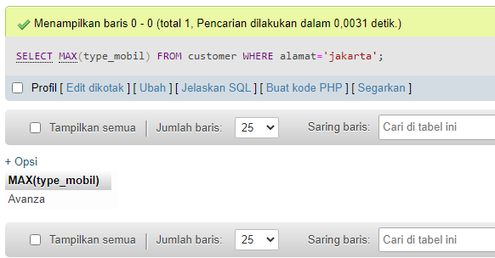

1. ( SELECT COUNT() )

[SELECT](http://localhost/phpmyadmin/url.php?url=https://dev.mysql.com/doc/refman/8.0/en/select.html) [COUNT](http://localhost/phpmyadmin/url.php?url=https://dev.mysql.com/doc/refman/8.0/en/group-by-functions.html#function_count)(id_pendaftaran) FROM pendaftaran WHERE id_jenis_cucian='2';

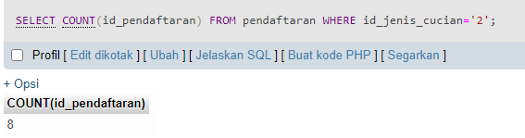

1. ( SELECT AVG() )

[SELECT](http://localhost/phpmyadmin/url.php?url=https://dev.mysql.com/doc/refman/8.0/en/select.html) [AVG](http://localhost/phpmyadmin/url.php?url=https://dev.mysql.com/doc/refman/8.0/en/group-by-functions.html#function_avg)(total_biaya) FROM pendaftaran WHERE id_jenis_cucian='1';

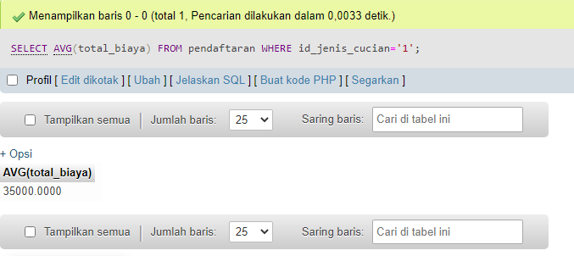

1. ( INNER JOIN )

[SELECT](http://localhost/phpmyadmin/url.php?url=https://dev.mysql.com/doc/refman/8.0/en/select.html) customer.id_customer, pendaftaran.id_customer FROM customer INNER JOIN pendaftaran ON customer.id_customer = pendaftaran.id_customer;

