- (SELECT)
SELECT no_antrian, id_customer FROM pendaftaran;
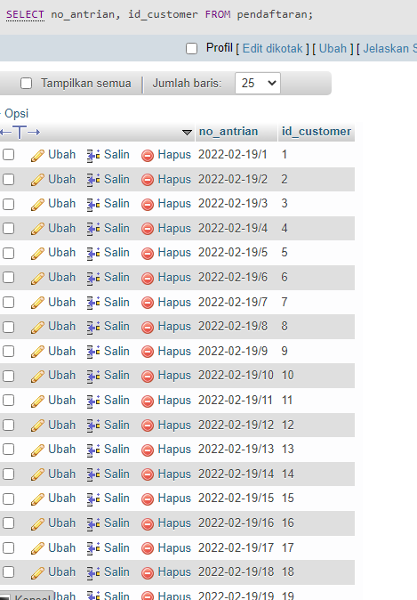

- ( DISTINCT )
SELECT DISTINCT alamat FROM customer;

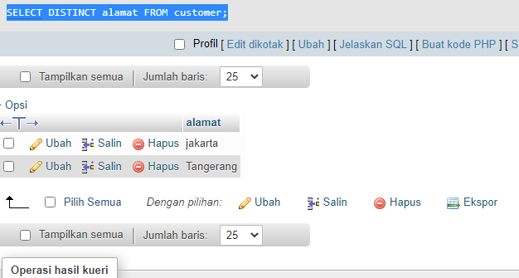

- ( WHERE )
SELECT nama, no_hp FROM customer WHERE alamat='jakarta';
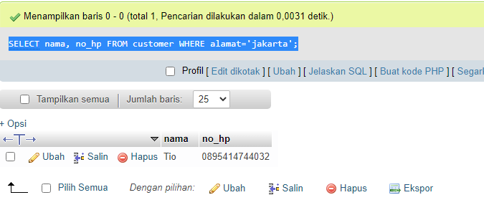

- ( Sintax AND )

SELECT nama, no_hp FROM customer WHERE alamat='tangerang' AND type_mobil='Innova';
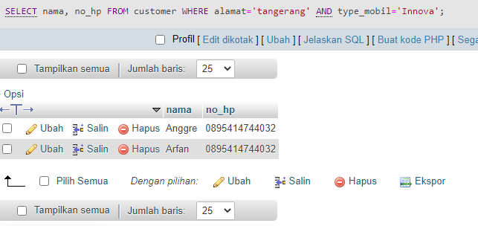

- ( Sintax OR )

SELECT nama, no_hp FROM customer WHERE alamat='tangerang' OR alamat='Jakarta';
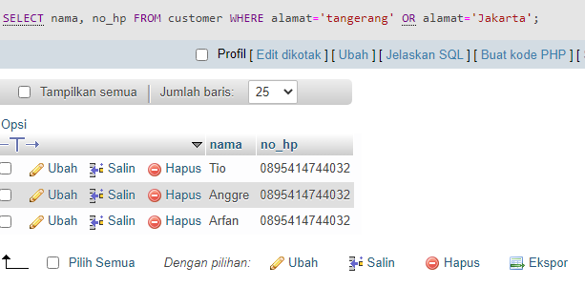

- ( Sintax NOT )
SELECT nama, no_hp FROM customer WHERE NOT alamat='Jakarta';
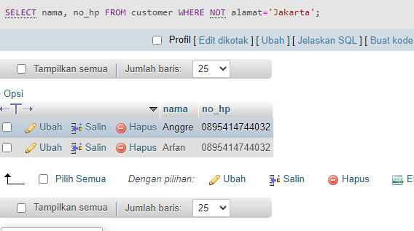

- ( ORDER BY )
SELECT no_antrian, id_customer, id_jenis_cucian, tgl_pendaftaran FROM pendaftaran ORDER BY total_biaya DESC;
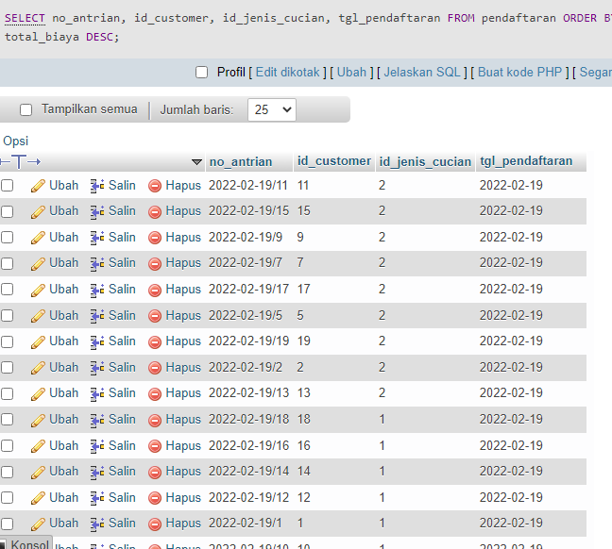

- ( INSERT INTO )
INSERT INTO `customer`(`id_customer`, `nama`, `no_hp`, `alamat`, `nomor_plat`, `type_mobil`) VALUES ('4','Eni Jumeias','0895414744032','Jakarta','b4544asd','Avanza');
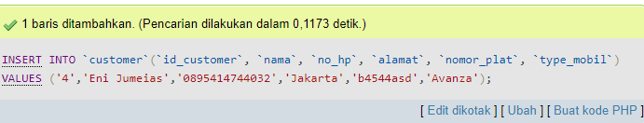

- ( UPDATE )
UPDATE `pendaftaran` SET `id_jenis_cucian`='1', `total_biaya`='35000' WHERE id_pendaftaran ='11';
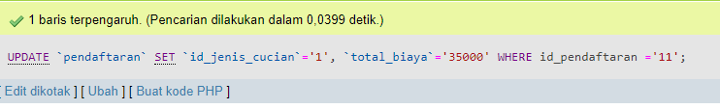

- ( DELETE )
DELETE FROM pendaftaran WHERE id_pendaftaran= '15';
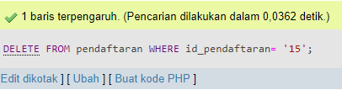

- ( SELECT MIN() )
SELECT MIN(total_biaya) FROM pendaftaran WHERE id_jenis_cucian='2';
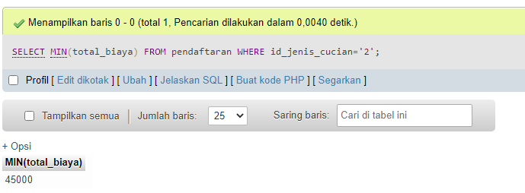

- ( SELECT MAX() )
SELECT MAX(type_mobil) FROM customer WHERE alamat='jakarta';
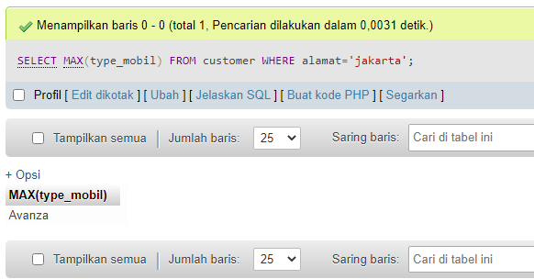

- ( SELECT COUNT() )
SELECT COUNT(id_pendaftaran) FROM pendaftaran WHERE id_jenis_cucian='2';
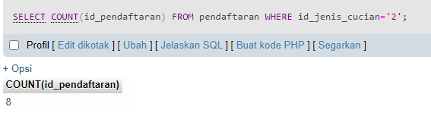

- ( SELECT AVG() )
SELECT AVG(total_biaya) FROM pendaftaran WHERE id_jenis_cucian='1';
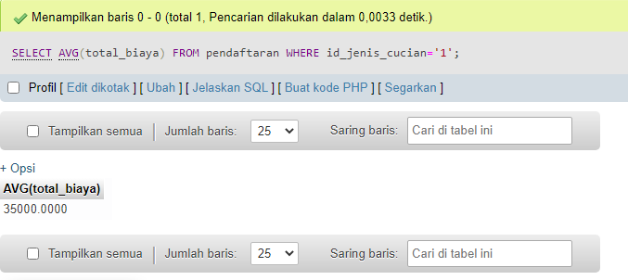

- ( INNER JOIN )
SELECT customer.id_customer, pendaftaran.id_customer FROM customer INNER JOIN pendaftaran ON customer.id_customer = pendaftaran.id_customer;
