- ( INNER JOIN ) SELECT * FROM customer INNER JOIN pendaftaran ON pendaftaran.id_customer = '2';
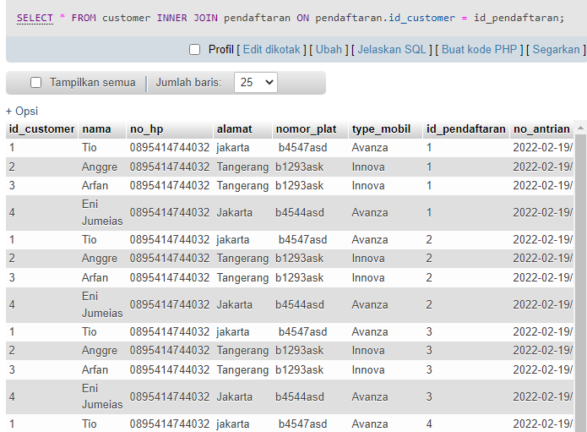

- ( LEFT JOIN )
SELECT * FROM customer LEFT JOIN pendaftaran ON pendaftaran.id_pendaftaran = type_mobil;
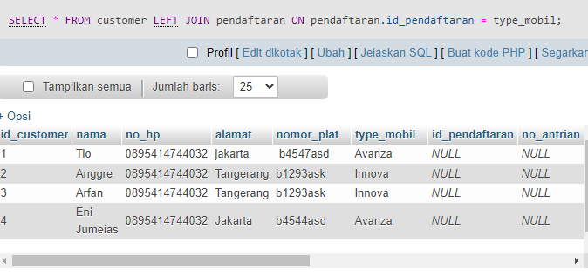

- ( RIGHT JOIN )
SELECT * FROM customer RIGHT JOIN pendaftaran ON pendaftaran.id_pendaftaran = type_mobil;
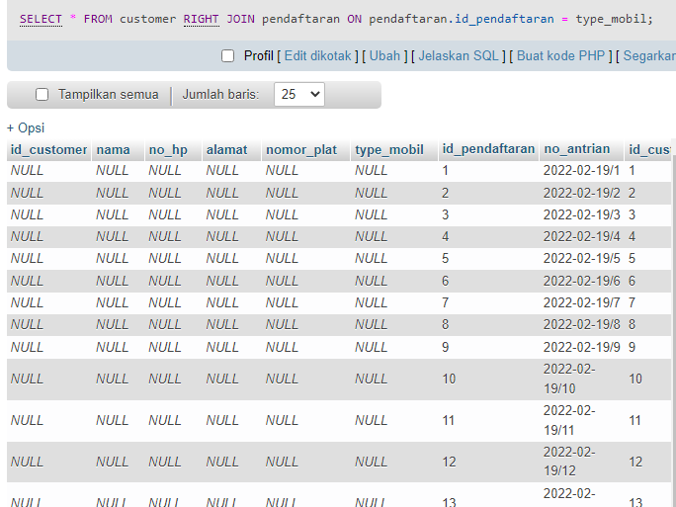

- ( SELF JOIN )
SELECT A.nama AS NamaCustomer1, B.nama AS NamaCustomer2, A.alamat FROM customer A, customer B WHERE A.id_customer <> B.id_customer AND A.alamat = B.alamat ORDER BY A.alamat;
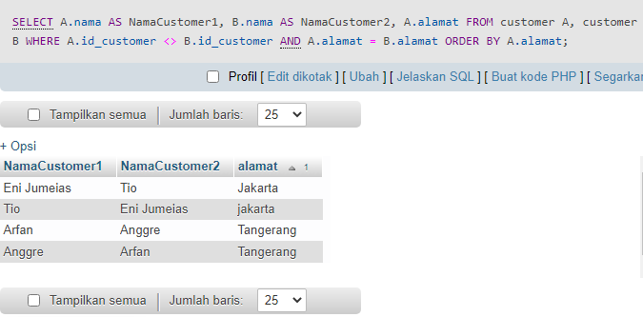

- ( FULL JOIN )
SELECT * FROM customer FULL JOIN pendaftaran ON pendaftaran.id_customer = type_mobil='avanza';

- 