Thiết kế cơ sở dữ liệu
Quan hệ giữa các lớp trong CSDL

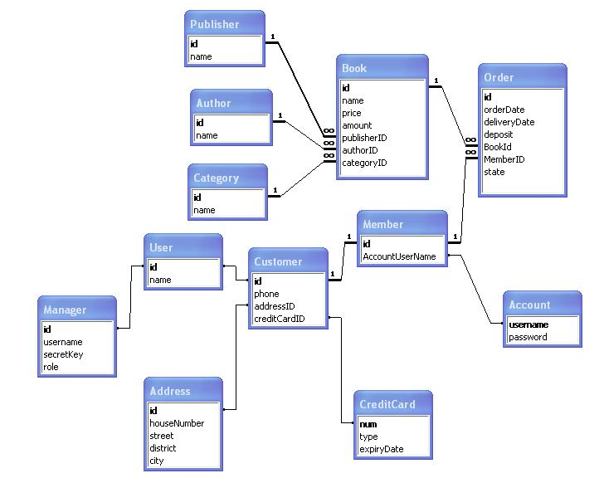

Lược đồ quan hệ
Publisher(ID:INTEGER, name: VARCHAR(30))
Author(ID:INTEGER, name: VARCHAR(30))
Category(ID:INTEGER, name: VARCHAR(30))
Book(ID:INTEGER, name: VARCHAR(30), price:INTEGER(10), amount: INTEGER, publisherID: INTEGER, authorID: INTEGER, categoryID: INTEGER)
Order(ID:INTEGER, orderDate: DATE, deliveryDate: DATE, deposit: INTEGER(10), sate: INTEGER, bookID: INTEGER(10), memberID: INTEGER)
User(ID:INTEGER, name: VARCHAR(30))
Manager(ID:INTEGER, username: VARCHAR(30), secretKey: INTEGER, role: VARCHAR(30))
Customer(ID:INTEGER, phone: VARCHAR(30), addressID: INTEGER, creditCardID: INTEGER)
Member(ID:INTEGER, accountUsername: VARCHAR(30))
Address(ID:INTEGER, houseNumber: VARCHAR(30), street: VARCHAR(30), district: VARCHAR(30), district: VARCHAR(30))
CreditCard(num:INTEGER, type: VARCHAR(30), expiryDate: DATE)

