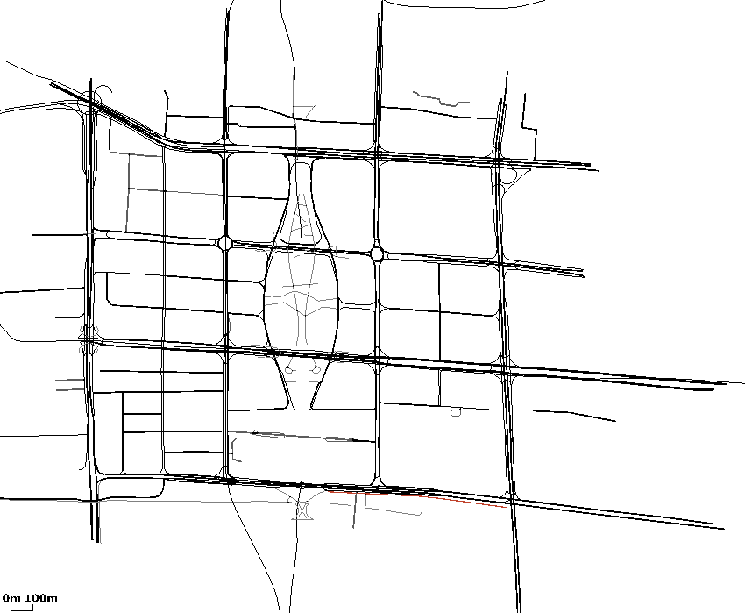
input_zhujiang2
(main.cc)开始时间：2017-2-24 16:33:50
(main.cc)结束时间：2017-2-24 16:52:18
(main.cc)method:RunNrndnSim()
(main.cc)seed:54321
节点:
4 19 21 58 75 84 138 212 250 266
281 289 301 309 338 379 400 445 465 466
(main.cc)certain_count定点数量:20
(main.cc)certain_interval定点间隔:15
(main.cc)random_accident:1随机
(main.cc)accidentNum:500
(main.cc)transRange:300
(main.cc)noFwStop:1
(main.cc)TTLMax:10
(main.cc)interestFreq:0.005
(main.cc)nodeSum:500
(main.cc)simulationTime:1106
(main.cc)runningTime:18m27s

//NDN DIST CDS
arrivalR accuracyR hitR avgDelay avgFwd avgIntFwd SumFwd IntByteSent HelByteSnt DatByteSnt ByteSnt disinterestR
0.478524 0.0244791 0.805391 1.46825 57.3285 1.03455 10100 9086907 6144903 10081410 25313220 0.975521
0.657799 0.0214592 0.860215 0.0857791 68.9788 0 13037 0 6146736 14481487 20628223 0.978541
0.697042 0.0191856 0.836674 0.154139 21.6042 0 4148 0 24704864 4540643 29245507 0.980814

