input_zhujiang2_800
(main.cc)开始时间：2017-2-24 16:33:58
(main.cc)结束时间：2017-2-24 17:29:57
(main.cc)method:RunNrndnSim()
(main.cc)seed:54321
节点:
72 76 88 94 117 153 187 197 216 219
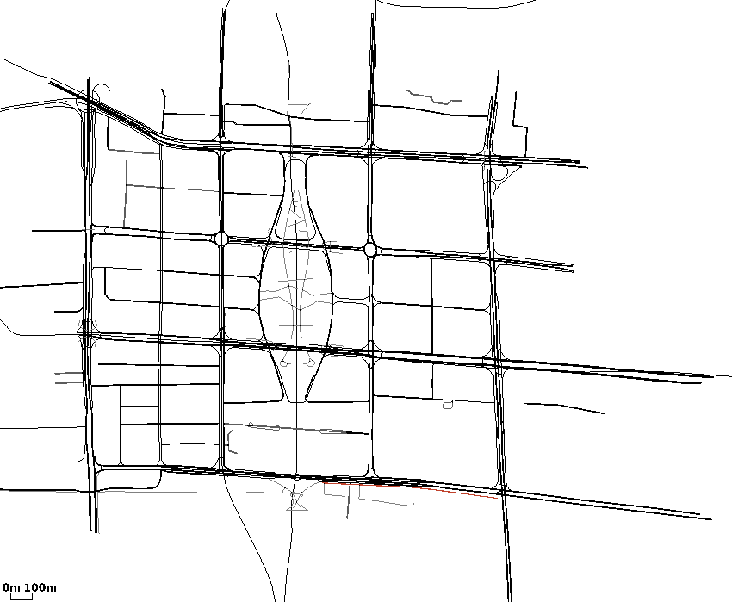
325 421 436 489 492 531 672 677 705 716
(main.cc)certain_count定点数量:20
(main.cc)certain_interval定点间隔:15
(main.cc)random_accident:1随机
(main.cc)accidentNum:801
(main.cc)transRange:300
(main.cc)noFwStop:1
(main.cc)TTLMax:10
(main.cc)interestFreq:0.005
(main.cc)nodeSum:801
(main.cc)simulationTime:948
(main.cc)runningTime:55m59s

//NDN DIST CDS
arrivalR accuracyR hitR avgDelay avgFwd avgIntFwd SumFwd IntByteSent HelByteSnt DatByteSnt ByteSnt disinterestR
0.432818 0.0573214 0.840481 2.17358 106.824 1.03964 22645 15462852 12588957 24905456 52957265 0.942679
0.567206 0.0405226 0.867926 0.20121 145.115 0 35408 0 12590726 39027700 51618426 0.959477
0.546012 0.0730239 0.711952 0.203507 33.3669 0 8275 0 65291570 9057379 74348949 0.926976

