input_556
(main.cc)开始时间：2017-2-24 16:34:59
(main.cc)结束时间：2017-2-24 17:13:31
(main.cc)method:RunNrndnSim()
(main.cc)seed:54321
节点:3 89 119 190 234 236 252 271 285 290
291 293 372 388 401 423 440 476 523 547
(main.cc)certain_count定点数量:20
(main.cc)certain_interval定点间隔:15
(main.cc)random_accident:1随机
(main.cc)accidentNum:557
(main.cc)transRange:300
(main.cc)noFwStop:1
(main.cc)TTLMax:10
(main.cc)interestFreq:0.005
(main.cc)nodeSum:557
(main.cc)simulationTime:909
(main.cc)runningTime:38m31s

//NDN DIST CDS
arrivalR accuracyR hitR avgDelay avgFwd avgIntFwd SumFwd IntByteSent HelByteSnt DatByteSnt ByteSnt disinterestR
0.260836 0.204927 0.750508 1.07519 53.3614 1.02274 10882 15561472 10406412 11708355 37676239 0.795073
0.412856 0.127413 0.797008 0.366225 89.008 0 22252 0 10409083 24650032 35059115 0.872587
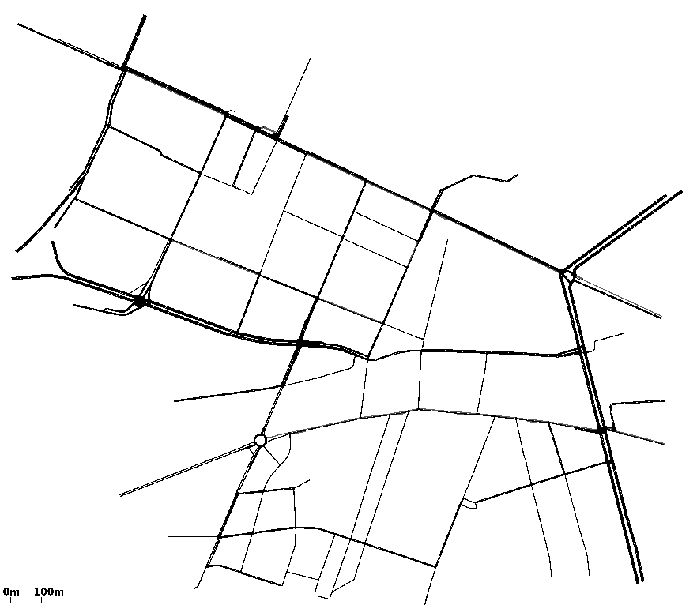
0.383458 0.166362 0.704155 0.150721 12.4336 0 3183 0 45959115 3486479 49445594 0.833638

