input_zhujiang2
(main.cc)开始时间：2017-2-22 21:7:16
(main.cc)结束时间：2017-2-22 21:24:46
(main.cc)method:RunNrndnSim()
(main.cc)certain_count定点数量:20
(main.cc)certain_interval定点间隔:15
(main.cc)random_accident:0定点
(main.cc)accidentNum:500
(main.cc)transRange:300
(main.cc)noFwStop:1
(main.cc)TTLMax:10
(main.cc)interestFreq:0.005
(main.cc)nodeSum:500
(main.cc)simulationTime:1106
(main.cc)runningTime:17m30s

//NDN DIST CDS
arrivalR accuracyR hitR avgDelay avgFwd avgIntFwd SumFwd IntByteSent HelByteSnt DatByteSnt ByteSnt disinterestR
0.643406 0.0883816 0.935491 2.56349 122.717 1.02966 8726 9062307 6144903 8381110 23588320 0.911618
0.561542 0.0906269 0.92052 0.268658 120.911 0 6771 0 6146736 7464908 13611644 0.909373
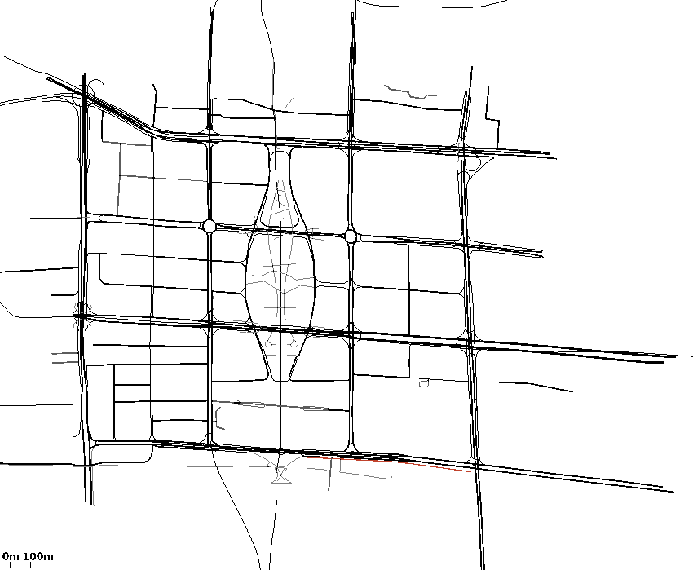
0.581929 0.146828 0.816473 0.225601 33.1228 0 1888 0 24714240 2064143 26778383 0.853172

