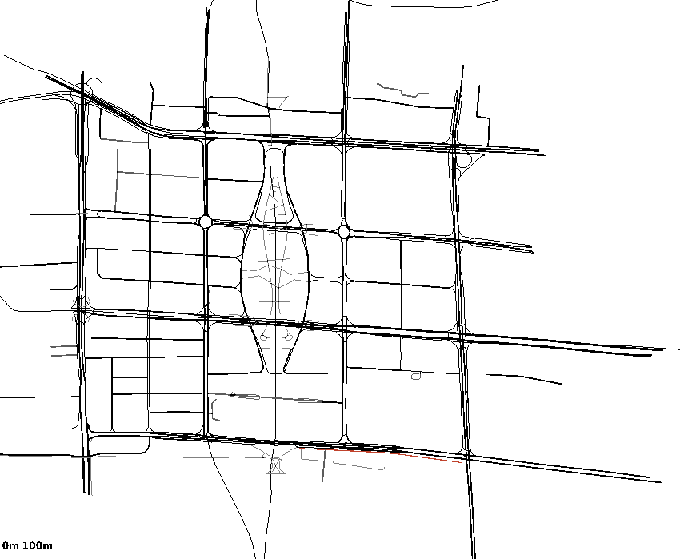
input_zhujiang2
(main.cc)开始时间：2017-2-22 20:22:25
(main.cc)结束时间：2017-2-22 21:3:31
(main.cc)method:RunNrndnSim()
(main.cc)certain_count定点数量:20
(main.cc)certain_interval定点间隔:15
(main.cc)random_accident:1随机
(main.cc)accidentNum:500
(main.cc)transRange:300
(main.cc)noFwStop:1
(main.cc)TTLMax:10
(main.cc)interestFreq:0.005
(main.cc)nodeSum:500
(main.cc)simulationTime:1106
(main.cc)runningTime:41m6s

//NDN DIST CDS
arrivalR accuracyR hitR avgDelay avgFwd avgIntFwd SumFwd IntByteSent HelByteSnt DatByteSnt ByteSnt disinterestR
0.096361 0.186675 0.322318 4.28923 20.2501 1.02907 213105 8156908 6144903 268361398 282663209 0.813325
0.210425 0.150337 0.340915 4.1544 32.5576 0 520726 0 6146736 602982535 609129271 0.849663
0.269061 0.0966817 0.490763 2.12751 7.46843 0 224994 0 22724900 246280031 269004931 0.903318

