input_250
(main.cc)开始时间：2017-2-21 23:34:11
(main.cc)结束时间：2017-2-22 0:23:46
(main.cc)method:RunNrndnSim()
(main.cc)certain_count定点数量:20
(main.cc)certain_interval定点间隔:15
(main.cc)random_accident:1
(main.cc)accidentNum:251
(main.cc)transRange:300
(main.cc)noFwStop:1
(main.cc)TTLMax:10
(main.cc)interestFreq:0.005
(main.cc)nodeSum:251
(main.cc)simulationTime:883
(main.cc)runningTime:49m35s

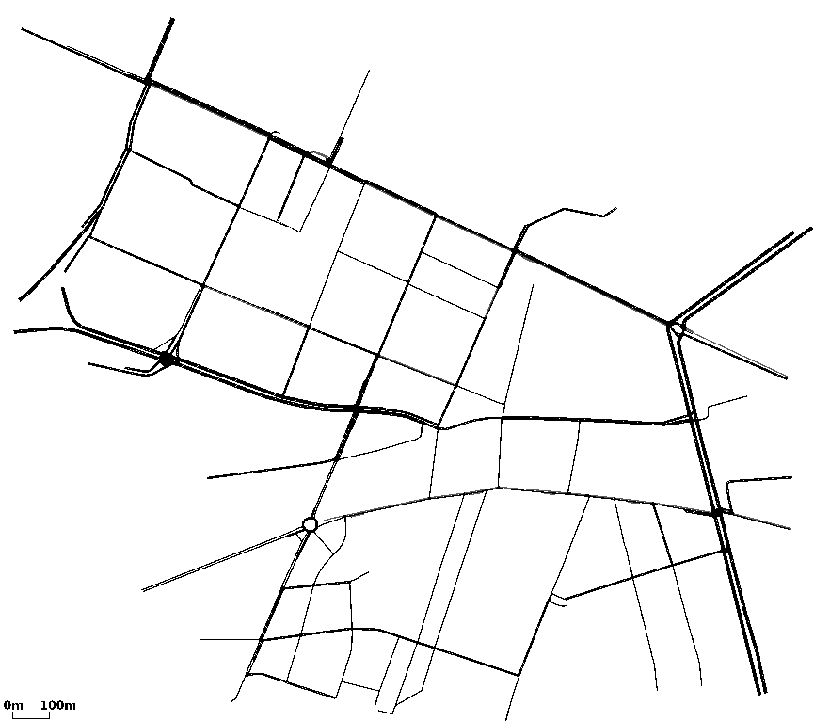

//NDN DIST CDS
arrivalR accuracyR hitR avgDelay avgFwd avgIntFwd SumFwd IntByteSent HelByteSnt DatByteSnt ByteSnt disinterestR
0.0944673 0.305187 0.475646 3.46947 13.2074 1.01372 223244 5562012 4371045 287435328 297368385 0.694813
0.132471 0.286308 0.495044 4.10483 21.4824 0 447263 0 4372786 529056101 533428887 0.713692
0.204056 0.227638 0.74201 0.938913 4.18094 0 149042 0 13840478 163281158 177121636 0.772362

