input_250
(main.cc)开始时间：2017-2-22 0:24:51
(main.cc)结束时间：2017-2-22 0:40:47
(main.cc)method:RunNrndnSim()
(main.cc)certain_count定点数量:20
(main.cc)certain_interval定点间隔:15
(main.cc)random_accident:0
(main.cc)accidentNum:251
(main.cc)transRange:300
(main.cc)noFwStop:1
(main.cc)TTLMax:10
(main.cc)interestFreq:0.005
(main.cc)nodeSum:251
(main.cc)simulationTime:883
(main.cc)runningTime:15m55s

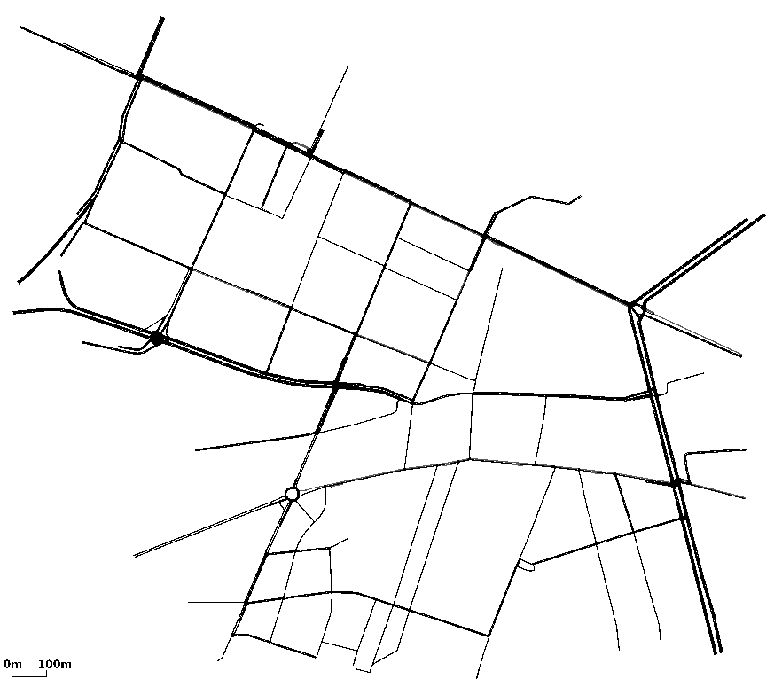

//NDN DIST CDS
arrivalR accuracyR hitR avgDelay avgFwd avgIntFwd SumFwd IntByteSent HelByteSnt DatByteSnt ByteSnt disinterestR
0.187951 0.100268 0.637775 0.799528 29.2821 1.01231 3024 6538079 4371045 2828304 13737428 0.899732
0.318177 0.067142 0.698574 0.411543 44.6774 0 5540 0 4372786 6211489 10584275 0.932858
0.306132 0.0641376 0.689562 0.118155 6.40157 0 813 0 14592218 891321 15483539 0.935862

