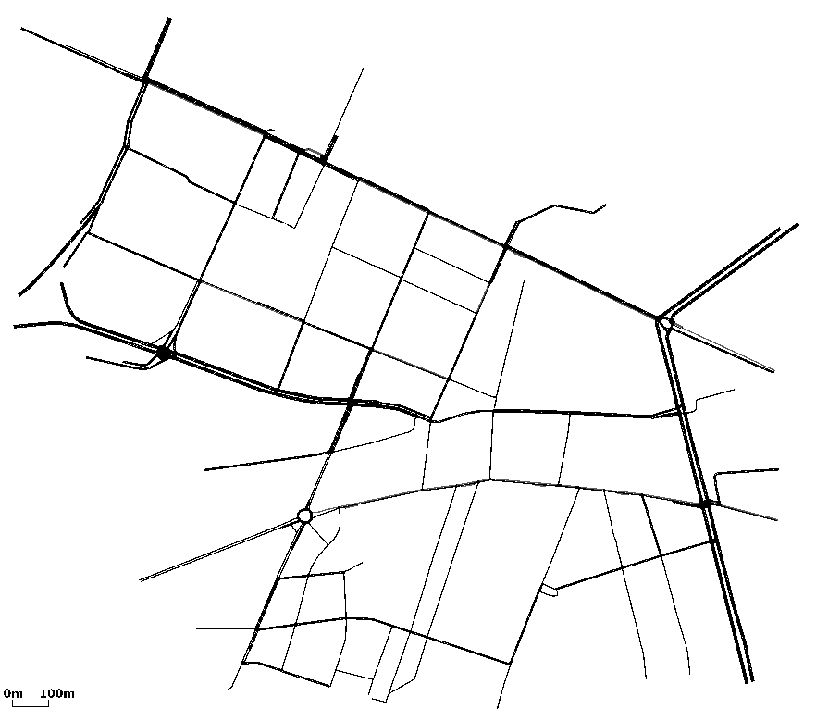
input_556
(main.cc)开始时间：2017-2-22 0:49:9
(main.cc)结束时间：2017-2-22 3:46:27
(main.cc)method:RunNrndnSim()
(main.cc)certain_count定点数量:20
(main.cc)certain_interval定点间隔:15
(main.cc)random_accident:1
(main.cc)accidentNum:557
(main.cc)transRange:300
(main.cc)noFwStop:1
(main.cc)TTLMax:10
(main.cc)interestFreq:0.005
(main.cc)nodeSum:557
(main.cc)simulationTime:909
(main.cc)runningTime:177m17s

//NDN DIST CDS
arrivalR accuracyR hitR avgDelay avgFwd avgIntFwd SumFwd IntByteSent HelByteSnt DatByteSnt ByteSnt disinterestR
0.0784606 0.386 0.356248 4.37349 19.7312 1.01283 730112 12893921 10406412 946560348 969860681 0.614
0.0776931 0.355676 0.293976 4.05615 39.0498 0 1327030 0 10409083 1553271009 1563680092 0.644324
0.15026 0.262734 0.481269 2.87253 6.33939 0 577354 0 39177223 632424182 671601405 0.737266

