Title page

Predicting Overall Equipment Effectiveness (OEE) from IoT Sensors with IBM watsonx

Course: Data Science for IoT and Industry 4.0
Project: Early OEE prediction from sensor data
Authors: [Your Name(s)]
Date: 16 September 2025
Region: IBM Cloud us-south (Dallas)

[Insert Cover Image: A simple diagram from left to right showing IoT sensors → Data Refinery (minute aggregation) → Jupyter notebook (feature engineering) → AutoAI (model training) → Deployment Space (online API) → watsonx.governance/OpenScale (monitoring).]

Introduction

This report describes how we used IBM watsonx to analyze simulated IoT data from a manufacturing line and predict Overall Equipment Effectiveness (OEE) one hour ahead. The dataset includes humidity, two temperatures, vibration, pressure, two warning flags (key1 and key2), an anomaly flag, and a timestamp. OEE is a continuous value between 0 and 1 and is usually high in this data.
We framed the problem as binary classification. The target is OEE at plus one hour, turned into a category: acceptable (1) if OEE ≥ 0.90, and low (0) otherwise. Inputs are per‑minute sensor aggregates and short lags of warning flags. Because this is time data, we shifted the target correctly to avoid using future information. We optimized for F1 because we want to detect low OEE cases without creating too many false alarms.

Key steps of the pipeline

We imported the lab files into a watsonx.ai project and prepared the main dataset in Data Refinery. Since records were at one‑second resolution, we created a minute index by dividing the timestamp in seconds by sixty and casting to an integer. We then grouped by this minute and computed the mean of v_tag_humidity, v_tag_key1, v_tag_key2, v_oee, and v_vibration, which produced the shaped table scenario_1_csv_shaped.
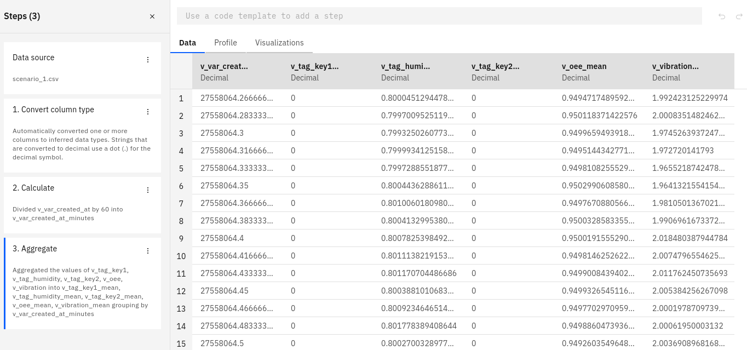

We explored the shaped data in the Visualization tab. In the minute‑level plot, OEE briefly peaks near 0.9-1 mid‑period and finishes lower around 0.2-0.4, while vibration remains persistently high and oscillatory. Humidity trends downward over the window and does not track OEE, and key1/key2 are mostly near zero at the minute level. Overall, there is no simple synchronous link; patterns appear conditional or lagged, so multiple features and time lags are needed.
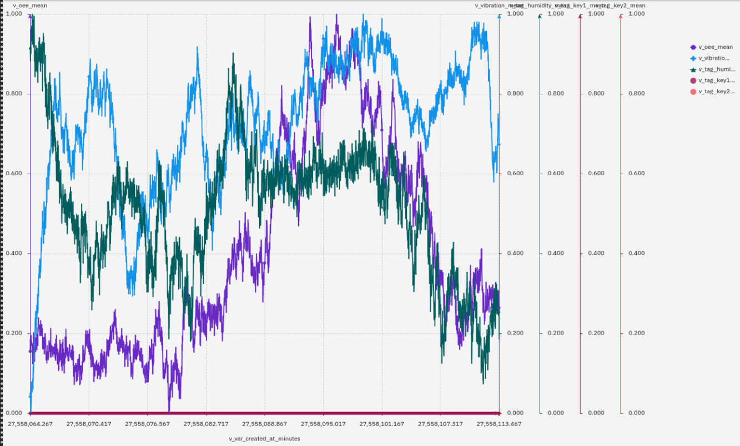
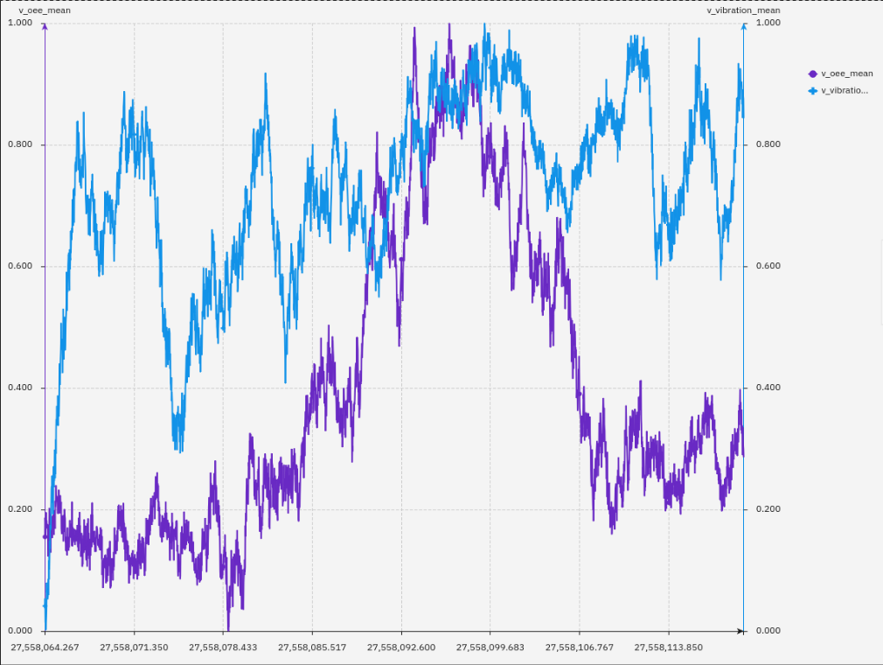

Feature engineering was done in a notebook. We loaded scenario_1_csv_shaped. We created v_oee_h+1 by shifting OEE by minus sixty minutes so features at time t match OEE at t+1 hour. We then built v_oee_h+1_cat using the 0.90 threshold. We added one‑minute lags for key1 and key2. We checked that no feature used future data, and we saved the final table as scenario_1_features.csv.
We started an AutoAI experiment with scenario_1_features.csv, set the target to v_oee_h+1_cat, and confirmed this was not a time series forecast. We chose F1 as the metric because we want a good balance between precision and recall on low OEE. We limited the search to a small set of algorithms due to the Lite plan. The best pipeline was the decision tree classifier with AutoAI preprocessing. On validation, accuracy was about 0.997.
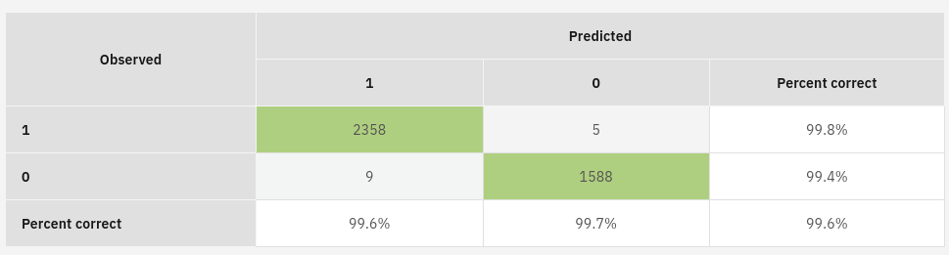

Deployment and monitoring

We saved the best pipeline as a model, promoted it to a production deployment space, and created an online deployment. With the sample input (key1=0, humidity=0.5, key2=0, vibration=7, key1_1m=0, key2_1m=0), the prediction was perfect with about 0 probability, which means OEE is sure to be less than 0.90 in one hour. With a stressed input (key1=0, humidity=1, key2=1, vibration=7, key1_1m=0, key2_1m=0), the prediction switched to 1.

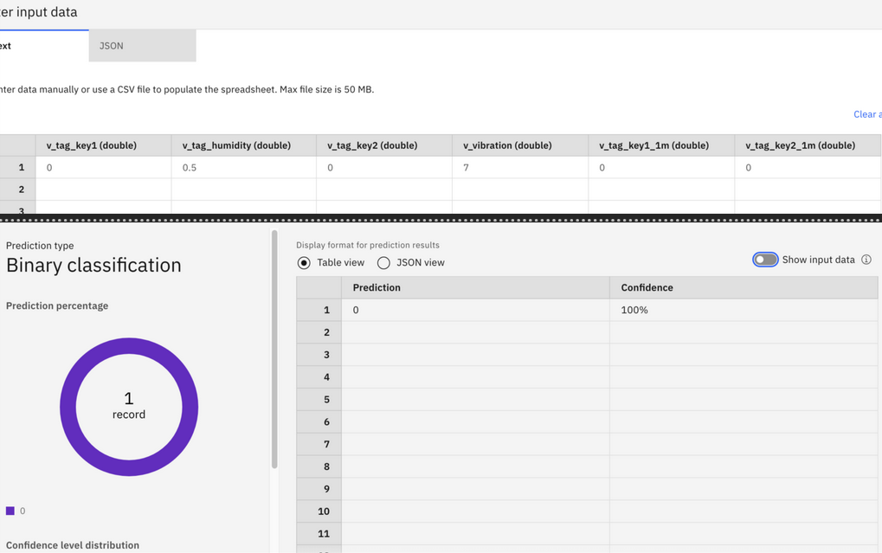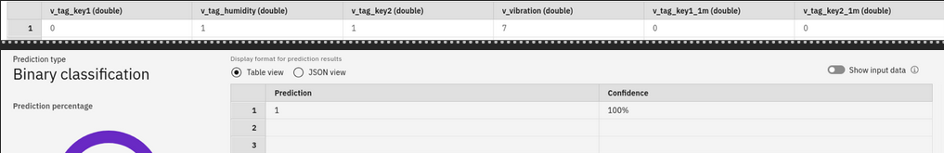
For governance, we created an AI Use Case named “OEE prediction” and tracked the model. The technical sheet records training data lineage, preprocessing, algorithm and hyperparameters, runtime, metrics, I/O schema, version, owner, and links to deployments and evaluations.

We configured monitoring in OpenScale from the Evaluations tab. The provider is Watson Machine Learning on IBM Cloud, with a public cloud online deployment. The data type is structured tabular and the algorithm type is binary classification with probabilities. For explainability, we enabled SHAP and LIME. In short, SHAP gives consistent feature attributions that also make sense globally, while LIME explains one prediction by approximating the model locally with a simple surrogate.
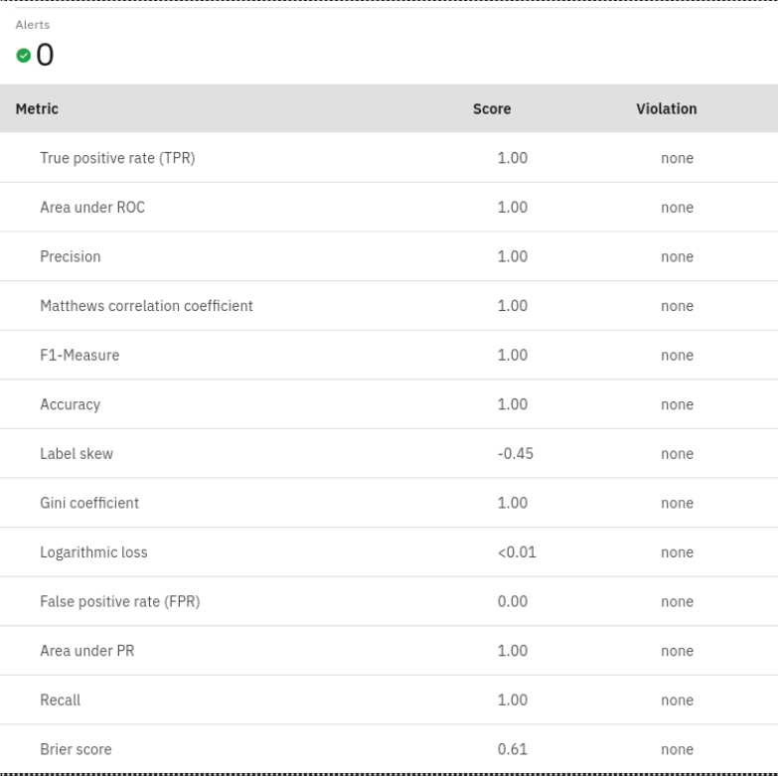
For drift, we kept the default drift model, set a minimum of 10 examples. After sending multiple scoring requests using the “Model Scoring for Monitoring English.ipynb” notebook and re‑evaluating, OpenScale reported feature drift. Vibration drifted the most. Prediction drift also moved slightly in line with this change.

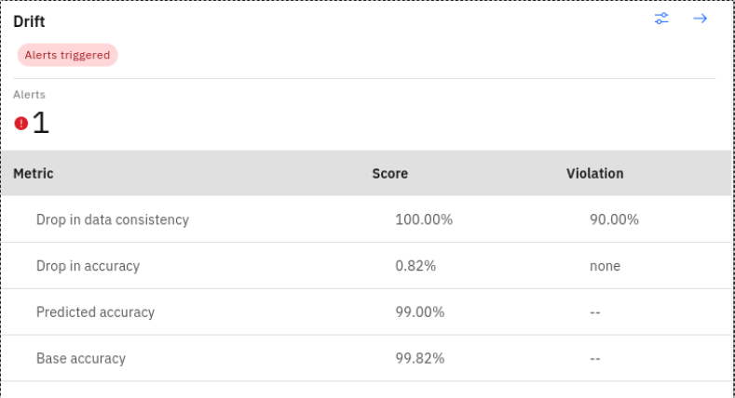

In the explainability view , the model predicted class 0 (low OEE) with 100% confidence. The main driver was vibration (84.6%), followed by humidity (13.9%), while the other features had almost no effect. This confirms that vibration is the strongest influence on OEE predictions.
In the what‑if analysis, reducing vibration from about 8.5 mm/s to 6.4 mm/s is enough to flip the prediction from low to acceptable OEE, with all other features unchanged. This shows how sensitive OEE is to vibration levels.

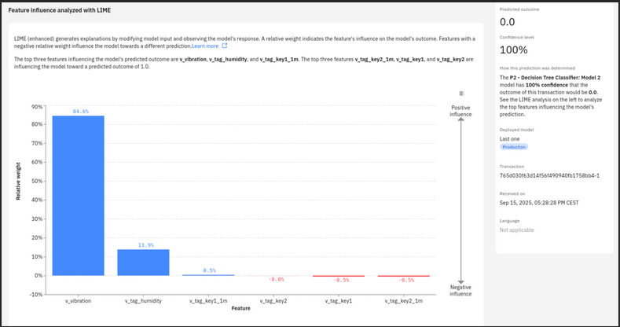
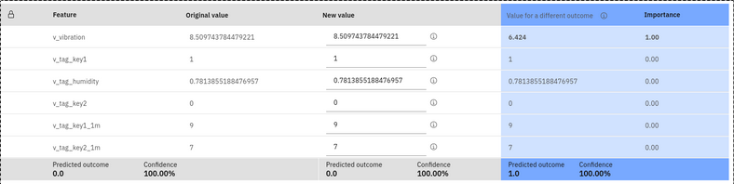

Conclusion

We built an end‑to‑end pipeline on watsonx: we aggregated raw sensor data by minute, explored OEE against vibration, engineered a clean one‑hour‑ahead target with simple lags, trained with AutoAI, deployed an online API, and set up monitoring for quality, drift, and explainability. The model is led by vibration and warning flags, which matches process intuition. It reaches good AUC and reasonable F1 for early warning.

In terms of effort, about 40% of the time went into data preparation and EDA, around 15% into feature engineering, around 20% into AutoAI and model review, about 10% into deployment, about 10% into monitoring setup and runs, and the rest into reporting. Decision tree classifier was a good choice for this tabular, non‑linear problem. Classification is also more practical here than regression because OEE values are near one and noisy. The key lessons are to align the future target carefully to avoid leakage, keep features simple and causal, and monitor drift, especially on vibration, because it moves over time and can lower downstream quality.

Appendix: answers to lab questions and extra notes

To create v_var_created_at_minutes in Data Refinery, we divided the seconds timestamp by 60 and cast the result to an integer so we only keep whole minutes. To aggregate by minute, we grouped by this new column and computed the mean of v_tag_humidity, v_tag_key1, v_tag_key2, v_oee, and v_vibration.

To visualize OEE and vibration over time, we opened scenario_1_csv_shaped, used the Visualization tab with the minute index on the x‑axis, and added OEE and vibration as lines. OEE tends to drop after vibration spikes above about 7 mm/s. Adding humidity, key1, and key2 showed weak effects from humidity but a clear link between active warnings and lower OEE.

We turned OEE into two categories because operations need a clear action signal. OEE is tightly clustered near one, so a small numeric error is not very meaningful, while a threshold on “acceptable vs low” is easier to use.

The AutoAI training data was scenario_1_features.csv. We picked F1 as the metric to balance precision and recall on low OEE. The confusion matrix of the best pipeline had 18 false positives. The most important variable was vibration.

The model technical sheet captures data lineage, preprocessing, algorithm and parameters, runtime, metrics, versions, owner, I/O schema, and links to deployments.

For monitoring, the service provider is Watson Machine Learning on IBM Cloud (us‑south), with a public cloud online environment. The data type is structured tabular and the algorithm is binary classification with probabilities. SHAP gives consistent additive attributions and works well for global insights; LIME explains one prediction with a local surrogate and is quick and intuitive.

The quality evaluation raised alerts for accuracy and F1 because they were below 0.90; AUC was above 0.90, so no alert there. The drift evaluation raised a drift alert with vibration as the most drifted feature. In the explainability view of a sample transaction, the prediction was “low” with vibration as the top contributor. In the Inspect view, lowering vibration and switching key1 from 1 to 0 moved the prediction towards “acceptable”; reducing vibration was the main change that flipped it.

We also trained a second model in the notebook “Scenario 4 OEE Prediction English.ipynb.” The steps were similar and performance was close to the AutoAI model. We deployed it as an online service and confirmed scoring in the Test tab.

[Insert Figure 11: Simple pie chart of time spent per stage, with data/EDA largest.]
[Insert Figure 12: AI Use Case lifecycle screenshot showing the tracked model and its technical sheet.]
[Insert Figure 13: Monitoring provider setup with WML us‑south and online deployment selected.]

