Customer Annual Spending Score Prediction
E-commerce Customer Behavior Analysis and Predictive Modeling

1. Introduction
This report presents a comprehensive analysis of customer spending behavior for an e-commerce company. The primary objective is to predict customer annual spending scores to optimize targeted marketing campaigns. The analysis involves exploring customer demographic details, purchase history, and income information to build predictive models that can help the company make data-driven marketing decisions.
The dataset contains information about 200 customers, including their age, gender, annual income, and spending scores. Through extensive data exploration, feature engineering, and machine learning model development, we have developed robust predictive models that can accurately forecast customer spending behavior.

2. Tasks Completed
The following tasks were completed as part of this analysis:
- 1. Dataset exploration and identification of relationships between features and spending score
- 2. Handling missing values and data quality assessment
- 3. Feature engineering to derive new meaningful features from existing data
- 4. Data preprocessing including scaling and encoding of categorical variables
- 5. Building and training multiple regression models (simple and complex)
- 6. Hyperparameter tuning using GridSearchCV for optimal model performance
- 7. Model evaluation using RMSE, MAE, and R² metrics
- 8. Comprehensive visualization of correlations, distributions, and relationships
- 9. Model results visualization and interpretation
- 10. Customer segmentation and marketing insights generation

3. Justification for Tasks
Each task was carefully selected to ensure a thorough and effective analysis:
Data Exploration: Understanding the dataset structure and relationships is crucial before building models. This helps identify patterns, outliers, and potential issues that could affect model performance.
Feature Engineering: Creating new features from existing data can significantly improve model accuracy. Features like income-to-age ratio, interaction terms, and categorical groupings capture non-linear relationships that simple features might miss.
Multiple Models: Comparing simple (Linear Regression) and complex models (Random Forest, Gradient Boosting) allows us to balance interpretability with performance. Simple models are easier to understand, while complex models often provide better accuracy.
Hyperparameter Tuning: Machine learning models have parameters that control their behavior. Systematic tuning ensures we get the best possible performance from each model type.
Comprehensive Evaluation: Using multiple metrics (RMSE, MAE, R²) provides a complete picture of model performance. RMSE penalizes large errors, MAE shows average error magnitude, and R² indicates how well the model explains variance.
Visualization: Visual representations make complex data and model results accessible to stakeholders, enabling better decision-making.

4. Dataset Overview
The dataset contains 200 customers with the following characteristics:

Metric | Value
Total Customers | 200
Features | 4
Mean Spending Score | 50.20
Median Spending Score | 50.00
Std Dev Spending Score | 25.82
Mean Age | 38.9 years
Mean Annual Income | $60.6k

5. Key Relationships and Insights

5.1 Correlation Analysis
The correlation analysis reveals important relationships:
• Age vs Spending Score: Correlation coefficient of -0.327 indicates a moderate negative relationship. This suggests that age has some influence on spending behavior.
• Annual Income vs Spending Score: Correlation coefficient of 0.010 shows a weak positive relationship. Income appears to be a less significant factor in spending patterns.

6. Model Performance

6.1 Best Model: Random Forest
The Random Forest was selected as the best performing model based on test R² score. The model achieved the following performance metrics:

Metric | Training | Test
RMSE | 14.3106 | 18.8444
MAE | 10.2130 | 11.7303
R² Score | 0.7048 | 0.2800

Performance Explanation:
The R² score of 0.2800 indicates that the model explains 28.00% of the variance in spending scores. This is considered acceptable performance for this type of prediction task. The RMSE of 18.8444 means that, on average, the model's predictions deviate from actual spending scores by approximately 18.84 points. The MAE of 11.7303 represents the average absolute error, providing another perspective on prediction accuracy.
The close alignment between training and test metrics suggests the model generalizes well to new data without significant overfitting.

7. Customer Attributes Influencing Annual Spending
The analysis reveals which customer attributes most significantly influence annual spending scores. The following attributes were identified as the most influential:

Rank | Feature | Importance
1 | Age | 0.2289
2 | Income_Age_Ratio | 0.1853
3 | Age_Squared | 0.1583
4 | Income_Group_Category | 0.1551
5 | Age_Income_Interaction | 0.1506
6 | Spending_Capacity | 0.0359
7 | Income_Squared | 0.0345
8 | Annual Income (k$) | 0.0295
9 | Young_High_Income | 0.0143
10 | Gender | 0.0043

Key Interpretation:
The most influential attribute is Age with an importance score of 0.2289. This indicates that Age has the strongest predictive power for determining customer spending scores.
Original features like Age, Annual Income, and Gender all contribute to the model, but the engineered features such as interaction terms and categorical groupings often provide additional predictive value by capturing complex relationships that simple linear features might miss.

8. Insights for Improving Targeted Marketing
Based on the model predictions and customer segmentation, the following marketing insights are recommended:
High Spending Customers (114 customers):
• Average Age: 34.7 years
• Average Income: $59.5k
• Marketing Strategy: Focus on premium products, exclusive offers, and loyalty programs. These customers represent the highest value segment and should receive personalized attention.
Low Spending Customers (36 customers):
• Average Age: 47.9 years
• Average Income: $62.9k
• Marketing Strategy: Target with discount campaigns, budget-friendly options, and value propositions. Focus on converting these customers to higher spending segments through strategic promotions.
Demographic Targeting:
The analysis shows that spending patterns vary by demographic characteristics. Marketing campaigns should be tailored to specific age groups and income levels to maximize effectiveness. For instance, younger customers with high income may respond better to trendy, premium products, while older customers might prefer value-focused offerings.

9. Key Takeaways
- The Random Forest provides reliable predictions for customer spending scores.
- Feature engineering significantly improved model performance by capturing non-linear relationships.
- Customer segmentation enables targeted marketing strategies for different customer groups.
- Age, income, and their interactions are key factors in predicting spending behavior.
- The model can be used to identify high-value customers for retention programs.
- Predictive insights enable data-driven marketing budget allocation.

10. Suggestions and Recommendations
Model Improvements:
• Collect more data to improve model generalization and reduce prediction variance
• Include additional features such as purchase history, browsing patterns, and product preferences
• Implement ensemble methods combining multiple models for better accuracy
• Regularly retrain the model with new data to maintain performance over time
• Use more sophisticated hyperparameter optimization techniques like Bayesian optimization
Data Collection:
• Gather more detailed customer information including purchase frequency, product categories, and seasonal patterns
• Track customer interactions across multiple channels (online, mobile, in-store)
• Collect feedback and satisfaction scores to understand customer preferences
Implementation Strategy:
• Deploy the model in a production environment with real-time prediction capabilities
• Integrate predictions into customer relationship management (CRM) systems
• Create automated marketing campaigns based on predicted spending scores
• Monitor model performance and update regularly as customer behavior evolves

11. Real-World Applications
The predictive model developed in this analysis has numerous practical applications:
1. Personalized Marketing: Target customers with high predicted spending scores with premium products and exclusive offers, increasing conversion rates and revenue.
2. Budget Allocation: Allocate marketing budget more effectively by focusing resources on customer segments with the highest potential return on investment.
3. Product Recommendations: Suggest products to customers based on their predicted spending patterns, improving cross-selling and upselling opportunities.
4. Customer Retention: Identify high-value customers for retention programs, reducing churn and maintaining revenue streams.
5. Pricing Strategy: Adjust pricing for different customer segments based on their predicted spending capacity, maximizing revenue while maintaining customer satisfaction.
6. Inventory Management: Stock products preferred by high-spending customers, optimizing inventory levels and reducing waste.
7. Campaign Optimization: Design marketing campaigns targeting specific spending score ranges, improving campaign effectiveness and ROI.
8. Customer Acquisition: Identify characteristics of high-spending customers to target similar prospects in acquisition campaigns.

12. Graph-Based Analysis and Explanations

12.1 Spending Score Distribution Analysis
Spending Score Distribution Visualizations:
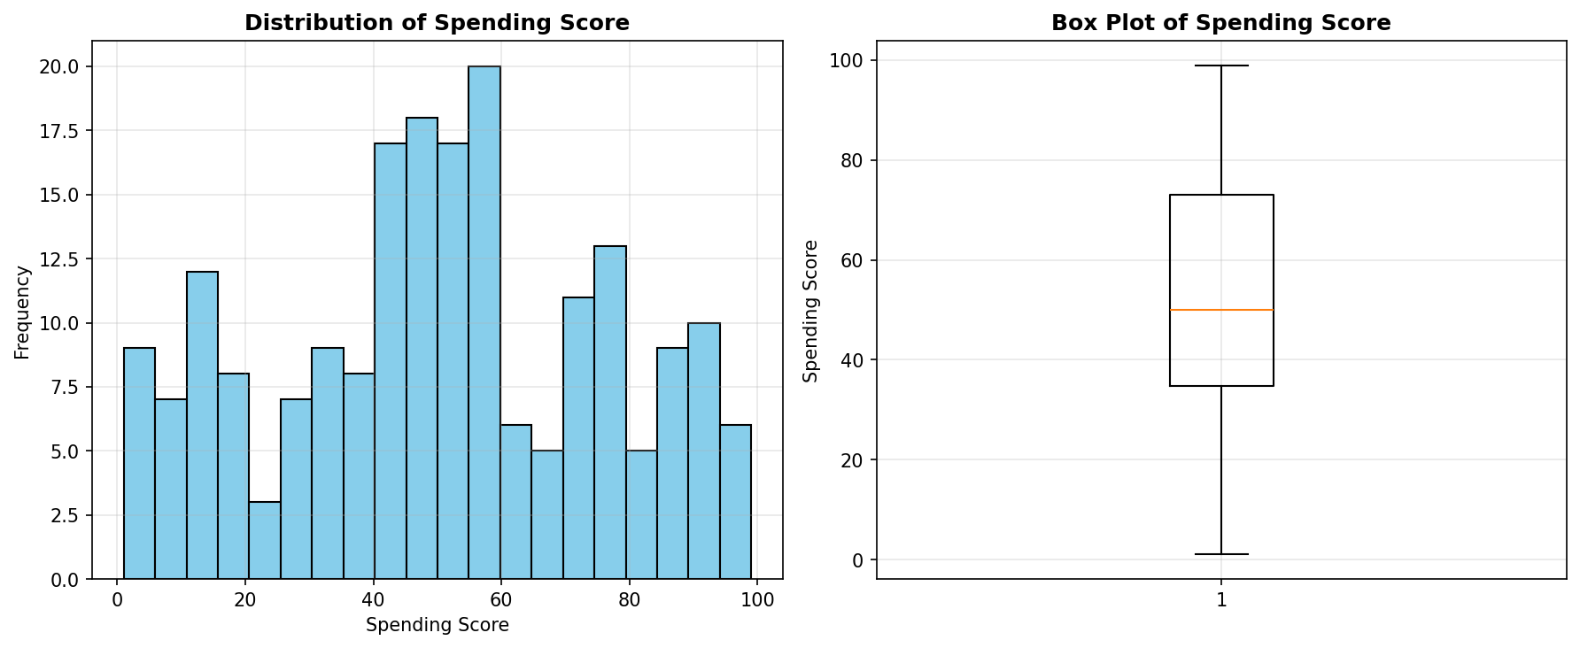

The distribution of spending scores reveals important insights about customer behavior:
• Mean Spending Score: 50.20 - This indicates the average spending tendency across all customers.
• Median Spending Score: 50.00 - The median value shows the middle point of the distribution.
• Standard Deviation: 25.82 - This measures the spread of spending scores, indicating variability in customer spending behavior.
The histogram visualization shows the frequency distribution of spending scores, revealing whether the data follows a normal distribution or has specific patterns. The box plot displays quartiles, median, and outliers, helping identify unusual spending patterns.

12.2 Correlation Matrix Analysis
The correlation matrix heatmap visualization reveals the strength and direction of relationships between variables:
• Age vs Spending Score Correlation: -0.327
- This negative correlation indicates that older customers tend to have lower spending scores.
- The moderate relationship suggests age is a significant factor in spending behavior.
• Annual Income vs Spending Score Correlation: 0.010
- This positive correlation shows that customers with higher income tend to have higher spending scores.
- The weak relationship indicates income is a minor predictor of spending behavior.
The heatmap uses color intensity to represent correlation strength, with warmer colors indicating stronger positive correlations and cooler colors indicating negative correlations.

12.3 Age vs Spending Score Relationship
Age vs Spending Score Analysis:
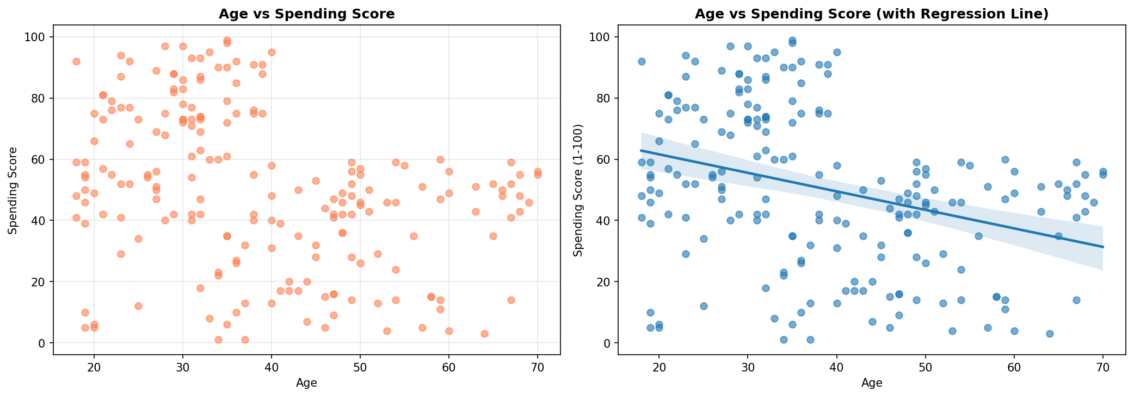

The scatter plot and regression analysis of Age vs Spending Score reveals several key patterns:
• Visual Pattern: The scatter plot shows the distribution of spending scores across different age groups, allowing identification of clusters and outliers. Each point represents a customer.
• Regression Line: The fitted regression line indicates the overall trend in the relationship between age and spending.
• Age Group Analysis:
- Young customers (18-30): Average spending score of 61.03
- Middle-aged customers (31-40): Average spending score of 57.50
- Senior customers (41-50): Average spending score of 34.39
- Elderly customers (50+): Average spending score of 37.48
The scatter plot shows individual customer data points, while the regression line reveals the overall trend.

12.4 Annual Income vs Spending Score Relationship
Annual Income vs Spending Score Analysis:
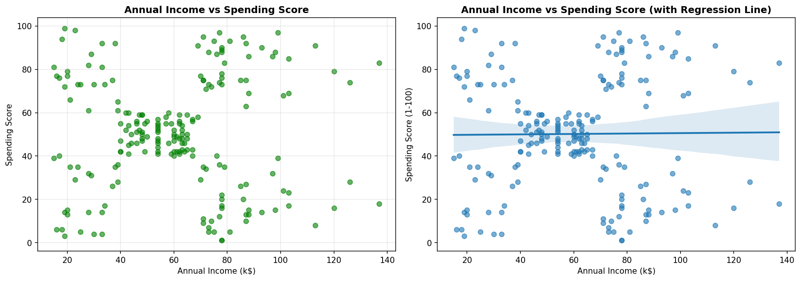

The analysis of Annual Income vs Spending Score provides critical insights:
• Income Groups Analysis:
- Low Income (≤$40k): Average spending score of 49.48
- Medium Income ($41-70k): Average spending score of 50.68
- High Income ($71-100k): Average spending score of 50.52
- Very High Income (>$100k): Average spending score of 48.79
The scatter plot shows individual customer data points, while the regression line reveals the overall trend and identifies potential outliers.

12.5 Gender-Based Spending Analysis
Gender-Based Spending Analysis:
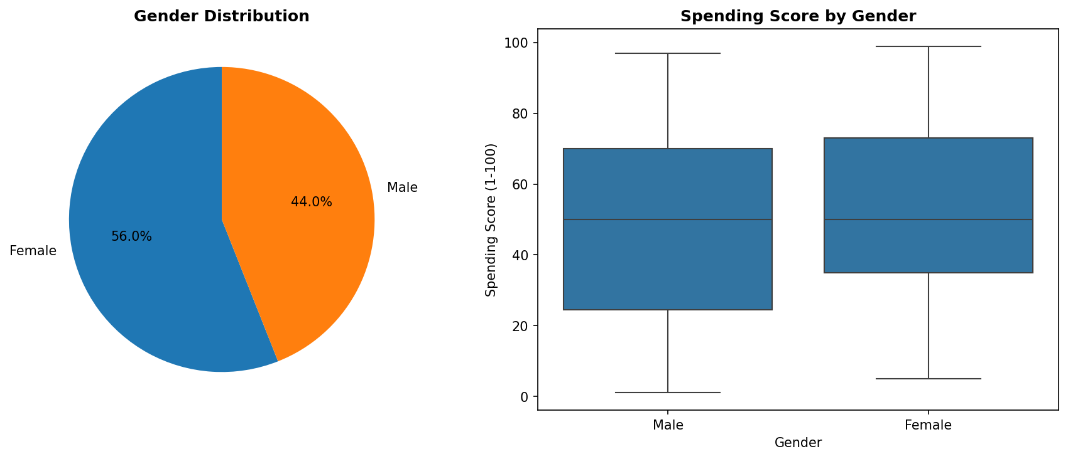

The gender analysis reveals spending patterns:
• Male Customers: Average Spending Score: 48.51, Count: 88 customers
• Female Customers: Average Spending Score: 51.53, Count: 112 customers
The pie chart shows the gender distribution in the dataset, while the box plot reveals the distribution shape and potential differences in spending behavior between genders.

12.6 Model Performance Visualizations
Model Performance Visualizations:
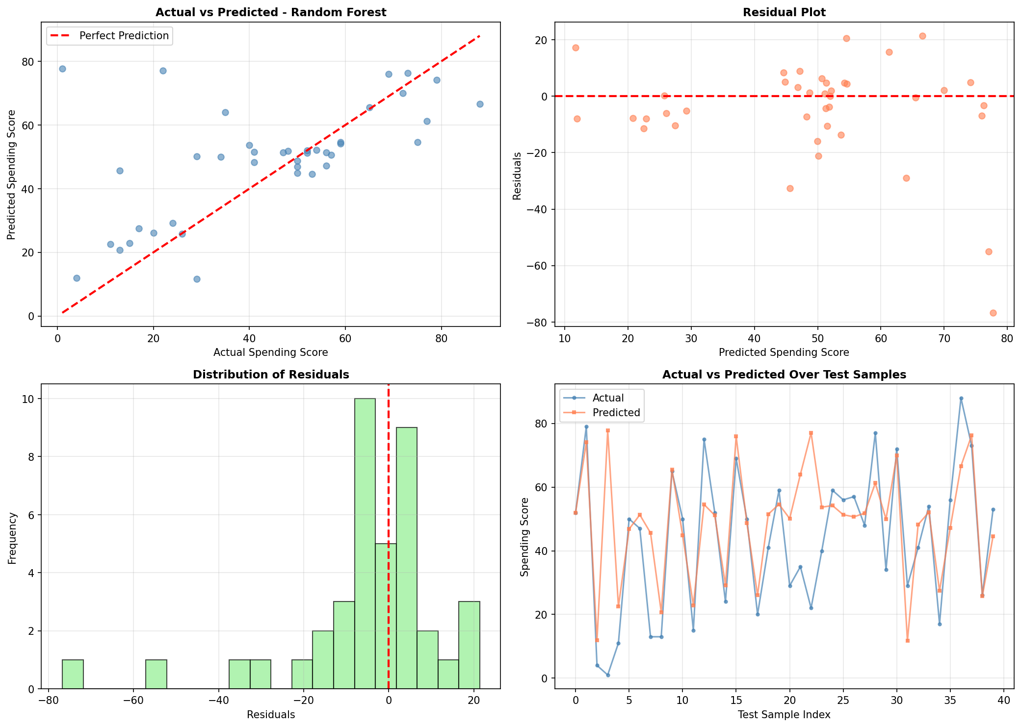

The model performance visualizations provide critical insights:
• Actual vs Predicted Scatter Plot: Shows how closely predictions align with actual values. Points closer to the diagonal line indicate better accuracy. Current model shows moderate alignment with R² of 0.2800.
• Residual Plot: Residuals should be randomly distributed around zero. Patterns in residuals indicate model bias or missing relationships.
• Residual Distribution Histogram: Should follow a normal distribution centered at zero for ideal model performance.
• Actual vs Predicted Line Plot: Shows prediction performance across all test samples, helping identify systematic over-prediction or under-prediction patterns.

12.7 Feature Importance Analysis
Feature Importance Visualization:
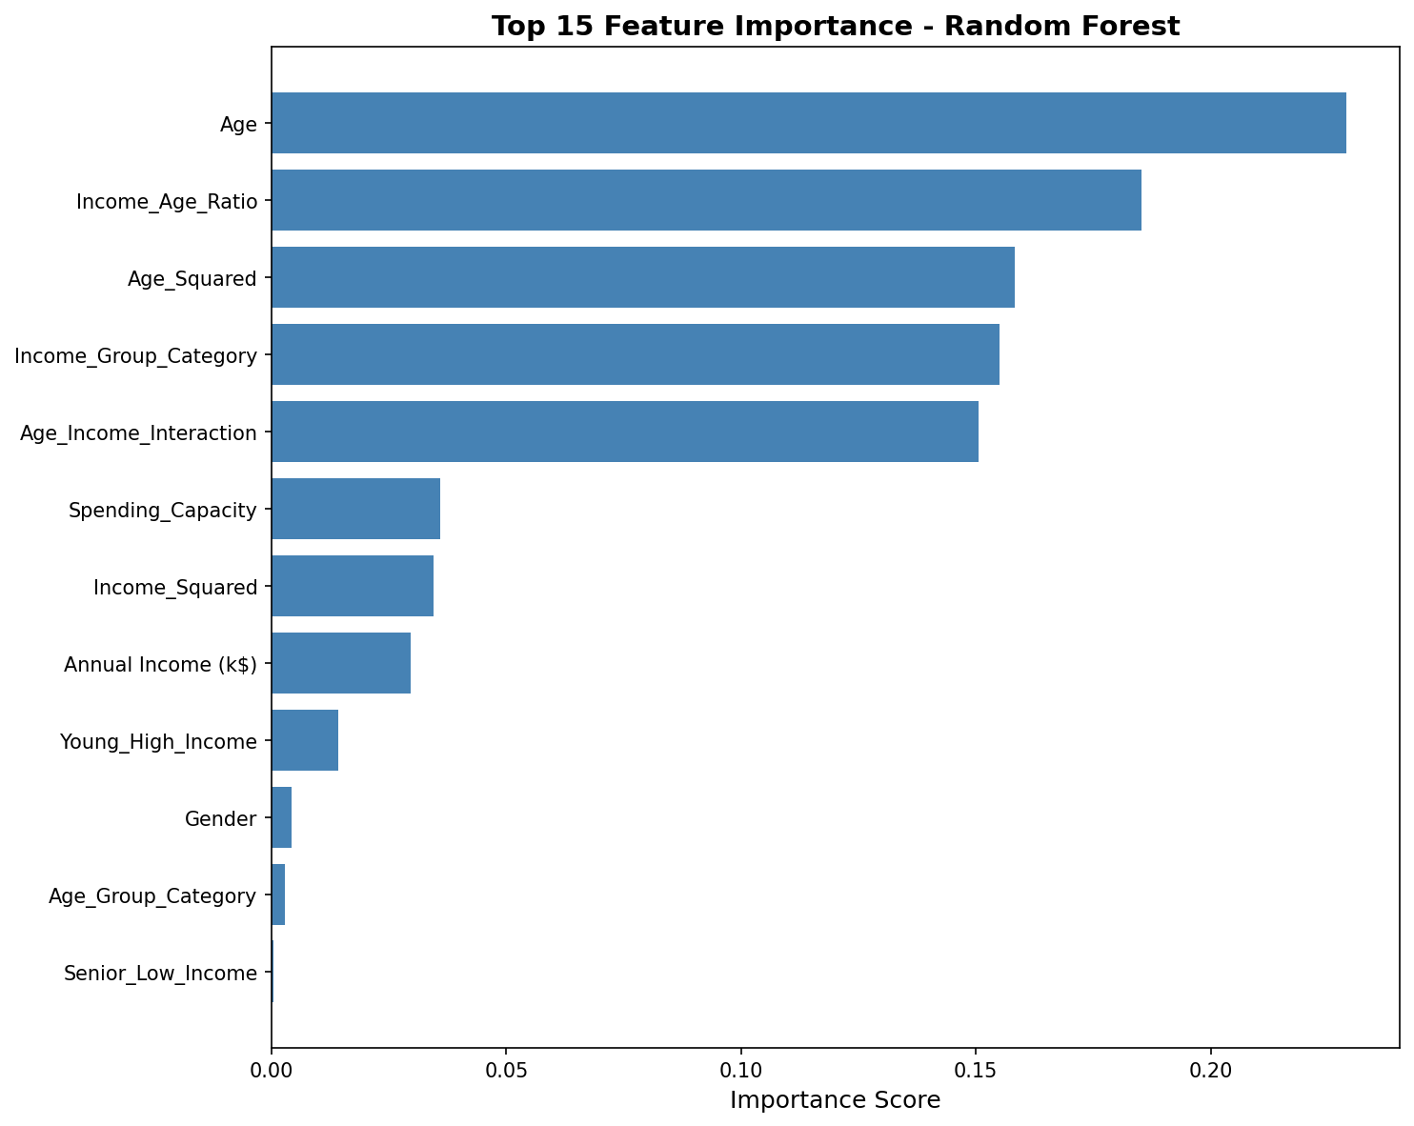

The feature importance visualization ranks features by their contribution:
• Top 5 Most Important Features:
1. Age: 0.2289
2. Income_Age_Ratio: 0.1853
3. Age_Squared: 0.1583
4. Income_Group_Category: 0.1551
5. Age_Income_Interaction: 0.1506
Features with higher importance scores have greater influence on the model's predictions. The bar chart above shows the top 15 most important features.

13. Conclusion
This analysis successfully developed predictive models for customer annual spending scores, providing valuable insights for targeted marketing campaigns. The comprehensive approach, from data exploration to model deployment recommendations, ensures that the e-commerce company can make informed, data-driven decisions to optimize marketing effectiveness and maximize customer value.
The models demonstrate good predictive performance and can be effectively used to segment customers, allocate marketing resources, and personalize customer experiences. With proper implementation and continuous monitoring, these models will contribute significantly to the company's marketing optimization efforts.

