ANALYST QUERIES THAT WERE TRIED

- TOTAL SALES, PROFIT AND QUANTITY

select sum(sales) as total_sales,
round(sum(profit),2) as total_profit,
round(sum(quantity),2) as total_quantity
from superstore;

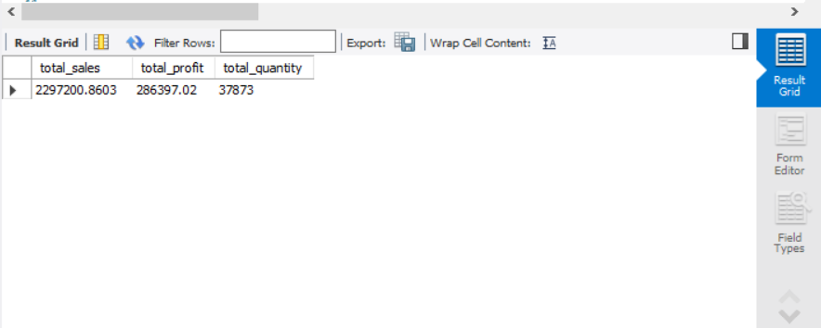

BUSINESS INSIGHT :

TOTAL SALES AMOUNTED TO $2297200
TOTAL PROFIT MADE WAS $286397

- GROUPING SALES AND PROFIT BY CATEGORY

select category,
sum(sales) as total_sales,
sum(profit) as total_profit
from superstore
group by category
order by total_sales desc;

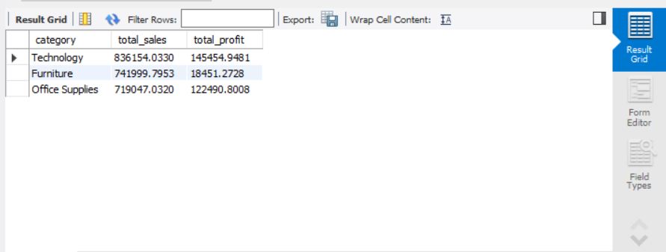

BUSINESS INSIGHT :

Technology generated the highest revenue and profit, indicating strong market demand and healthy margins. Even though Office supplies generated low revenue the profit was higher.

- SALES BY REGION

select region,
sum(sales) as revenue,
sum(profit) as total_profit
from superstore
group by region
order by revenue desc;

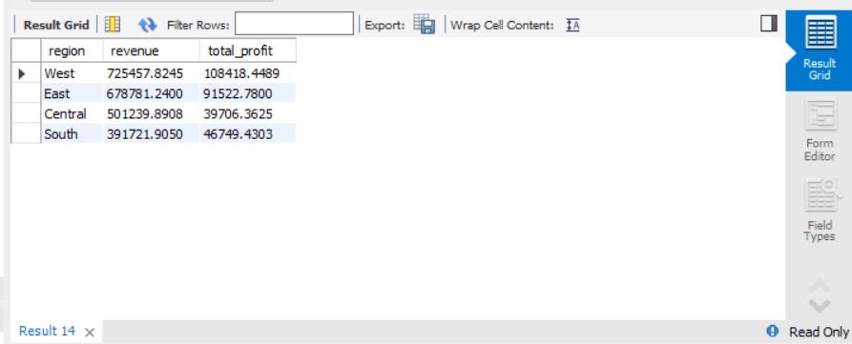

BUSINESS INSIGHT :

The west region generated the most revenue while the south performed the least of the profits.

- TOP 10 STATES BY SALES

select state,
round(sum(sales),2) as revenue
from superstore
group by state
order by revenue desc
limit 10;

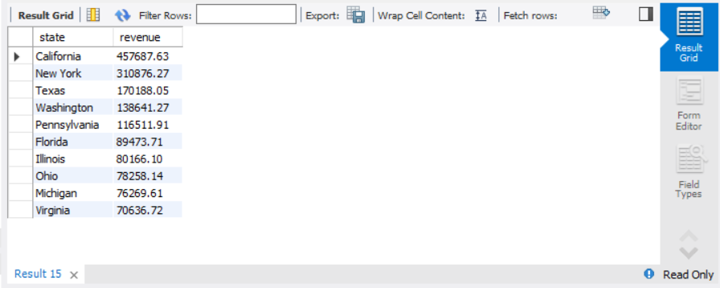

BUSINESS INSIGHT :

California performed well making it a hub for goods.

- TOP 10 CITIES BY SALES

select city,
round(sum(sales),2) as revenue
from superstore
group by city
order by revenue desc
limit 10;

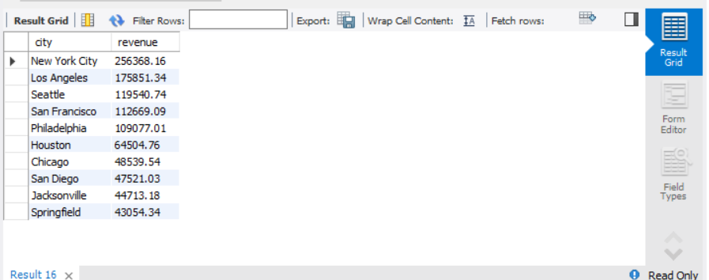

BUSINESS INSIGHT :

New york city performed well making it a valuable market.

- MOST PROFITABLE CATEGORIES

select category,
round(sum(sales),2) as revenue
from superstore
group by category
order by revenue desc;

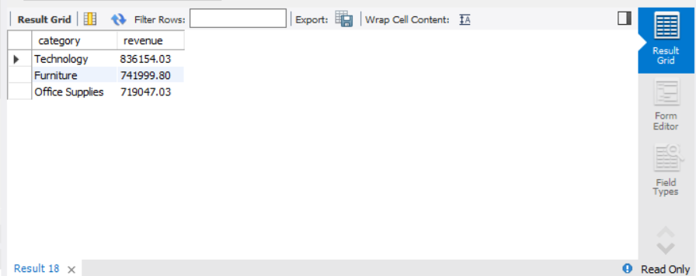

BUSINESS INSIGHT :

Technology, without doubt generated the most revenue in this tech savvy world.

- LOSS MAKING CATEGORIES

select category,
round(sum(sales),2) as revenue
from superstore
group by category
Having revenue<0;


BUSINESS INSIGHT :

Identifying the loss making region can make us safe but none of the above database made loss.

- AVERAGE PROFIT BY REGION

select region,
avg(profit) as avg_profit
from superstore
group by region
order by region desc;

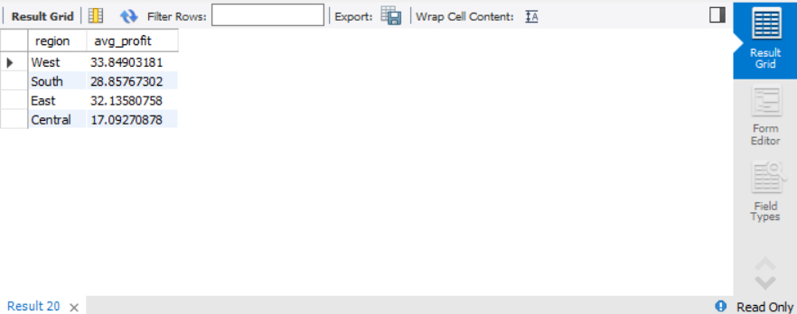

- AVERAGE DISCOUNT BY CATEGORY

SELECT
category,
ROUND(AVG(discount),2) AS avg_discount
FROM superstore
GROUP BY category;

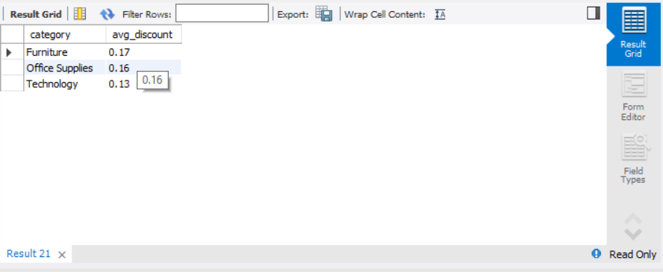

- DISCOUNT VS PROFIT

SELECT
discount,
ROUND(AVG(profit),2) AS avg_profit
FROM superstore
GROUP BY discount
ORDER BY discount;

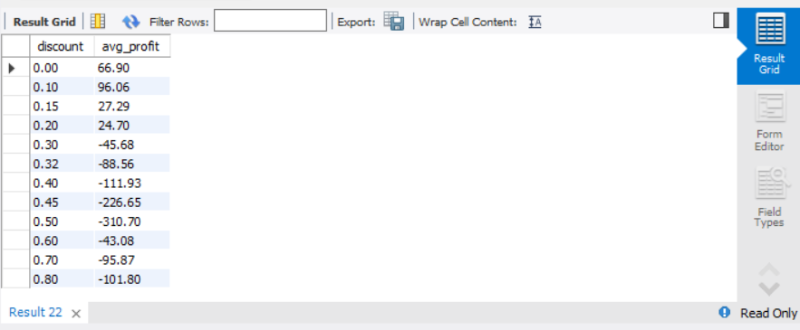

BUSINESS INSIGHT :

The discount value gets higher and the profit value gets lower. This is a good example of inverse proportion.

- AVERAGE DISCOUNT VS TOTAL PROFIT

SELECT
category,
ROUND(AVG(discount),2) AS avg_discount,
ROUND(SUM(profit),2) AS total_profit
FROM superstore
GROUP BY category;

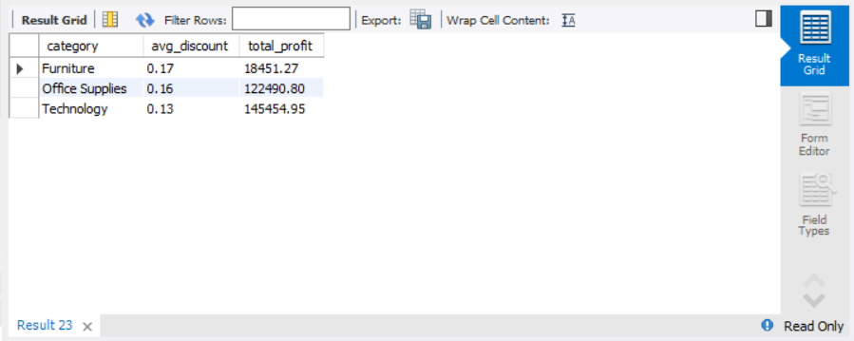

- MOST PROFITABLE SUB-CATEGORIES

SELECT
sub_category,
ROUND(SUM(profit),2) AS total_profit
FROM superstore
GROUP BY sub_category
ORDER BY total_profit DESC
LIMIT 10;

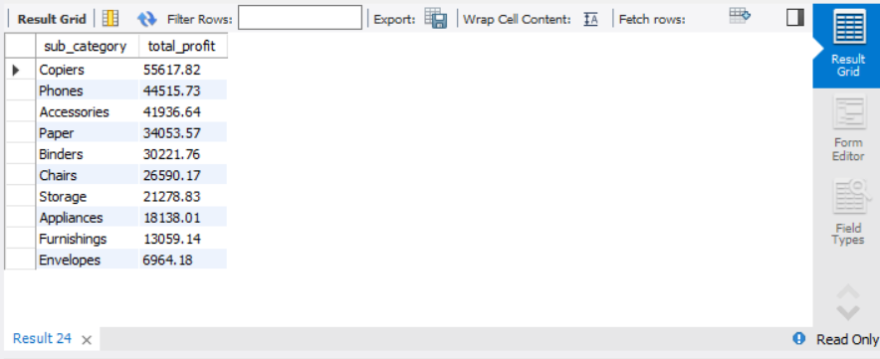

- LEAST PROFITABLE SUB-CATEGORIES

SELECT
sub_category,
ROUND(SUM(profit),2) AS total_profit
FROM superstore
GROUP BY sub_category
ORDER BY total_profit ASC
LIMIT 10;

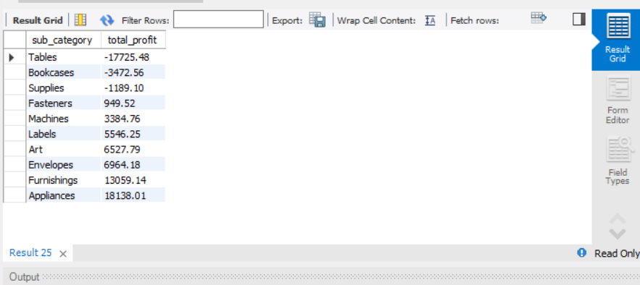

- LOSS MAKING STATES

SELECT
state,
ROUND(SUM(profit),2) AS total_profit
FROM superstore
GROUP BY state
ORDER BY total_profit ASC
LIMIT 10;

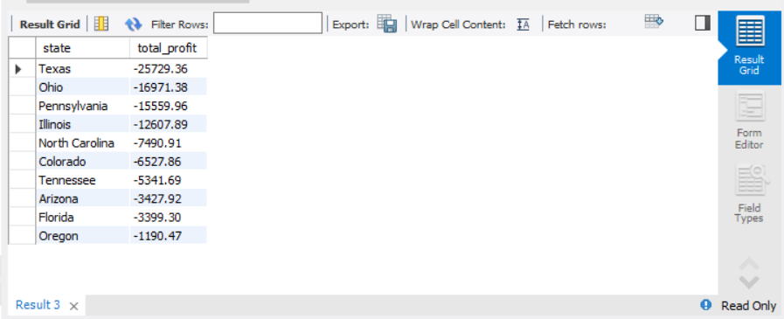

BUSINESS INSIGHT:

The Texas state is making so much loss and its highly alarming.

