466/566 Assignment No.2: Gene Expression Analysis

Objective: Build your Python program that can compare results of gene expression analysis and conduct motif finding.

Due Date: 06:00 PM, Friday, Oct 4, 2019. Late submission will incur 5 % penalty per day and after 10-day period, your assignment will not be graded.

General Requirement:

You are provided with two files that contain a list of genes with significantly differential gene expressions. These data are obtained from three types of tissues (C: healthy control tissues, L: lung cancer tissues, P: prostate cancer tissues). The numbers indicate the average copy numbers of mRNAs expressed (or measured) for each gene by sequencing mRNAs in a specific tissue (C, L or P). For instance, the gene with GeneID of ENSEMBL008 has a much higher expression level in L than in C, whereas it has a much lower expression level in C than in P. In general, when we compare two tissue types (e.g., L versus C), up-regulated genes (denoted as ‘+’) in L using C as the reference can be simply defined as those with NumL/NumC≥1.5, which means that the expression of a given gene in tissue type L is more than 1.5 fold change than that in tissue type C. Accordingly, down-regulated genes (denoted as ‘-’) in L using C as the reference can be simply defined as those with NumC/NumL≥1.5. If the expression level of a gene in one tissue is 0 whereas it has an expression of over 5 in the other tissue, we will treat it as a special case, marked as ‘s’. If a gene is neither up-regulated or down-regulated, we use ‘.’ symbol to indicate that expression change for this gene is not significant enough. For example, NumL/NumC=1 will indicate no change in gene expression between two tissue types for a given gene. Your program will need to decide whether the expression of a given gene has a consistent or different status (i.e., ‘+’, ‘-’ , ‘.’ or ‘s’) between two measurements comparisons (i.e., the comparison between NumL and NumC in file cancer_lung_expression.txt versus the comparison between NumP and NumC in file cancer_prostate_expression.txt). If a gene is labelled as the same status, your program will print ‘Congruence’. Otherwise, your program will print ‘Disparity’ for that specific gene (see the output example on page 3).

(1) File Name: cancer_lung_expression.txt (Tab-delimited file)
GeneID NumL NumC
ENSEMBL001 5 15
ENSEMBL002 0 60
ENSEMBL003 5 25
ENSEMBL004 7 20
ENSEMBL005 22 40
ENSEMBL006 77 81
ENSEMBL007 88 2
ENSEMBL008 62 8
ENSEMBL009 6 18
ENSEMBL010 20 4

(2) File Name: cancer_prostate_expression.txt (Tab-delimited file)
GeneID NumP NumC
ENSEMBL001 30 15
ENSEMBL002 10 60
ENSEMBL003 41 25
ENSEMBL004 0 20
ENSEMBL005 67 40
ENSEMBL006 9 81
ENSEMBL007 2 2
ENSEMBL008 90 8
ENSEMBL009 0 18
Moreover, your program needs to find the common gene set for these two expression files, the gene set expressed in any of these two files, and the gene sets uniquely expressed in only one of these two files. What is the biological or biomedical relevance related to these different gene sets? Well, based on your finding, for instance, the common genes for both cancer_lung_expression.txt and cancer_prostate_expression.txt might be the candidate genes that cause cancers in general, and the unique genes in each file might be the candidate genes that cause lung cancer or prostate cancer specifically. Then, researchers can take further action to explore these candidate genes in depth.

We will also provide you with two FASTA files (gene.1.fa and gene.2.fa), which are the sequences for the genes shown in the aforementioned two files of gene expression experiments.

(3) File Name: gene.2.fa
>ENSEMBL001 gene_A
TGTCCAACGGGCCGAGGTTGTCTCTTTCGAGATCTTGTCGCGGGGGGGGGCTGCCTGTGGCGGTGGGTGG
AGTGCGGGTCACAGATGCCTCGCACCCCTCCCCCGACAATGTGGCCCGTATGGAGGGTCTCG
>ENSEMBL002 gene_D
CCTGCCGCCGCGGGCGCGCATGCGCCCCGGCCCGTACTGGCCGGTGGTGCACCCGGCTGCGGGATCACCT
CCGACACCCCGAGCGGGCCCGGGTTTTCACGTGCCTGGTCCCGCCACGCCCACCACATCTGGCGG
>ENSEMBL003 gene_P
CGTCCTGCGGTCCGTGCACGGCGCCGCCCCCGTGCGGCTCAAGGCGGCCGCGGTGCTACGCGGCAGGCCG
TCATCGAGCTCAAGACAGGTGTCAGTGGGGGTTCGTAGGGTGGG
……

The gene.1.fa is similar to gene.2.fa except that all sequences in gene.1.fa is longer than those in gene.2.fa. Creation of two fasta files is only for the purpose of testing your code, so that you will not “hard-code” the printout (see below). When we test your program, we only use one of these two FASTA files. For example, we will issue the following commands to test your program:

$python3 MiamiID_assign2.py -f gene.1.fa -l cancer_lung_expression.txt -p cancer_prostate_expression.txt
$python3 MiamiID_assign2.py -f gene.2.fa -l cancer_lung_expression.txt -p cancer_prostate_expression.txt

Obviously, you need to codes command line options -h -f -l -p and their long options --fas=, --lung=, and --pros=.

Once your program gets the common gene set for both two files, the gene set unique to file (1) and the gene set unique to file (2), your program will prompt the user to ask him/her which set is selected for motif finding. For instance, if a user selects the common gene set (e.g., ENSEMBL001, ENSEMBL008, ENSEMBL009, ENSEMBL010 and ENSEMBL0110), your program will conduct motif finding for every gene sequences from this set using gene.1.fa or gene.2.fa, which is specified as -f option and value.

Then, your program is expected to give the following print-out in the exact format. Anything different from this format will incur deduction of points:

1. Files: FASTA (gene.2.fa) Cancer Exp (cancer_lung_expression.txt,cancer_prostate_expression.txt)

2. Expression Data for cancer_lung_expression.txt
GeneID NumL:NumC:Exp
ENSEMBL001 5:15:-
ENSEMBL003 5:25:-
ENSEMBL004 7:20:-
ENSEMBL005 22:40:-
ENSEMBL006 77:81:.
ENSEMBL007 88:2:+
ENSEMBL008 62:8:+
ENSEMBL009 6:18:-
ENSEMBL010 20:4:+
ENSEMBL011 30:5:+
ENSEMBL013 25:27:.
…

3. Expression Data for cancer_prostate_expression.txt
GeneID NumP:NumC:Exp
ENSEMBL001 30:15:+
ENSEMBL002 10:60:-
ENSEMBL003 41:25:+
ENSEMBL005 67:40:+
ENSEMBL006 9:81:-
ENSEMBL007 2:2:.
ENSEMBL008 90:8:+
ENSEMBL010 21:4:+
ENSEMBL011 3:5:-
ENSEMBL012 5:21:-
ENSEMBL013 4:27:-
ENSEMBL015 17:31:-
…

4. Expression Comparison (cancer_lung_expression.txt) vs (cancer_prostate_expression.txt)
ENSEMBL001 NumL:NumC:Exp (5:15:-) NumP:NumC:Exp (30:15:+) Disparity
ENSEMBL019 NumL:NumC:Exp (29:7:+) NumP:NumC:Exp (22:7:+) Congruence
ENSEMBL017 NumL:NumC:Exp (47:22:+) NumP:NumC:Exp (10:22:-) Disparity
ENSEMBL022 NumL:NumC:Exp (44:3:+) NumP:NumC:Exp (3:3:.) Disparity
ENSEMBL007 NumL:NumC:Exp (88:2:+) NumP:NumC:Exp (2:2:.) Disparity
ENSEMBL024 NumL:NumC:Exp (42:8:+) NumP:NumC:Exp (4:8:-) Disparity
…

5. Common Genes for cancer_lung_expression.txt and cancer_prostate_expression.txt
ENSEMBL001, ENSEMBL019, ENSEMBL017, ENSEMBL022, ENSEMBL007, ENSEMBL024…

6. Genes unique for cancer_lung_expression.txt
ENSEMBL018, ENSEMBL009, ENSEMBL014, ENSEMBL004, ENSEMBL023

7. Genes unique for cancer_prostate_expression.txt
ENSEMBL016, ENSEMBL025, ENSEMBL012, ENSEMBL002

8. Which set do you want to examine (5|6|7) 6

8. Your answer is [6]
We will do motif finding for the following sequences:
ENSEMBL007, ENSEMBL005, ENSEMBL003

ENSEMBL003
Motif Frequency Position (Start-End)
AAGAA 5 [5-9,15-19,25-29,…]
AAGAAA 1 [13-18]
AAGTAA 2 [24-29, 105-110]
…

ENSEMBL005
Motif Frequency Position (Start-End)
AAGAA 5 [5-9,15-19,25-29,…]
AAGAAA 1 [13-18]
AAGCAA 2 [24-29, 105-110]
…

ENSEMBL007
Motif Frequency Position (Start-End)
AAGAA 5 [5-9,15-19,25-29,…]
AAGAAA 1 [13-18]
AAGGAA 2 [24-29, 105-110]
…

The common motifs for this set of genes are AAGAA, AAGAAA, …

# For CSE students, you do need to show position coordinates, whereas other students are not required to show position coordinates. All other displays are similar for all students.

Specific Requirements for functions:

(1) def get_seq_fasta(file_name): This function takes file name (e.g., either gene.1.fa or gene.2.fa) as the input. It will return a dictionary where the key is the sequence name and the value is the sequence. All the sequences within the fasta file needs to be saved into such dictionary.

(2) def get_expression(file_name): This function takes one expression file as the input (tab-delimited file) and returns 5 variables: dict, col1, col2, col3, col4 into the main program. The dictionary will has a key like ENSEMBL003, with the value like 5:25:-, whereas col1, col2 and col3 are variables that dynamically store column head or label information, such as GeneID, NumL and NumC. The last variable col4 can store the string Exp as its value. To generate the output as shown in part 2. and 3. as shown in the previous printout, you must have print statements inside your main program, not in this function. The part 1. shown in the previous printout also needs to be printed in the main program, not in this function.

(3) def common_genes(dict1, dict2): This function takes two dictionaries generated by function get_expression() and returns a set called common_set that stores the common expressed genes (GeneID) presenting in both dictionaries. If the expression level of a gene in one tissue is 0, it will be treated as an unexpressed gene. The function call for this function will generate part 5. as shown in the previous printout. The relevant print statement must be in your main program, not in this function.

(4) def unique_genes(dict1, dict2): This function takes two dictionaries generated by function get_expression() and returns two sets: one is called uniq_g1 and the other uniq_g2 . uniq_g1 will store the expressed genes (GeneID) only presenting in file (1) not in file (2). uniq_g2 will store the expressed genes (GeneID) only presenting in file (2) not in file (1). The function calls for this function will generate part 6. and 7. as shown in the previous printout. The relevant print statements must be in your main program, not in this function.

(5) def compare(dict1, dict2, common_set): This function takes two dictionaries generated by function get_expression()and the common_set generated by common_genes(). This function will not return anything to the main program. Instead, it will have print statements that give a print-out as shown in part 4. in the previous print-out. Here, strings (NumL:NumC:Exp) and
(NumP:NumC:Exp) can be hard-coded and embedded within the print statements.

(6) def motif_finder(dict): This function takes a dictionary as the input, where the keys and values are gene names and sequence of the gene, respectively. The motif is ‘AAG*AA’, where ‘*’ means any base of ATGC of length 0-2 (eg. AAGAA, AAGTAA, AAGCAA, AAGTTAA). This function will return a dictionary, where the keys are the gene names and the values are lists of tuples, where each list element is the tuple of one targeted motif and its occurrence (eg. {'ENSEMBL001': [('AAGAA', 15),('AAGTAA',3),( 'AAGCAA',1) … ], 'ENSEMBL006': [('AAGAA', 5),('AAGTAA',1),( 'AAGCAA',2) … ],…}).

(7) def motif_finder_CS(dict): For CS students, you have different requirement than biology students. This function has the same input as the function motif_finder(), however, it will return a dictionary, where the keys are the gene names, the values are the nested dictionaries. For the nested dictionaries, each key is the targeted motif and each value is a list of tuples that show start and end positions of the detected motif (e.g., {'ENSEMBL001': {'AAGAA':[(5,9),(25,29),(35,39)…],'AAGTAA':[(85,90),(106,121)],'AAGCAA',[(11,16),(40,45)] … ]}, 'ENSEMBL006': {'AAGAA':[], 'AAGTAA':[], 'AAGCAA',2[]…}).

For both CSE students and BIO students, in your main program, in your main program, you need to write codes to find common motifs returned by the function call of motif_finder_CS()and motif_finder(), respectively.

(8) def heatmap (dataframe1, dataframe2, imgfile): This is one more function specifically for CSE students. This function takes two dataframes(one for ‘cancer_lung_expression’ file, the other one for ‘cancer prostate_expression’ file) as the input and generate a heatmap as the output. For each expression file, you need to calculate the fold change of cancer expression level to the control, where FoldC_L equal to NumL/NumC, and FoldC_P equal to NumP/NumC. Then you need to use the fold change values to plot a heatmap. The X axis shows different groups (e.g. FoldC_L VS. FoldC_P) while the Y axis includes the gene names. A title is needed for each plot, and the plot is saved in a file specified by imgfile as the file name. 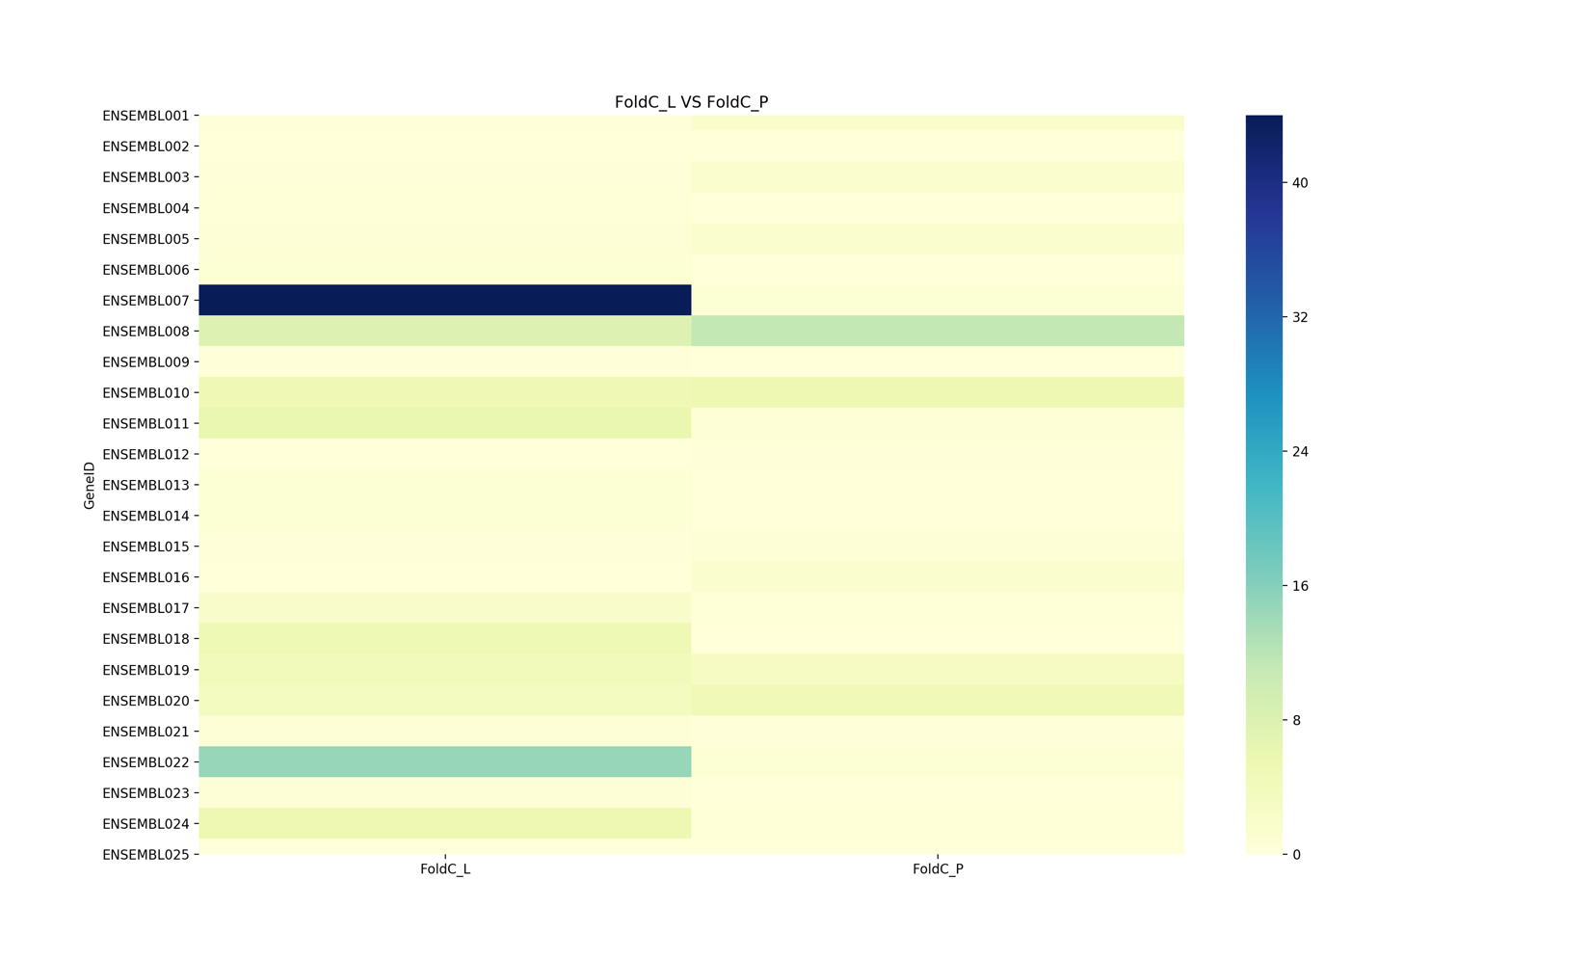
Grading Rubrics

Coding Components | % grades for others | % grades for CSE
(1) get_seq_fasta() | 15 | 10
(2) get_expression() | 10 | 10
(2) common_genes() | 10 | 10
(3) unique_genes() | 10 | 10
(4) compare() | 10 | 15
(5) motif_finder() | 15
(7) motif_finder_CS() |  | 15
(8) heatmap() |  | 10
Main portion of the script | 20 | 10
Proper Comments, Names, Format, Design | 10 | 10
Total Grade Points | 100 | 100

