AWS-TASk-2

Set up a VPC with an Internet gateway, create a public subnet with 256 IP addresses, a private subnet with 256 IP addresses, make a route table connecting the Internet gateway and the subnets, and launch a Linux EC2 instance by using the above VPC and public subnet.

Step 1  
Creating VPC  
  
Step 2   
After creating VPC then I proceed to create internet gateway

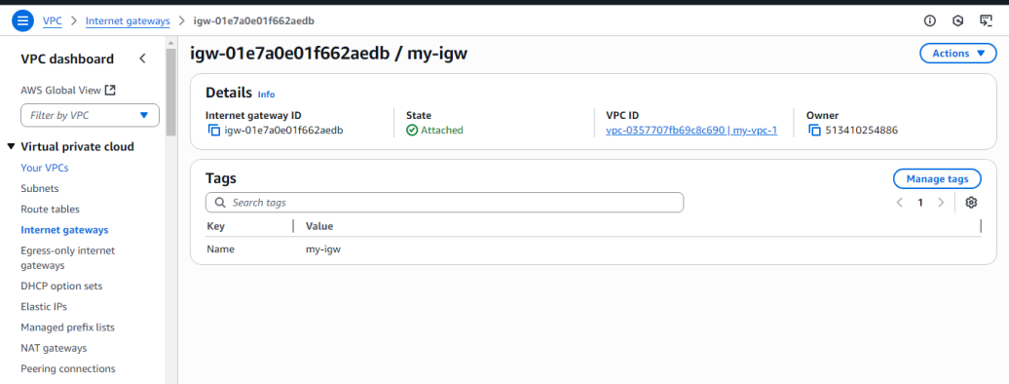

Step 3   
After creating IGW I am creating two subnets   
1. PublicSubnet – IPV4 as (10.0.1.0/24)  
2.PrivateSubnet - IPV4 as (10.0.2.0/24)  
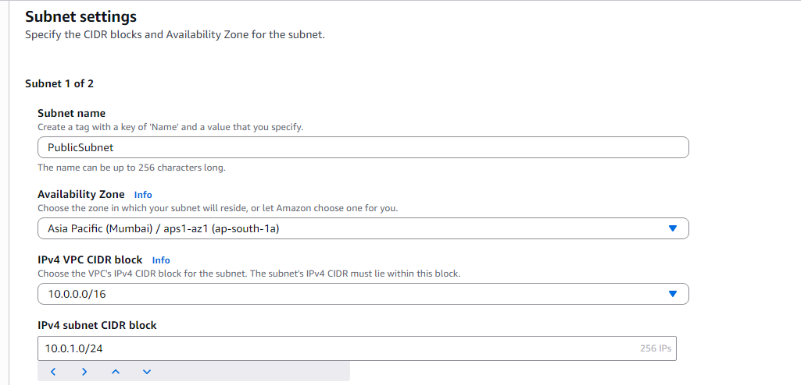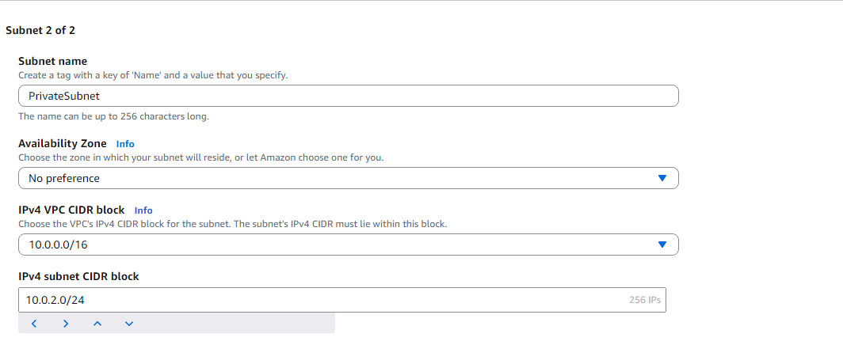

Step 4

After creating IGW I am creating Route Table

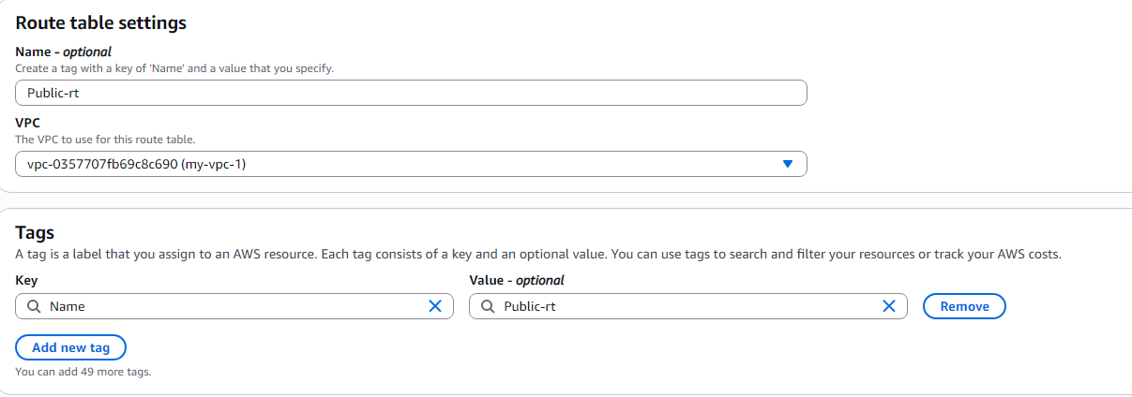

Step 5

Enabling IPV4  
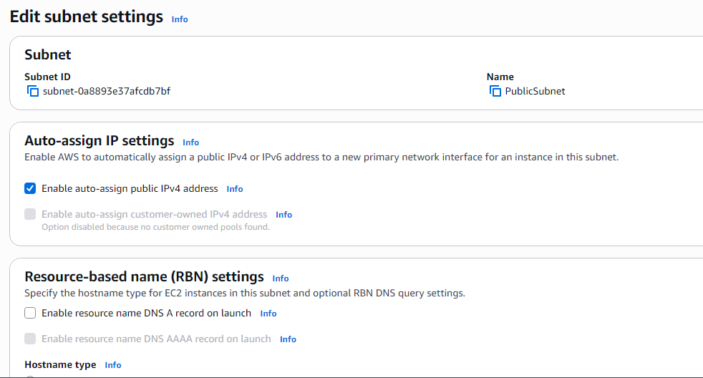

Step 6

Launching an instance

In network setting I going to edit I am updating my VPC here

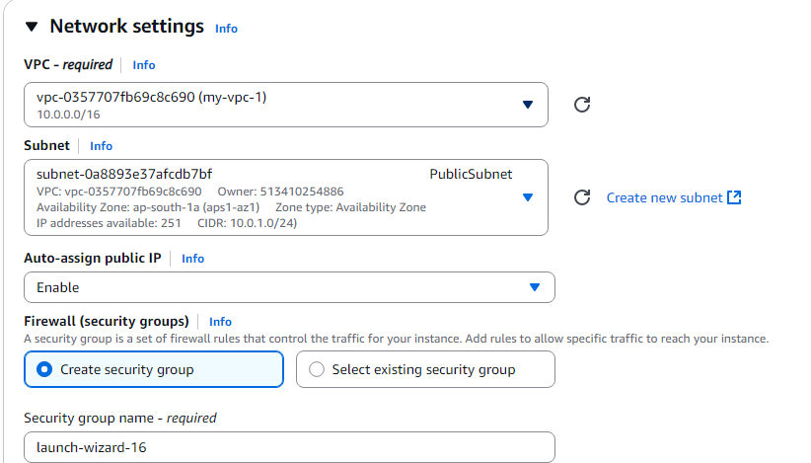

O/P

