**AWS Task-3**

**Task Description:**

1. Create a S3 bucket, with no public access and upload files to the bucket & view the logs using cloudwatch for the uploaded files.
2. Launch two ec2-instances and connect it to a application load balancer, where the output traffic from the server must be an load balancer IP address

Step 1

Created the S3 bucket with private access

My bucket name: **my-aws-task3-19-9**

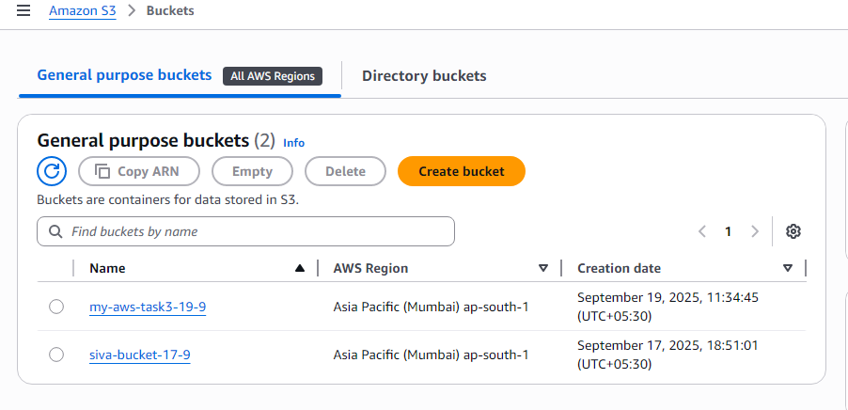

Step 2:

I am uploading an image file

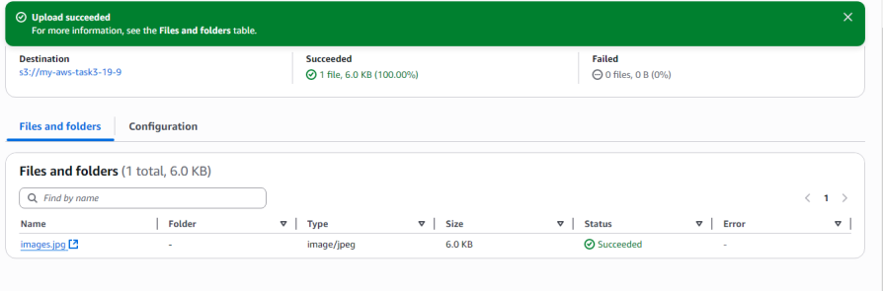

Step 3:

Creating a Cloud trail

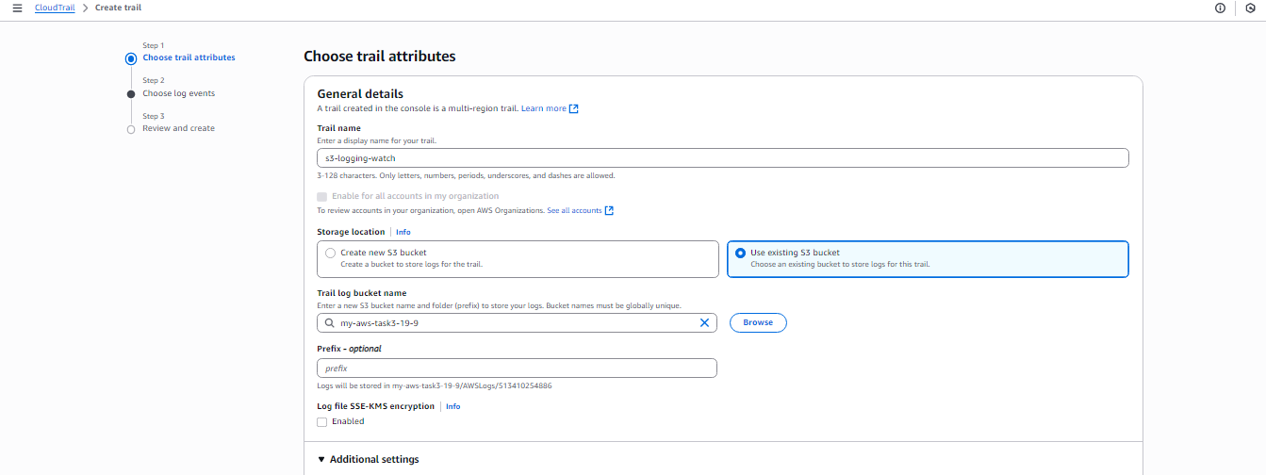

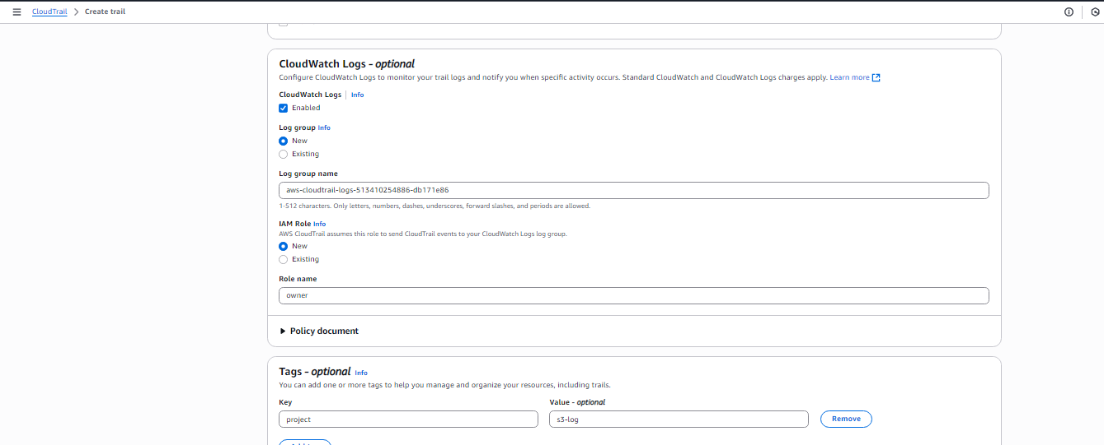

Step 4

Choosing the log events

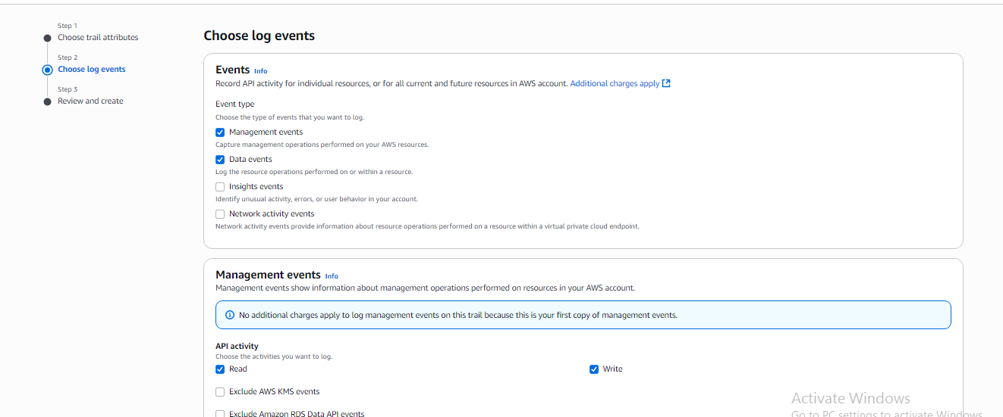

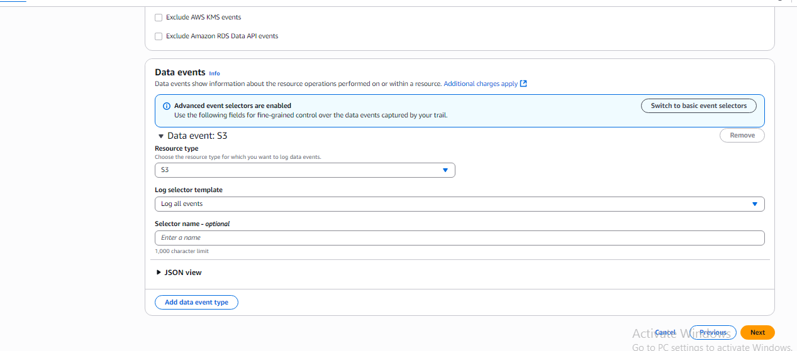

Step 5

Cloud trail Created

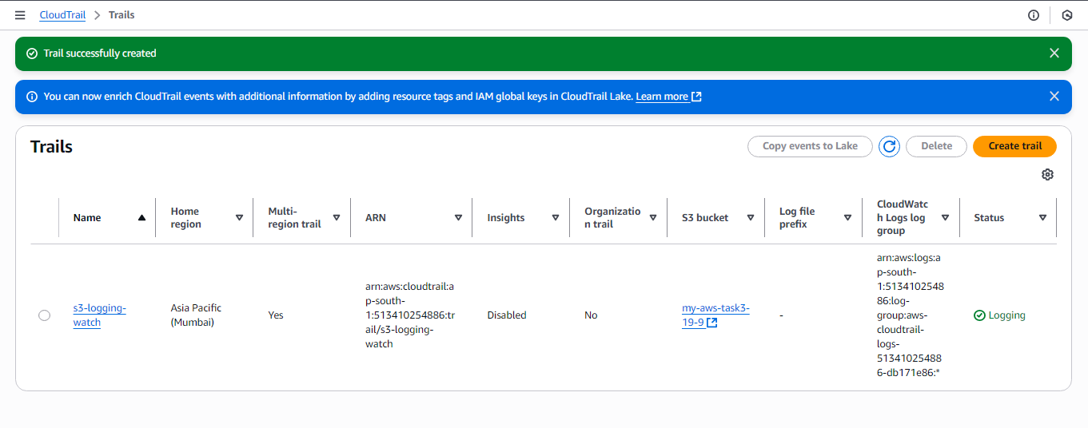

Step6

I have created 2 instances named as Web1 and Web2

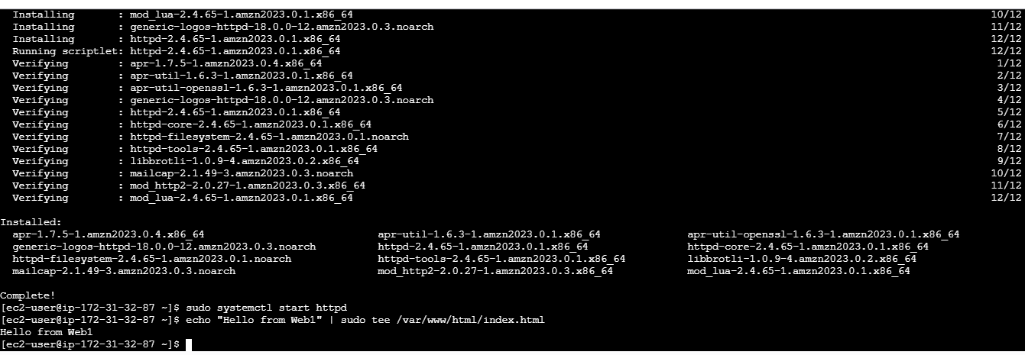

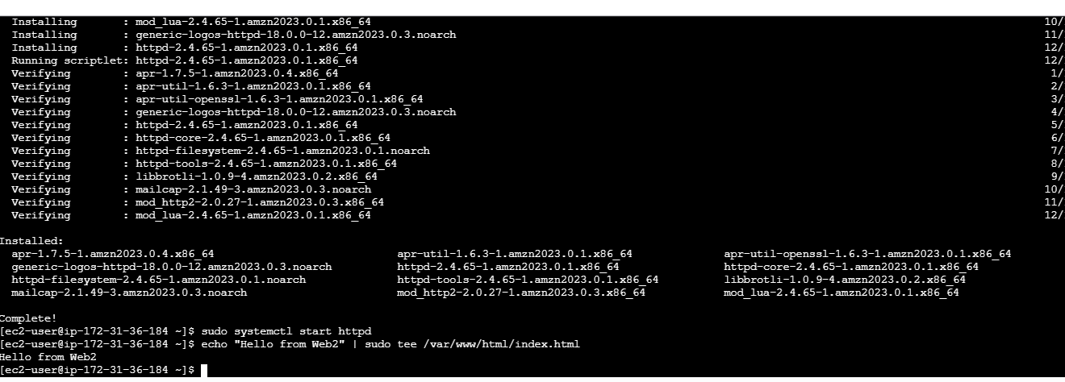

Step7

Creating the Load balancer

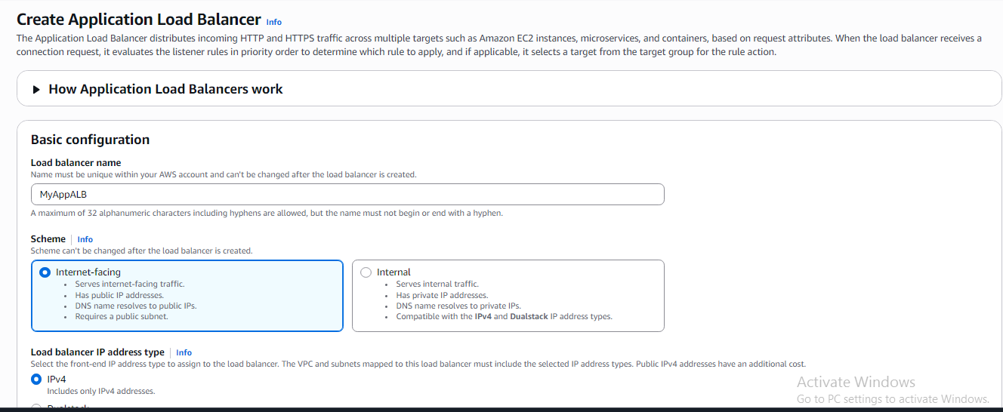

Step8

Creating Target Group

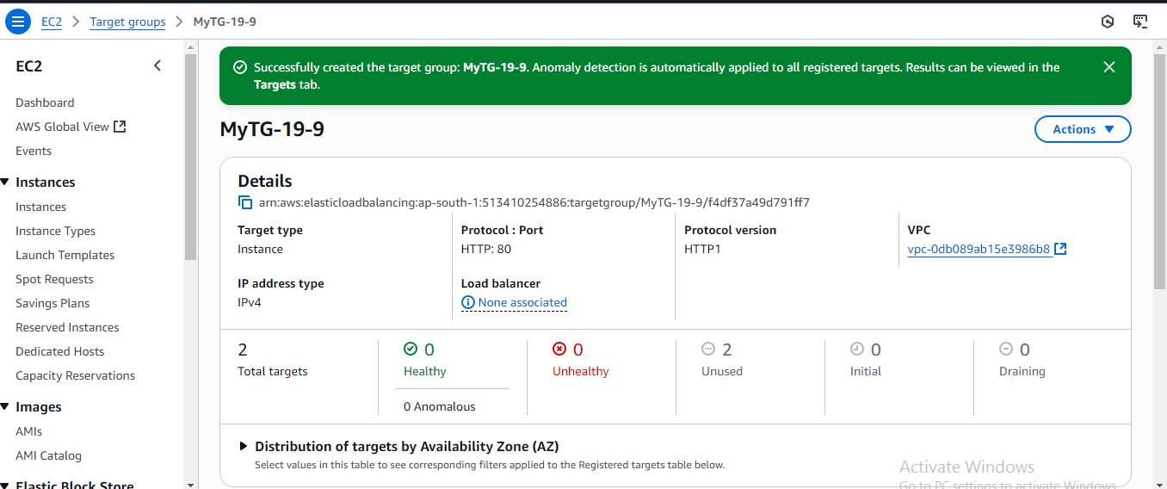

Step9

I added created target group in load balancer

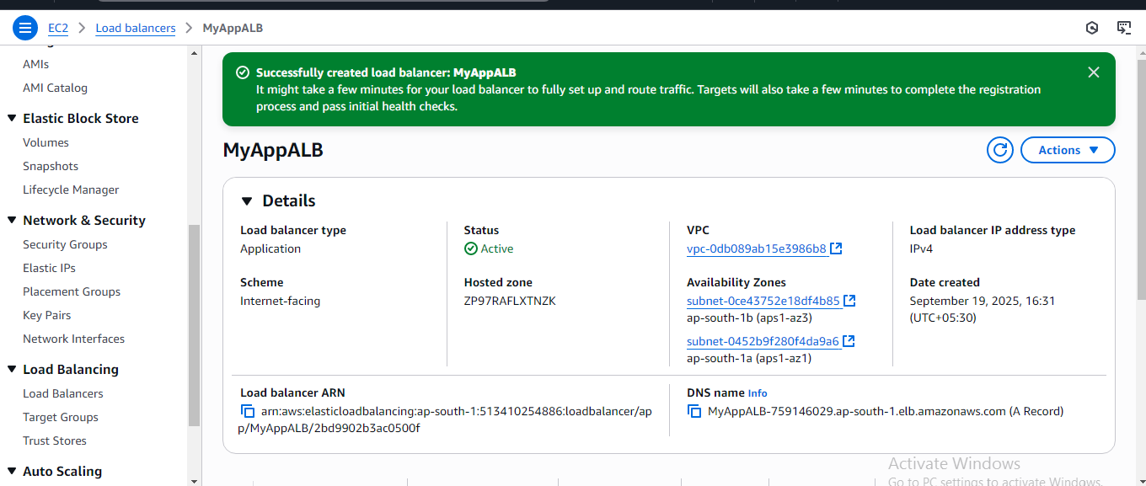

Step 10

Output is verified when I refresh the page instance get loaded

