1. Create a shell script to print the HTTP error code of guvi.in & print, the success/failure message based on the error code response

#!/bin/bash

url="https://guvi.in"

status_code=$(curl -o /dev/null -s -w "%{http_code}" $url)

echo "HTTP Status Code = $status_code"

if [ $status_code -eq 200 ]; then

echo "Success Website is working"

else

echo "Website return error code = $status_code"

fi

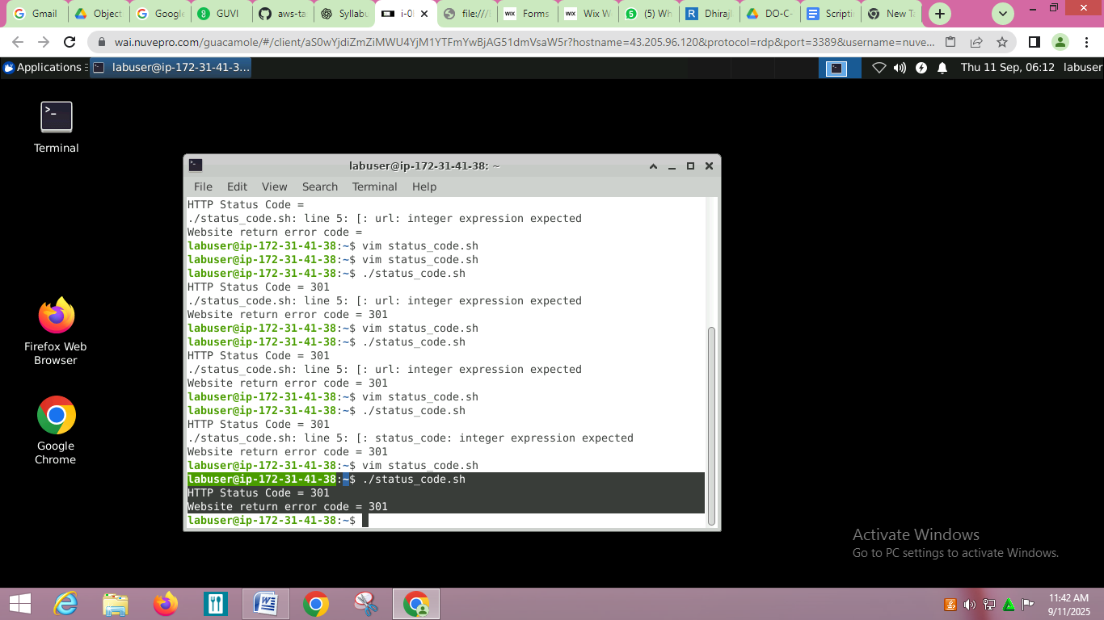

#!/bin/bash

if [ $# -eq 0 ]; then

echo "Usage: $0 <filename>"

exit 1

fi

INPUT_FILE=$1

sed -i '5,$s/give/learning/g' "$INPUT_FILE"

echo "Replacement done. File $INPUT_FILE updated."  
  
  
I/P

1 hello

2 give test

3 welcome give here

4 random line

5 give me give

6 welcome give

