**AWS Task-4**

**Task Description:**

Launch an EC2 instance (Linux and Windows) along with a web server. Then, create an EBS volume of 5 GB, attach it to an EC2 machine (Linux and Windows), and take a snapshot. Finally, create an EBS volume using the taken snapshot.

Step1

I created a EC2 instance in linux server

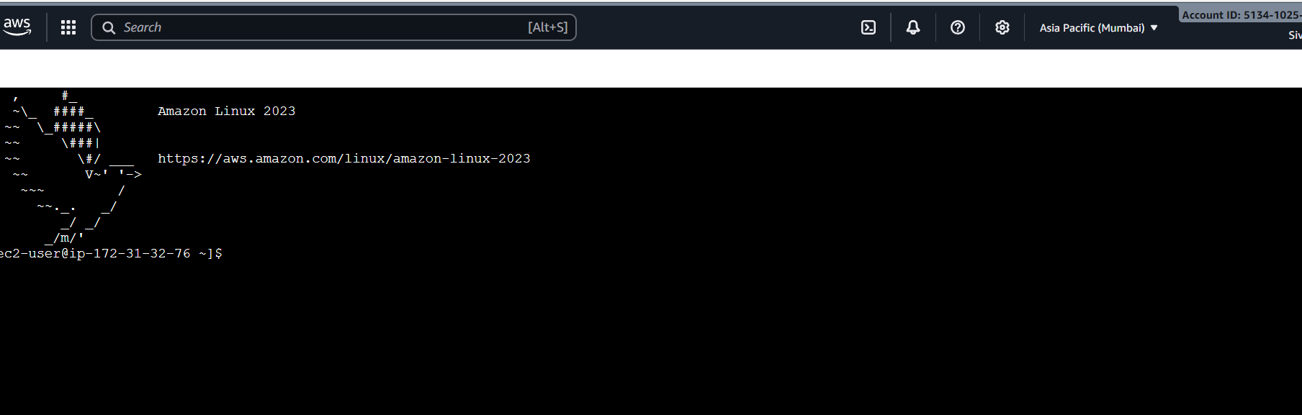

Step 2

I am launching the Linux server

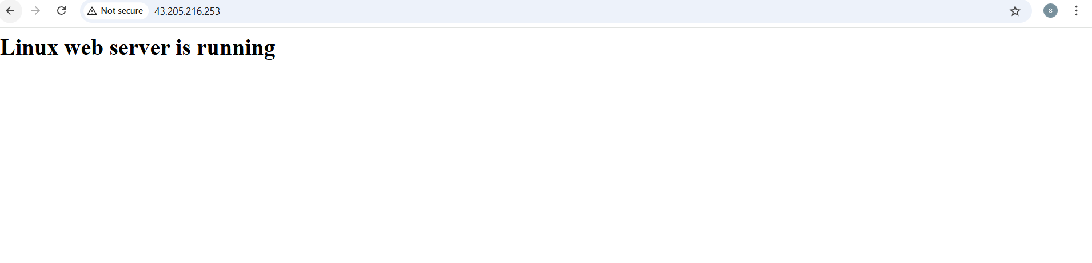

Step 3

Launching an windows server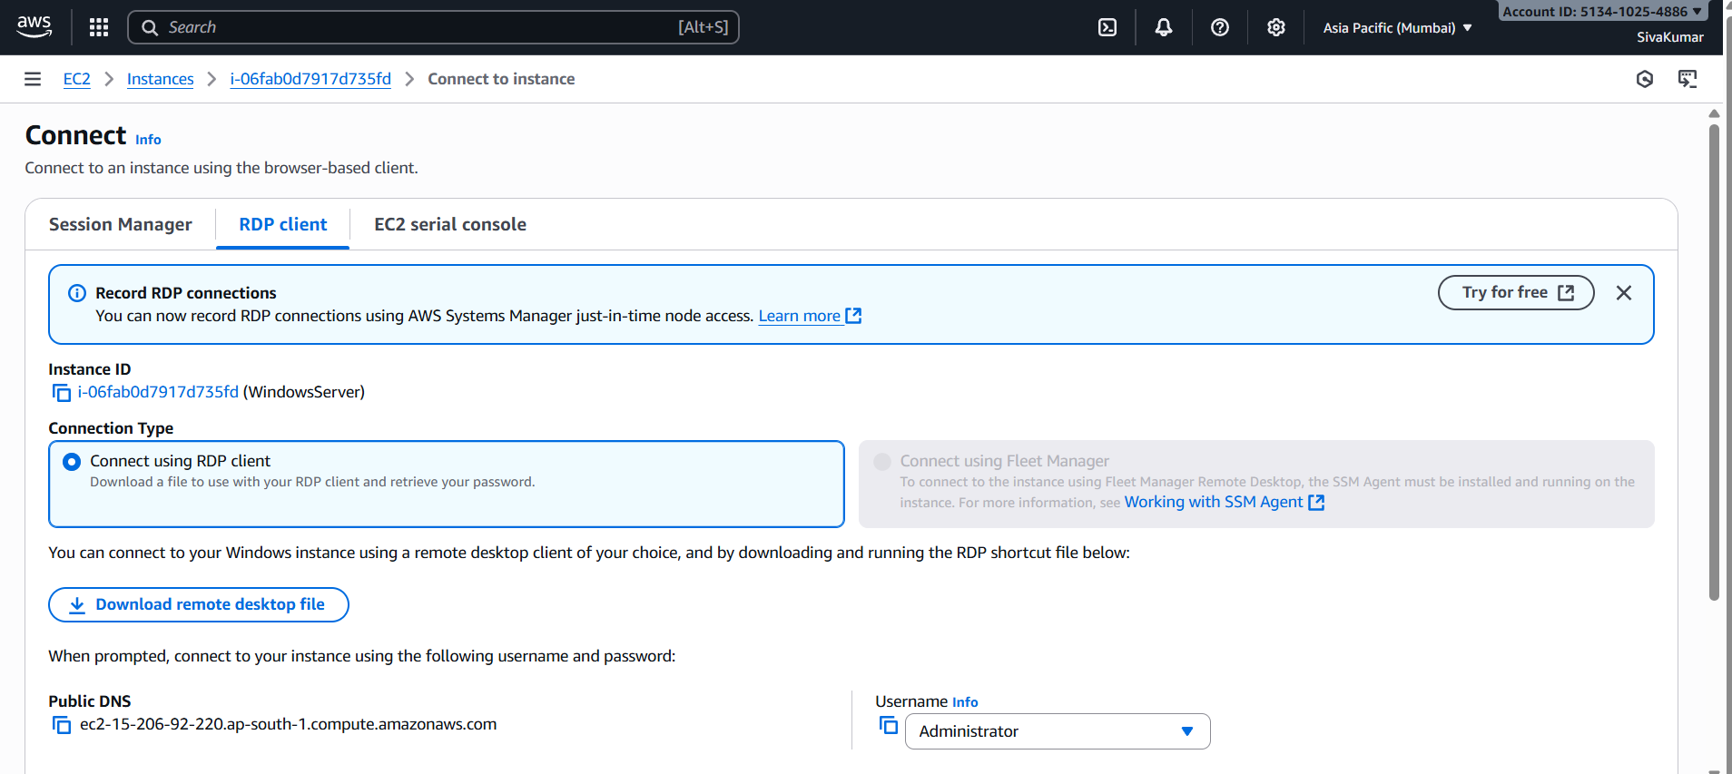

Step 4

I am connecting my windows server in my local RDP

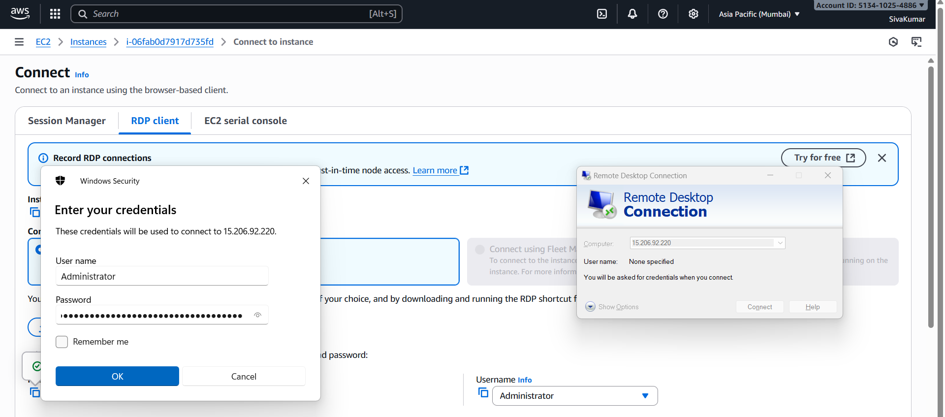

Step5

My windows machine



Step 6

I got an output from my RDP

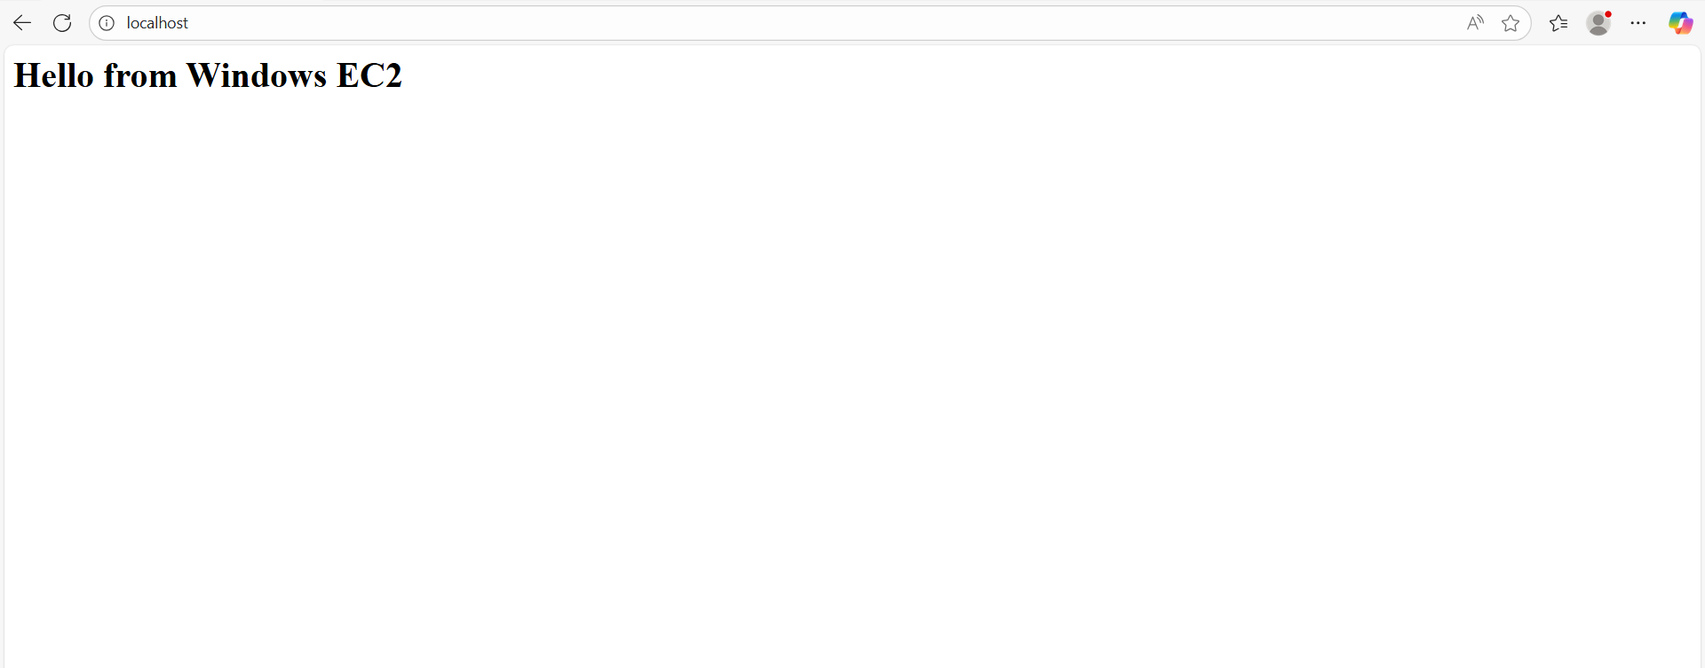

Step 7

I got my output from my local machine

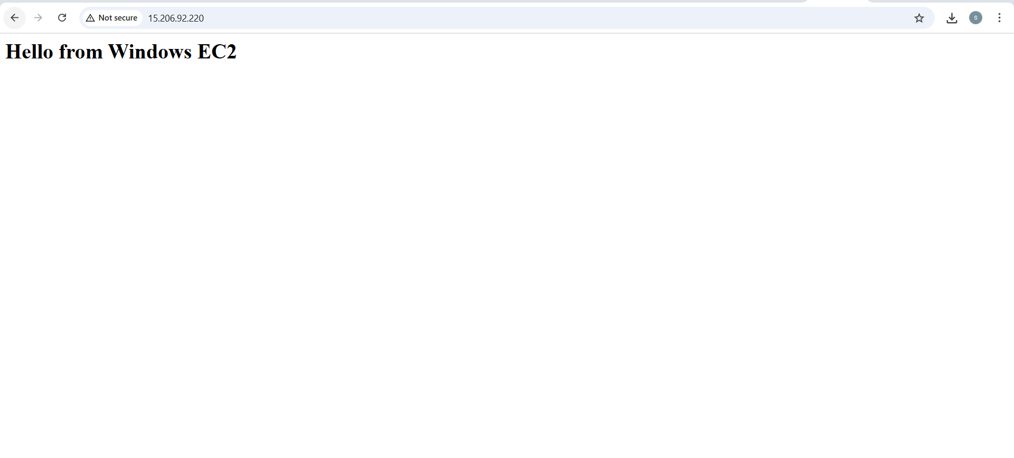

Step 8

I am creating a volume to 5 GB

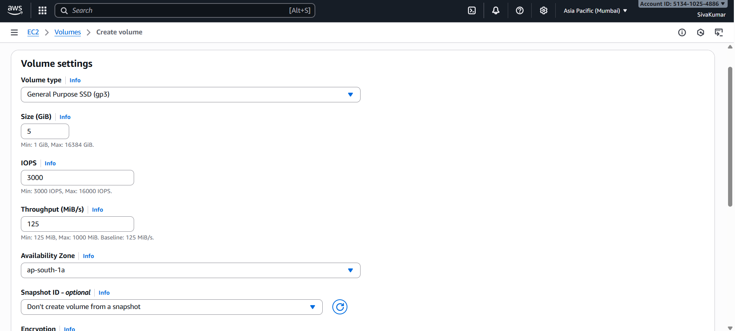

Step 9

I am attaching my Linux instance to volume

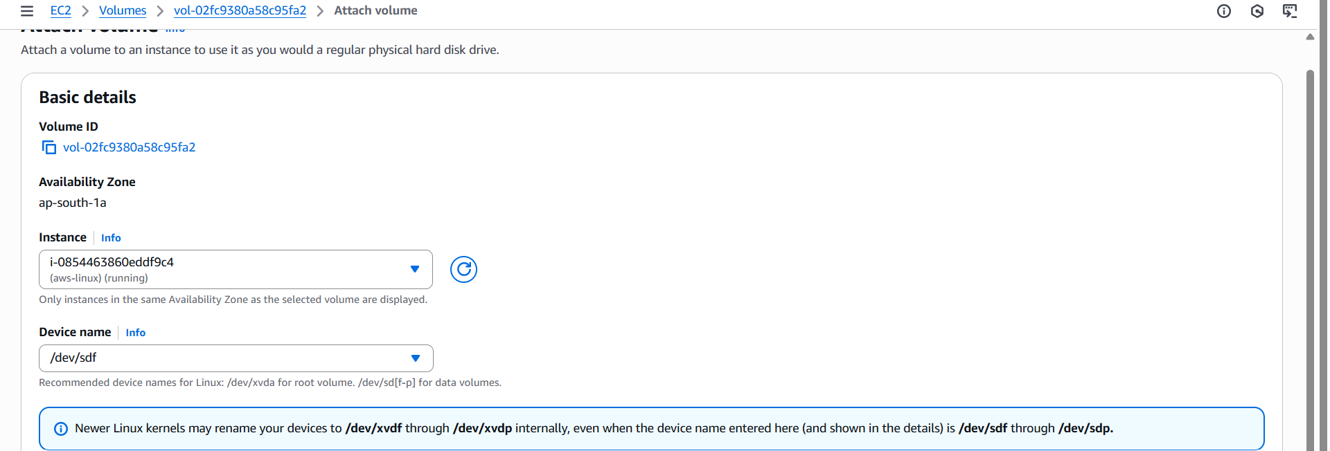

Step 10

Output for linux

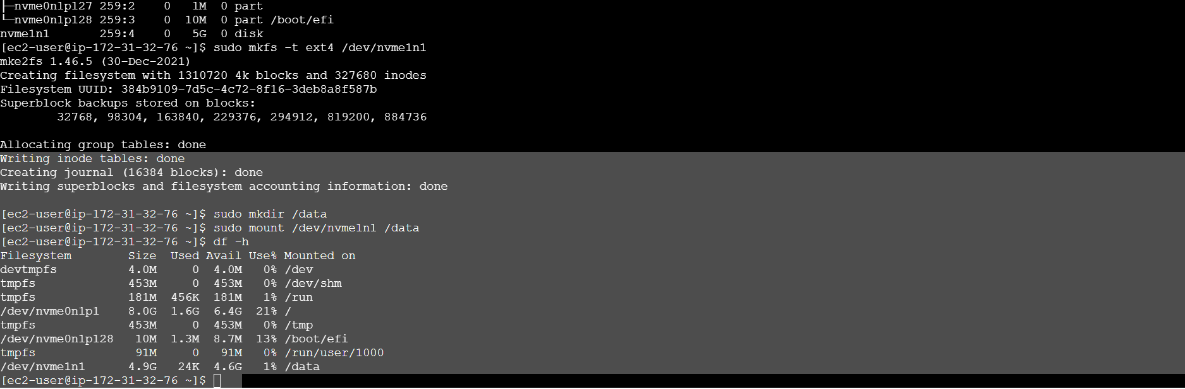

Step 11

I attached volume for windows instance

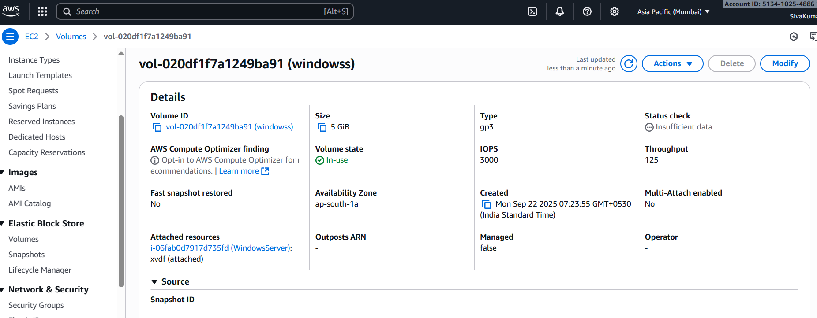

Step 11

Partition done for windows as E:

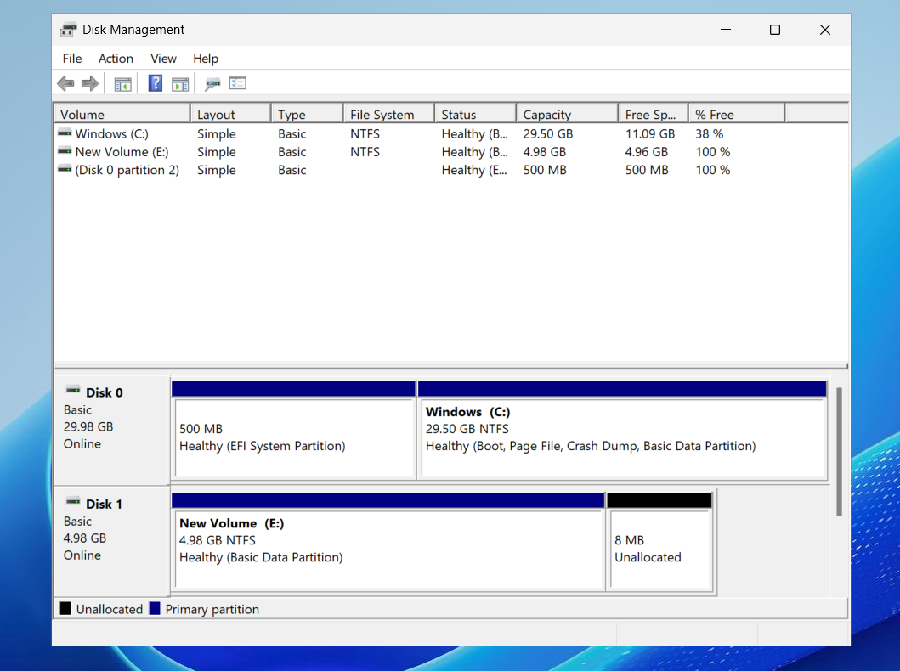

Step 12

Creating snapshot for Linux

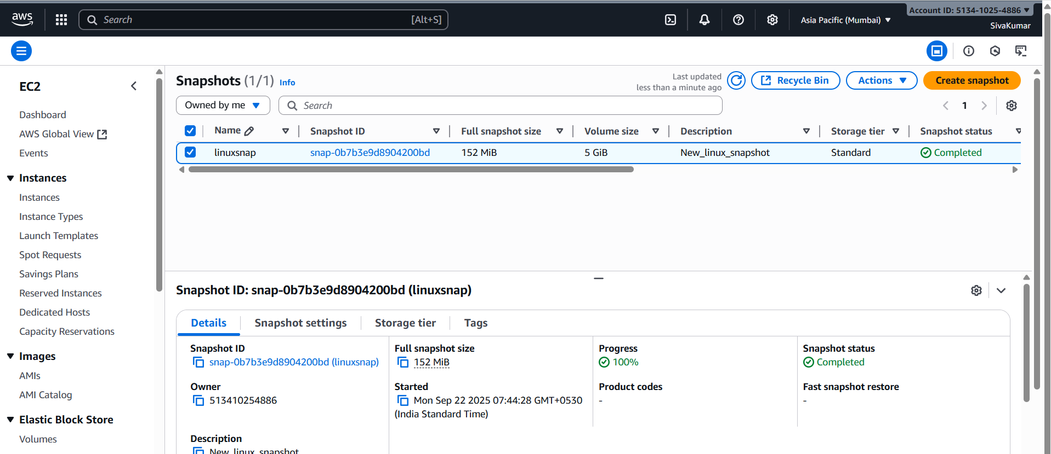

Step 12

Creating snapshot for windows

