Task Description:

Install Prometheus and Grafana on a Linux EC2 machine, connect Prometheus to Grafana, and create a dashboard to view metrics.

Step 1
Launch an EC2 instance
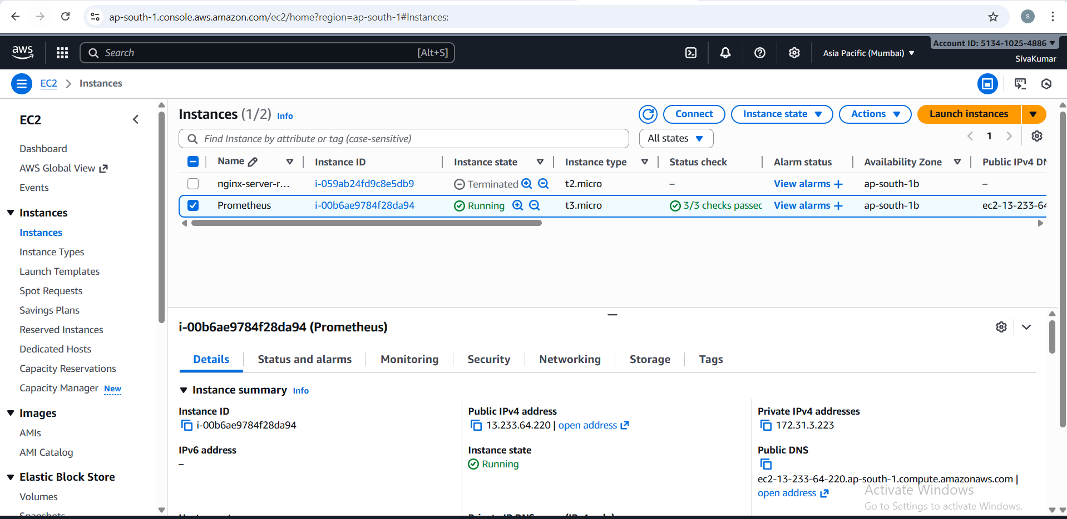
Step 2
Installing Dependencies
sudo apt update -y
sudo apt install wget tar –y
Step3
Download Promrtheus
cd /opt
sudo wget https://github.com/prometheus/prometheus/releases/download/v2.53.0/prometheus-2.53.0.linux-amd64.tar.gz
sudo tar -xvf prometheus-2.53.0.linux-amd64.tar.gz
sudo mv prometheus-2.53.0.linux-amd64 prometheus
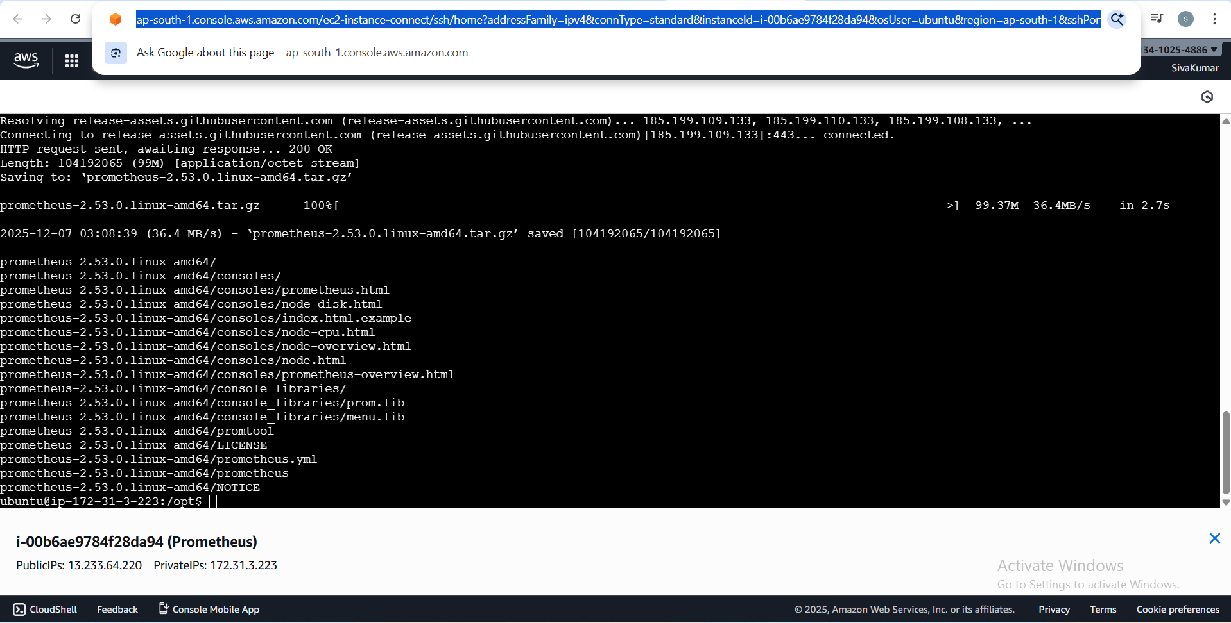

Step 4
Create Prometheus User
sudo useradd --no-create-home --shell /bin/false Prometheus

Step 5
Move Binaries
sudo cp /opt/prometheus/prometheus /usr/local/bin/
sudo cp /opt/prometheus/promtool /usr/local/bin/
Step 6
Config File
sudo nano /etc/prometheus/prometheus.yml
global:
scrape_interval: 5s

scrape_configs:
- job_name: 'prometheus'
static_configs:
- targets: ['localhost:9090']

Step 8
Move Config Files
sudo mkdir -p /etc/prometheus
sudo cp /opt/prometheus/prometheus.yml /etc/prometheus/
sudo cp -r /opt/prometheus/consoles /etc/prometheus/
sudo cp -r /opt/prometheus/console_libraries /etc/prometheus/

Step 9
Create systemd service
sudo nano /etc/systemd/system/prometheus.service

[Unit]
Description=Prometheus
After=network.target

[Service]
User=prometheus
ExecStart=/usr/local/bin/prometheus \
--config.file=/etc/prometheus/prometheus.yml \
--storage.tsdb.path=/var/lib/prometheus/ \
--web.console.templates=/etc/prometheus/consoles \
--web.console.libraries=/etc/prometheus/console_libraries

Restart=always

[Install]
WantedBy=multi-user.target

Step 10
To Start Prometheus
sudo systemctl daemon-reload
sudo systemctl enable prometheus
sudo systemctl start prometheus
sudo systemctl status Prometheus

Step 11
Need to add security default port number for Prometheus as 9090
http://13.233.64.220:9090
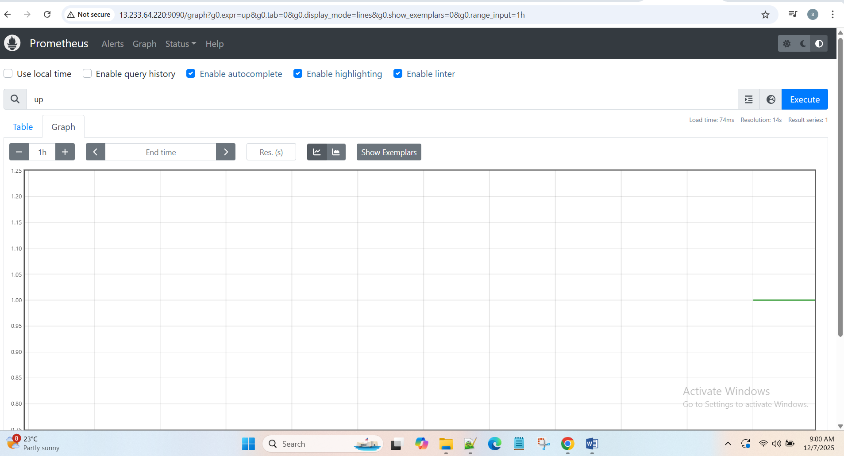

Install Grafana

Step 1
Add Grapfana Repo.
sudo apt install -y apt-transport-https software-properties-common wget
wget -q -O - https://packages.grafana.com/gpg.key | sudo apt-key add -
sudo add-apt-repository "deb https://packages.grafana.com/oss/deb stable main"
sudo apt update -y

Step 2
Install Grafana
sudo apt install grafana –y

Step 3
Start Grafana
sudo systemctl start grafana-server
sudo systemctl enable grafana-server

Step 4
Set the default port for grafana as 3000
http://13.233.64.220:3000/login
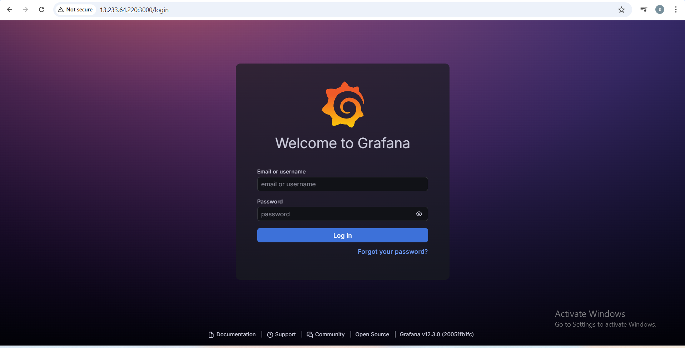
Default username and password as admin
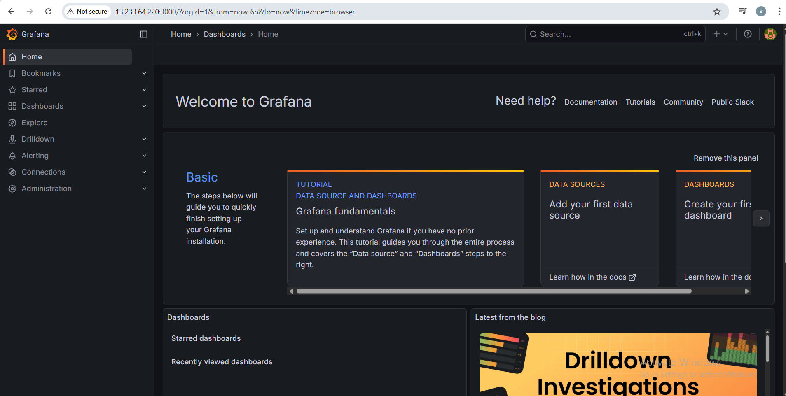

Connect Prometheus to Grafana
Goto-> Data Source -> select Prometheus -> Paste the promethues URL ->Click Save & Test
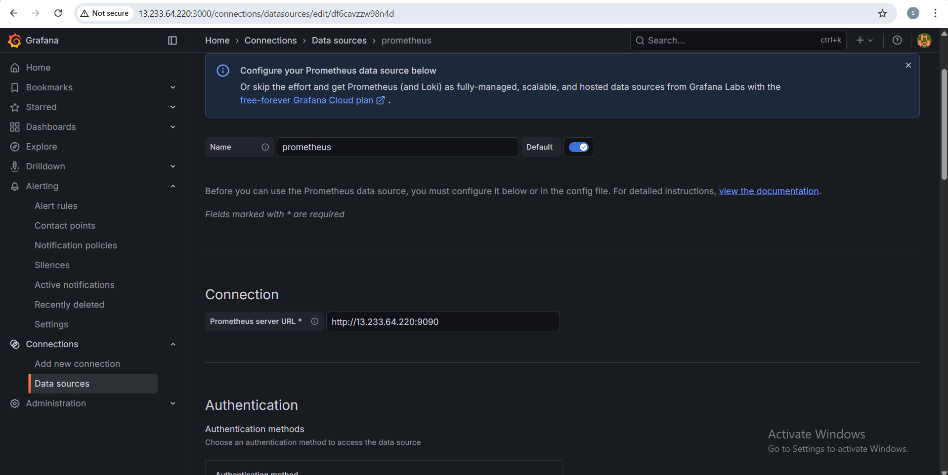
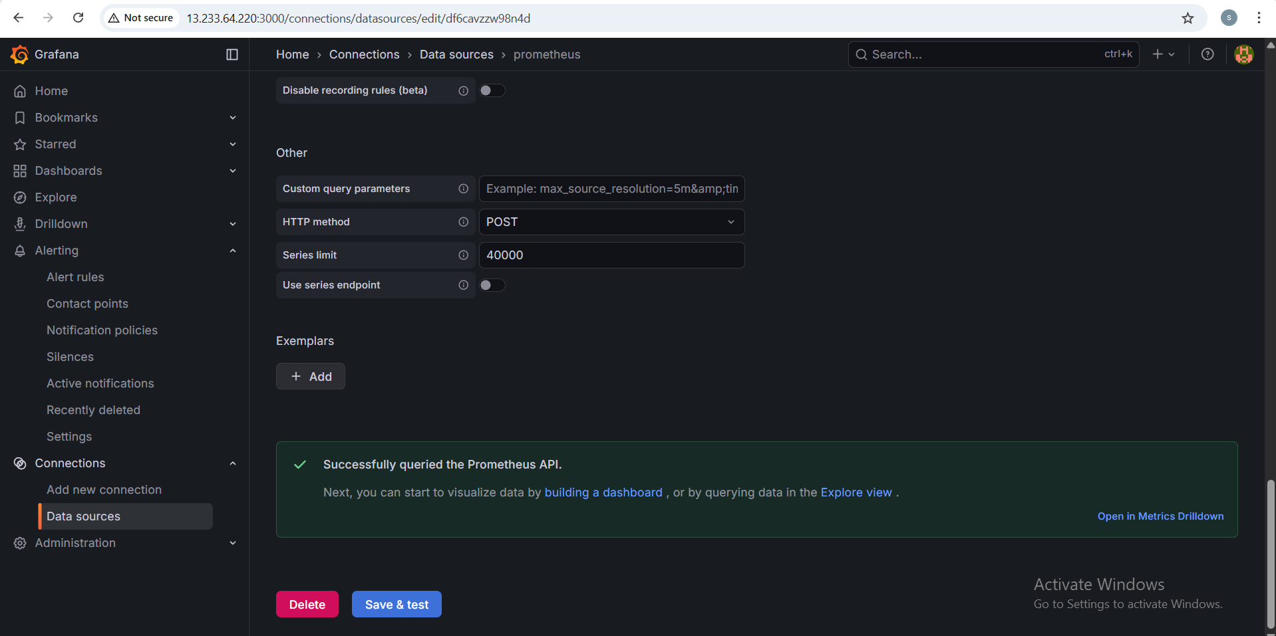
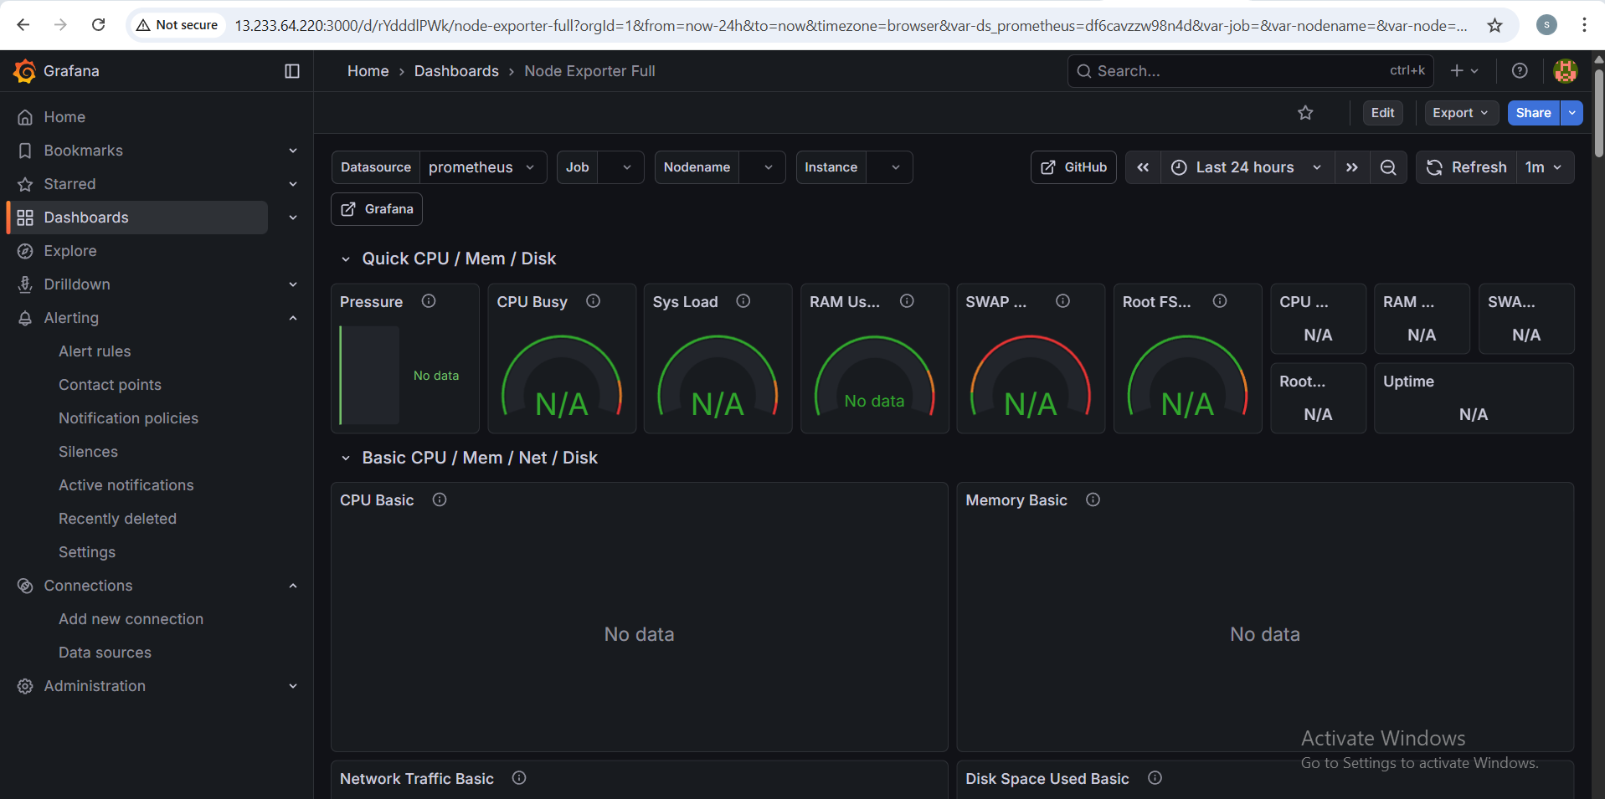

After Installing the Node Exporter
Step1
Download Node Exporter
cd /opt
sudo wget https://github.com/prometheus/node_exporter/releases/download/v1.7.0/node_exporter-1.7.0.linux-amd64.tar.gz
sudo tar -xvf node_exporter-1.7.0.linux-amd64.tar.gz
sudo mv node_exporter-1.7.0.linux-amd64 node_exporter

Step 2
Create System User
sudo useradd -rs /bin/false node_exporter
Step 3
Create System Service
sudo nano /etc/systemd/system/node_exporter.service
[Unit]
Description=Node Exporter
After=network.target

[Service]
User=node_exporter
Group=node_exporter
ExecStart=/opt/node_exporter/node_exporter

[Install]
WantedBy=default.target

Step 5
Start Node Exporter
sudo systemctl daemon-reload
sudo systemctl start node_exporter
sudo systemctl enable node_exporter

sudo systemctl status node_exporter

Step 6
Add Node Exporter to Prometheus
sudo nano /etc/prometheus/prometheus.yml
global:
scrape_interval: 5s

scrape_configs:
- job_name: 'prometheus'
static_configs:
- targets: ['localhost:9090']

- job_name: 'node_exporter'
static_configs:
- targets: ['localhost:9100']

Step 8
Restart Prometheus
sudo systemctl restart prometheus
sudo systemctl status prometheus

Default Port number 3100
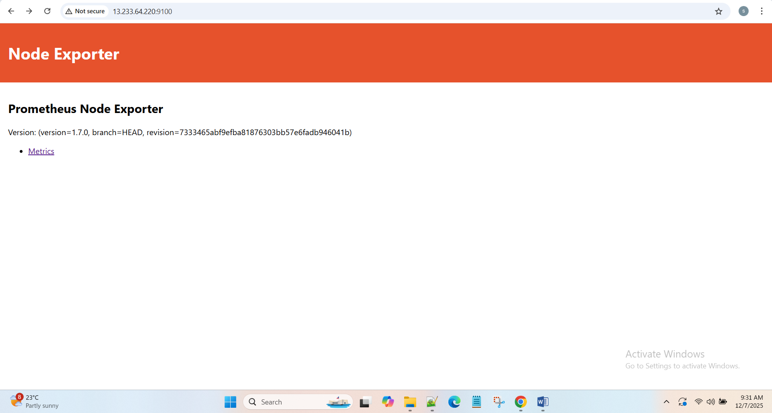

Step 9
Refresh the Grifana Page we will get the output
