Terraform Task

Task Description:

Launch Linux EC2 instances in two regions using a single Terraform file.

Step 1
Create a empty folder named as terraform.

Step 2
Open notepad++ make a code for terraform and name as main.tf

Step 3
Folder structure
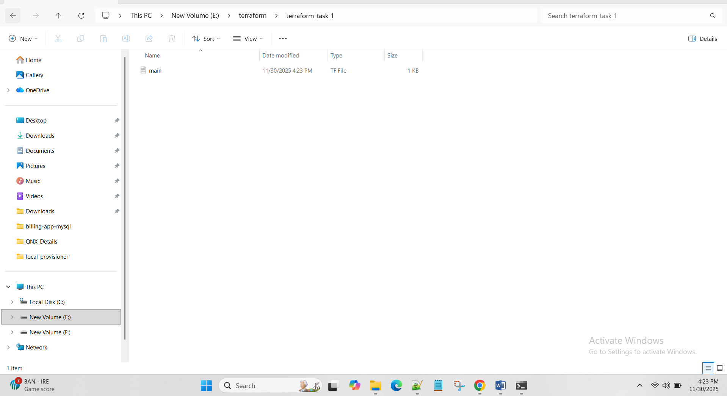

Step 4

Terraform to create 2 instance

terraform {
required_providers {
aws = {
source = "hashicorp/aws"
version = "~> 5.0"
}
}
}

provider "aws" {
region = "ap-south-1"
}

resource "aws_security_group" "allow_ssh" {
name = "allow_ssh"
description = "Allow SSH"

ingress {
from_port = 22
to_port = 22
protocol = "tcp"
cidr_blocks = ["0.0.0.0/0"]
}

egress {
from_port = 0
to_port = 0
protocol = "-1"
cidr_blocks = ["0.0.0.0/0"]
}

tags = {
Name = "allow_ssh"
}
}

resource "aws_instance" "server" {
count = 2
ami = "ami-02b8269d5e85954ef"
instance_type = "t3.micro"
vpc_security_group_ids = [aws_security_group.allow_ssh.id]

tags = {
Name = "server-${count.index + 1}"
}
}

output "public_ips" {
value = aws_instance.server[*].public_ip
}

Step 5
Cmd to execute terraform
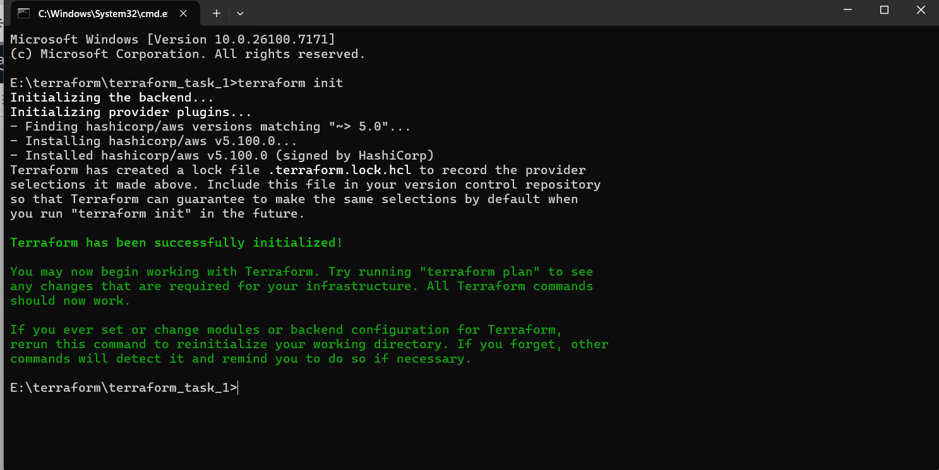
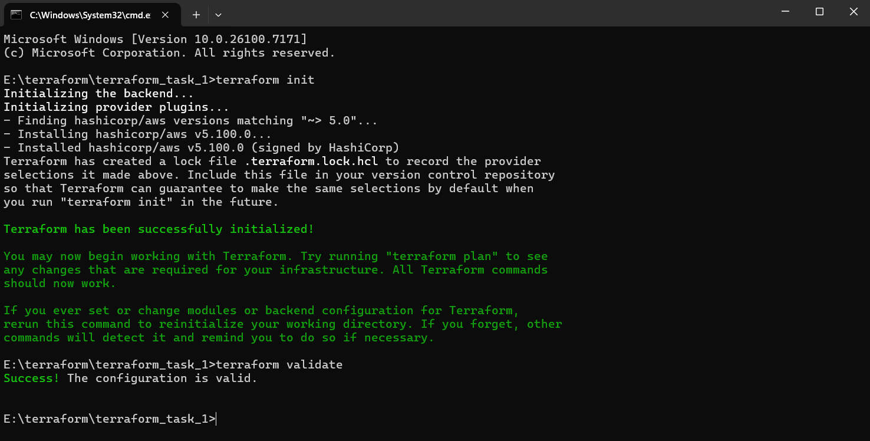
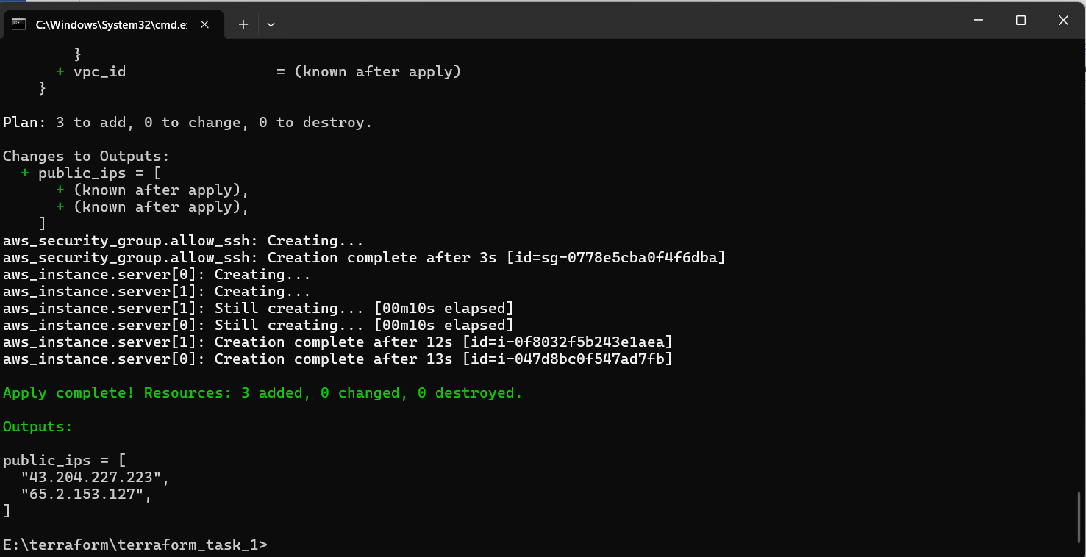

O/P
Login in AWS and check
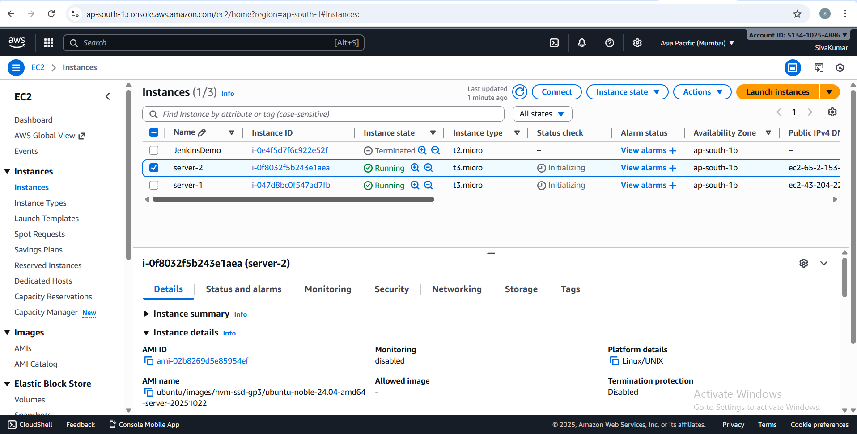
To destroy the instance – terraform destroy –auto-apply
