EXPERMENT-11

AIM:
To create a clone of a virtual machine in VirtualBox and test it by loading the cloned VM.
PROCEDURE:
STEP 1: Open Oracle VirtualBox and select the virtual machine you want to clone.
STEP 2: Go to Machine → Clone.
STEP 3: Enter a name for the cloned VM.
STEP 4: Choose the type of clone:
• Full Clone, Linked Clone
STEP 5: Click Clone → Wait for the process to complete.
STEP 6: Start the cloned VM → Verify that it works independently and has the same state as the original VM at the time of cloning.
DESIGN:
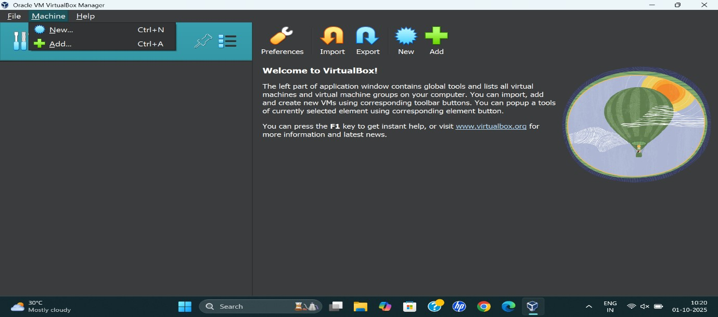

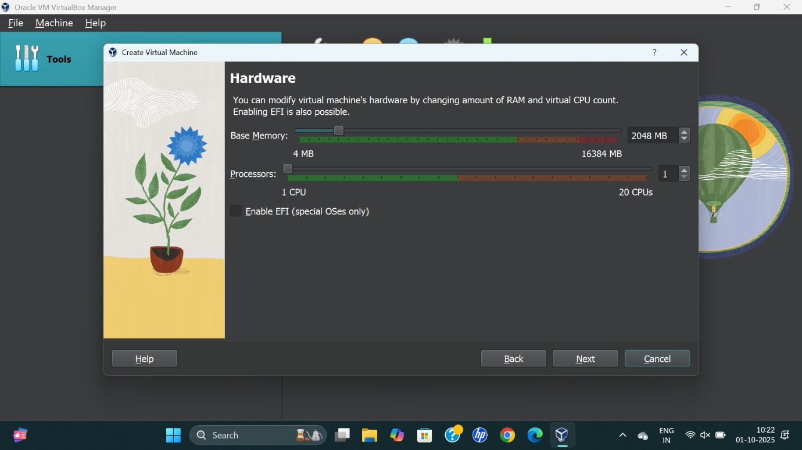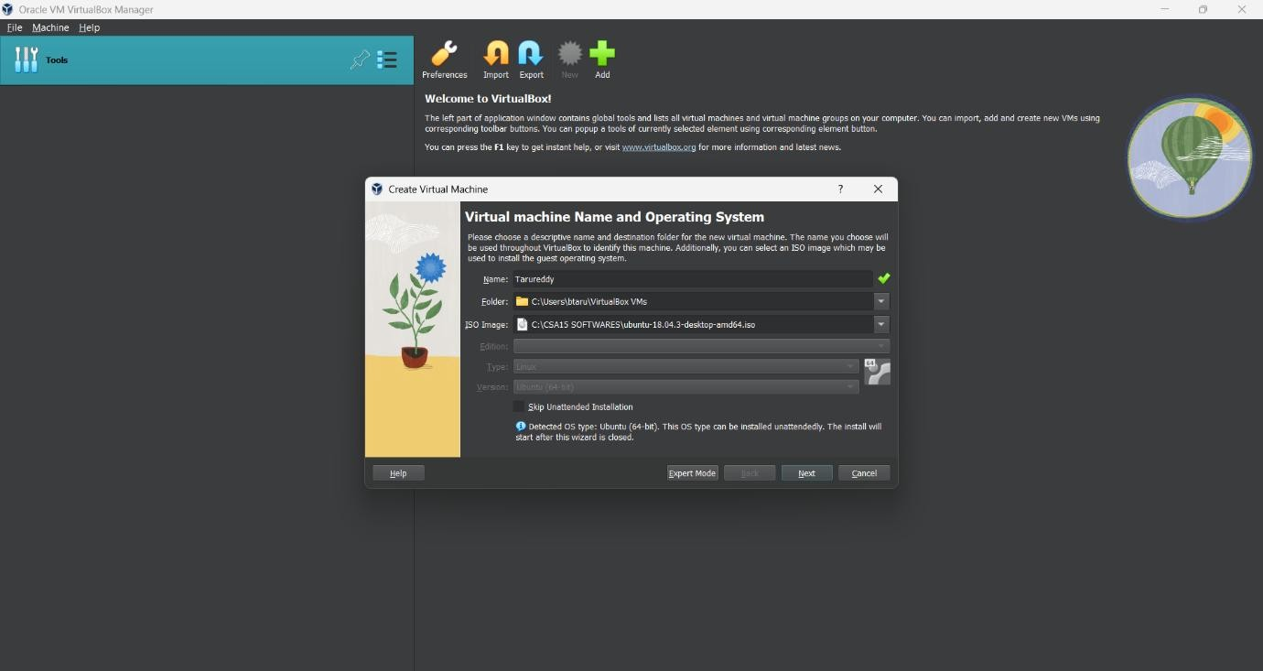

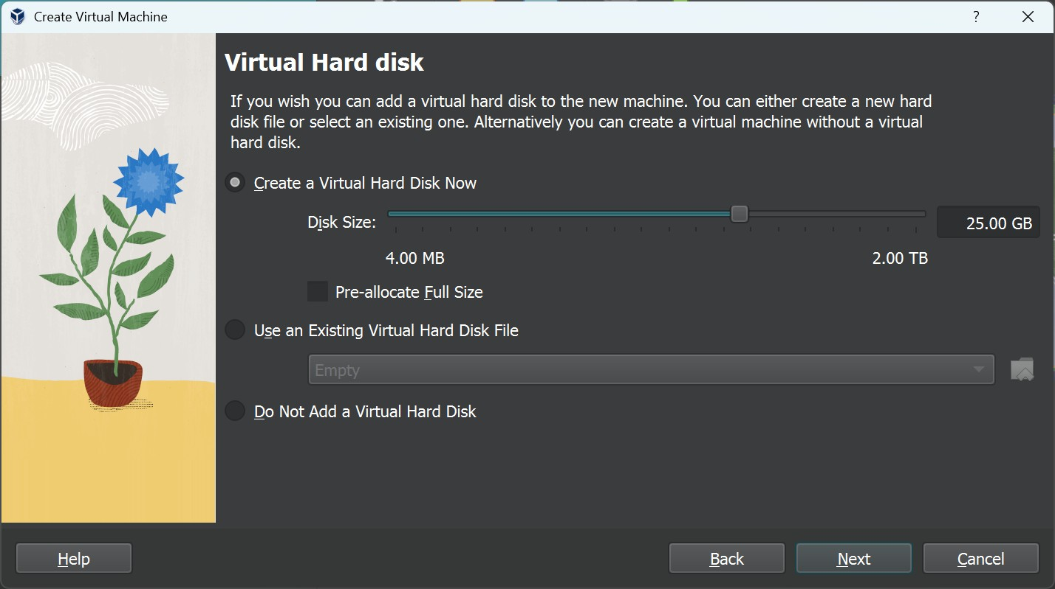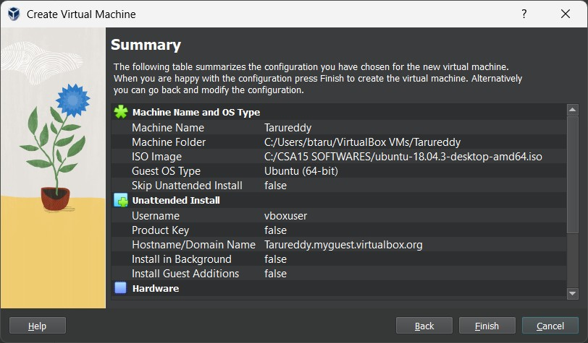

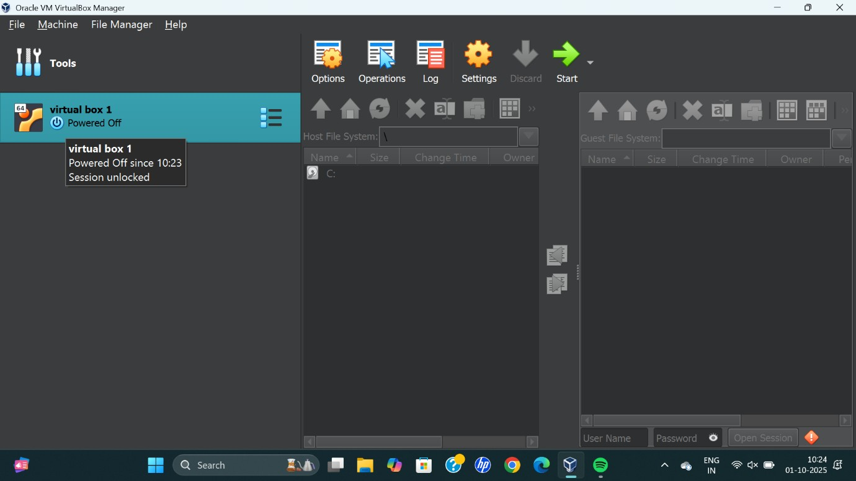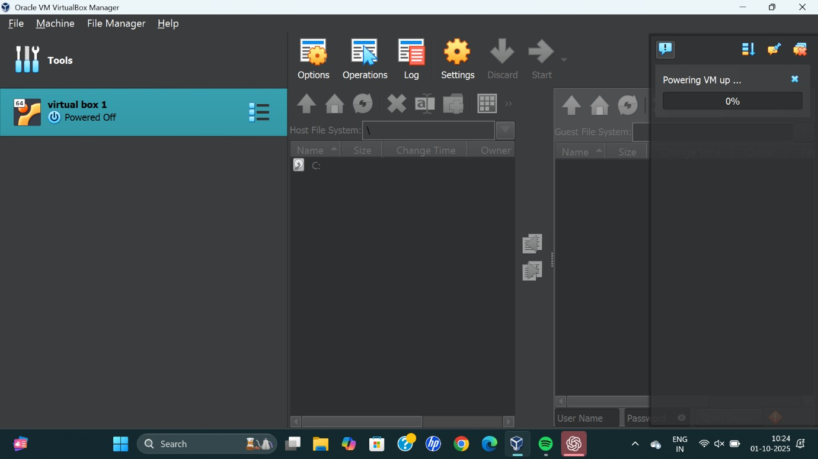

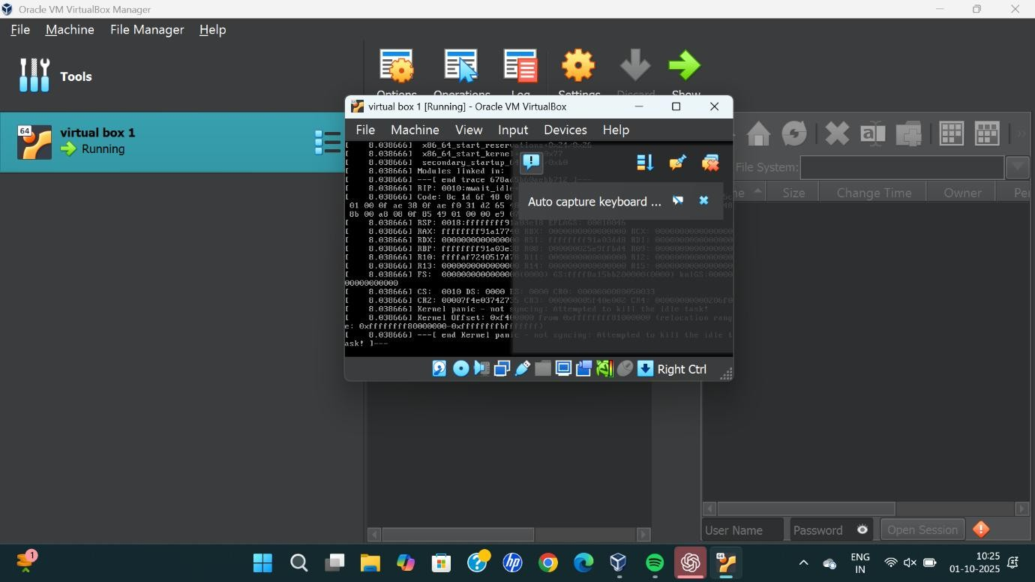
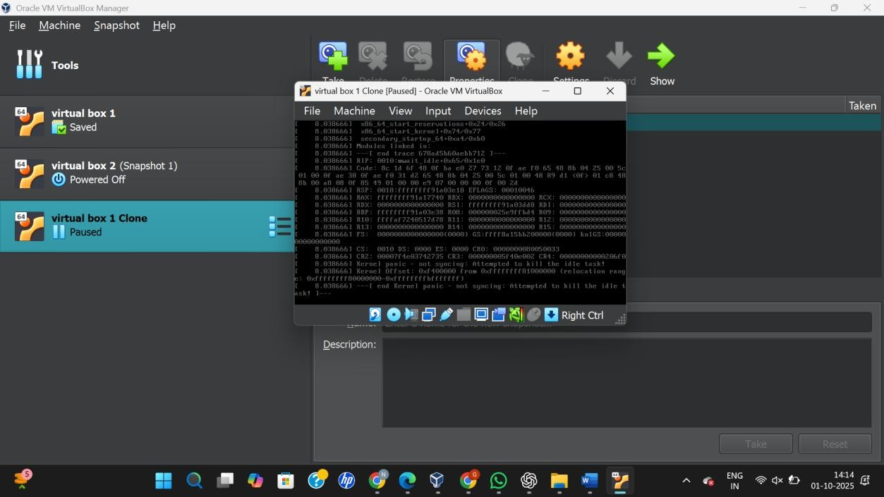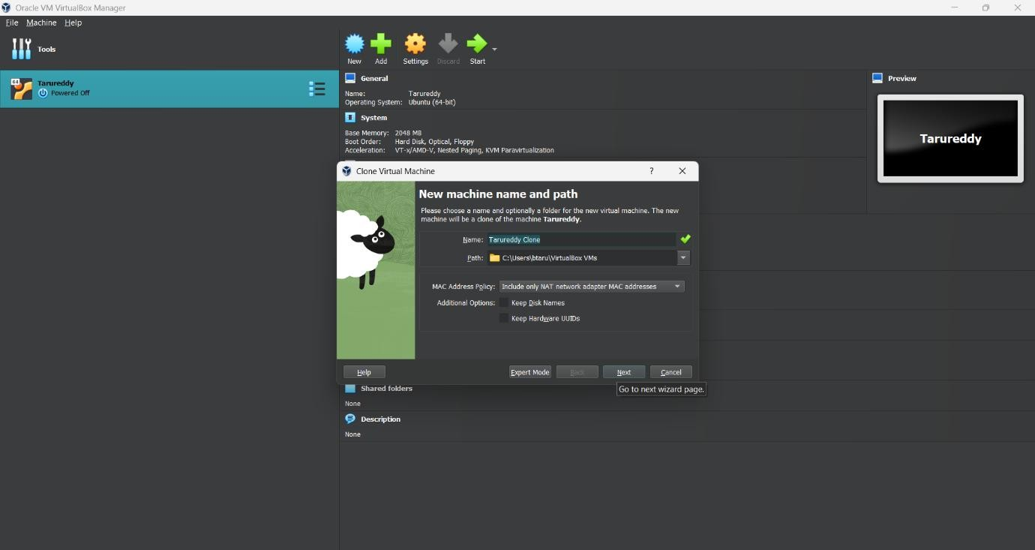
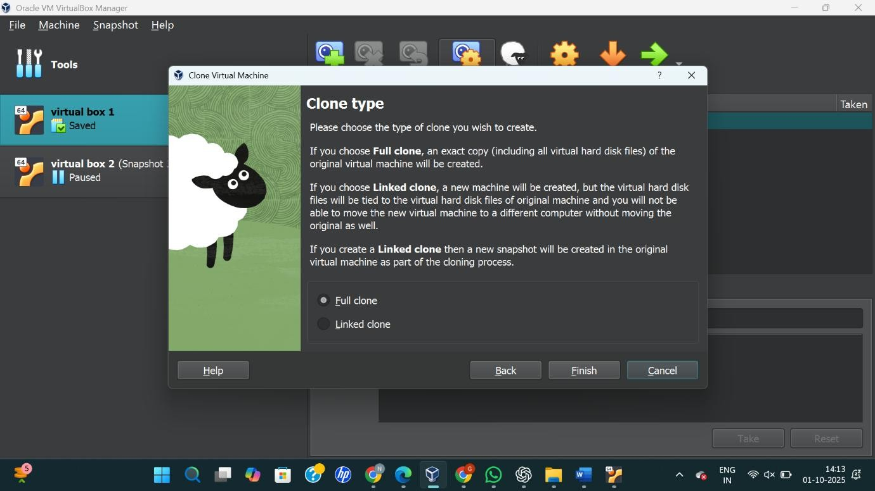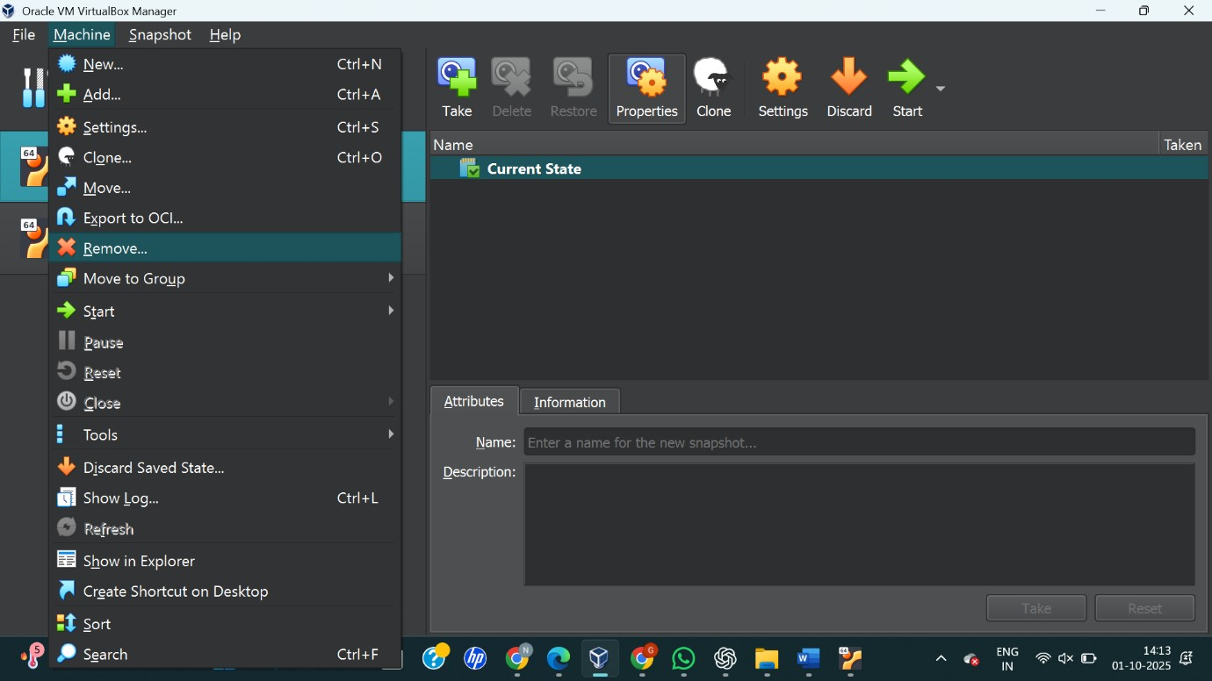



RESULT:
A virtual machine was successfully cloned in VirtualBox and tested by starting the cloned VM, confirming it loads correctly with the previous state.

