EXPERIMENT-13

Aim
To create an Infrastructure as a Service (IaaS) Resource Group in Microsoft Azure public cloud environment for organizing and managing cloud resources.

Requirements / Software Used
- Microsoft Azure Portal
- Azure for Students Subscription
- Web Browser (Google Chrome / Microsoft Edge)
- Internet Connection
- Computer/Laptop

Algorithm
- Open the Microsoft Azure Portal.
- Sign in with the Azure account.
- Search for Resource Groups in the Azure portal.
- Click Create Resource Group.
- Select the Azure subscription.
- Enter the Resource Group name (RG-IaaS-Lab).
- Choose the desired region (e.g., Central India).
- Click Review + Create.
- Verify the entered details.
- Click Create to deploy the Resource Group.
- Wait for the deployment to complete successfully.
- Verify the created Resource Group in the Azure dashboard.

Output
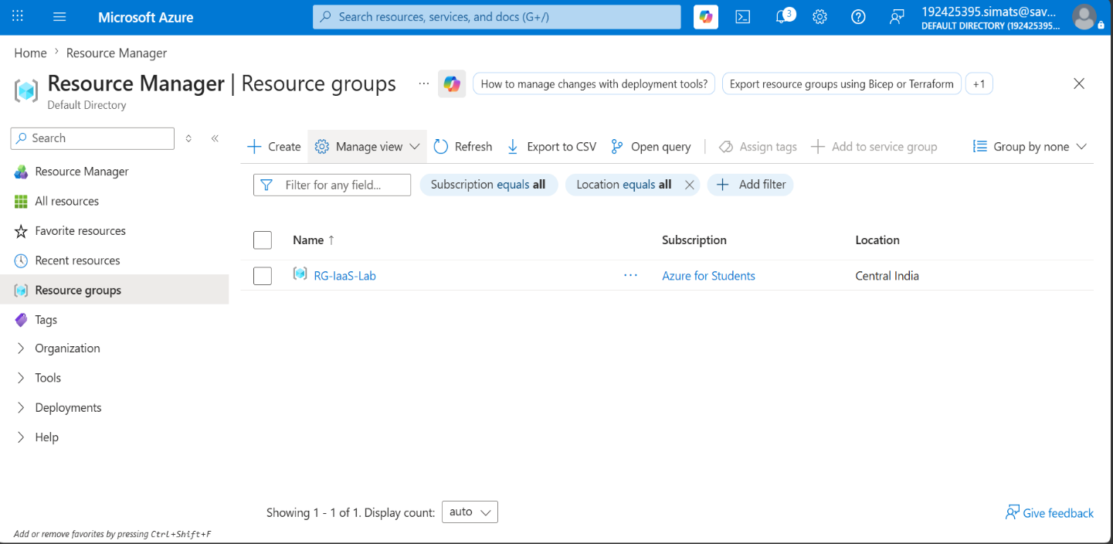

Result
The IaaS Resource Group named RG-IaaS-Lab was successfully created in Microsoft Azure. The Resource Group can now be used to deploy and manage cloud resources such as Virtual Machines, Storage Accounts, and Virtual Networks.

