EXPERIMENT-15
AIM:
Connect remotely and launch the cloud VM image
PROCEDURE:
STEP1: CREATE AN ACCOUNT IN MICROSOFT AZURE.
STEP2: GOTO RESOURCE GROUPAND CREATE A RESOURCE GROUP.
STEP3: GIVE NECESSARY THINGS FOR RESOURCE GROUP.
STEP4: CREATE AVIRTUAL NETWORK FOR TO CREATE AVIRTUALMACHINE.
STEP5: NOW CREATE A VIRTUAL MACHINE WITH UR IPADDRESS ANUSERNAME AND PASSWORD FOR YOUR VIRTUAL MACINE.
STEP6: AND YOUR VIRTUAL MACHINE IS DEPLOYED.
STEP7: NOW CONNECT THE VIRTUAL MACHINE AND DOWNLOAD THE RDP FILETO OPEN YOUR WINDOWS VIRTUAL MACHINE. STEP8: CREATED ANEW WINDOWS VIRTUAL MACHINE
DESIGN: 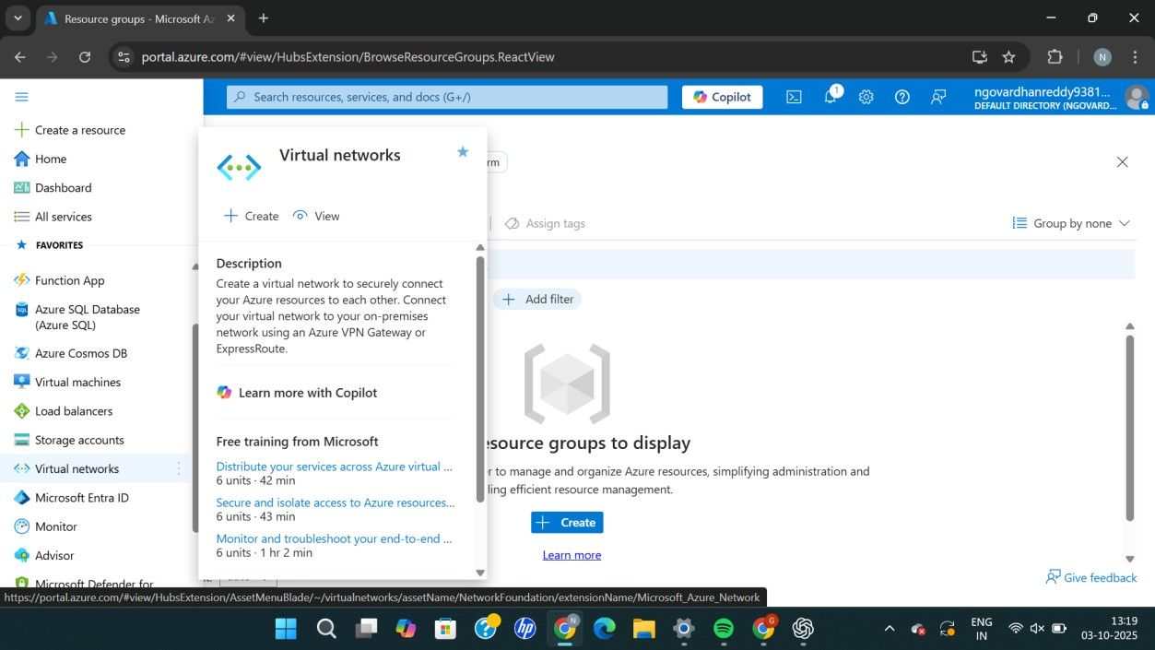

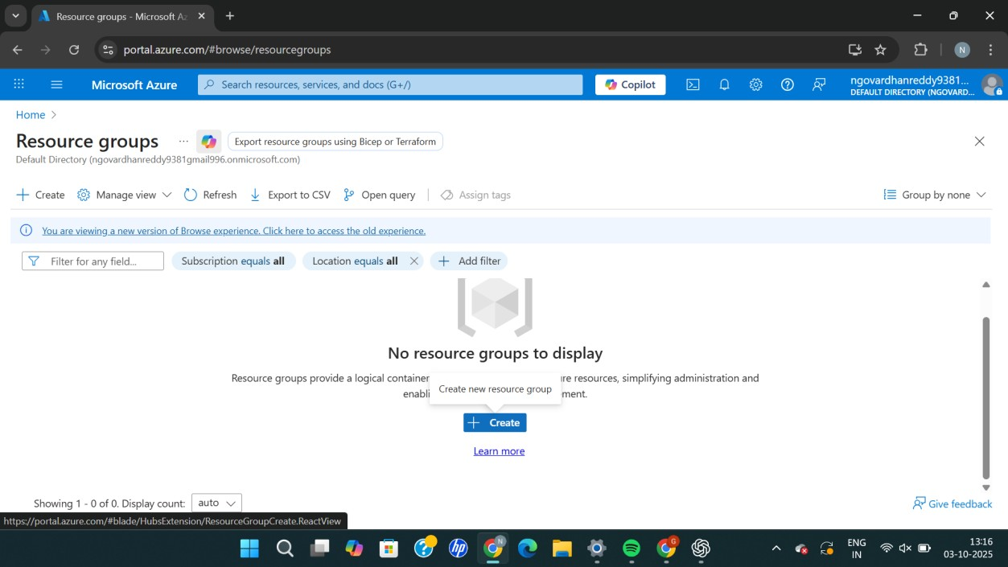

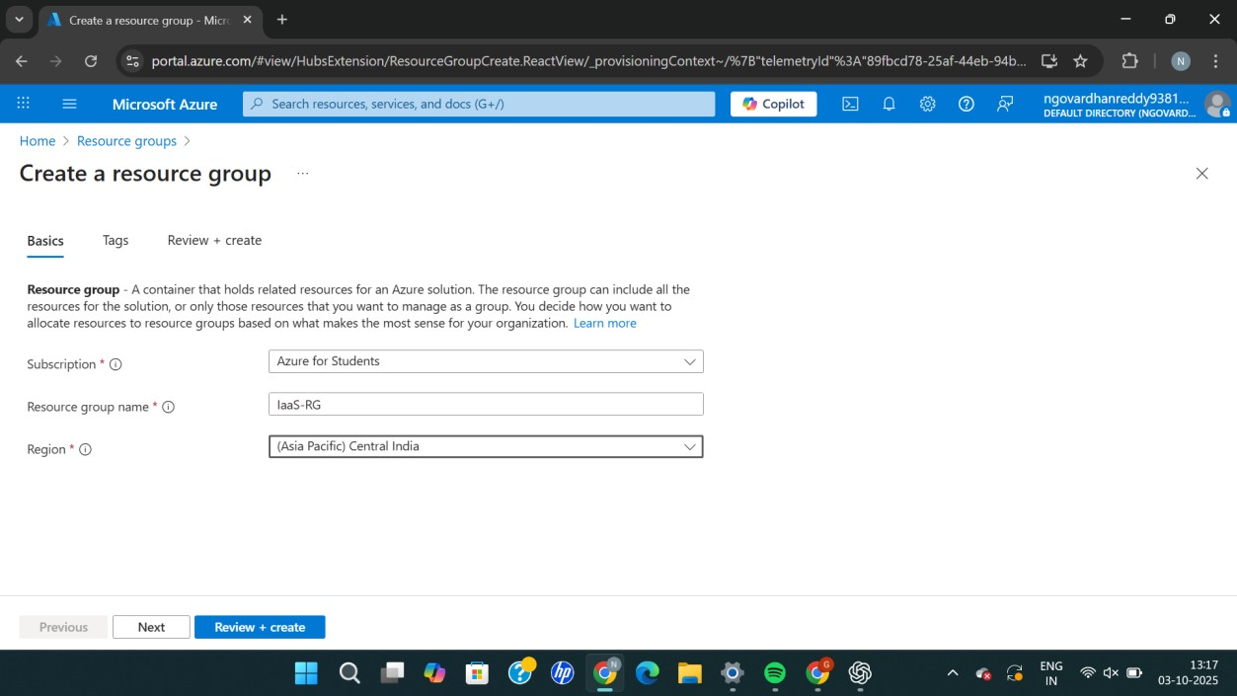
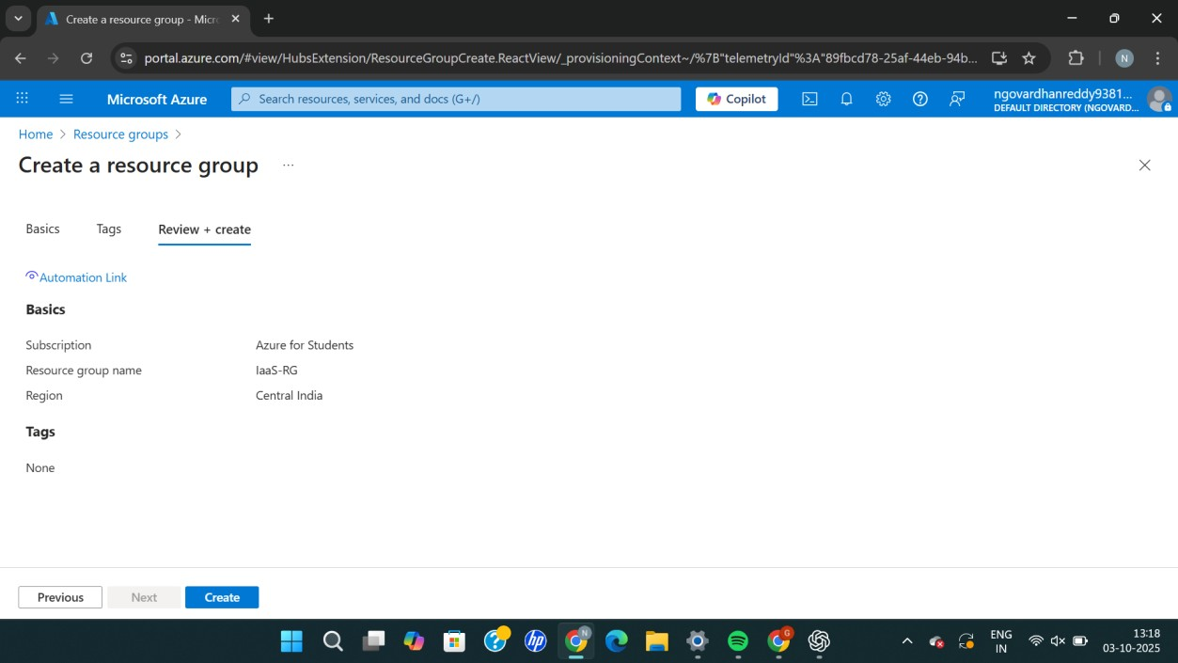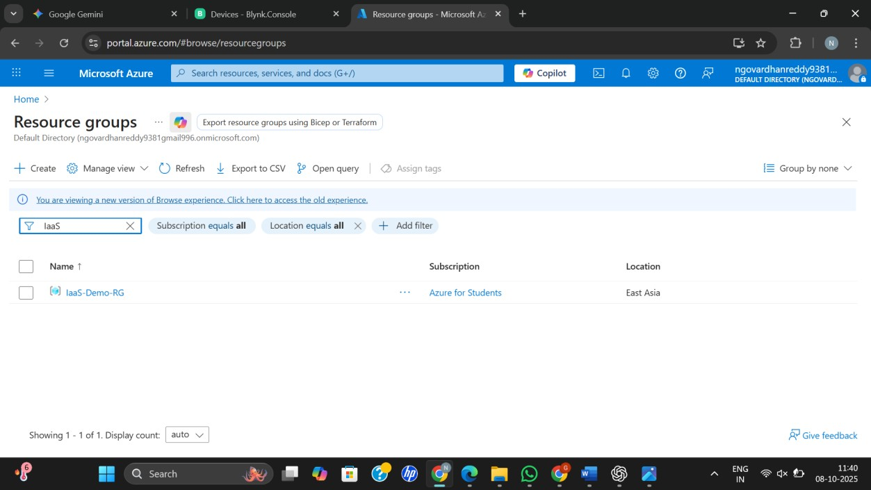

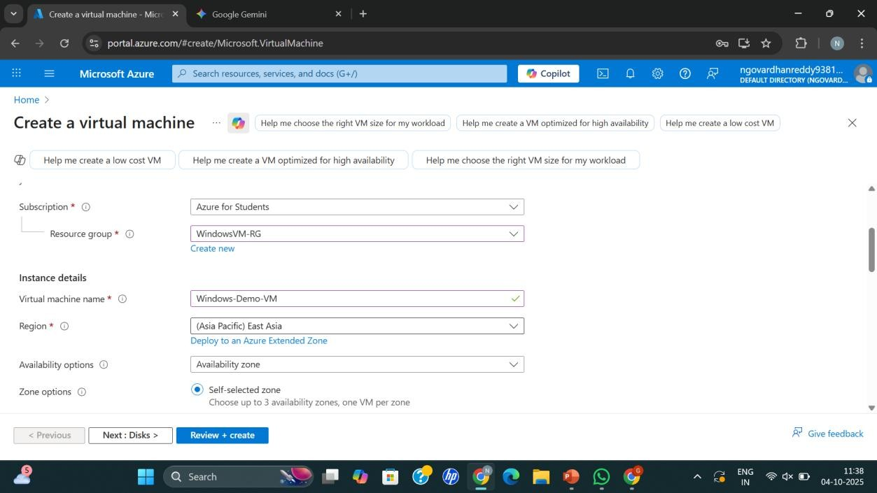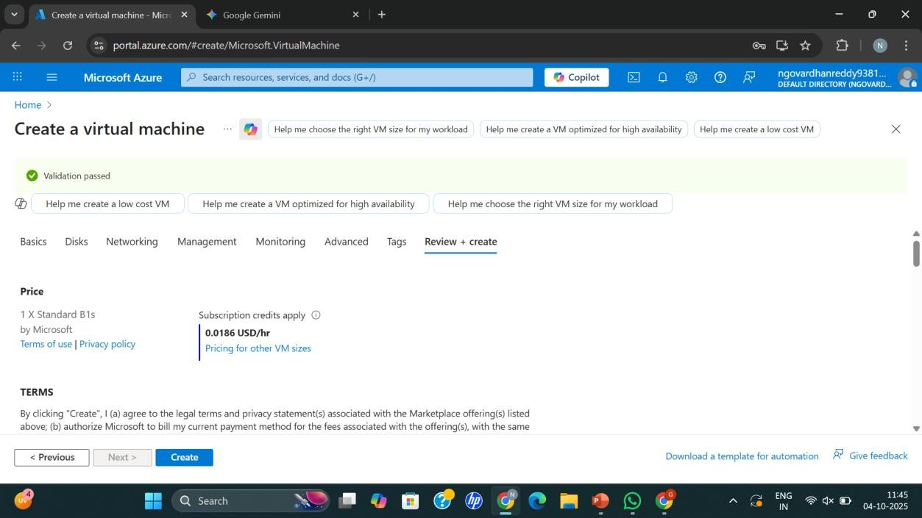
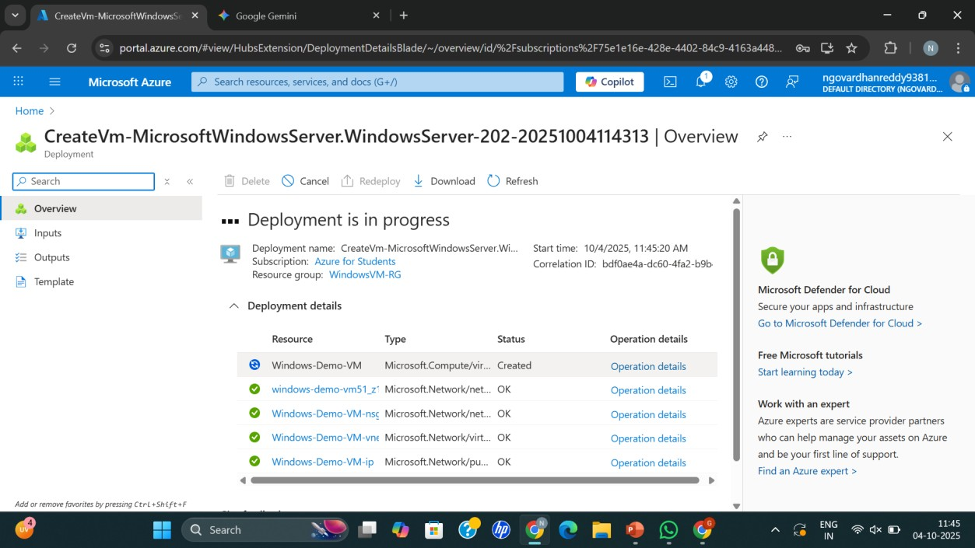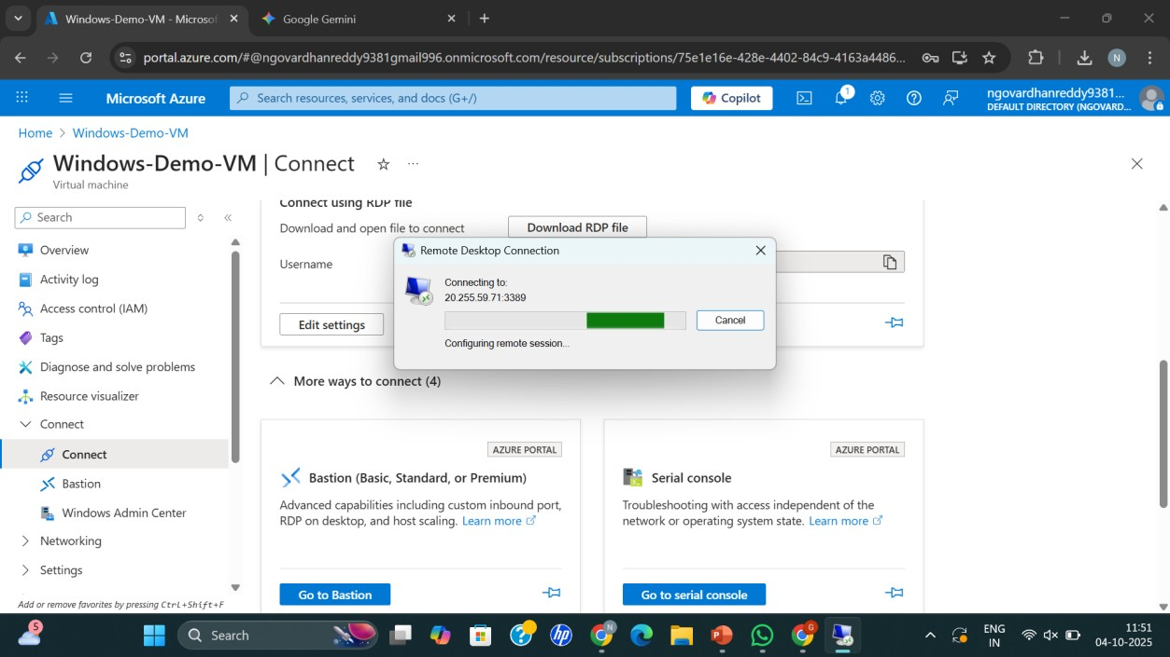
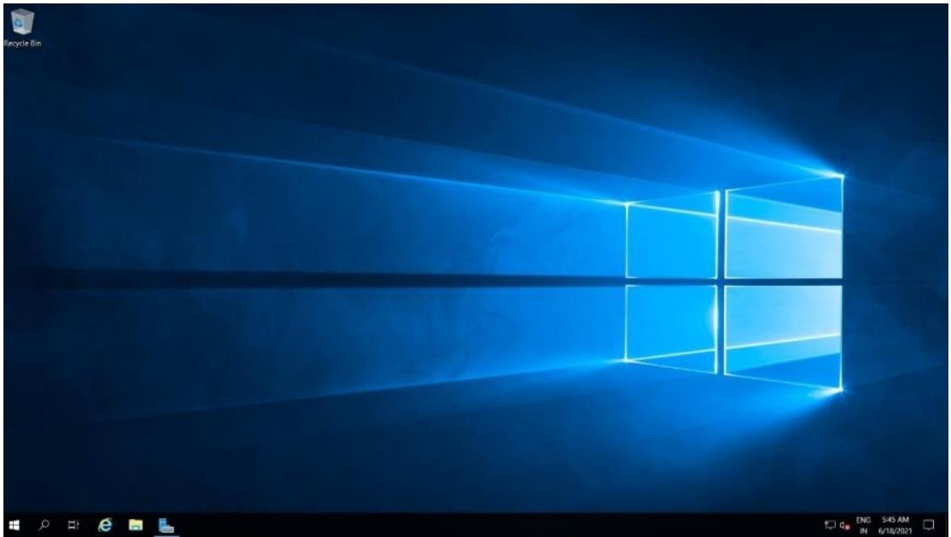
RESULT:
successfully demonstrated infrastructure as a service (iaas) by creating a virtual machine using a public cloud service provider (azure), configure with required memory and cpu.

