EXPERIMENT-16
Aim:
Create a simple web site using any public cloud service provider (azure/gcp/aws) and check the public accessibility of the stored file to demonstrate storage as a service
Procedure:
STEP1: FIRSTLY, GO TO APPSERVICE TO CREATE AN WEBAPP.
STEP2: ENTER THE RESOURCE GROUPAND WEBAPP NAME AND REGIONAND SELECT THE LINUX OS. STEP3: AFTER ENTER THE ALL THE NECESSARY THINGS CLICK THEREVIEWAND CREATE AND CLICK THE CREATE THE WEB APP.
STEP4: AND OUR DEPLOYMENT IS COMPLETED.
STEP5: GOTO WEBSITE URL LINK STEP6: THIS IS OUR WEBAPP SERVICE.
DESIGN:
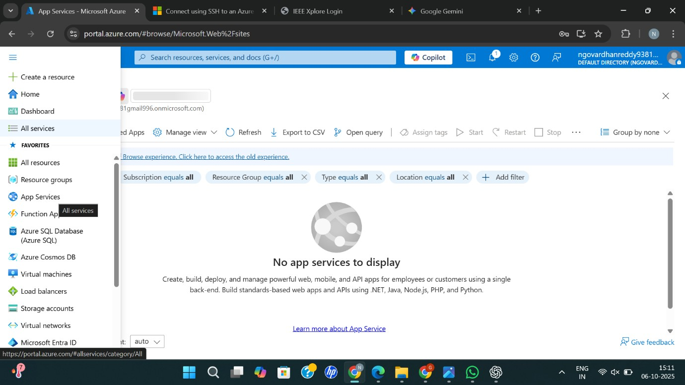
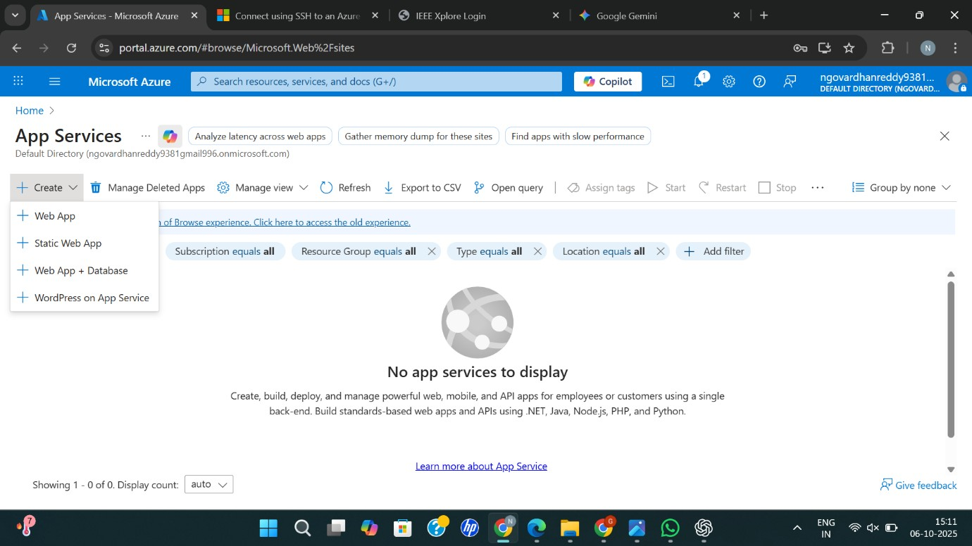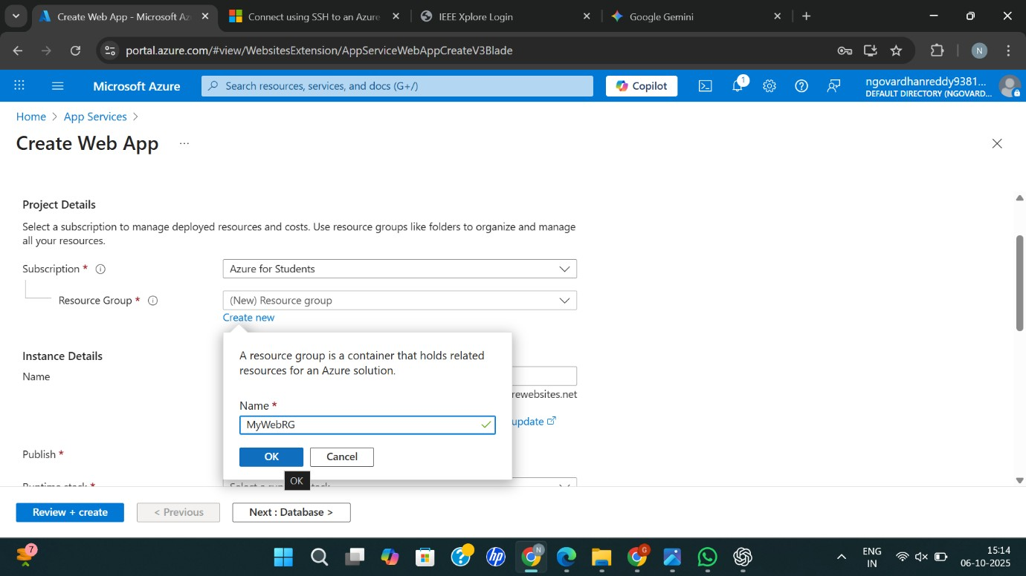
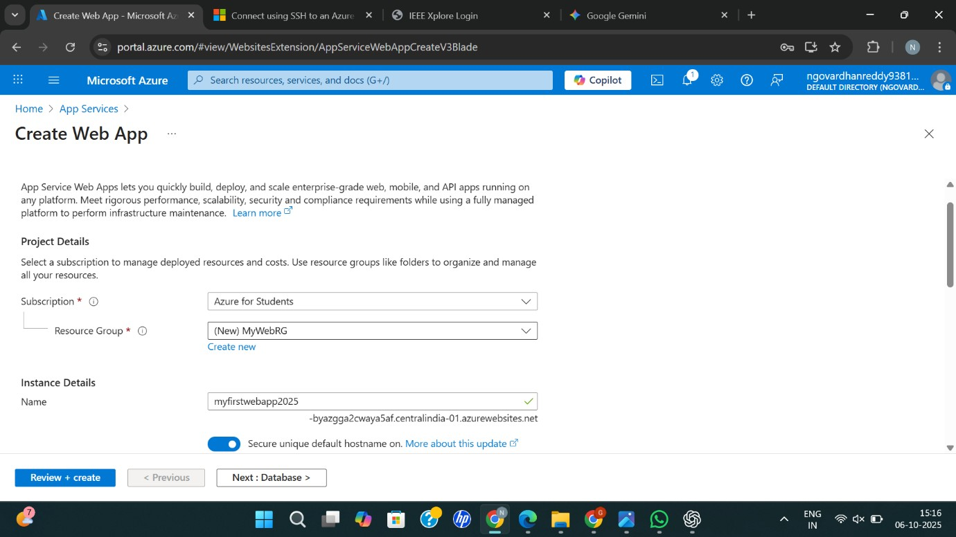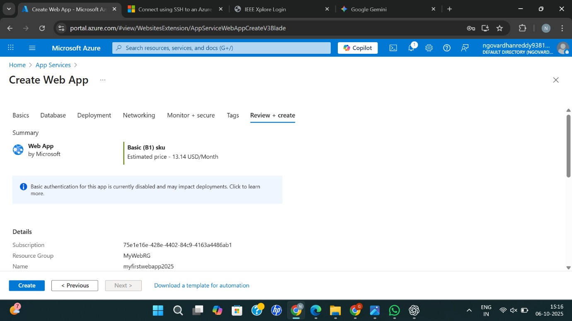
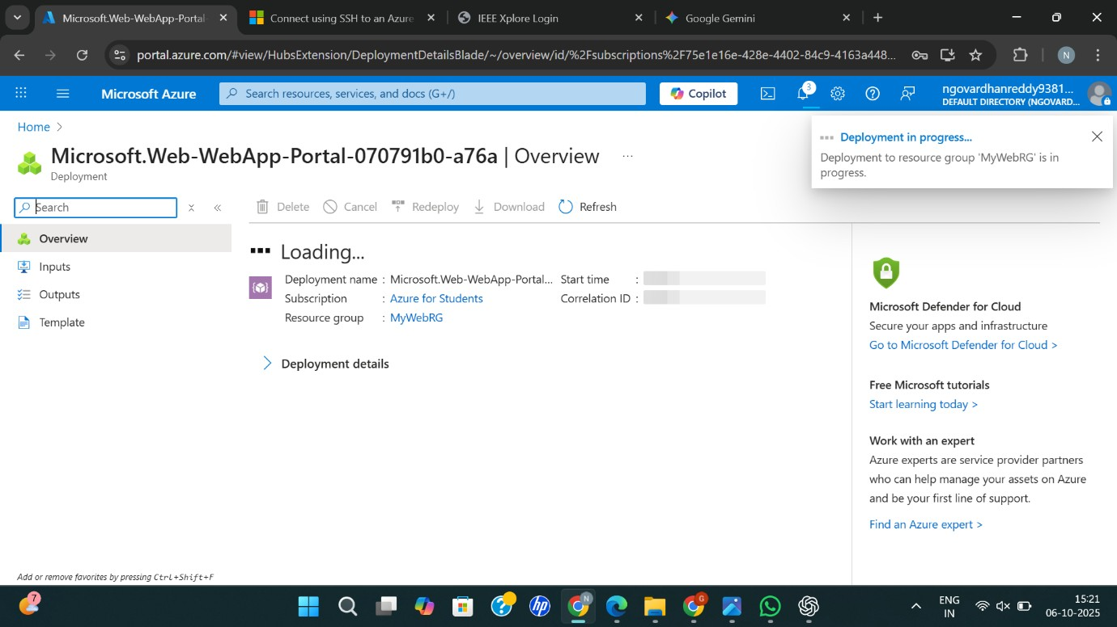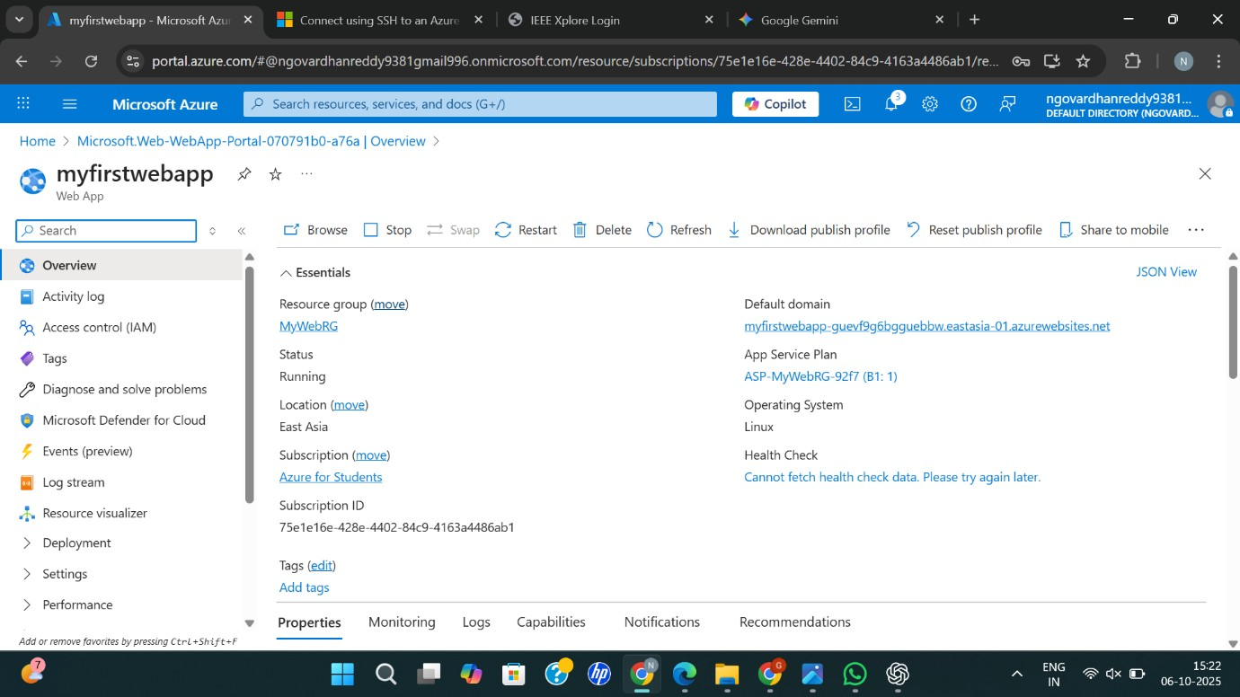
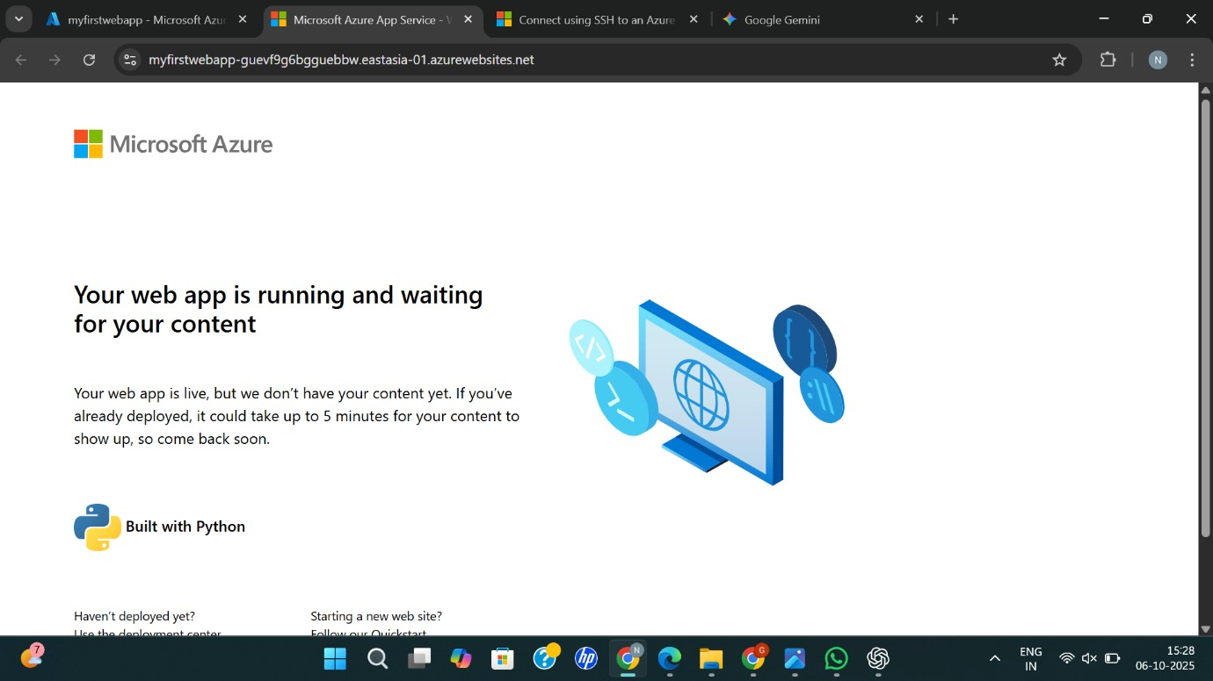
RESULT: Successfully Created a simple web site using any public cloud service provider (azure/gcp/aws) and check the public accessibility of the stored file to demonstrate storage as a service

