EXP NO 17
AIM: To Create a Simple Web Application using Java or Python and host it in any Public Cloud Service Provider (Azure/GCP/AWS) to demonstrate Platform as a Service (PaaS).
Procedure:
- Create Flask App:
  - Create a folder FlaskApp. o Create app.py with: from flask import Flask app = Flask(__name__) @app.route('/') def home():
return "Hello! Flask App on Azure PaaS" if __name__ == '__main__':
app.run()
Create requirements.txt:
flask gunicorn
- Log in to Azure Portal:
  - Go to https://portal.azure.com o Sign in.
- Create Web App (PaaS):
  - Click Create a Resource → Web App
  - Fill details:
    - Resource Group: PaaS-Flask-RG
    - Name: flask-paas-demo
    - Runtime: Python 3.x
    - Region: nearest o Click Create.
- Deploy App:
  - Compress the folder as .zip.
  - In Azure Portal → your Web App → Deployment → ZIP Deploy o Upload the .zip file.
- Test the App:
  - Click Browse in the Web App Overview o Open the link, you will see:
  - Hello! Flask App on Azure PaaS
- Cleanup (Optional):
  - Delete the Resource Group to stop charges.
Design:
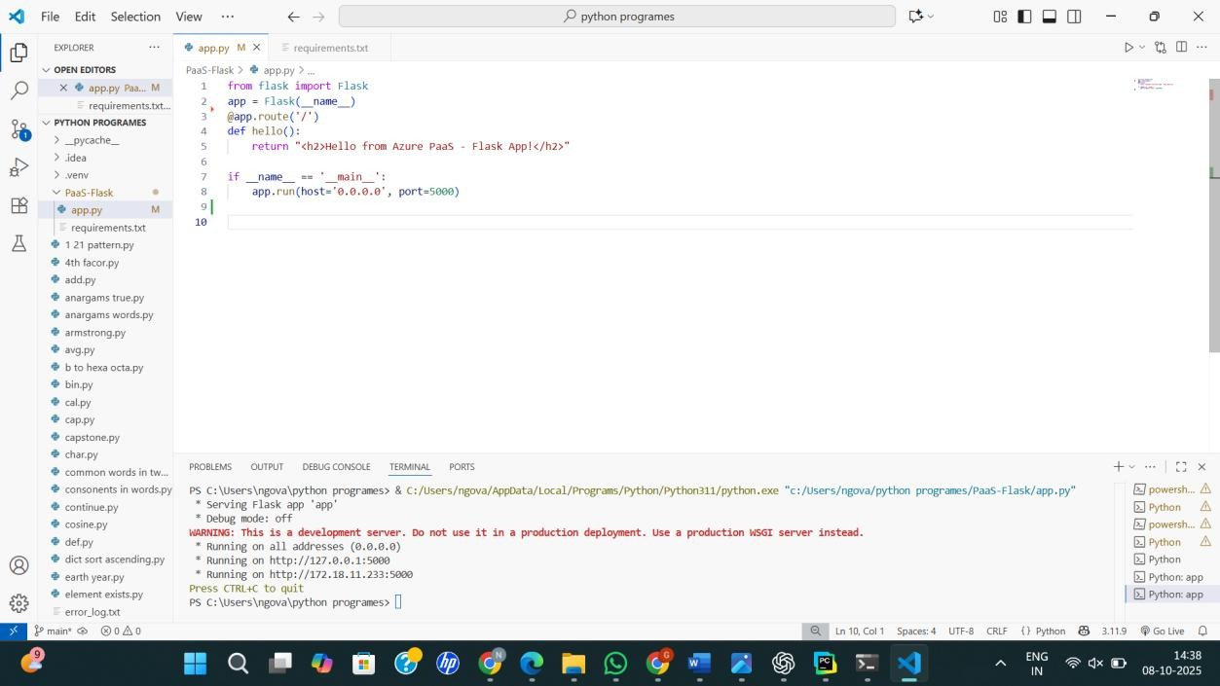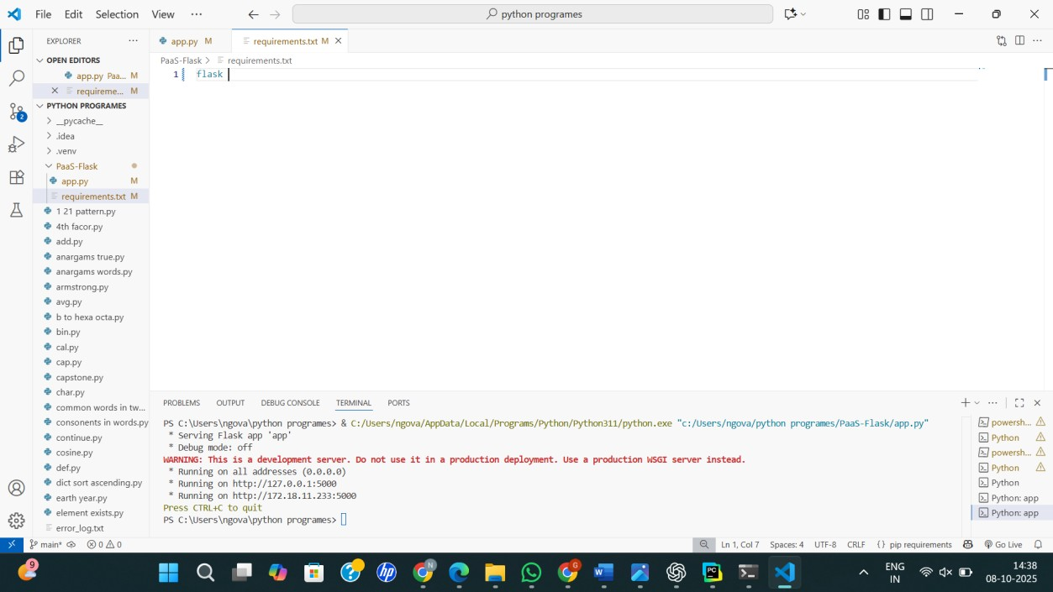

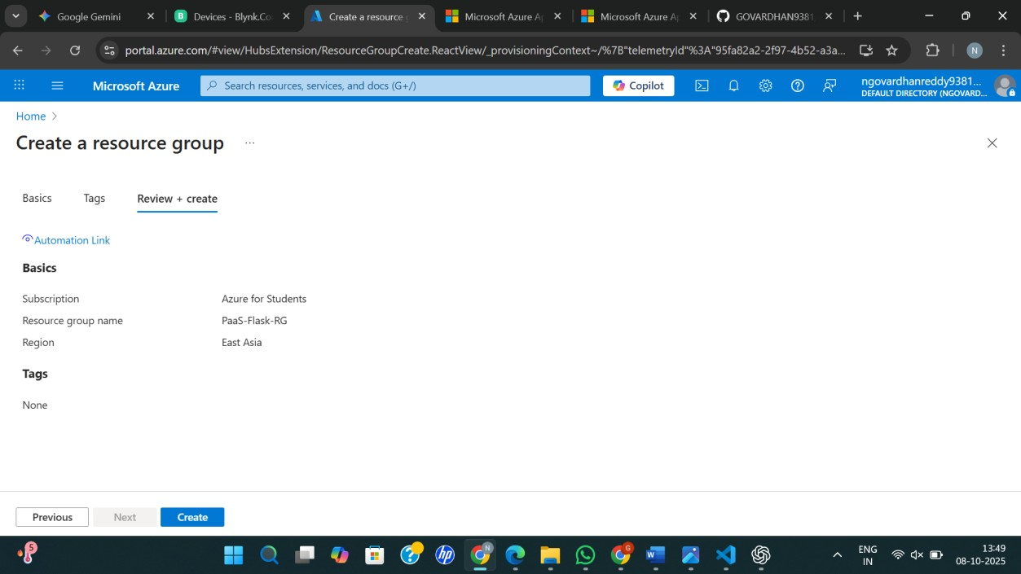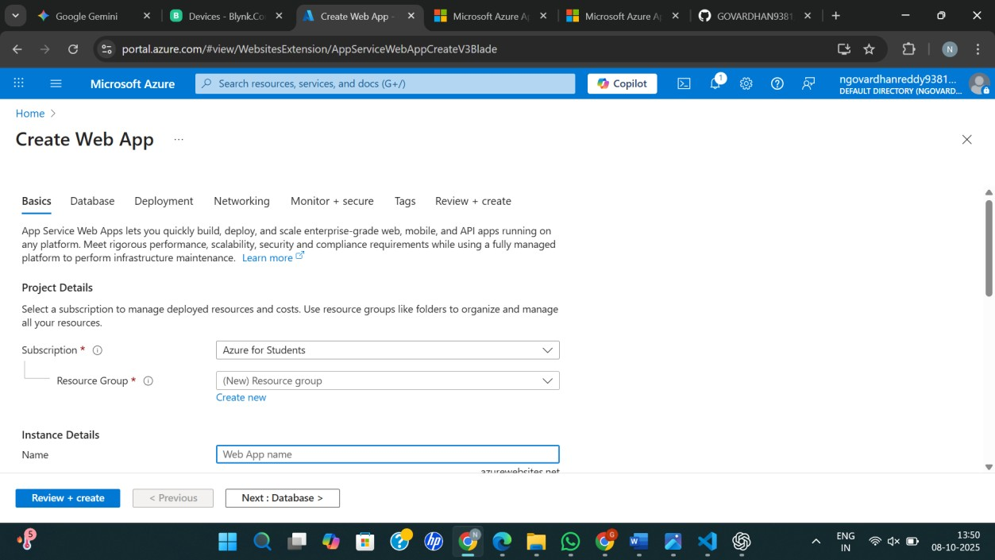
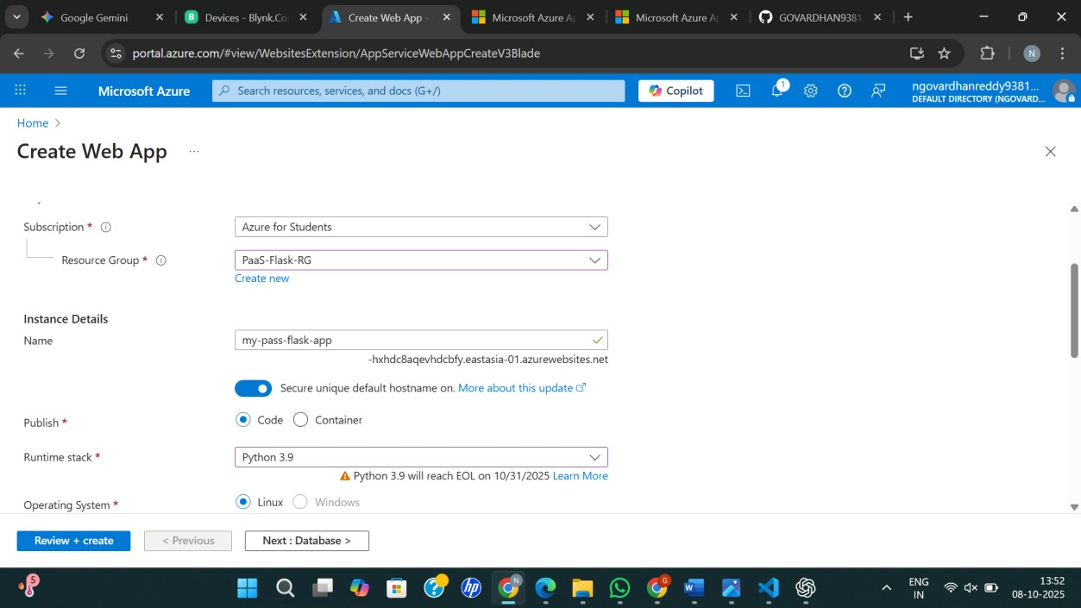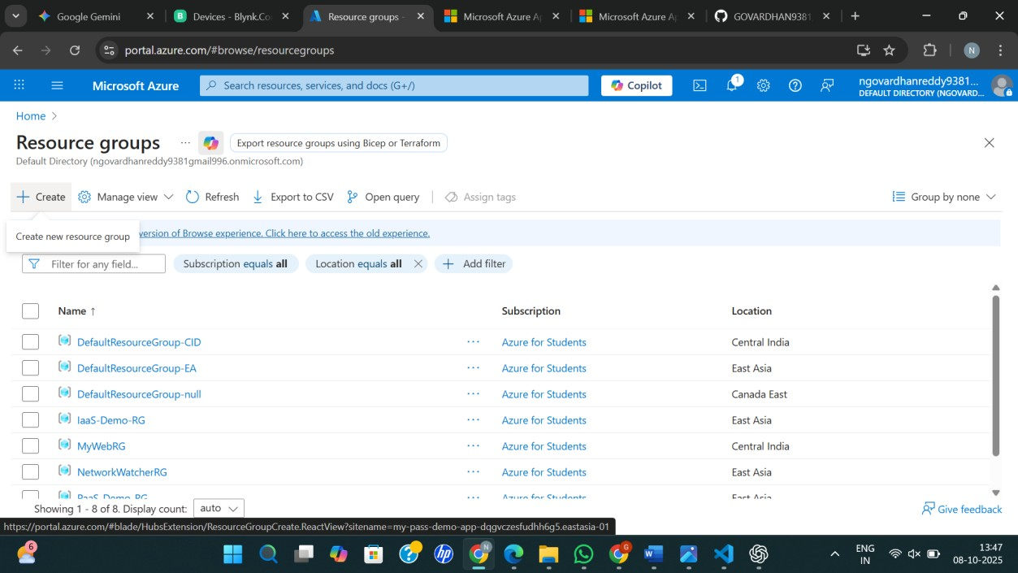

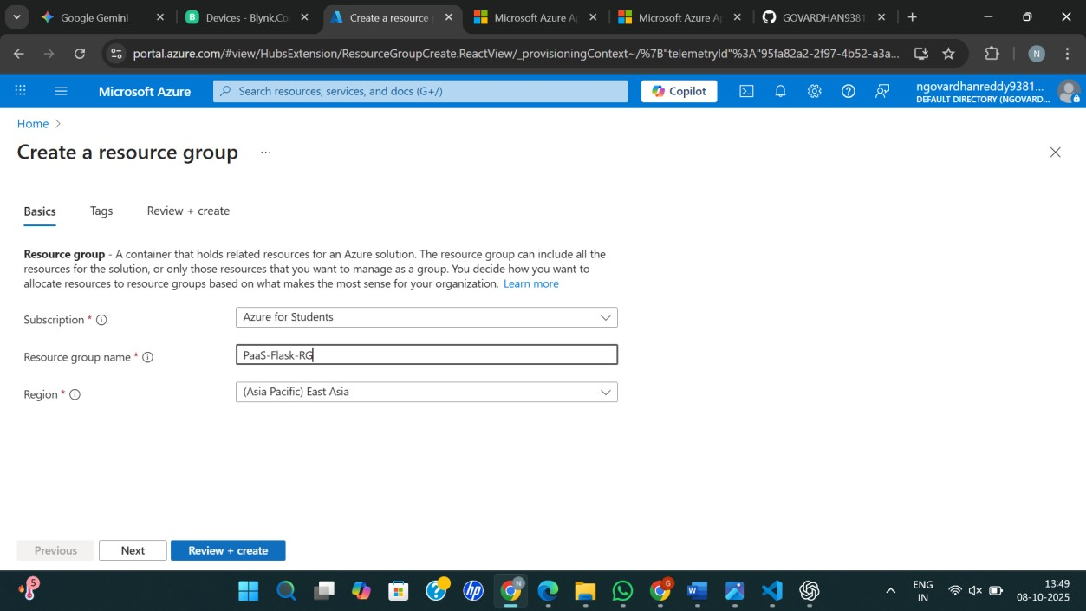

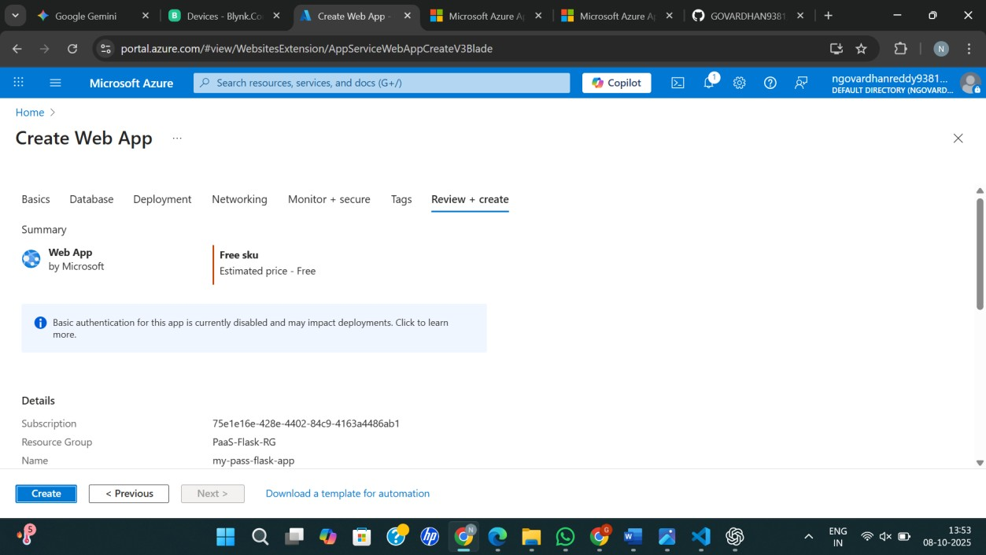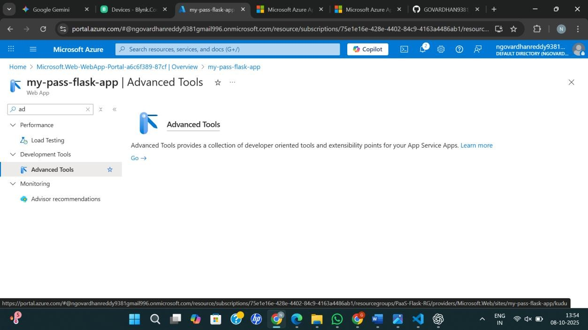

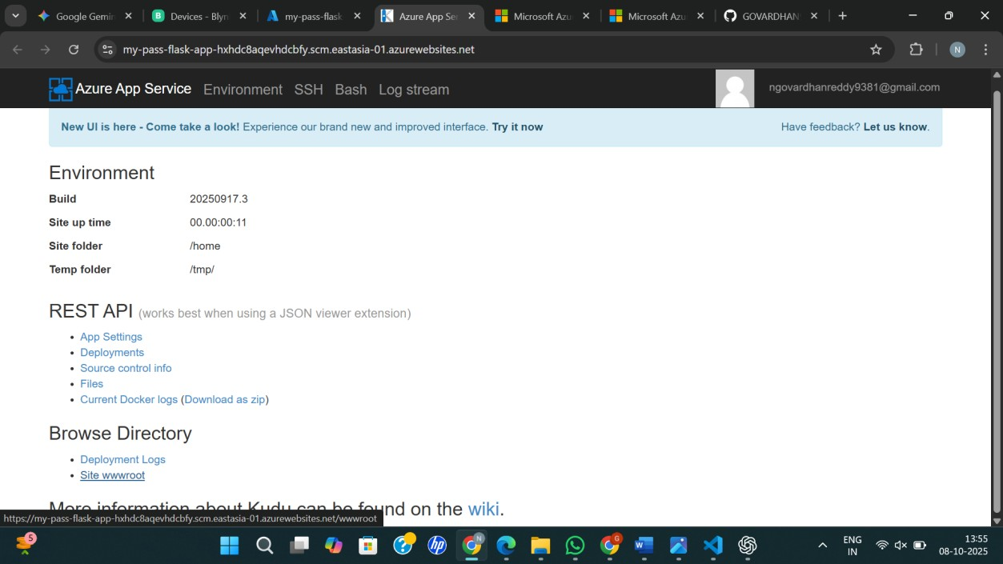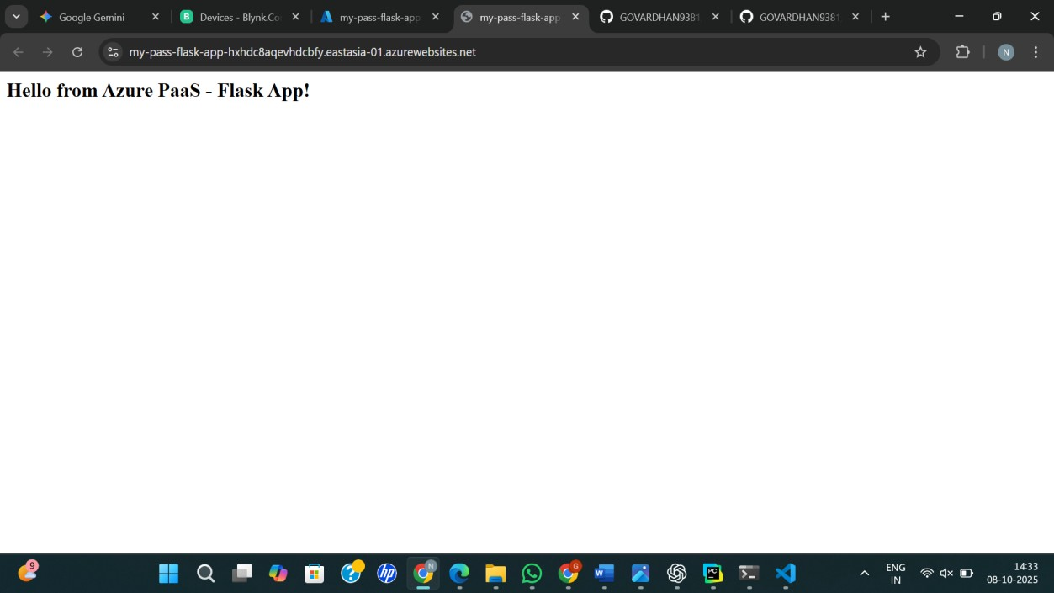

RESULT:
Created a Simple Web Application using Java or Python and host it in any Public Cloud Service Provider (Azure/GCP/AWS) to demonstrate Platform as a Service (PaaS).

