EXP-18
Aim: Visualize the ChickWeight dataset using boxplot, histogram, bar plot, line chart, and scatter plot.
Algorithm
- Load the dataset.
- Set layout for multiple plots.
- Draw the 5 types of plots.
- Reset layout.
Pseudocode
START
Load ChickWeight dataset
Set plotting layout
Draw boxplot of weight
Draw histogram of weight
Draw bar plot of diet counts
Draw line chart of average weight over time
Draw scatter plot of weight vs time colored by diet
Reset plotting layout
END
Output
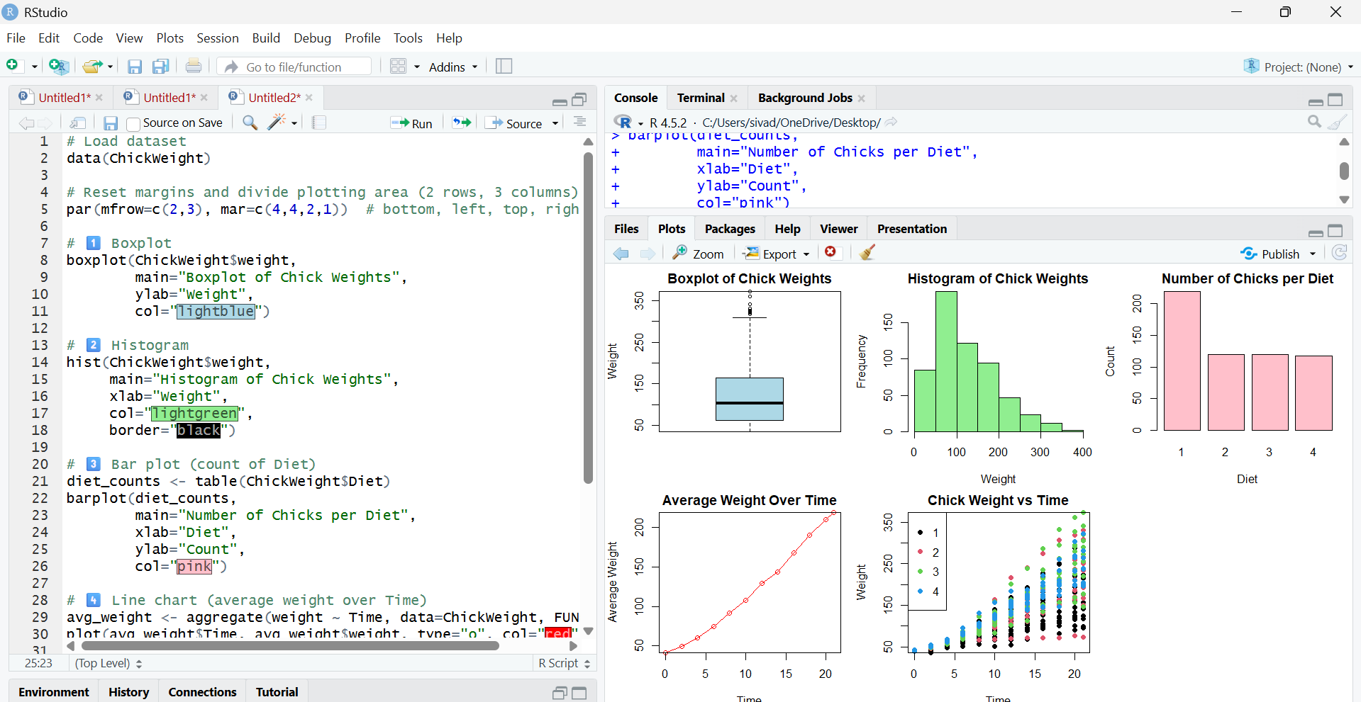
Result
All plots show chick weight distribution, trends over time, and differences among diets, giving a clear visual understanding of growth patterns.

