EXP-19
Aim
To build a linear regression model using the Advertising dataset to predict Sales based on Spend.
Algorithm
- Load the advertising dataset.
- Fit a regression model using Sales ~ Spend.
- Predict sales using the model.
- Display predicted sales values.
Pseudocode
START
Load Advertising dataset
Create regression model: Sales ~ Spend
Use model to predict Sales
Display predicted Sales
END
Output:
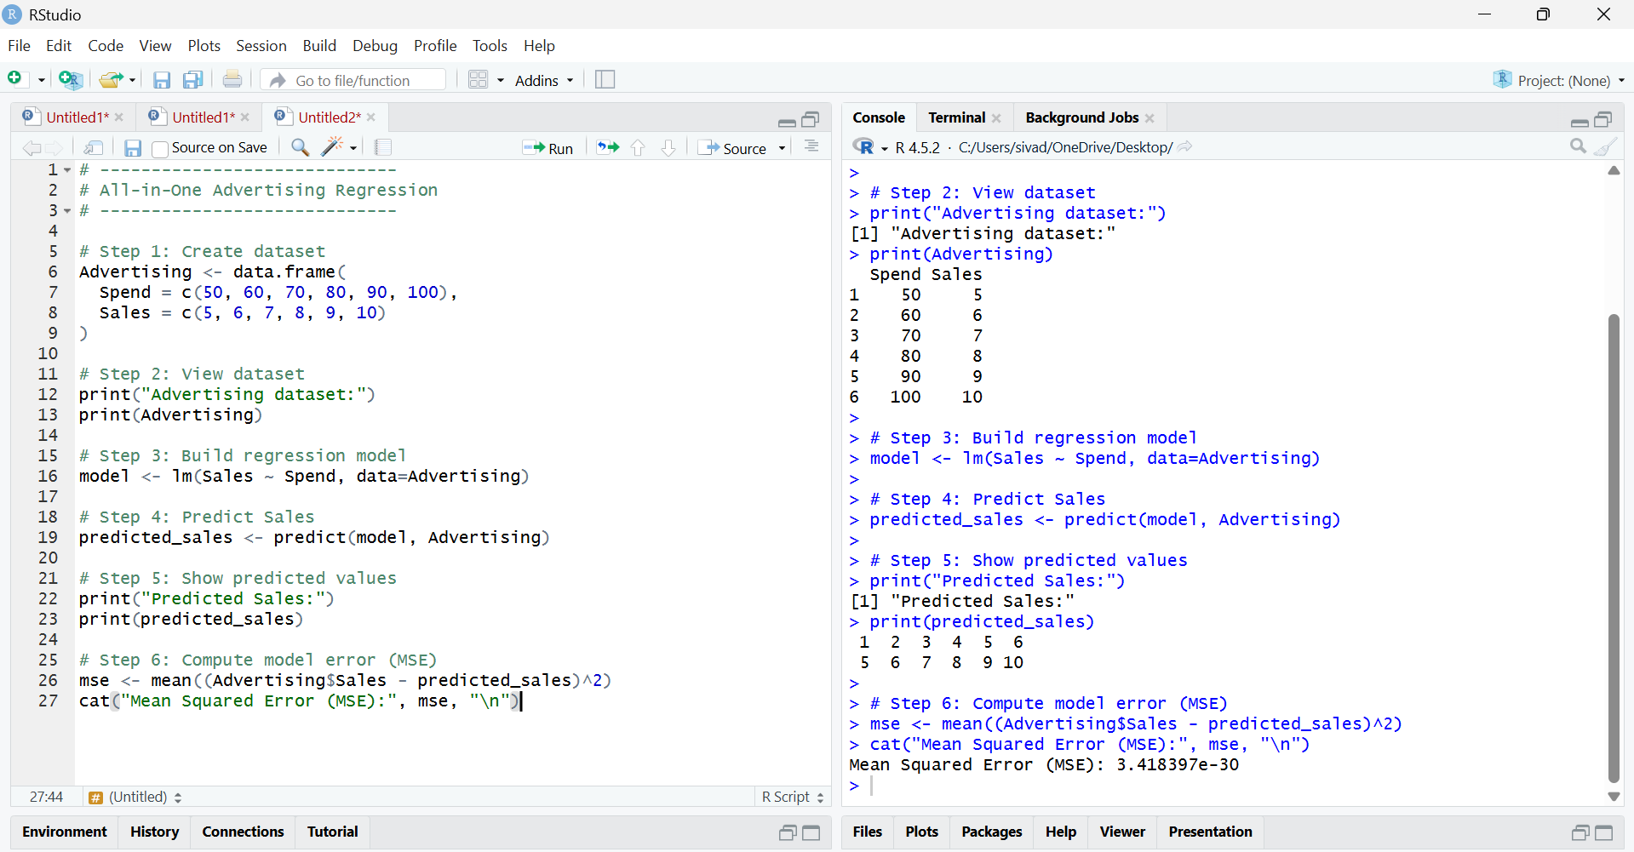
Result
The regression model predicts Sales based on Spend, and the predicted sales values are generated using the trained linear model.

