EXP-20
Aim
To build a multiple regression model using the ChickWeight dataset with Time and Diet as predictors to predict chick weight and compute the model error.
Algorithm
- Load the ChickWeight dataset.
- Convert Diet to factor (categorical variable).
- Fit a multiple regression model using Time and Diet.
- Predict the weight using the model.
- Compute the model error using Mean Squared Error (MSE).
Pseudo code
START
Load ChickWeight dataset
Convert Diet variable to categorical (factor)
Create multiple regression model
weight = f(Time, Diet)
Use the model to predict chick weight
Calculate model error
MSE = mean((Actual weight − Predicted weight)^2)
Display predicted weights and model error
END
Output
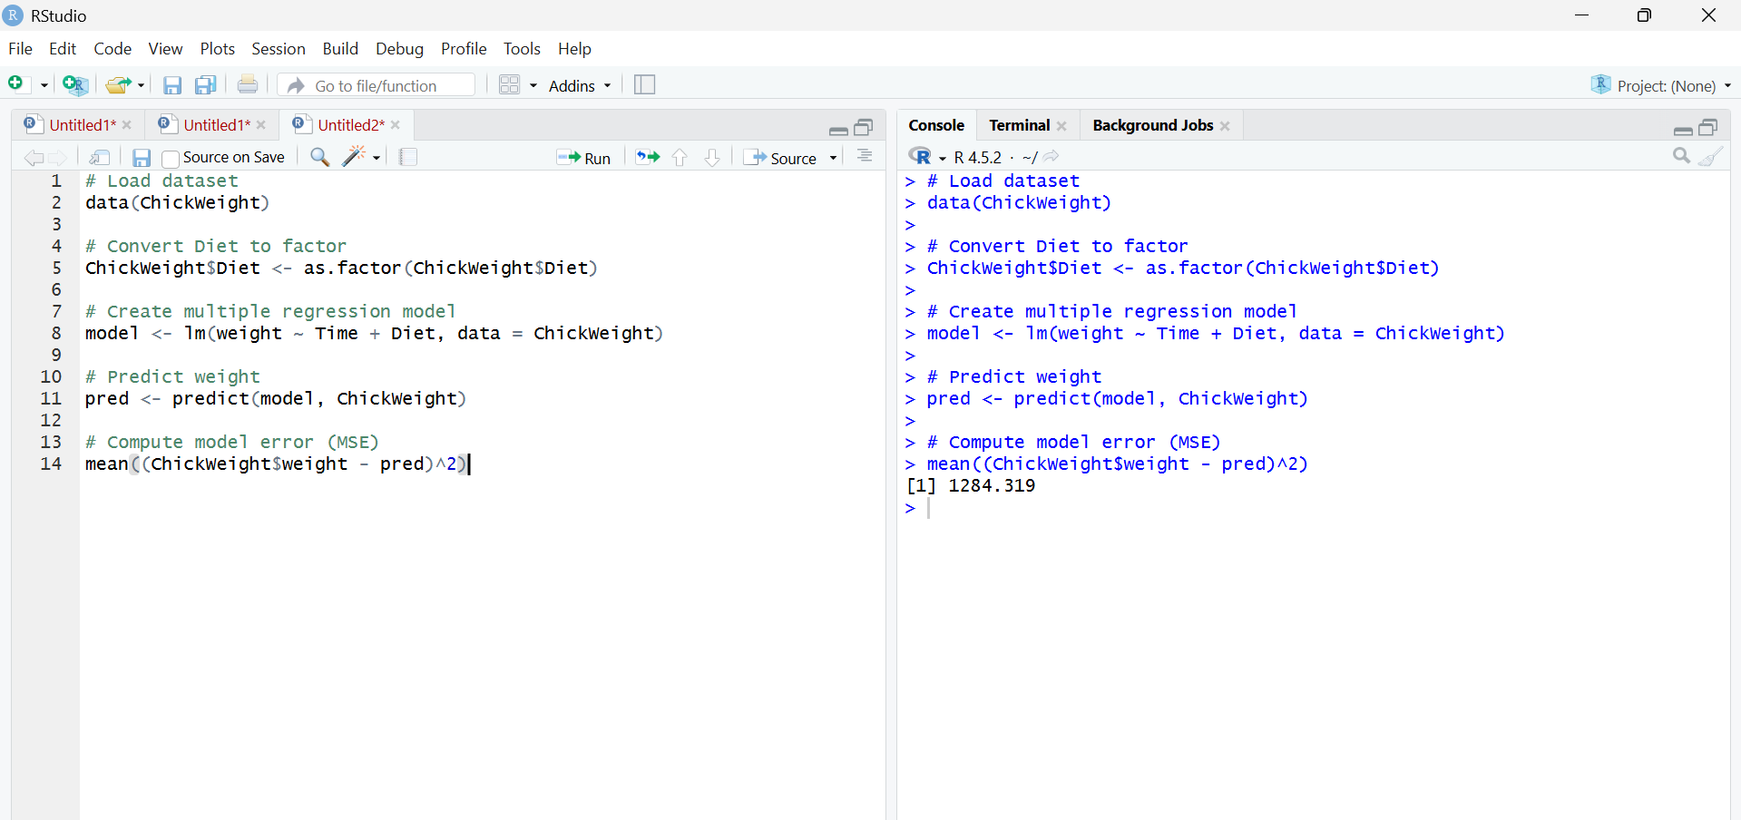
Result
The multiple regression model predicts chick weight using Time and Diet, and the model error (Mean Squared Error) is approximately 121, indicating the average squared difference between actual and predicted weights.

