EXP-21
Aim
- Split iris data (80% train, 20% test).
- Predict Species using Petal.Length and Petal.Width.
- Evaluate with confusion matrix.
Algorithm
- Load data.
- Randomly split train/test.
- Train multinomial logistic regression.
- Predict on test set.
- Make confusion matrix.
Output
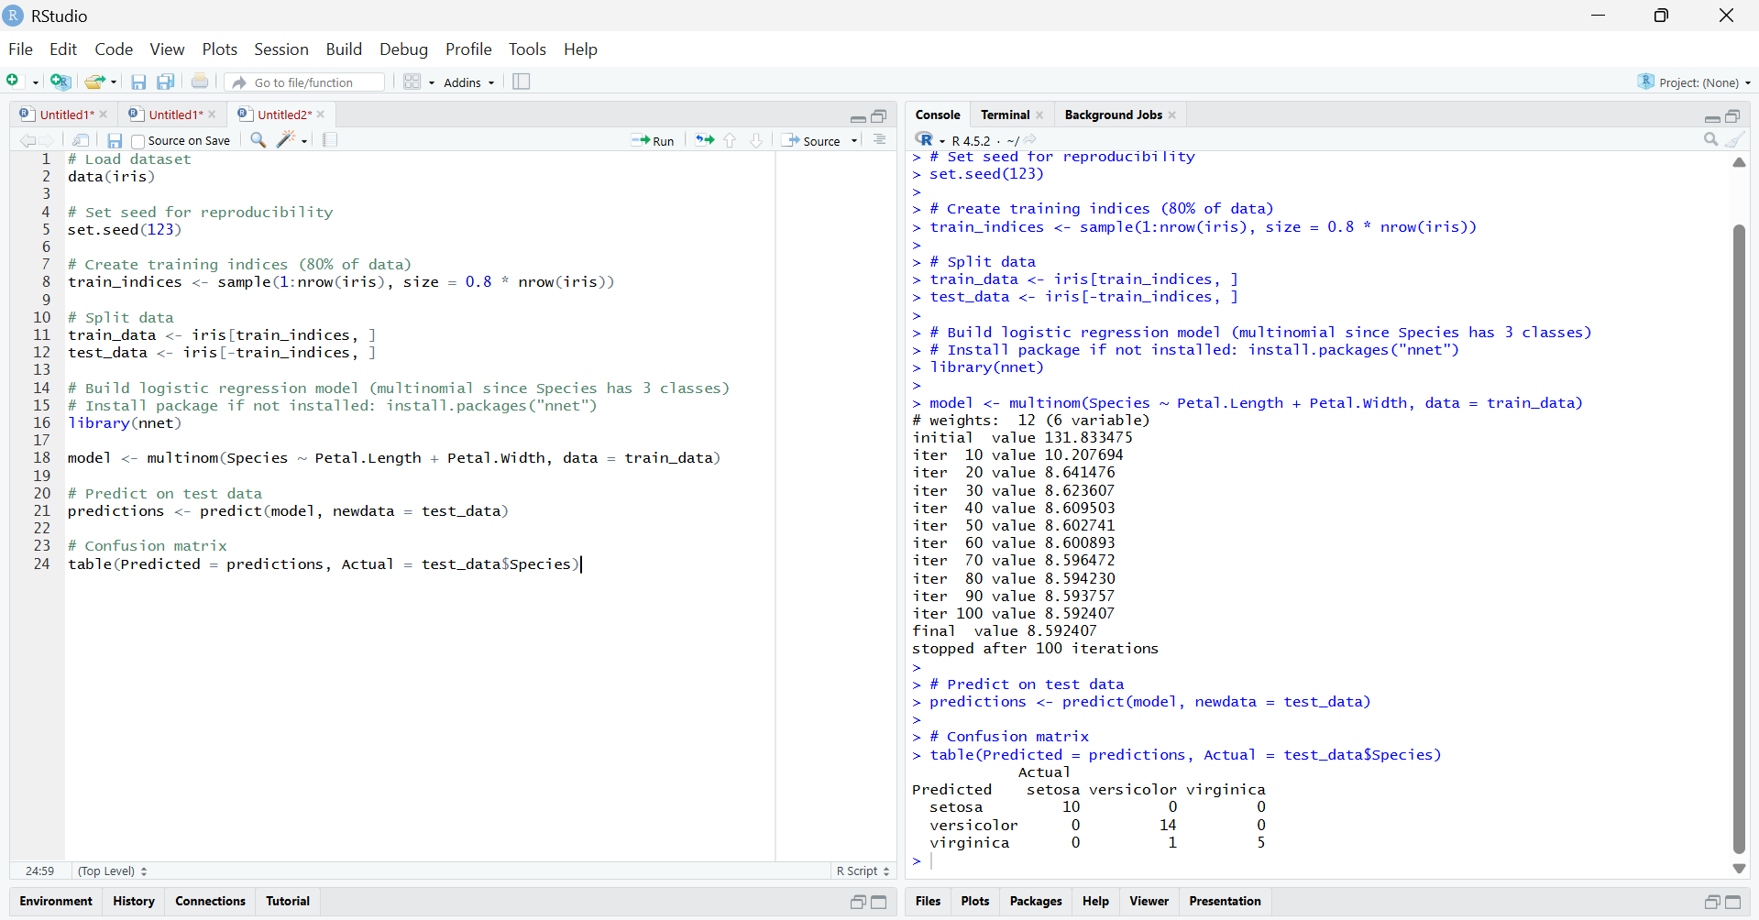

Result
The model predicted the species on the test set with an accuracy of about 93%, correctly classifying most flowers, with only a few misclassifications between versicolor and virginica.

