EXP-1
Aim: To create numeric, character, and logical vectors in R and display their type and content.
Algorithm:
Step 1: Start the program.
Step 2: Create a numeric vector using the c() function.
Step 3: Create a character vector using the c() function.
Step 4: Create a logical vector using the c() function.
Step 5: Display the content of each vector using print().
Step 6: Display the data type of each vector using typeof().
Step 7: Stop the program.
Pseudo code:
BEGIN
Create numeric vector N with values (10, 20, 30)
Create character vector C with values ("Apple", "Banana", "Mango")
Create logical vector L with values (TRUE, FALSE, TRUE)

Display "Numeric Vector Content"
Display N
Display "Type of Numeric Vector"
Display type of N

Display "Character Vector Content"
Display C
Display "Type of Character Vector"
Display type of C

Display "Logical Vector Content"
Display L
Display "Type of Logical Vector"
Display type of L
END
Output:

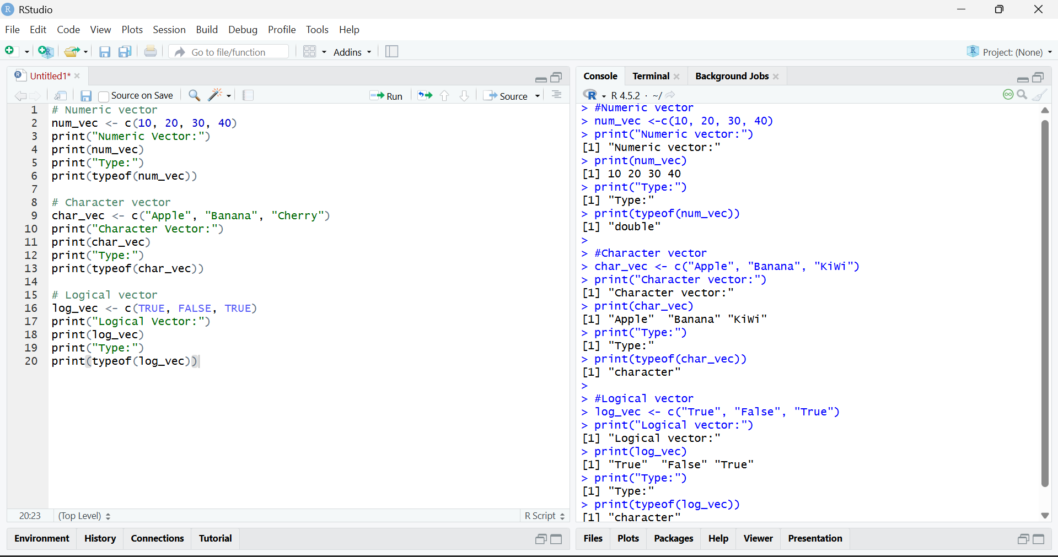

Result:

Numeric, character, and logical vectors were successfully created and their content and data types were displayed.

