EXP-2
Aim: To create labelled matrices of size 5×4, 3×3, and 2×2 in R and fill them by row and by column.

Algorithm:

Step 1: Start the program.
Step 2: Create a 5×4 matrix using matrix() function (fill by row).
Step 3: Assign row and column names.
Step 4: Create a 3×3 matrix (fill by column).
Step 5: Assign row and column names.
Step 6: Create a 2×2 matrix (fill by row).
Step 7: Assign row and column names.
Step 8: Display all matrices.
Step 9: Stop the program.

Pseudo code:

BEGIN
Create matrix A of size 5×4 filled by row
Assign row and column labels to A
Display A
Create matrix B of size 3×3 filled by column
Assign row and column labels to B
Display B
Create matrix C of size 2×2 filled by row
Assign row and column labels to C
Display C
END

Output:

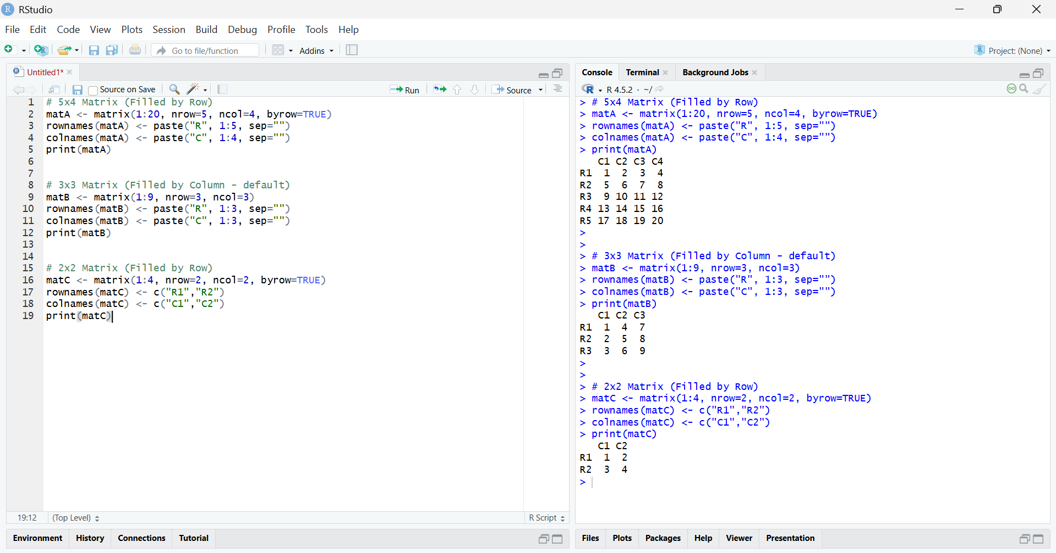

Result:

The labelled matrices of sizes 5×4, 3×3, and 2×2 were successfully created.
The matrices were filled by row and by column as specified, and row and column labels were assigned correctly.

