EXP-3
Aim: To write an R program to create and display a 3D array with specified rows, columns, and tables.

Algorithm:

Step 1: Start the program.
Step 2: Specify the number of rows, columns, and tables.
Step 3: Create a 3D array using the array() function.
Step 4: Assign row, column, and table names.
Step 5: Display the array.
Step 6: Stop the program.

Pseudo code:

BEGIN
Set number of rows = r
Set number of columns = c
Set number of tables = t
Create array A with values and dimensions (r, c, t)
Assign row names
Assign column names
Assign table names
Display A
END

Output:

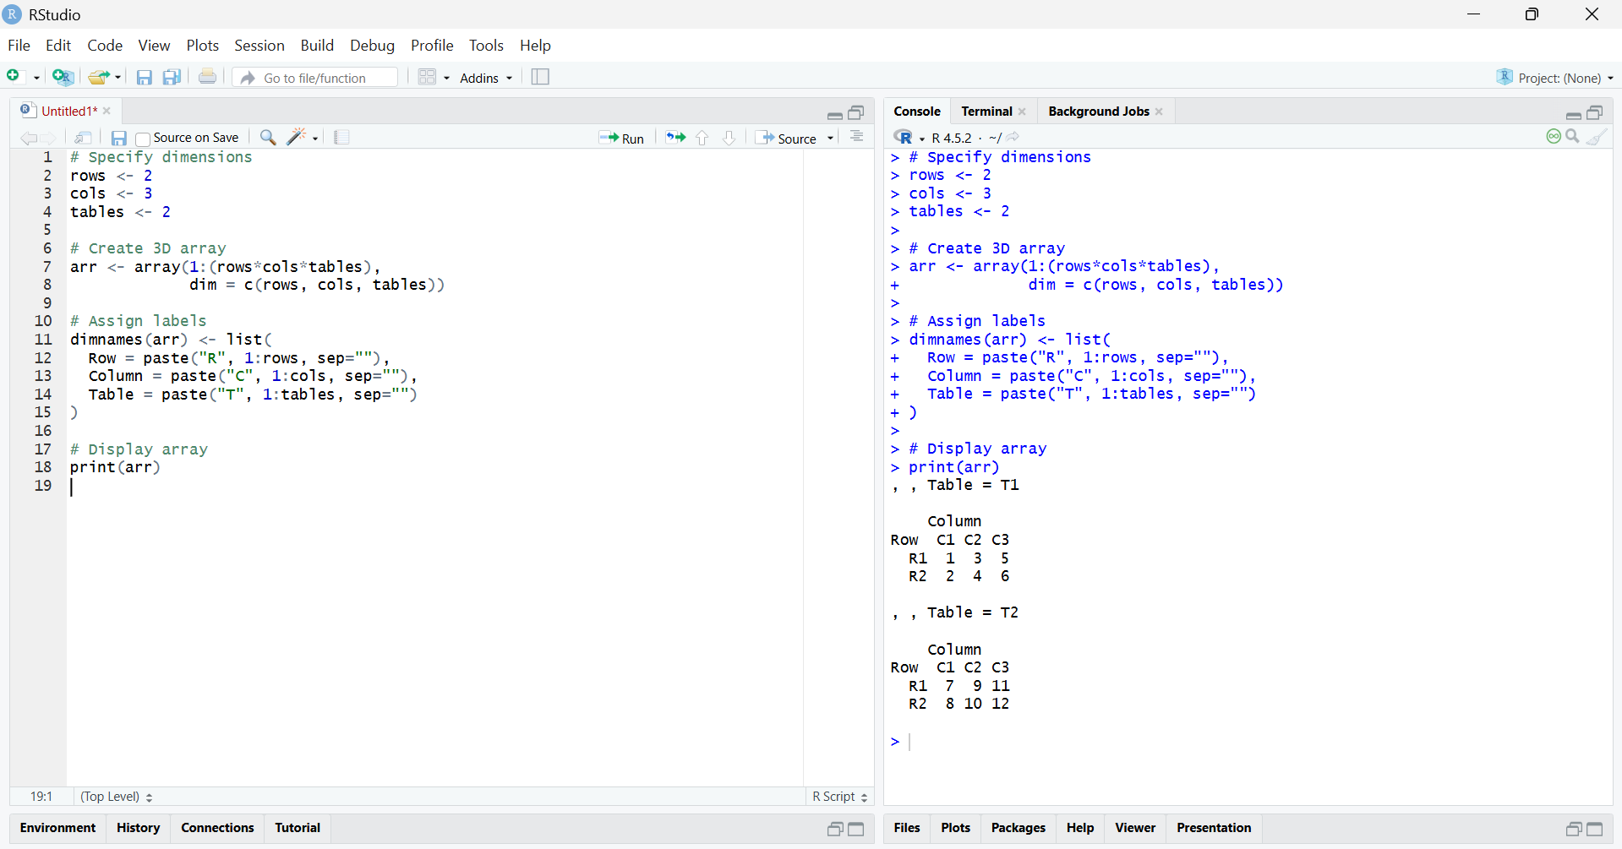

Result:

The 3D array with specified rows, columns, and tables was successfully created and displayed using the array() function in R.

