EXP-4

Aim:
To create arrays from vectors with dimension names and print specific elements in R.

Algorithm:

Step 1: Start the program.
Step 2: Create a vector with required values.
Step 3: Convert the vector into an array using the array() function.
Step 4: Assign dimension names using dimnames().
Step 5: Display the array.
Step 6: Access and print specific elements using indexing.
Step 7: Stop the program.

Pseudo code:
BEGIN
Create vector V with values
Create array A using V with specified dimensions
Assign row names
Assign column names
Assign table names
Display array A
Print specific element using indexing
Print specific row/column if needed
END

Output:

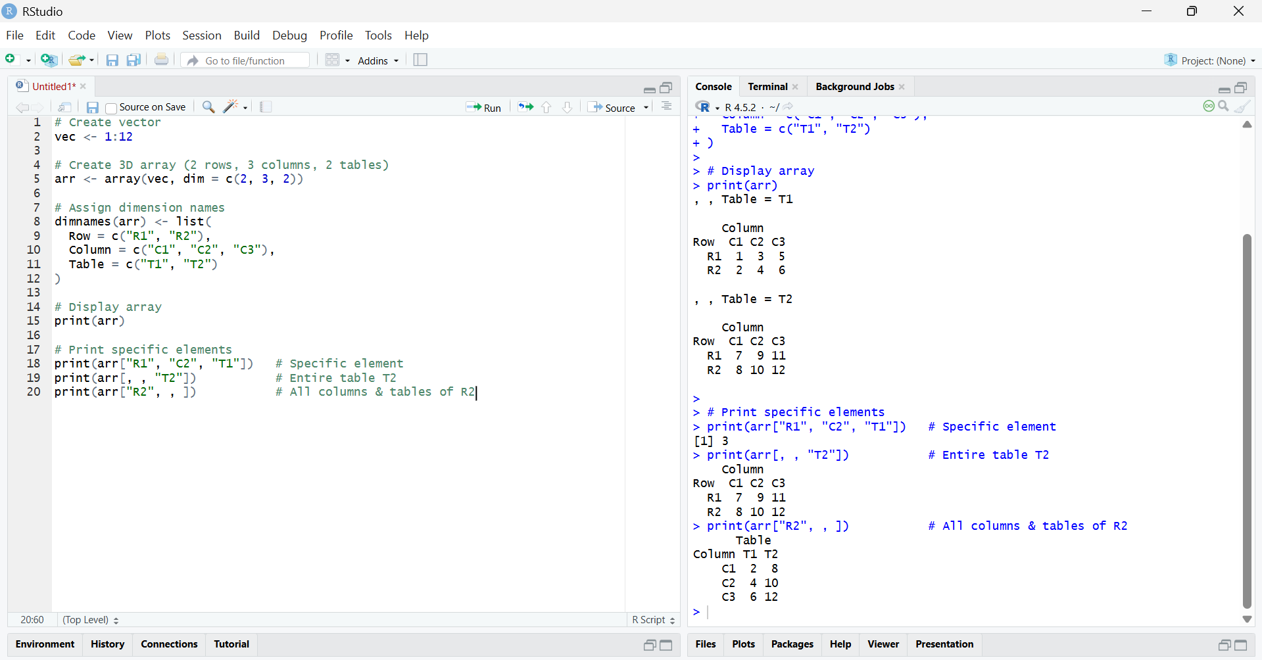

Result:
The array was successfully created from a vector with dimension names.
Specific elements, rows, and tables were accessed and displayed correctly using indexing.

