EXP-5
Aim:
To create and manipulate factor variables using the women dataset (heights) and a random sample of LETTERS in R.

Algorithm:
Step 1: Start the program.
Step 2: Load the built-in women dataset.
Step 3: Convert the height column into a factor variable.
Step 4: Display levels and summary of the factor.
Step 5: Generate a random sample of LETTERS.
Step 6: Convert the sample into a factor.
Step 7: Modify levels if required.
Step 8: Display results.
Step 9: Stop the program.
Pseudo code:
BEGIN
Load women dataset
Convert women$height into factor F1
Display F1
Display levels of F1
Generate random sample from LETTERS
Convert sample into factor F2
Display F2
Display levels of F2
Modify levels of F2 (if needed)
Display updated factor
END

Output:

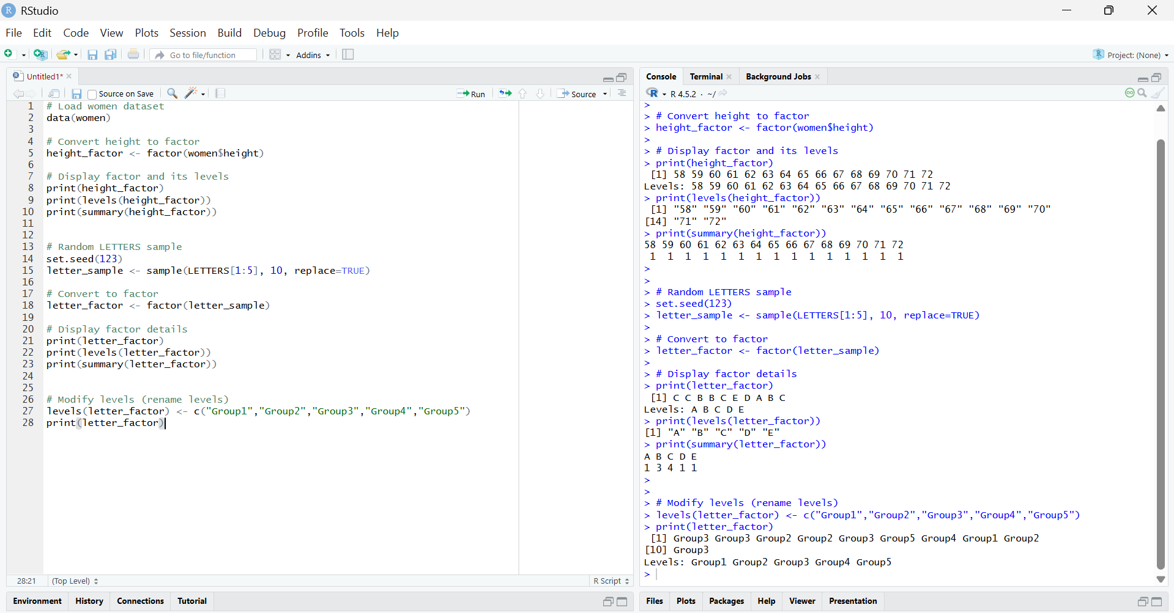

Result:
Factor variables were successfully created from the women dataset heights and a random LETTERS sample. Levels were displayed and modified successfully using factor manipulation functions.

