EXP-10
AIM
To create a data frame exam_data with name, score, attempts, and qualify fields, and perform extract, add row/column, sort, and save to file operations.

ALGORITHM
- Start
- Create vectors for name, score, attempts, qualify
- Create data frame using data.frame()
- Display the data frame
- Extract required rows/columns
- Add new row
- Add new column
- Sort the data frame
- Save to file
- Stop

PSEUDOCODE
BEGIN
Create vectors: name, score, attempts, qualify
Create data frame exam_data
PRINT exam_data
Extract specific column/row
Add new row
Add new column
Sort by score
Save data frame to file
END

OUTPUT:

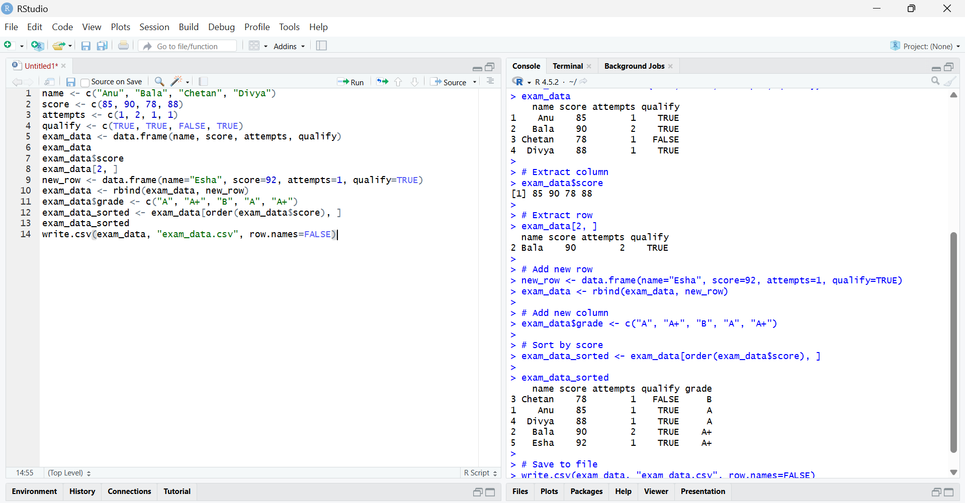
RESULT:
The data frame exam_data was successfully created, explored, modified, sorted, and saved to a file.

