EXP-6
AIM: To create an R list containing a vector, a matrix, and a function, and to display its contents.
Algorithm:
- Start
- Create a numeric vector.
- Create a matrix using matrix() function.
- Create a function.
- Combine vector, matrix, and function into a list using list().
- Display the list.
- Stop.
Pseudo code:
BEGIN
Create vector v
Create matrix m
Define function f
Create list L = list(v, m, f)
Print L
END
Output:
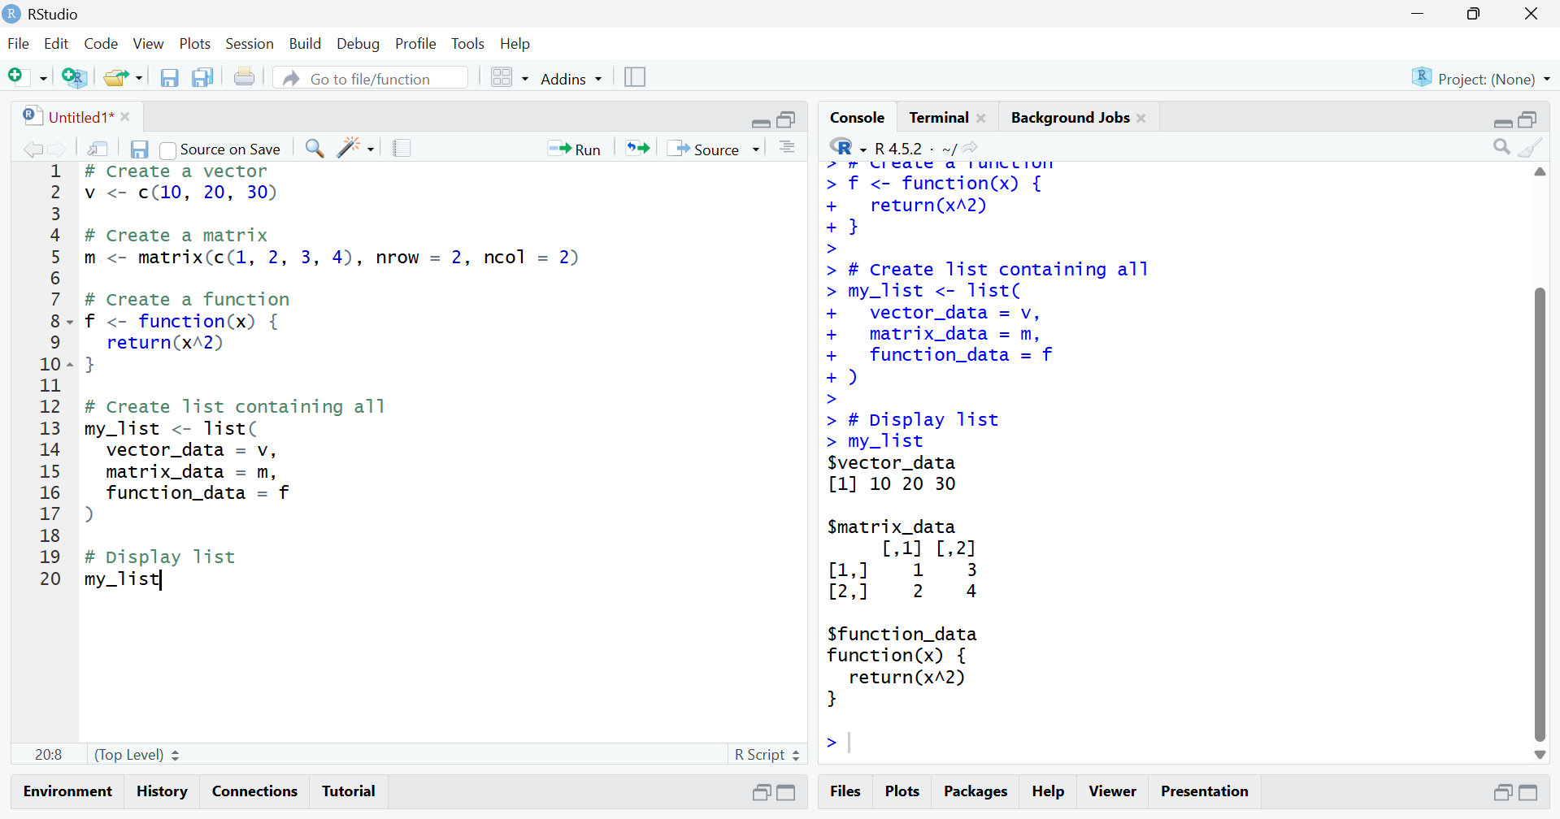
Result:
The R list containing a vector, matrix, and function was created and displayed successfully.

