EXP-8
AIM:
To generate random numbers from a normal distribution and count their occurrences.
ALGORITHM:
- Start
- Generate random numbers using rnorm()
- Store the values
- Count occurrences using table()
- Display results
- Stop
PSEUDOCODE:
BEGIN
Generate n random numbers using normal distribution
Store numbers in variable x
Count frequency of each value
Print frequency
END
OUTPUT:
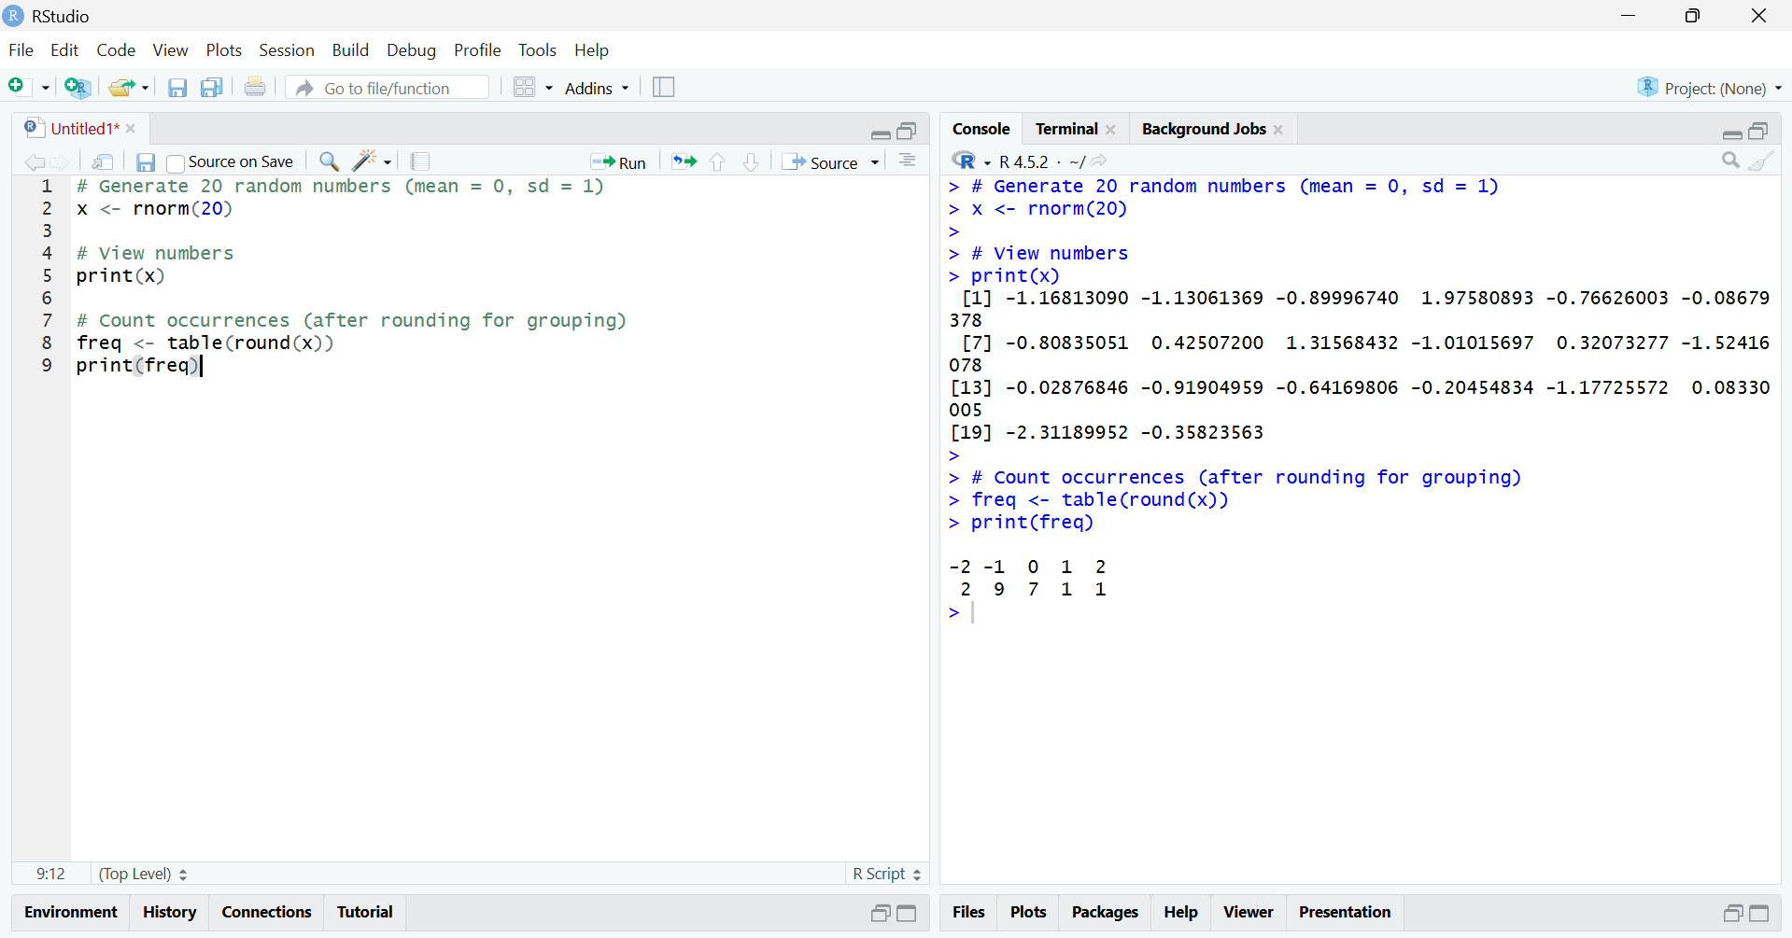
RESULT
Random numbers from a normal distribution were generated successfully, and their frequency of occurrence was displayed.

