EXP-9
AIM
To create an empty plot in R with specified x-axis and y-axis limits.
ALGORITHM
- Start
- Use plot() function
- Set type = "n" (no points drawn)
- Specify x-axis and y-axis limits using xlim and ylim
- Display plot
- Stop
PSEUDOCODE
BEGIN
Call plot function
Set type = "n"
Set x-axis limits
Set y-axis limits
Display empty plot
END
OUTPUT:
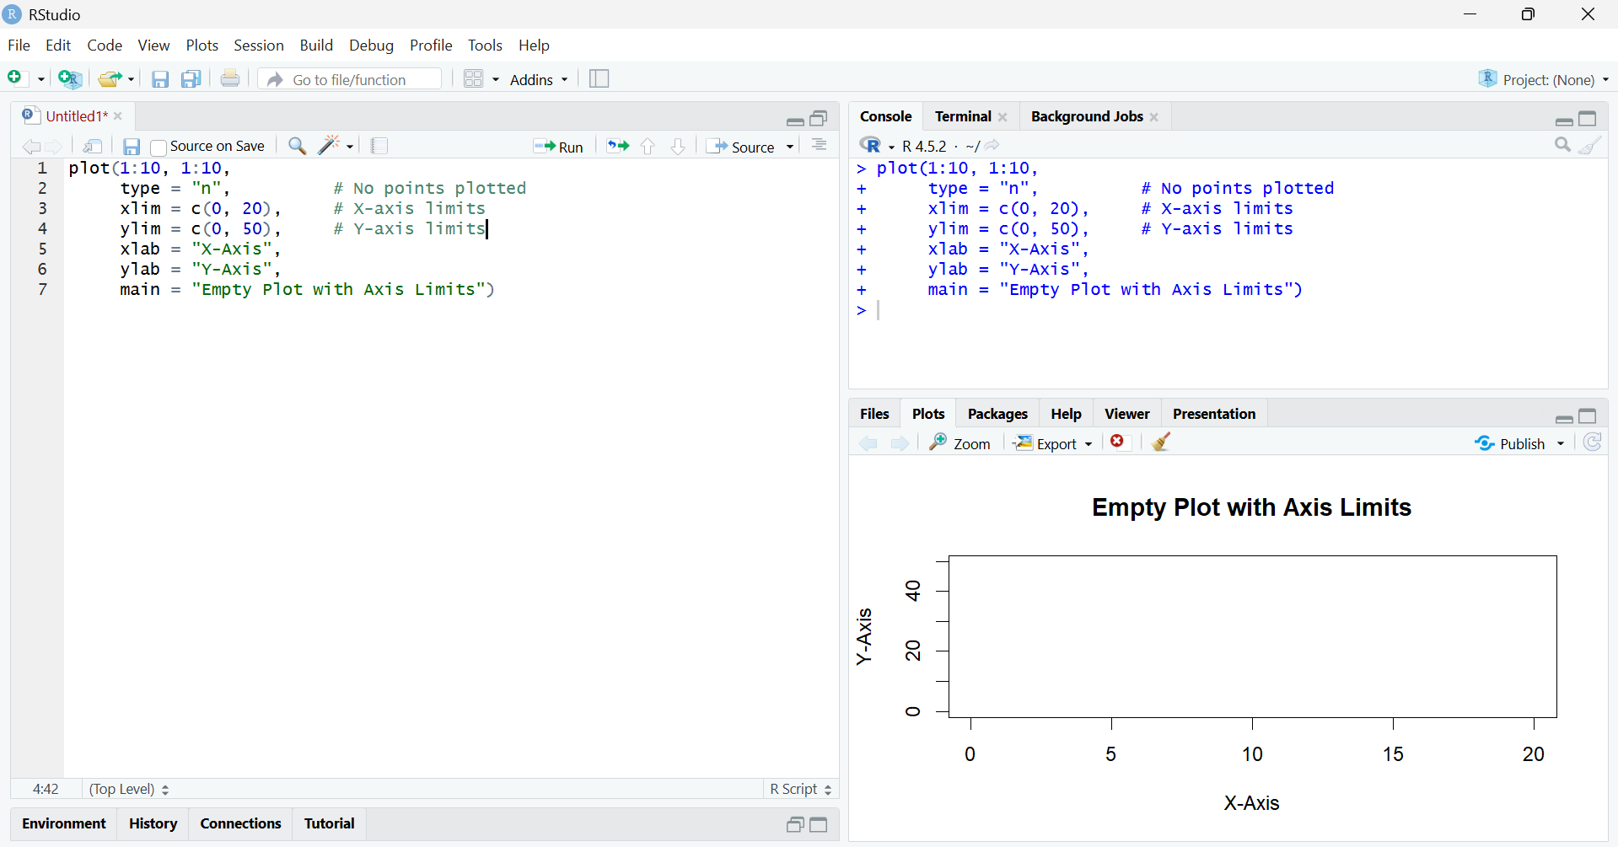
RESULT
An empty plot was successfully created with specified x-axis and y-axis limits.

