EXP-7
1. Program: Factors of a Number
Aim: To write an R program to find the factors of a given number.
Algorithm:
- Start
- Read a number num
- For each number from 1 to num
- If num is divisible by the current number, print it
- Stop
Pseudo code:
BEGIN
INPUT num
FOR i = 1 TO num
IF num mod i == 0
PRINT i
END FOR
END
Output:
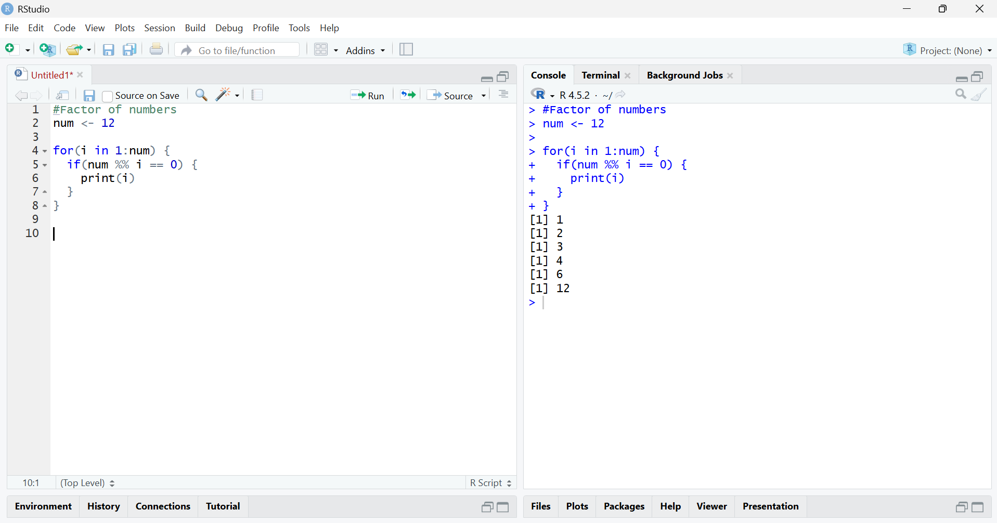
Result:
The factors of the given number were displayed successfully.

2.Program: Generate 10 Random Integers (-50 to 50)
Aim: To generate 10 random integers between -50 and 50.
Algorithm:
- Start
- Use sample() function
- Generate 10 random numbers from -50 to 50
- Display the numbers
- Stop
Pseudo code:
BEGIN
Generate 10 random numbers between -50 and 50
PRINT numbers
END
Output:
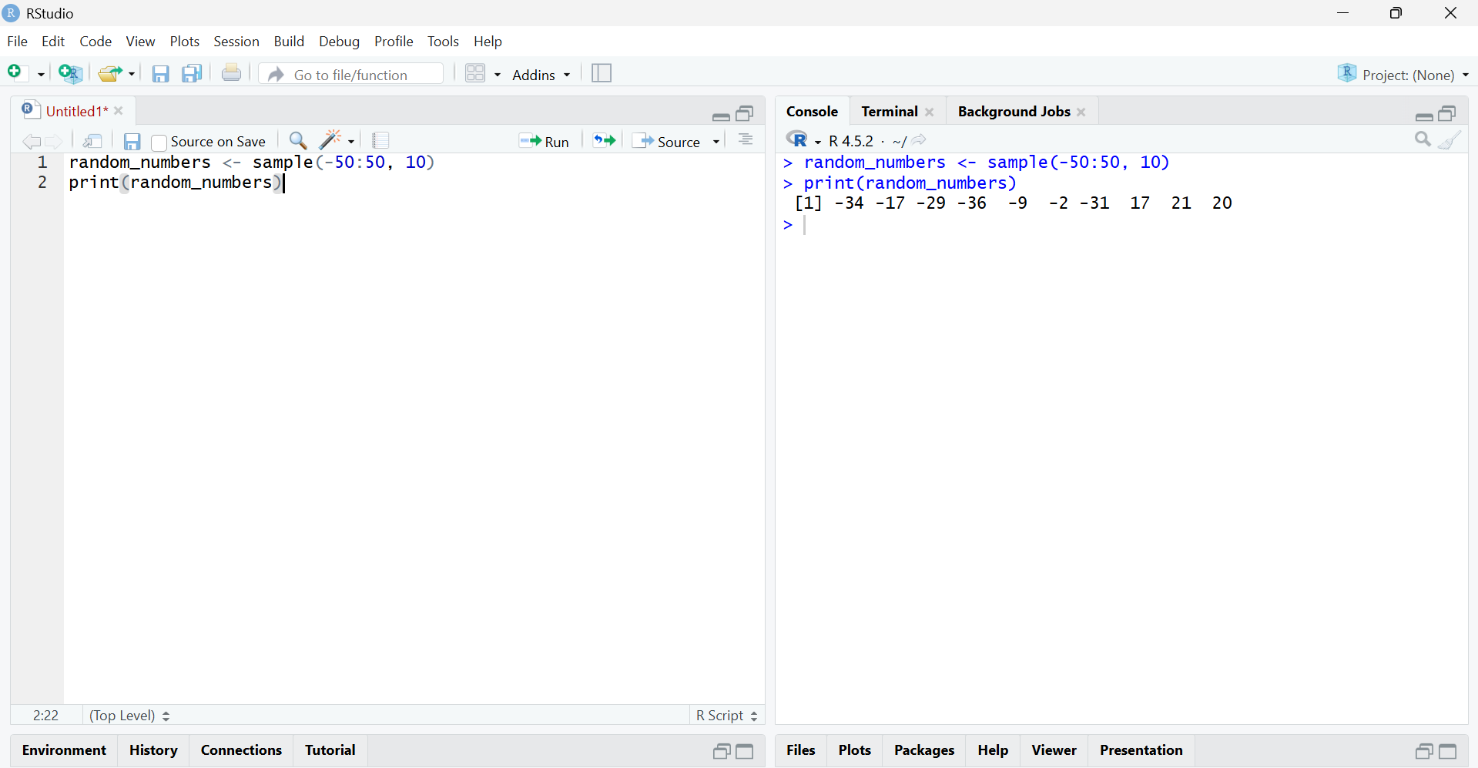

Result:
Ten random integers between -50 and 50 were generated and displayed.

3.Program: FizzBuzz (1–100)
Aim: To print numbers from 1 to 100 using FizzBuzz logic.
Algorithm:
- Start
- For numbers from 1 to 100
- If divisible by 3 and 5 → print "FizzBuzz"
- Else if divisible by 3 → print "Fizz"
- Else if divisible by 5 → print "Buzz"
- Else print number
- Stop
Pseudo code:
BEGIN
FOR i = 1 TO 100
IF i divisible by 3 AND 5
PRINT "FizzBuzz"
ELSE IF divisible by 3
PRINT "Fizz"
ELSE IF divisible by 5
PRINT "Buzz"
ELSE
PRINT i
END FOR
END
Output:
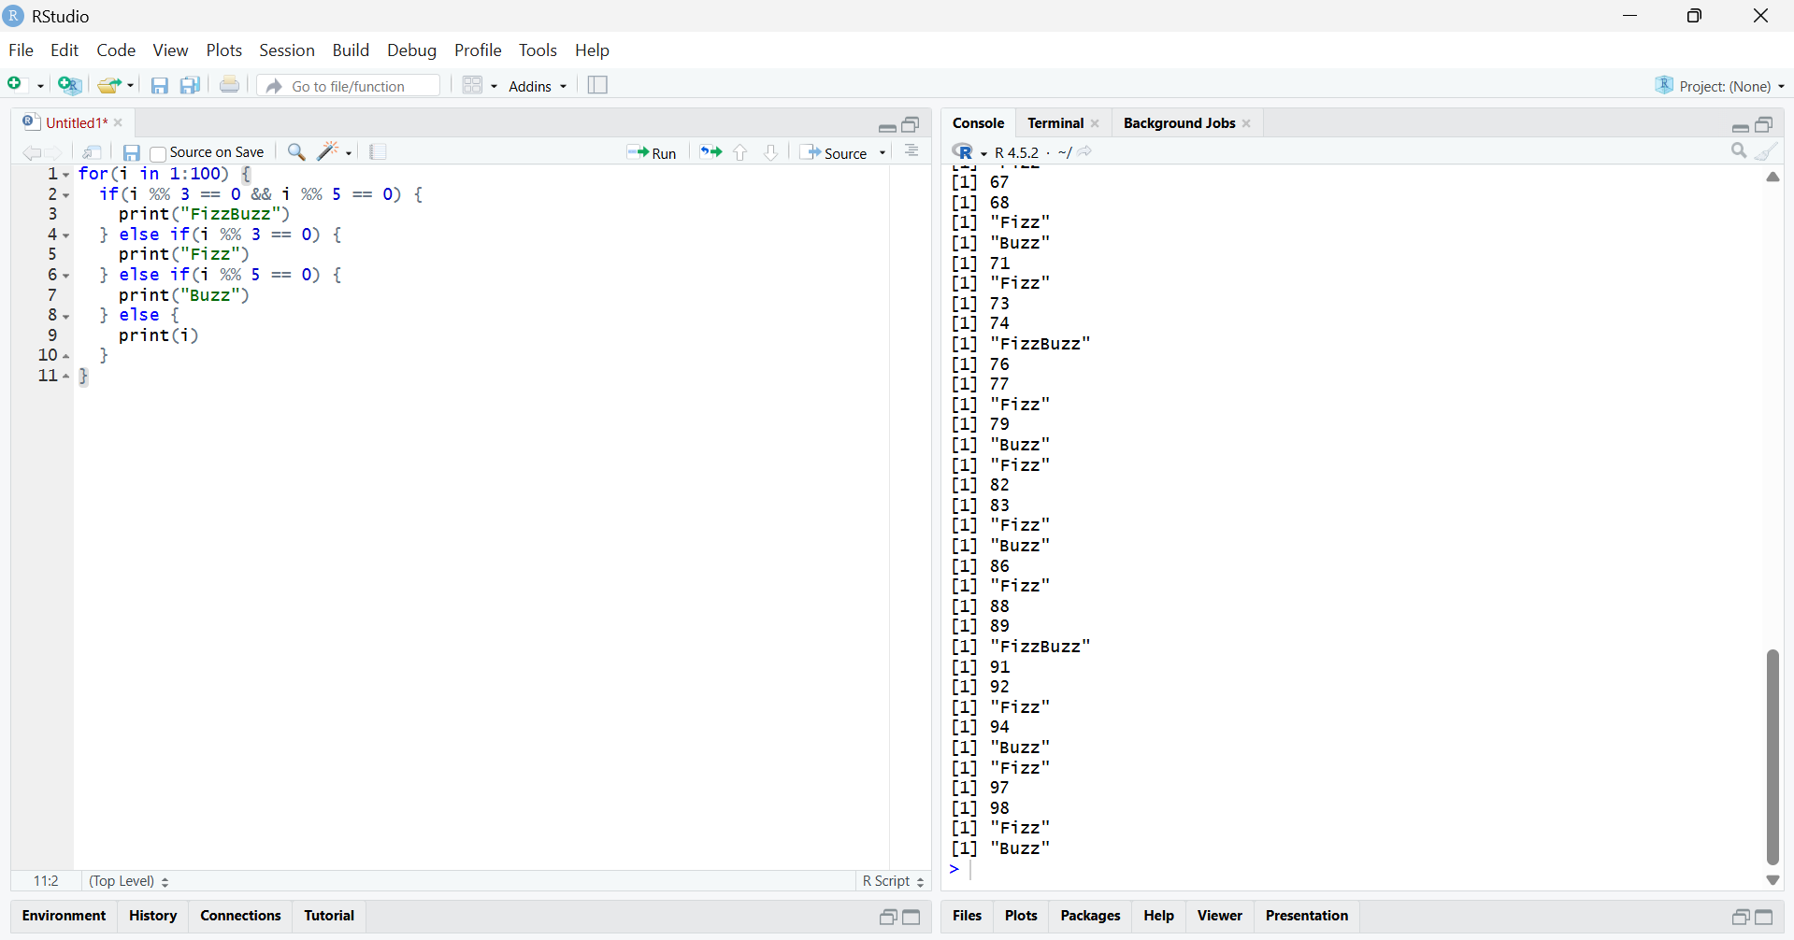

Result:
Numbers from 1 to 100 were printed successfully according to FizzBuzz logic.

